

**ME 493 Final Report – Year 2012**

***HUMIDIFYING A SEALANT CURE OVEN***

June 11th, 2012

**Team Members:**

THONG TRUONG

PAUL LUCAS

KHOI NGUYEN

ASGEDOM GEBREHIWOT

MIRCEA BEC

MESHARI Al EBRAHIM

**Academic Advisor:**

DR. FARYAR ETESAMI

**Industrial Advisor:** RORY OLSON

# Executive Summary

Boeing is the world’s leading aerospace company and the largest manufacturer of commercial and military aircrafts. With an ever-increasing product line, more efficient manufacturing and design process is required in order to meet customer needs. As a result, the proper application of sealant to the aircraft parts is essential in achieving the required quality and reliability. The application of sealant on the aircraft parts prevents them from getting corroded which jeopardizes the load carrying capability of the aircrafts. The sealant curing process requires controlled temperature and relative humidity conditions in order to avoid extensive and costly maintenance. Boeing’s current sealant curing method is inconvenient and inefficient. Boeing would like to improve upon the current curing methods.

Rory Olson, a research and development engineer at Boeing approached the MCECS in order to improve the current curing method. The Boeing’s senior design team is designing a humidity controlled curing oven which will be retrofitted to Boeing’s current ovens. A prototype will be delivered by June 2012.

The oven has been modified with a new insulation and installed a humidifier to control the humidity as well as the temperature by Portland State University’s Capstone Team 2012 and ready to be displayed to Boeing. The team has followed strictly to the steps of the design process to satisfy all the requirements from problem design specification to prototyping and testing. This document will familiarize the reader with the final design concept and design of the oven as well as testing results and various evaluations showing the oven meets all the design specifications.

Contents

Executive Summary 2

Introduction and Background 4

Mission Statement 5

Main Design Requirements 6

Top Level Design Alternatives 6

Final Design 8

Mechanical System 9

Structure 9

Electrical System 10

Water Supply 10

Evaluation of Quality and Reliability 10

Evaluation of Safety and Ergonomics 10

Evaluation of Cost and Financial Performance 11

Evaluation for Mobility and Capacity 11

Dimension 11

Weight 11

Capacity 12

Structural 12

Maintenance 12

Conclusion 13

Appendixes 14

Appendix A: Product Development Specifications 14

Appendix B: Decision Matrix 18

Appendix C: Project Timeline 19

Appendix D: Calculations for Pressure, Heat Loss, and Mass Flow Rate 20

Appendix E: Drawings & Models 22

Appendix F: Part Illustrations and Humidifier Circuit Diagram 23

Appendix G: References 25

# 

# Introduction and Background

Boeing designs aircrafts that resist corrosion through the use of proprietary corrosion inhibiting sealants. The sealant curing process is essential in order to guarantee the quality and reliability of the aircraft and control corrosion to avoid jeopardizing the intended load carrying capability of the airplane [3]. The sealant curing process requires controlled temperature and relative humidity conditions in order to avoid extensive and costly maintenance.

Boeing uses a two-component polysulfide sealant containing corrosion inhibiting chromate to effectively eliminate corrosion. Two current approaches of curing the sealant are the “traditional” and “lean” methods.

The traditional method utilizes large curing ovens, from 300 to 500 ft2 (Figure 2). Although the ovens allow for humidity control, accelerating the curing process, they are not equipped with corrosion resistant materials and are therfore easily corroded. These ovens require dedicated wiring and plumbing making them costly and difficult to transport.

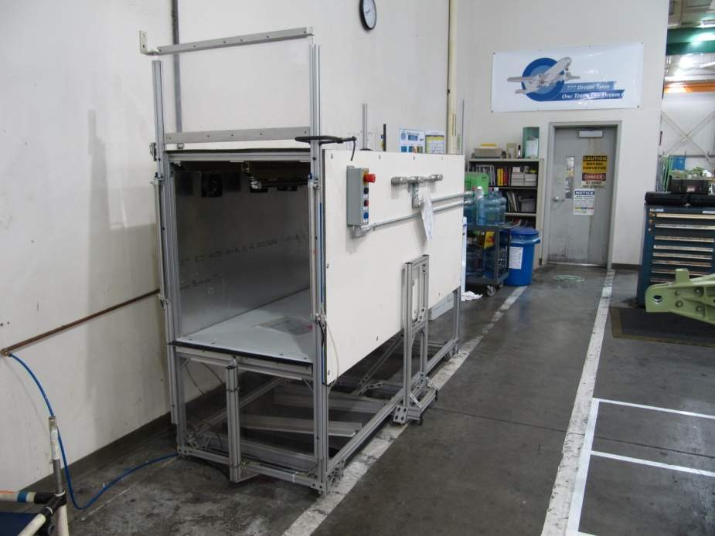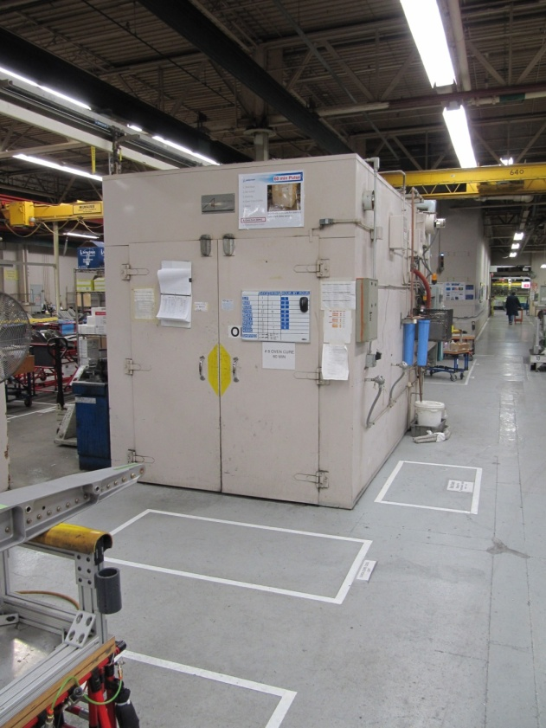

Figure 1.1: *Lean method oven.*

Figure 1.2: *Traditional method oven.*

Their large size also contributes to poor flow conditions and poor temperature stability. The more recent “lean” method utilizes smaller ovens offering better flow control and temperature stability (Figure 1). The small dimensions (3’ wide x 6’ long x 4’ deep) and power requirements (120 Volts at 60 Hz) allow the machine to be moved with relative ease and located wherever a typical wall outlet can be found. However, these ovens are not equipped with humidity control and also require fixed plumbing.

Table 1: *Advantages and disadvantages of the lean and traditional methods.*

|  |  |  |
| --- | --- | --- |
| **Method** | **Advantages** | **Disadvantages** |
| **Lean** | * Mobile * Good Environment Control * Good Flow Control | * No Humidity Control * Plumbed |
| **Traditional** | * Humidity Controlled * Holds Many Parts | * Large Size * 240 Volts Hardwired * Plumbed |

# Mission Statement

The purpose of this project is to design an efficient curing oven that can embrace the advantages of each of the current methods known as “lean” and “traditional”. The capstone team’s design must be retrofit-table to Boeing’s existing lean ovens with dimensions of 3’wide x 3’ long x 4’ deep with significant enhancements. These enhancements include a non-corrosive, humidity and temperature controlled environment that maintain the required lightweight design of less than 250 lbs. A successful prototype of the oven would be transferred to Boeing’s facility for utilization by the end of June.

# Main Design Requirements

A detailed list of customer’s requirements was specified in the PDS document which is attached in Appendix A. The main design requirements are summarized below.

* Humidity inside the oven must be controlled at 50±5% RH.
* Temperature inside the oven needs to be maintained at 130±5oF.
* The designed oven is expected to last for at least 5 years.
* No silicone products may be used in the fabrication or assembly of the oven.
* The size of the oven for this project will be 3’wide x 3’tall x 4’deep chamber that opens on both ends.
* There should be minimum maintenance required once the oven is deployed.
* Power source for operating the oven must be 120v AC at 60Hz.
* The designed oven should not be plumbed; it must have an onboard water supply with a 35lb weight limit.

# Top Level Design Alternatives

In the internal and external search section of the design process, three of the most common methods in controlling the humidity were researched: water atomizing, steam injection, and water bath evaporation. The top level design of this project is focused on controlling the humidity at ±50% RH and the temperature at 135 o ± 5 oF. There are several factors that impact the final design: the positioning of the water supply, humidifying mechanism, performance, cost, and manufacturability. After extensive discussions and evaluations, there were three alternative designs which needed to be considered. The strengths and weakness of each alternative are summarized below.

Table 2: *Strengths & weaknesses of each design method based on external search.*

|  |  |  |
| --- | --- | --- |
| **Method** | **Strengths** | **Weaknesses** |
| **Pressure Jet / Rotary Atomizing** | * Low Maintenance * Operate Under Range of Flow Rates * Suitable for low Temperature Humidity | * Large Droplet Size * Effects Temperature * Require Separate Air and Water System |
| **Steam Injection** | * High Range of Humidity * Dry Process * No Temperature Change | * Delay in Steam Supply * Costly * Complex Design * Requires Plumbing |
| **Ultrasonic Humidifier** | * Small Water Droplets (1 micron) * Simply System * No Delay in Moisture Supply | * Effects Temperature * Costly |

The ultrasonic humidifier was chosen for the final design. The concept scoring matrix is summarized in Appendix B. As Boeing’s requirement, the final product would be easily retrofit to their current ovens, a simple but effective means of humidification was necessary. The ultrasonic humidifier provides a finer droplet size than the pressure jet or rotary atomizers (1 micron diameter) resulting in a fine mist that may be easily evaporated.

The rotary atomizer breaks the water into fine droplets via a rotating disc. The nature of this process leads to inconsistent droplet size therefore, making it more difficult to control moisture, temperature and humidity levels. The ultrasonic atomizer uses a high frequency vibration to generate a consistent droplet size which results in a low velocity spray. The smaller droplet sizes are more easily evaporated so moisture is of little to no concern. Both the rotary and pressure jet atomizing methods require air pressure. The ultrasonic system is pressure-free making it simpler to design.

Steam injection requires a boiler to be kept at a high temperature in order to provide steam to the chamber. This process utilizes both a large quantity of water and energy. The amount of water needed to supply the boiler is sufficient enough to require the system be plumbed. In comparison, the ultrasonic humidifier runs at room temperature requiring very little power (45 Volts) and allows for a gravity fed water supply to be used, meeting the product design specifications.

# Final Design

The final design of the curing chamber consists of both mechanical and electrical systems. A resistive heating element is controlled by a binary (on/off) controller and two thermocouples. The humidity is supplied by the ultrasonic humidifier which the humidity level is maintained through a binary controls system. The gravity fed water supply is fitted with a ball valve for tank/humidifier maintenance.



Figure 2.1: *Temperature and Humidity Control System Diagram.*

Operation of the sealant oven may be characterized into three modes:

1. Heating mode: The heating element is turned on and the temperature is brought up 135 oF. During this time the part may be inserted into the oven to reach oven temperature, preventing condensate from accumulating on the part.
2. Curing mode: Once the oven has reached operating temperature the humidifier will be activated bringing the humidity to 50% RH. The RH and temperature controllers will maintain the operating conditions throughout the curing process.
3. Cooling mode: The system will be switched off and the oven doors opened to allow for a rapid cool down process.

# Mechanical System

The mechanical components of the curing chamber determine the performance, maintenance, and structural integrity of the system. The system consists of four major components: the shell and structure, water supply and electrical systems.

## Structure

As received by Boeing, the ovens structural members where constructed from extruded aluminum T-slot channel. For this reason the structural members used in the design of all new system components used the same.

In detail, a 1/16th inch 6061-T6 aluminum sheeting was used for the oven shell for several reasons. Firstly, its light weight helps meet the weight requirements stipulated by the PDS. Secondly, it is relatively easily formed and cut which allowed the team to utilize the tools provided by the Mechanical Engineering Departments machine shop. Thirdly, it is relatively corrosion resistant at the ovens operating conditions and cheap to replace. All the necessary shapes were designed in SolidWorks and then drawn onto the metal sheeting for cutting and bending.

As mentioned all structural parts utilized extruded aluminum T-slot channel. SolidWorks was used to design the components to mount the humidifier, controls box, and water supply (Refer to Appendix E for drawings). To facilitate maintenance and assembly the gussets, brackets, corner plates, and screws where all compatible with the T-slot channel.

To retard heat transfer, the inner walls of the oven are lined with 1½ inch blanket fiberglass insulation with an R-value of 30 and a layer of foil single bubble insulation to minimize heat transfer due to radiation.

## Electrical System

The 48 VDC operating voltage for the Ultrasonic humidifier is switched on and off by a solid state DC relay controlled by the Level Controller (Stultz Air Technology Systems, Inc., 2012). The level controller, microprocessor based, receives input from the sensors (RH and Temp.) and in turn controls the float valves (filling the humidifier unit), fan, and nebulizers. When signal is sent to the processor it checks the low and high water float switches. If the water is too low, the water fill valve solenoid is switched on and monitored until the water level reaches the high level, it is then turned off. When the water level is above the low water level the fan is turned on to push the mist from the nebulizer unit.

## Water Supply

The water supply is made of clear plastic allowing the end user to visually determine the water level. A valve is fitted between the supply and the humidifier for maintenance purposes.

# Evaluation of Quality and Reliability

Based on the specification of the ultrasonic humidifier and its components, the prototype is theoretically reliable as the humidifier can be operated up to 24 hours per day, which is more than sufficient as the typical testing takes only 6 hours. The components of the humidifier are easily replaceable upon failure. Some of the components that are susceptible to possible failure are the fuse, nebulizer unit, print plate, float switch, solenoid valve and circuit board, these components are easily replaceable.

# Evaluation of Safety and Ergonomics

The humidifier unit is equipped with internal safety mechanisms. The safety control is built into the microprocessor. The voltage supplied to the nebulizer affects the amount of mist produced. Voltage exceeding the 48V operating conditions will damage the transducer while too low a voltage restricts mist production. The processor monitors the voltage within a range, if out of this range the processor will not send current to the solid state relay (Stultz Air Technology Systems, Inc., 2012). In the same manner if the temperature dips out of operating range or the water stops being supplied via the float valves the microprocessor turns off the solid state relay and fan and drains the tank to avoid freezing. An LED mounted on the control box will signal alarm should any of the above happen.

Ergonomics required that the end user lift no more than 35 pounds over 5 feet high. This constraint was met by providing a pump to bring water into the systems water supply. This allows the end user to use a hand cart to bring a 5 gallon jug of water over to the oven, place the pump in the 5 gallon tank and fill the onboard water supply without lifting any weight.

# Evaluation of Cost and Financial Performance

The total budget for this particular project was set to be around $5,000. The amount of money spent on purchasing parts reached roughly $4,100. With labor cost not taken in consideration, the amount of money spent was considered as development cost. All parts were purchased and approved by Boeing Company. By keeping the development cost under budget all desirable goal were met.

# Evaluation for Mobility and Capacity

## Dimension

After rebuilding the interior of the oven to fit for humidity, dimensions remained the same (3ft x 3ft x 4ft). The ultrasonic-humidifier in comparison to the other methods is relatively small (10.71” x 8.27), which meets the requirements of having system that will retrofit with Boeing’s current ovens.

## Weight

The whole system (water tank, ultrasonic humidifier, interior design) weights approximately 80lb which meets the requirement of 100lb.

## Capacity

The mass flow-rate of the current design (Stulz-Ultrasonic Humidifier) ranges from 0 to 4.4 lbm/hr, which meets the 1.46 lbm/hr requirement.

## Structural

The interior was rebuilt using 6061-Aluminum plate (1/16” thick). Aluminum T-slot beam were used to mound the humidifier and water thank in place. Other components such as: PVC and flexible tubes, sensors, valves, vinyl tubes and electric wires were also used at the assembly of the system.

## Maintenance

|  |  |
| --- | --- |
| **ITEM** | **INTERVAL** |
| **Cleaning Air filter** | During every cleaning of the water tank interior. |
| **Replacing Fuse** | If burned out. |
| **Inspection electrical parts and cleaning the water tank interior.** | Every 1,000 hours of operation.  Ex: Humidifier is operated 8 hours per day which is approximately every 4 months. |
| **Replacing ultrasonic nebulizer unit and print plate** | Transducer- After about 10,000 to 15,000 hours of operation. Nebulizing Print Plate- If damaged or causing problems. Heat sink- If damaged or eroded. |
| **Replacing Float switch** | Heat sink- If damaged or eroded. |
| **Replacing Solenoid valve** | Heat sink- If damaged or eroded. |
| **Replacing Printed Circuit board** | If the printed circuit board is damaged or if relays or If the printed circuit board is damaged or if relays or |

Figure 3.1: *Ultrasonic Humidifier Maintenance*

# Conclusion

This document reflects all designs, requirements and product design specifications we have determined that our third chosen design has met all specified requirements effectively and working within the constraints given by Boeing. The final design was the most simple and efficient in term of structure, quality, reliability and maintenance. It was quite expensive, but it fitted our dedicated budget. Since the design is a proof of concepts device, we have shown that within the requirements listed the concept of sealant cure oven is achievable within budget, performance and maintenance requirements. The only issue that we have to face is the missing control panel due to the delay from the vendor, so we are not yet to be able to fully test our prototype. We have done some initial tests based on the Home Depot humidifier and it met the PDS requirements. We are confident that as soon as we receive the control panel, our final prototype will satisfy all the requirements. Overall, our design has met the performance, quality, reliability, and life in service requirements. We will keep working on installing the control panel to the oven once we receive it. Several tests will be made to verify the validation of the data based on the product design specifications and requirements from Boeing.

# Appendixes

## Appendix A: Product Development Specifications

|  |  |  |  |  |  |
| --- | --- | --- | --- | --- | --- |
| **Performance** | | | | | |
| **Primary Customer** | **Requirements** | **Metrics** | **Targets** | **Basis** | **Verification** |
| Boeing | Humidity | Relative Humidity | 50%RH±5% | Customer Feedback | Testing of Prototype |
| Boeing | Temperature | Degrees oF | 130±5°F | Customer Feedback | Testing of Prototype |

|  |  |  |  |  |  |
| --- | --- | --- | --- | --- | --- |
| **Quality and Reliability** | | | | | |
| **Primary Customer** | **Requirement** | **Metrics** | **Target** | **Basics** | **Verification** |
| Boeing | Part Failure | - | 1 per 1000 | Customer Feedback | Testing |

|  |  |  |  |  |  |
| --- | --- | --- | --- | --- | --- |
| **Life in Service** | | | | | |
| **Primary Customer** | **Requirement** | **Metrics** | **Target** | **Basics** | **Verification** |
| Boeing | 5 years continued operation | Years | 5 years | Customer Feedback | Prototyping |

|  |  |  |  |  |  |
| --- | --- | --- | --- | --- | --- |
| **Materials** | | | | | |
| **Primary Customer** | **Requirement** | **Metrics** | **Target** | **Basics** | **Verification** |
| Boeing | No part interaction with Silicon or water | - | No interaction | Group Decision with Customer’s Input and Requirement | Design |
| Boeing | Corrosion Resistance | - | Corrosion resistant metals | Customer Feedback | Design |

|  |  |  |  |  |  |
| --- | --- | --- | --- | --- | --- |
| **Dimensions** | | | | | |
| **Primary Customer** | **Requirement** | **Metrics** | **Target** | **Basics** | **Verification** |
| Boeing | Must be 3’×3’×4’ chamber with one opened-end | Varied with different parts | Variable Size | Customer Feedback | Design |

|  |  |  |  |  |  |
| --- | --- | --- | --- | --- | --- |
| **Testing** | | | | | |
| **Primary Customer** | **Requirement** | **Metrics** | **Target** | **Basics** | **Verification** |
| Project Team | Testing | +/- | Works as intended | Group Decision | Study of Testing Analysis |

|  |  |  |  |  |  |
| --- | --- | --- | --- | --- | --- |
| **Documentation** | | | | | |
| **Primary Customer** | **Requirement** | **Metrics** | **Target** | **Basics** | **Verification** |
| Boeing/PSU | PDS, Progress, Final Reports | Deadline | Meet the deadline | Department of ME | Grade |

|  |  |  |  |  |  |
| --- | --- | --- | --- | --- | --- |
| **Timelines** | | | | | |
| **Primary Customer** | **Requirement** | **Metrics** | **Target** | **Basics** | **Verification** |
| ME 492 | PDS/Progress Reports | Submitted Reports | 2 reports | Course Requirement | Grade |
| ME 493 | Design Report | Submitted Reports | 1 report | Course Requirement | Grade |
| Boeing | Completed design and prototype | Fully functional | Meet the Deadline | Customer Feedback and Course Requirement | Grade and Experience |

|  |  |  |  |  |  |
| --- | --- | --- | --- | --- | --- |
| **Environment** | | | | | |
| **Requirement** | **Metrics** |  | **Target** | **Basics** | **Verification** |
| Boeing | Operating process with clean, purified oven | Contamination of surroundings | No detectable contamination to the environment | Customer Feedback | Material and Process Record |

|  |  |  |  |  |  |
| --- | --- | --- | --- | --- | --- |
| **Maintenance** | | | | | |
| **Primary Customer** | **Requirement** | **Metrics** | **Target** | **Basics** | **Verification** |
| Boeing | Minimum maintenance | Maintenance Interval | 1 week | Customer Feedback | Similar System Comparison |

|  |  |  |  |  |  |
| --- | --- | --- | --- | --- | --- |
| **Weight** | | | | | |
| **Primary Customer** | **Requirement** | **Metrics** | **Target** | **Basics** | **Verification** |
| Boeing | Light Weight | Pounds | < 250 lbs | Group Decision with Customer’s Input | Measurement |

|  |  |  |  |  |  |
| --- | --- | --- | --- | --- | --- |
| **Ergonomics** | | | | | |
| **Primary Customer** | **Requirement** | **Metrics** | **Target** | **Basics** | **Verification** |
| Boeing | Weight Limit of Water Supply | Pounds | < 35 lbs | Customer Feedback | Measured |

|  |  |
| --- | --- |
| **Criteria** | **Reasons** |
| Cost of production per part (material and labor) | Boeing’s responsibility |
| Competition Products | Not applicable |
| Shipping | The part is installed and operated at Boeing facility. |
| Packaging | None required |
| Aesthetics | None required |
| Legal (Related patents) | Legal constrains and patents controlled by Boeing |
| Disposal | None required |
| Applicable Codes and Standards | Not applicable |

## Appendix B: Decision Matrix

Table 3: Concept scoring matrix.

|  |  |  |  |  |  |
| --- | --- | --- | --- | --- | --- |
|  | **Weight** | **Atomizing Water** | | **Steam Injection** | **Ultrasonic Humidifier** |
| **Performance**  Humidity Control  Temperature Uniformity  Moisture Prevention |  | | | |  |
| 3 | | 9 | 11 | 15 |
| 1 | | 2 | 3 | 4 |
| 2 | | 2 | 5 | 8 |
| **Cost** | 3 | | 12 | 3 | 3 |
| **Mobility** | 1 | | 3 | 2 | 5 |
| **Total** | 10 | | 28 | 24 | 35 |

## Appendix C: Project Timeline

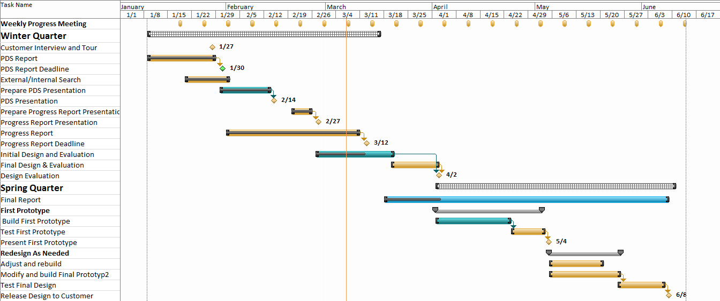

## Appendix D: Calculations for Pressure, Heat Loss, and Mass Flow Rate

|  |  |
| --- | --- |
| **State 1**: (Room condition)  P1,a = 101.33 kPa  T1 = 25oC = 298.15 K = 77oF  RH = 65%  P*Air (25oC) = 3.17 kPa  V1 = 36 ft3 = 1.02 m3 | **State 2**: (Required condition)  P2 = ?  T2 = 57oC = 135oF = 330.15 K  RH = 50%  P*Air (57oC) = 17.85 kPa  V2 = 36 ft3 =1.02 m3 |

Assume curing products occupied 50% volume

Legend:

P = the system pressure; T = the system temp.; RH = the relative humidity of the system

P*Air (T) = the saturated vapor pressure of air at temp. T

Applying air as ideal gas

Where Pv,1 = Φ (P*Air (25oC)) = 0.65 (3.17 kPa) = 2.06 kPa

P1 = Pa,1 + Pv,1 = 101.33 + 2.06 =103.39kPa

Hence Pa,2 = 112.21 kPa

Pv,2 = Φ (P*Air (57oC)) = 0.5 (17.85 kPa) = 8.93 kPa

P2 = Pa,2 + Pv,2 = 112.21 + 8.93 = 121.14kPa

Assume that 10% lost for leaking

**Poven**   **157.5 kPa.**

**\*\*Estimate the heat loss through the 2 doors:**

The heat flux may be determined from Fourier’s Law:

$$q_{x}^{"}=K\frac{∆T}{L}=0.71\frac{W}{m.K}×\frac{52 K}{0.006 m}=6153.33 \frac{W}{m^{2}}$$

The heat loss through the two doors of area:

$$Q_{loss}=Aq_{x}^{"}≈10.29 kW\left(2 h\right)=20.58 kWh$$

Where $A=2\left(3ft\right)\left(3ft\right)=18 {ft}^{2}≈1.67 m^{2}$

Assume that 20% heat loss through leaking

$$Q_{loss, actual}≈24.7 kWh$$

**\*\*Estimate the mass flow rate of vapor inlet:**

* Ultrasonic Humidifier condition (inlet to the oven)

T = 100oC = 373.15 K

P = 160 kPa

Inlet area (with 4 mist outlet of humidifier) is

$d_{inlet}=1.42"\left(\frac{1 ft}{12"}\right)(0.3048)=0.0361 m$

$$A=π{d_{inlet}}^{2}=0.0041m^{2}$$

Assume Velocity of vapor: V = 0.03 m/s = 108 m/hr

$$υ=\frac{RT}{P}=0.67\frac{m^{3}}{kg}≈0.3\frac{m^{3}}{lbm}$$

Where R = 0.287 kPa-m3/kg-K

|  |
| --- |
| V = 1.02 m3  P1 = 103.39 kPa  P2 = 157.50 kPa  T1= 298.15 K  T2 = 330.15 K  (Air) |

The gas constant of air is R = 0.287 kPa.m3/kg.K. The initial and final masses of air in the oven are:

$$m_{1}=\frac{P_{1}V}{RT_{1}}≈1.23 kg$$

$$m_{2}=\frac{P_{2}V}{RT_{2}}≈1.70 kg$$

Mass balance: $m_{in}-m_{out}=∆m_{system} → m_{in}=m_{2}-m_{1}≈0.46 kg≈1.02 lbm$

With 10% loss for leaking

**min** = 0.51 kg = **1.12 lbm**

## Appendix E: Drawings & Models

|  |  |
| --- | --- |
| \\khensu\Home06\thtruong\Desktop\3.JPG  Figure 4.1: Ultrasonic Humidifier | Figure 4.2: Humidifier modeled by Solidworks |
| Figure 4.3: Original Sealant Cure Oven | Figure 4.4: Modified Sealant Cure Oven with Humidifier and Water Tank |

## Appendix F: Part Illustrations and Humidifier Circuit Diagram

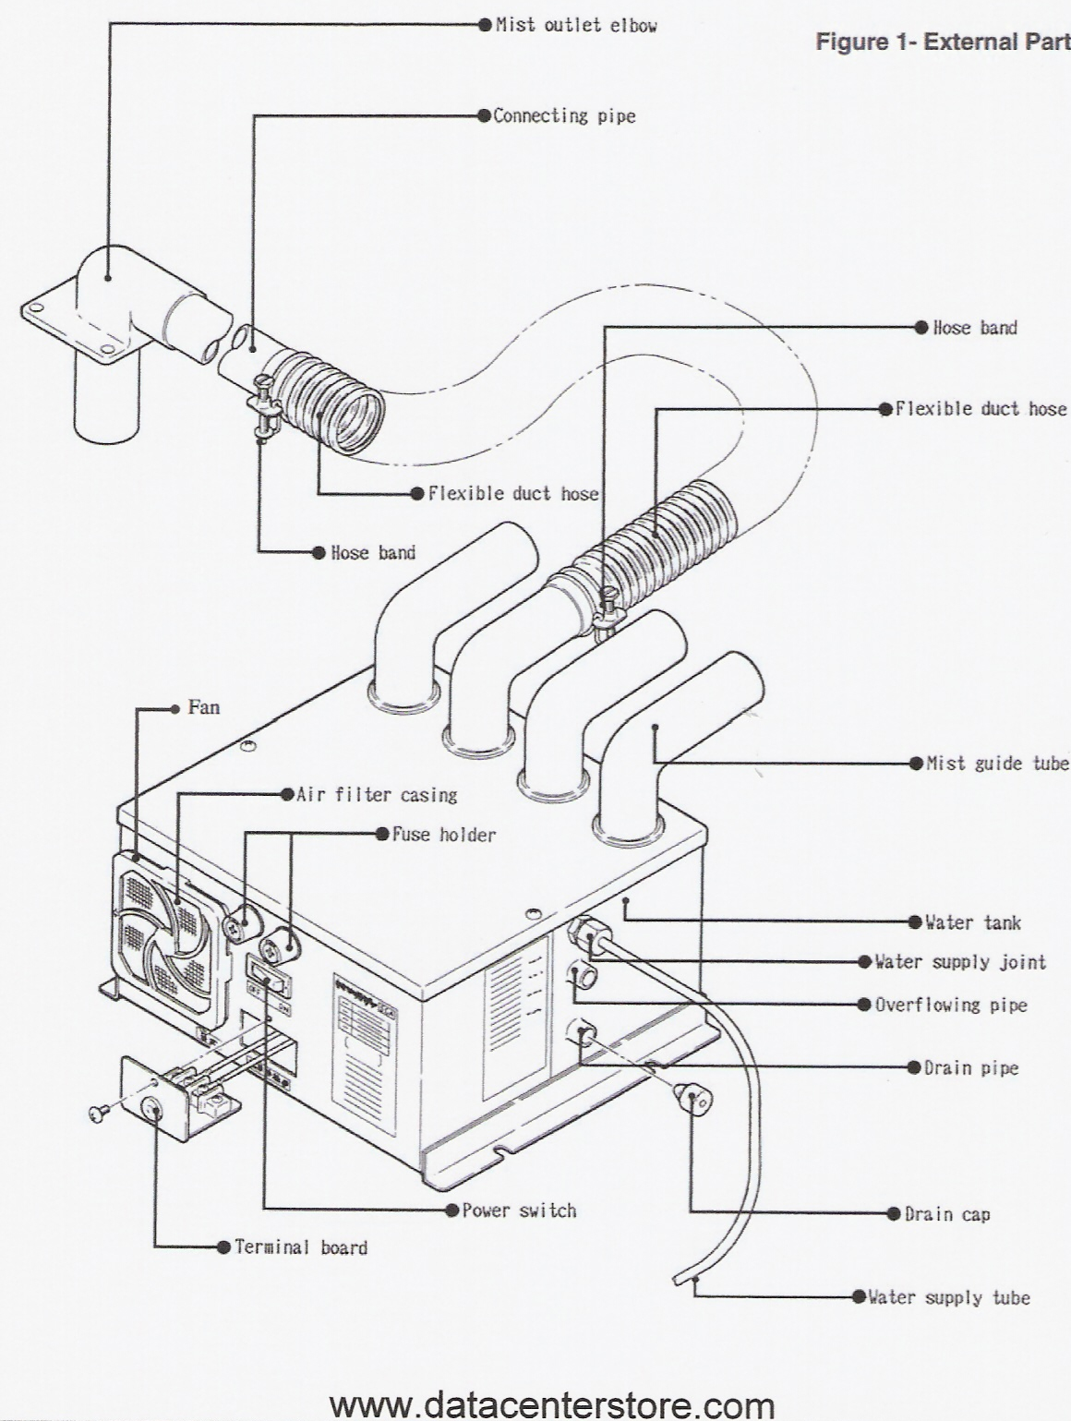

## 

## 

## Appendix G: References

1. *DRI-STEEM*. 1 Jan. 2012. 7 Mar. 2012 <http://www.dristeem.com/home>.
2. Incropera, Frank P., and Frank P. Incropera. *Fundamentals of Heat and Mass Transfer.* Hoboken, NJ: John Wiley, 2007. Print.
3. "The Boeing Company." *The Boeing Company*. Web. 08 Mar. 2012. <http://www.boeing.com/
4. "POYAM VALVES: General Service Valve Range: Gate Valves." *POYAM VALVES*. Web. 08 Mar. 2012. <http://www.poyam.com/english/products/general/gate_valve.php>.
5. "Sensor Selection Guides." *Watlow*. Web. 08 Mar. 2012. <http://www.watlow.com/products/guides/sensor/index.cfm>

**System Illustrations**

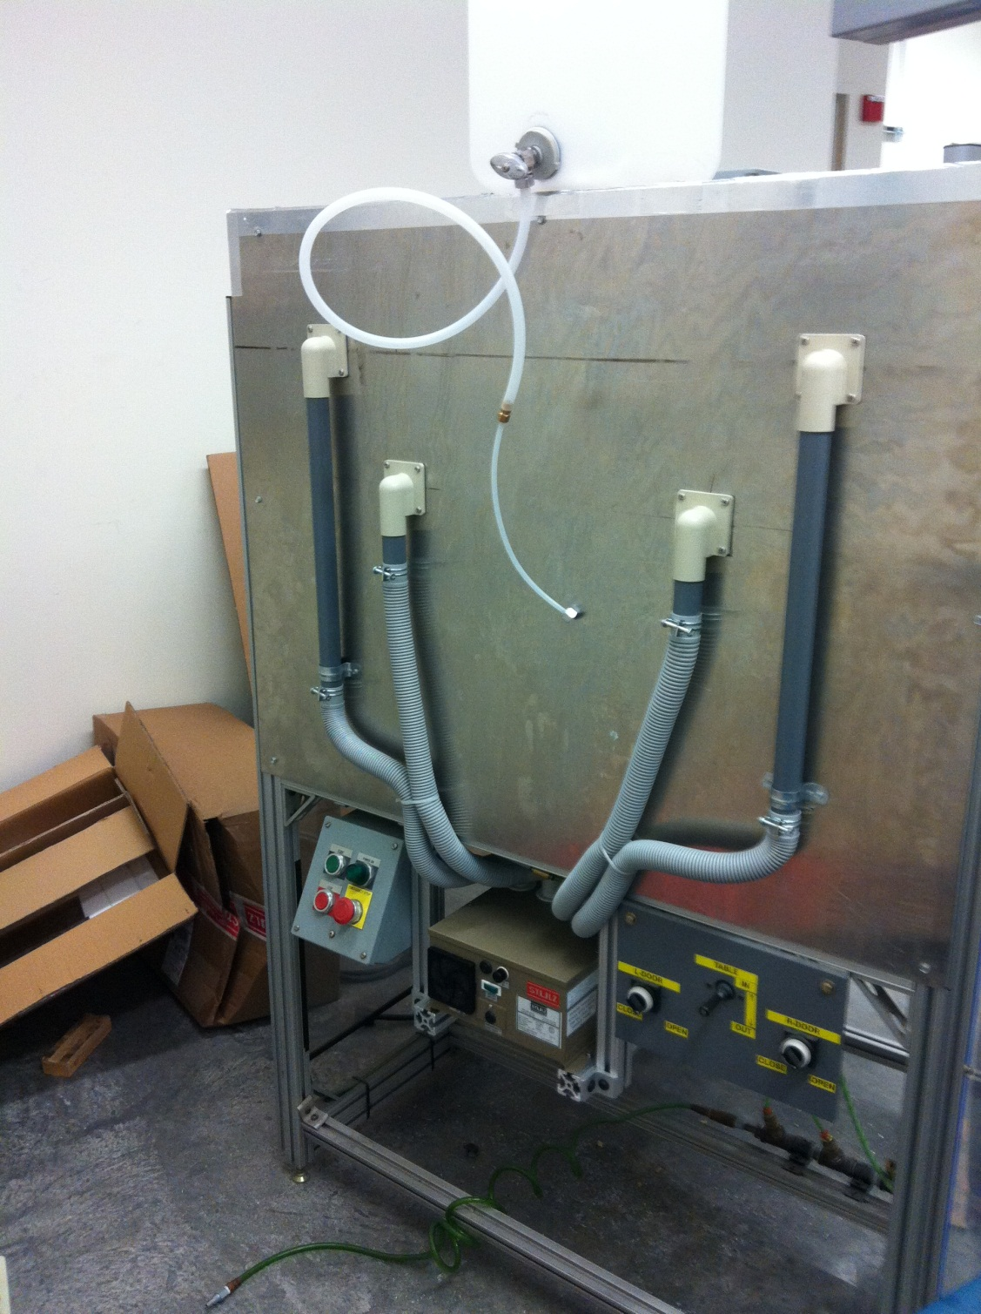

Figure 5.1: A fully installed system with humidifier and water tanks