|  |  |  |
| --- | --- | --- |
| **Vacuum Pump Vibration Isolation System** | Winter 2011 | |
| PROGRESS REPORT |
| **Sponsoring Company:**  [Edwards Vacuum Ltd](http://www.edwardsvacuum.com/).  **Contact Engineers:**  Mark Romeo  Bree DeArmond | | **Academic Advisor:**  Dr. Dave Turcic  **Team Members:**  Ron Pahle  Khoa T. Tran  Duc M. Le  Thanh Q. Nguyen |



# Executive Summary

Vibrations caused by machinery—such as vacuum pumps that service manufacturing equipment in micro-chip fabrication processes—can interfere with manufacturing equipment that is designed to work on a strict tolerance. Edwards Vacuum Ltd. is a top manufacturer of vacuum pumps and is currently trying to alleviate these problems to provide a better service for their customer, Intel Corporation. A design team from Portland State University’s Maseeh School of Engineering and Computer Science has been organized to help with this project.

The requirements for this project were previously detailed in a Product Design Specifications document. These requirements help outline the goals and constraints of the project. Some important requirements of our project include: cost of installation and operation, vibration reduction, ease of maintenance, and space restrictions. The next step in the design process was research, both external and internal. The external search consisted of investigating all known vibration isolation technologies on the market. The internal search consisted of new ideas on how to apply the existing technologies to Edwards’s system. Following research is a design selection and evaluation stage. After selection the detailed design takes place in which all aspects of the design are scrutinized. This report will address the current state of this project as well as discuss the next step to fulfill the expectations at Edwards Vacuum Ltd.

Table of Contents

Executive Summary 1

Project Background 3

Mission Statement 5

Project Plan 5

Final Product Design Specifications Summary and Update 5

External Search 7

Internal Search 14

Top-Level Design Evaluation and Selection 15

Progress of Detailed Design 16

Conclusion 16

References 17

Appendices 18

# Project Background

Undesired noise and vibrations are major problems in many engineering activities and domains. At Edwards Vacuum Ltd., vibrations from vacuum pumps present an issue to their customers at Intel Corporation. Fabrication of microchips at Intel involves precise operation at the nano-scale. This leads to a very strict tolerance to vibratory noise in Intel’s fabrications. At Intel, multiple vacuum pumps (from Edwards) are used for atmospheric control in sensitive microchip fabrication processes. Rotating equipment is a potential source of vibration and can transmit vibration from the vacuum pumps to the building structure and to the processing tools. These vacuum pumps are seated on a rigid steel frame on a concrete floor within a limited space as shown in Fig. 1. These pumps propagate vibration waves through the rigid frame to the floor and other piping fixtures attached to the frame.



***Figure 1:*** *Pump-frame system from Edwards Vacuum Ltd.*

Edwards wants to remain a top supplier of vacuum pumps and is anticipating Intel’s demand of further vibration reduction. Edwards has achieved a great amount of vibration reduction without looking into the dynamics of the supporting frame. The vacuum pumps are designed with vibration isolators as shown in Fig. 2. In fact, Edwards has legitimately satisfied all terms of its contract with Intel concerning vibrations. The capstone team at Portland State University expects to provide Edwards with another competing technique to reduce the overall vibration in its system.

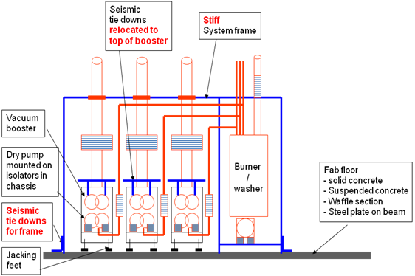

***Figure 2:*** *Edwards’s typical vacuum pump system (side-view).*

This report will cover the progress of the project during winter term. An overview of the External Search, Internal Search, Top-Level Design Evaluation and Selection, and Progress of Detailed Design will be presented. The External Search section will present all the existing vibration technologies that were researched by the team. The Internal Search section will discuss the brainstorming of how to implement these technologies into the pump-frame system. The Top-Level Design Evaluation and Selection section will present the best solutions from our research using our PDS. And finally the Progress of Detailed Design section will discuss where the project is right now in the design process as well as the tasks to be completed in the spring term.

# Mission Statement

Devise a solution to minimize the vibration propagated from the pump system through the steel frame and to the surrounding workplace. This is meant to reduce any interference the pumps vibrations could have on sensitive manufacturing equipment. There are a variety of constraints that will be addressed including seismic regulations, environmental cleanliness, and space limitations. This solution will consist of a working prototype, supporting data, detailed drawings, and a final report. Customers for this solution will be Edwards Vacuum Ltd. and its correspondents at Intel Corporation. The solution will be needed for full scale testing by April 11th, 2011 and a finalized design due on June 8th, 2011.

# Project Plan

The details of the project’s timeline are shown in a Gantt Chart in App. A. This timeline was constructed based on deadlines provided by ME492 and by Mark Romeo of Edwards Vacuum Ltd. The project is currently in the evaluation and selection process as well as diagnostic testing. The detailed design and implementation will be the main tasks to be completed in the following term.

# Final Product Design Specifications Summary and Update

The Product Design Specifications (PDS) can be changed anytime during the design process if necessary. After collecting preliminary data and discussing possible solutions with the sponsor, small changes have been made to the PDS.

* The “Cost of testing equipment” requirement has been removed because the sponsor is in charge of purchasing the testing equipment.
* The “Price per pump” criterion has been changed to “Total cost of product.” This change is a result of the possibility that adjustments could be made to the frame and not just the pump.
* The frame’s rigidity has become a significant constraint. This criterion arises when there is a desire to replace the frame’s bolt and nut connections with a vibration isolation system. The rigidity of the whole structure must qualify with the regional seismic regulations. We are working with the sponsor to define a metric for this criterion.

|  |  |  |  |  |  |  |
| --- | --- | --- | --- | --- | --- | --- |
| **COST** | | | | | | |
| Priority | Requirement | Customer | Metrics | Target | Target basis | Verification |
|  | Total cost of product | Edwards | $ | < 1000 | Edwards required | Design |

**Final PDS summary**

Below is the summary of all the main criteria.

|  |  |  |  |  |  |  |
| --- | --- | --- | --- | --- | --- | --- |
| **PERFORMANCE** | | | | | | |
| Priority | Requirement | Customer | Metrics | Target | Target basis | Verification |
|  | Vibration reduction | Edwards | % in acceleration | 25> | Edwards required | Prototyping |
|  | Power consumption | Edwards | Watt | 0 | Edwards required | Prototyping |
|  | Ease of use | Edwards | N/A | Totally passive operation | Edwards required | Prototyping |
|  | Life in service | Edwards | Years | 10 | Edwards required | Design |

|  |  |  |  |  |  |  |
| --- | --- | --- | --- | --- | --- | --- |
| **SIZE, SHAPE AND WEIGHT** | | | | | | |
| Priority | Requirement | Customer | Metrics | Target | Target basis | Verification |
|  | Size | Edwards | yes/no | Fitting within the frame | Ergonomic | Prototype |

|  |  |  |  |  |  |  |
| --- | --- | --- | --- | --- | --- | --- |
| **INSTALLATION AND MAINTENANCE** | | | | | | |
| Priority | Requirement | Customer | Metrics | Target | Target basis | Verification |
|  | Time to assemble/disassemble | Edwards | Minutes | < 15 | Product complexity/  Edwards required | Prototype |
|  | Mechanical compatibility | Edwards | Yes/No | Yes | Edwards required | Prototype |

# External Search

General Approach

Designing a vibration isolation solution is a dynamic process where concepts continuously evolve through vibration testing and evaluation. Not every vibration problem can be approached in the same fashion. A single technology alone will not solve this project’s vibration problem perfectly.

Vibration isolation can be passive, active, or semi-active. Passive vibration isolation is implemented by proper structural design to make sure the optimal dynamic properties, namely the mass, stiffness, and damping properties, are achieved. Active vibration isolation can be performed by measuring the sources of vibration and generating controllable forces to compensate for the vibration. Active vibration isolation involves typical feedback control systems that require sensors, micro-computers, and power actuators. Semi-active vibration isolation is an active control system, but instead of generating power to the structure, it seeks to control the damping and/or stiffness dynamically. This approach results in less power consumption and a more compact design, and it also requires innovative materials such as magnetically active fluids or piezoelectric components. Among the three branches of vibration isolation techniques, passive vibration isolation is the best method for our project. Edward’s engineers agree that passive vibration isolation would yield solutions with simplicity, low cost, low maintenance, and the potential for a compact design.

In passive vibration isolation, the stiffness elements provide the isolation and have little effect on the amplitude of the motion. In general, stiffer elements yield less effective isolation. Also, a heavier mass can further limit the amplitude of the vibrating system. However, a heavier mass does not reduce the transmitted force because the resonance frequency remains the same. Lastly, damping has 3 effects on the dynamics of the system: it lowers the transmissibility at the system’s resonant peaks, and it reduces the vibration amplitude at higher forcing frequencies; however, damping generally increases the system’s overall stiffness and therefore increases force transmissibility except at resonance peaks (T. P. C. Bramer, G. J. Cole, J. R. Cowell, A. T. Fry, N. A. Grundy, T. J. B. Smith, J. D. Webb, D. R. Winterbottom, 1977). These ideas will be considered during the detailed design.

Compound Mass System

One prominent solution in the path of passive vibration isolation is the compound mass system (John C. Snowdon, 1979). In this solution, the pump-frame system can be considered a two mass system (the pump’s mass and the frame’s mass). By adjusting the mass ratio and the stiffness ratio of the elements connecting the masses, the vibration transmissibility at operating frequencies higher than the system’s resonant frequencies can be reduced considerably. The compound mass system is shown in Fig. 3 along with an equation relating the mass ratio and the stiffness ratio. To ensure optimum isolation this equation must be followed.

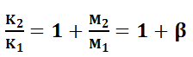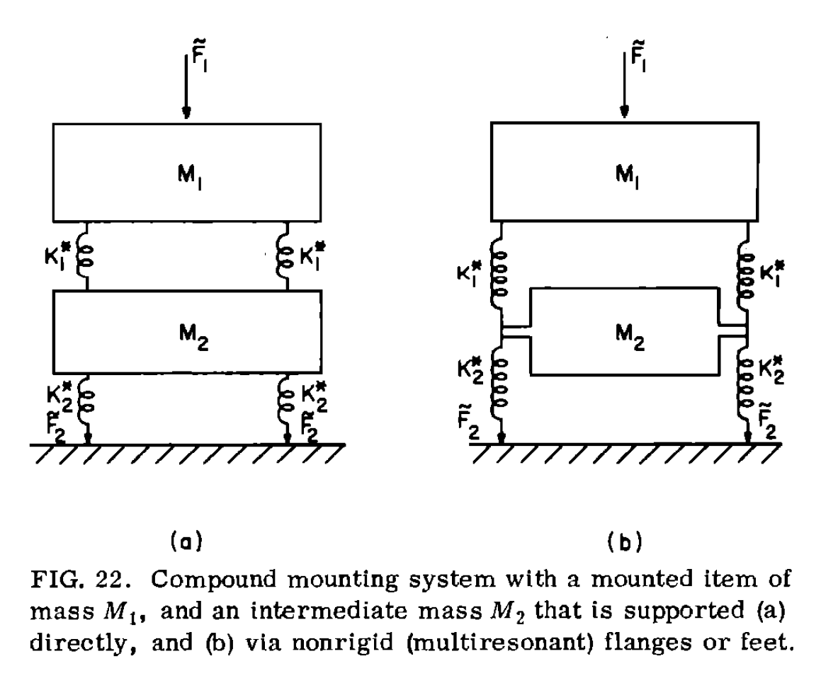

***Figure 3:*** *A model of the compound mass system. The upper mass (M1) represents the pump’s mass, and the lower mass (M­­2) represents the frame. The stiffness ratio must follow the equation above to ensure optimum isolation (John C. Snowdon, 1979).*

Research shows that increasing the mass ratio (β) of this system will decrease the transmissibility when operating above the system’s natural frequencies. For Edwards’s system, the addition of mass to the frame will be limited by space restrictions as well as ergonomic reasons. These concerns would be considered in the detailed design. The goal is to increase the frame mass as much as possible while ensuring a compact frame design and not hindering any maintenance operations of the pump.

Common Technologies

Some common passive isolation technologies include cork, elastomers, springs, and airbags as stiffness elements. Cork is an industrial material that can withstand substantial compressive load. Vibration isolators that use cork usually have a natural frequency of 50-60 Hz; diagnostic testing shows that this could be high for Edwards’s system. Cork has air pockets inside the material and can exhibit high internal damping. Cork can be combined with neoprene to give large deflection, hence a lower natural frequency. This material is cheap and has a long service life (Baker, 1975).

Elastomers are rubberlike materials that possess internal damping and very low stiffness. The stiffness and damping properties of an elastomer depend on the particular material, the type of fiber reinforcement, and geometrical configuration. A typical elastomer is rubber. Natural rubbers are susceptible to temperature effects, oxidants, sunlight, and liquid contamination, especially from machine oil. For Edwards’s system, machine oil would be the only possible issue. Synthetic rubbers like neoprene and silicone rubber possess higher damping and better resistance to environmental factors (Baker, 1975). A drawback to using an elastomer as a vibration isolator is that the machine weight can initiate a drifting effect, which is a continuous deformation of the material under constant load (Baker, 1975). Figure 4 shows a variety of cork and elastomer vibration isolators.

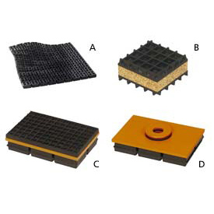

***Figure 4:*** *Available commercial anti-vibration mounting pads. A: Natural rubber or neoprene anti-vibration pads. B: Neoprene & Cork Vibration Pad. C: Vibration pad with a friction top. D: Steel top vibration pad. (globalindustrial.com)*

Metal springs act as linear stiffness elements and have a natural frequency between 3-10 Hz (Baker, 1975). Metal springs can support large loads and don’t have a drifting effect. Metal springs are usually inexpensive. Since it is a linear element, metal springs can simplify design analysis by performing close to theoretical prediction. Metal springs come in many configurations: tube, conical, and laminated leafs which are suitable for a variety applications. Figures 5 and 6 shows a variety of heavy duty spring configurations used in many industrial applications.

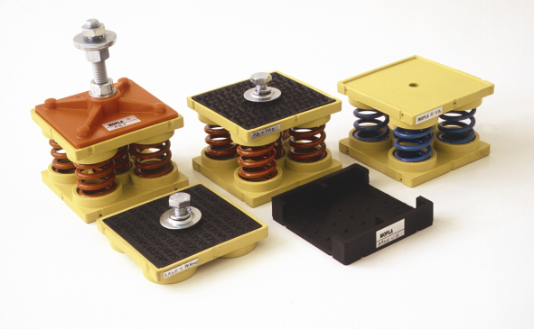

***Figure 5:*** *Mopla-5 series springs mounts from Anti-Vibration Methods Co Ltd. This model comprises 5 steel springs mounted within an elastomer top and bottom spring retainers/covers. The static load for these springs range from 12 to 920Kg per mount with numerous spring rates available (antivibrationmethods.com).*

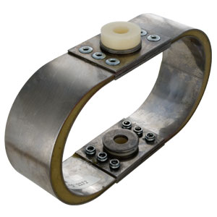

***Figure 6:*** *Elliptic Leaf Spring Mounts from Advanced Anti-vibration Components. The static loads for these springs range from 10 to 500 Kg per mount and have a natural frequency of 5~10 Hz (vibrationmounts.com).*

Air bags are powerful vibration isolators that are used in applications where high isolation is required. These applications generally consist of small amplitude of vibration at low frequencies (around 5 Hz). The pressure inside the air bag can be actively controlled or statically set at an optimum value. Air bag fabrication usually yields a higher price than other means of vibration isolation. Figure 7 shows a common air bag vibration isolator.

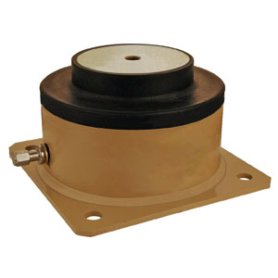

***Figure 7:*** *Air bag anti-vibration mount from Advanced Antivibration Components with synthetic rubber diaphragm and painted steel body (vibrationmounts.com).*

Another type of vibration control device is a viscous damper, also known as a shock absorber, linear damper, or dashpot. The force generated by a viscous damper is proportional to the velocity across the damper and is always in the opposite direction of motion. The advantages of viscous dampers are product availability, relatively easy modeling, and the ability to dissipate energy. However, viscous dampers have limitations such as being mechanically complex, requiring periodic inspection, and high prices. Figure 8 shows an example of an air damper with an installation demonstration.

[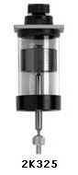](http://www.airpot.com/html/dashpot.html) 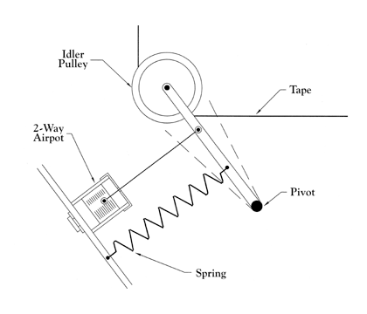

a) b)

***Figure 8:*** *Precision Air Damping Dashpot from Airpot Corporation. a) Airpot® 2K325 air damper; b) Example configuration of damper product for vibration damping (airpot.com).*

Viscoelastic damping is a method that uses the viscoelasticity of materials to reduce vibration. This is done with a hysteresis (history dependent) stress-strain loop when under a loading and unloading cycle so energy can dissipate after each cycle in the form of heat [10]. This method can be easily applied to the existing structure by coating it with either an unconstrained layer or a constrained layer material. However, temperature dependent performance and high cost are the primary disadvantages of this method.

Low-Wave-Speed media, which are any moderately loose media in which the wave propagation speed is sufficiently low, such as foam or powder, is also helpful in vibration isolation because it can add significant broadband damping to steel structures (Kripa K. Varanasi, 2004). The material can be added to the steel structure by either filling the inside of the pipe members or coating the outside of the structure. An example of how low-wave-speed media can be applied is shown in Fig. 9.

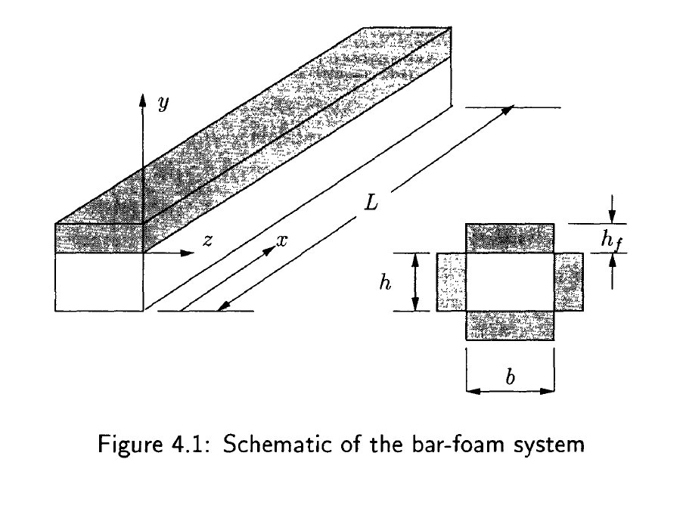

***Figure 9:*** *Schematic of a bar-foam system (Kripa K. Varanasi, 2004).*

With low-wave-speed media a high level of vibration attenuation can be achieved with little mass addition. This method is potentially inexpensive, durable and very robust. The limitations of low-wave-speed materials are that it is most effective only at resonance peaks and is not very effective at frequencies lower than 500 Hz, which may be of interest to Edwards’s system. Figure 10 shows the damping effects of low-wave-speed media for an experiment where an aluminum beam is struck with a hammer in the vertical direction.

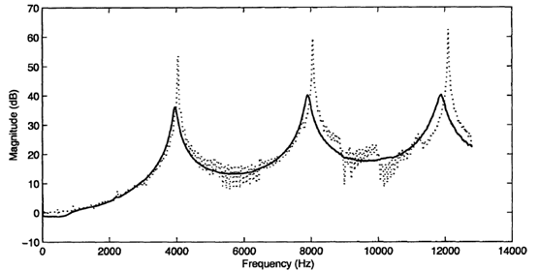

***Figure 10:*** *Effects of low-wave-speed media on the transmissibility through a beam. The dotted line represents transmissibility response with no media introduced, and the solid line represents the response after low-wave-speed media are introduced. The solid line shows a significant reduction in transmissibility at the resonant peaks (Kripa K. Varanasi, 2004).*

# Internal Search

An internal search has been done and the following models have been suggested. The first model is shown in Fig. 11a. In this method, the frame is bolted to a concrete base and the concrete base is connected to springs and dampers, which are bolted to the floor. This requires no changes in the existing frame structure. Only the mass of the concrete base and the specification of springs and dampers need to be determined to best suit this system.

A second model is shown in Fig. 11b. The four legs of the frame are connected to the springs which are bolted to the floor. Enclosures may be used to prevent the springs from being buckled or overloaded and keep the frame from tipping. This method will require modification of the frames’ legs or the addition of a mechanism that can hold the existing frame leg and the spring together.

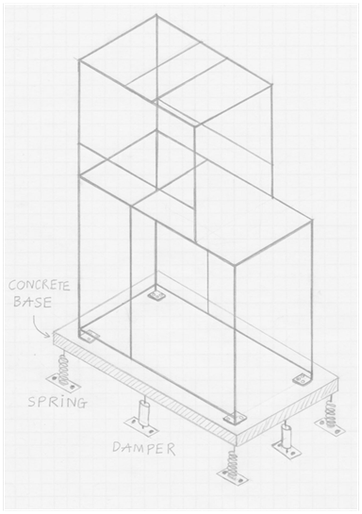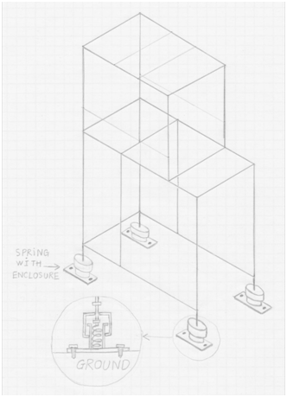

***Figure 11:*** *Schematics of how to apply a spring and damper system to the frame. The schematic on the left (Fig. 11a) uses an intermediate concrete base mounted on vibration isolators. The schematic on the right (Fig. 11b) has the frame directly mounted on vibration isolators.*

Another idea under consideration is isolating the upper pump – main vibration source – from the frame. Currently, the upper pump is sitting on a steel plate which is bolted to the frame in order to keep the whole system rigid and stable during operation. When considering vibration, bolts and nuts are not a good choice for binding the system. In order to isolate the vibration source (pump) from the frame, the bolts would need to be replaced with a locking mechanism that allows isolation while still satisfying the rigidity and stability requirements.

# Top-Level Design Evaluation and Selection

Vibration isolation projects are different in nature because of the unique characteristics of each system. A large portion of the project goes into learning about the system and determining the root cause of the vibration problems. This is done through extensive diagnostics and troubleshooting. In Edwards’s vacuum pump system the problems could be stemming from a variety of places. The pumps (source) might not have an adequate vibration isolation technique applied, the frame could be increasing the transmissibility due to a lack of stiffness, or there may be a combination of both. Until diagnostic testing is completed and the source of the problem is located, our design process continues to be somewhat analytical and research-oriented.

The current approach is to have multiple solutions that will apply to a variety of problems once the problem has been determined. A large portion of our brainstorming has surrounded the compound mass system and its implementation. The benefits of reducing the vibration across a large frequency range make this design ideal. The current designs that have been discussed are similar to the schematics shown in Fig. 11. This design will be considered if after diagnostics the problem appears to be in the stability of the frame.

Another design under consideration is improving the existing feet of the pumps. Airbag technology appears to be the most beneficial for this solution due to the fact that it works when small amplitudes of vibration are present. The common frequency ranges of the pumps are needed to determine the necessary characteristics of the air bags. This solution would be considered if the pump itself wasn’t getting adequate vibration isolation.

Technologies such as the low-wave-speed media and viscoelastic damping are still being considered due to their unique isolation and damping ability. The application of this technology would be simple and should provide benefits no matter the source of the problem. Currently all technologies are being considered for this project, focusing on the best solutions so that once the diagnostic testing is complete the detail design can begin.

# Progress of Detailed Design

The current stage of the project is to continue diagnostic testing. Delays in the purchasing of the testing equipment have led to a setback in the diagnostics stage. Testing should reveal the source of the vibration problem in Edwards’s system, resulting in fewer design possibilities. Until then all technologies and solutions will be considered as well as trying to find different ways to implement the technologies.

Following the project’s timeline (Gantt Chart, App. A), the project is currently in the middle of diagnostic testing, concept evaluation, and concept selection. These tasks are being approached diligently as the next task, the detailed design, requires an extensive job be done on the previously mentioned stages.

# Conclusion

The project has provided a lot of unforeseen obstacles that have led to complications and setbacks. Currently the project is in the evaluation and selection phase. Vibration testing needs to be completed and is a critical tool in selecting the final design concept. Previous testing hasn’t provided sufficient data to properly analyze the system. There are still many technologies being considered for this project and the group hopes to move forward with the detailed design once testing yields more useful data. The external and internal search will provide a good building block for the concept selection. New testing equipment is expected at Edwards’s facility in the next two weeks. This advanced equipment should be able to quantify the problem with the current system.

# References

1. John C. Snowdon, Vibration isolation: Use and characterization (Applied Research Laboratory, Pennsylvania State 20 July 1979)
2. J. K. Baker, Vibration Isolation (Published for the Design Council, The British Standard Institution, and the Council of Engineering Institutions by Oxford University Press, 1975)
3. T. P. C. Bramer, G. J. Cole, J. R. Cowell, A. T. Fry, N. A. Grundy, T. J. B. Smith, J. D. Webb, D. R. Winterbottom, Basic Vibration Control (Sound Research Laboratory Limited, 1977)
4. Globalindustrial.com. accessed 6 March 2011<http://www.globalindustrial.com/g/tools/vibration-isolators/pads/vibration-isolation-pads>
5. Antivibrationmethods.com. accessed 6 March 2011<http://www.antivibrationmethods.com/Products/SpringMounts/Mopla5/tabid/226/Default.aspx>
6. Vibrationmoounts.com. accessed 6 March 2011<http://www.vibrationmounts.com/Store.asp?Page=RFQ/VM05003.htm>
7. Vibrationmoounts.com. accessed 6 March 2011<http://www.vibrationmounts.com/RFQ/VM110509.htm>
8. Airpot Corporation. accessed 6 March 2011<http://www.airpot.com/html/dashpot.html>
9. Kripa K. Varanasi, Vibration Damping Using Low-Wave-Speed Media with Applications to Precision Machines (Massachusetts Institute of Technology, June 2004)
10. John D. Ferry, Viscoelastic properties of polymers 3rd Edition, 1980.

# Appendices

***Appendix A- Project Timeline***

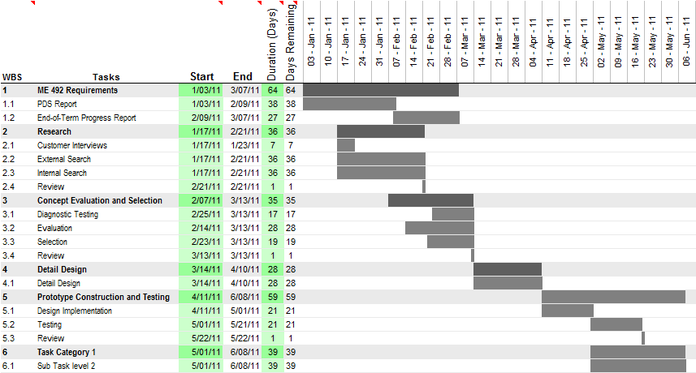

***Appendix B- Complete PDS***

In this section, all the criteria related to the product are listed with their corresponding priority level. These criteria have been discussed and developed by the team based on requirements from our customers as well as advice from experts. The PDS is outlined in Table 1.

Table 1: Applicable PDS criteria and page

|  |  |  |
| --- | --- | --- |
| **Criteria** | **Priority** | *Page* |
| Performance | High | 6 |
| Environment | High | 6 |
| Life in service | Low | 6 |
| Cost of production per part | Medium | 7 |
| Size | Medium | 7 |
| Weight | Low | 7 |
| Maintenance | Low | 7 |
| Installation | High | 7 |
| Ergonomics (Ease of operation) | Low | 7 |
| Materials | High | 7 |
| Quality and Reliability | High | 7 |
| Documentation | High | 7 |
| Competition products | Medium | 7 |
| Timelines | High | 7 |

Legend:

High priority Medium priority Low priority

|  |  |  |  |  |  |  |
| --- | --- | --- | --- | --- | --- | --- |
| **PERFORMANCE** | | | | | | |
| Priority | Requirement | Customer | Metrics | Target | Target basis | Verification |
|  | Vibration reduction | Edwards | % in acceleration | 25> | Edwards required | Prototyping |
|  | Power consumption | Edwards | Watt | 0 | Edwards required | Prototyping |
|  | Ease of use | Edwards | N/A | Totally passive operation | Edwards required | Prototyping |
|  | Life in service | Edwards | Years | 10 | Edwards required | Design |

|  |  |  |  |  |  |  |
| --- | --- | --- | --- | --- | --- | --- |
| **ENVIRONMENT** | | | | | | |
| Priority | Requirement | Customer | Metrics | Target | Target basis | Verification |
|  | Clean room compatible | End user | yes/no | Clean room qualified | End user required | Design |
|  | Eco friendly product | Self | yes/no | Green material | Group interest | Design |

|  |  |  |  |  |  |  |
| --- | --- | --- | --- | --- | --- | --- |
| **SIZE, SHAPE AND WEIGHT** | | | | | | |
| Priority | Requirement | Customer | Metrics | Target | Target basis | Verification |
|  | Size | Edwards | yes/no | Fitting within the frame | Ergonomic | Prototype |
|  | Weight | Edwards/  Self | lbs | < 100 | Product portability | Prototype |

|  |  |  |  |  |  |  |
| --- | --- | --- | --- | --- | --- | --- |
| **INSTALLATION AND MAINTENANCE** | | | | | | |
| Priority | Requirement | Customer | Metrics | Target | Target basis | Verification |
|  | Time to assemble/disassemble | Edwards | Minutes | < 15 | Product complexity/  Edwards required | Prototype |
|  | Tool requirement | Edwards | Number of special tool | 0 | Product complexity/  Edwards required | Prototype |
|  | Mechanical compatibility | Edwards | Yes/No | Yes | Edwards required | Prototype |
|  | Maintenance frequency | Edwards | Years | 10 | Edwards required | Testing |

|  |  |  |  |  |  |  |
| --- | --- | --- | --- | --- | --- | --- |
| **MATERIAL** | | | | | | |
| Priority | Requirement | Customer | Metrics | Target | Target basis | Verification |
|  | Clean room compatible materials | End user | Yes/No | Clean room qualified | End user required | Design |
|  | Reasonable price | Self | N/A | Inexpensive | Budget | Design |
|  | Easy to machine | Self | N/A | Can be machined in the machine shop | Self/Expert | Prototype |

|  |  |  |  |  |  |  |
| --- | --- | --- | --- | --- | --- | --- |
| **COST** | | | | | | |
| Priority | Requirement | Customer | Metrics | Target | Target basis | Verification |
|  | Price per pump | Edwards | $ | < 1000 | Edwards required | Design |
|  | Testing equipment | Self | $ | < 3000 | Budget/Expert | Testing |

|  |  |  |  |  |  |  |
| --- | --- | --- | --- | --- | --- | --- |
| **DOCUMENTATION** | | | | | | |
| Priority | Requirement | Customer | Metrics | Target | Target basis | Verification |
|  | PDS | PSU | Deadline |  | PSU | Report |
|  | Progress report | PSU | Deadline |  | PSU | Report |
|  | Final report | PSU/  Edwards | Deadline |  | PSU/Edwards | Report |
|  | Timeline | Self/  Edwards | Deadline |  | Self/Edwards | Report |