|  |  |  |
| --- | --- | --- |
| **Vacuum Pump Vibration Isolation System** | June 6, 2011 | |
| ME 493 Final Report-Year 2011 |
| **Sponsoring Company:**  [Edwards Vacuum Ltd](http://www.edwardsvacuum.com/).  **Contact Engineers:**  Mark Romeo  Bree DeArmond | | **Academic Advisor:**  Dr. Dave Turcic  **Team Members:**  Ron Pahle  Khoa T. Tran  Duc M. Le  Thanh Q. Nguyen |



# Executive Summary

Vibrations caused by machinery—such as vacuum pumps that service manufacturing equipment in micro-chip fabrication processes—can interfere with precision manufacturing equipment. Edwards Vacuum Ltd. is a top manufacturer of vacuum pumps and is currently trying to alleviate these problems to provide a better service for their customer, Intel Corporation. A design team from Portland State University’s Maseeh College of Engineering and Computer Science was organized to help with this project.

The requirements for this project were previously detailed in a Product Design Specifications document. These requirements helped outline the goals and constraints of the project. Some important requirements of the project include: cost of installation and operation, vibration reduction, ease of maintenance, and space restrictions. The next step in the design process was research, both external and internal. The external search consisted of investigating all known vibration isolation technologies on the market. The internal search consisted of new ideas on how to apply the existing technologies to Edwards’s system. Following the research was a design selection and evaluation stage.

The design selected was a plate isolator system that prevented that plate from propagating vibrations into the supporting frame. The designs performance was verified through testing. More testing was done to improve the designs characteristics, such as thickness, stiffness, and geometry. This specific isolator design is only applicable to the pump/frame system at Edwards’s manufacturing facility. However, the general results from this project should apply and help with devising other vibration reduction solutions for similar systems.

Even though the designs performance fell short of the teams goal, the results were satisfactory based on the low cost of the product. This report presents the plate isolator system and its success based on performance, cost, and completion of the PDS requirements.

Table of Contents

Executive Summary 1

Mission Statement 5

Main Design Requirements 6

Top-Level Design Alternatives 6

Viscoelastic Damping Material 6

Compound Mass Approach 7

Pump Feet Isolators 7

Rubber Isolators 8

Final Product Design 8

Material Selection 9

Isolator Thickness 10

Isolator Geometry 10

Final Product Evaluation 11

Cost 11

Manufacturability 11

Structural Integrity 12

Performance 12

Assembly 13

Other (PDS) 13

Conclusion 14

Appendices 15

Appendix A- Complete PDS 15

Appendix B- Testing Procedure 18

Appendix C- Viscoelastic Tape Testing and Results 21

Appendix D- Design Improvement Testing 23

Appendix E- Finite Element Analysis of Pump Frame 32

Appendix F- Rubber Pad Thickness and Geometry Analysis 35

Appendix G- Product Vendors 46

Appendix H- Bill of Materials 48

Appendix I- Product Cost 49

Appendix J- Manufacturing Instructions 49

Appendix K- Detailed Drawings and Assembly 51

Appendix L- Beam Strength of Material Analysis 53

Appendix M- Final Results from Prototype Testing 57

Appendix N- Suggestion for Further Research 63

References 64

Project Background

Undesired noise and vibrations are major problems in many engineering activities and domains. At Edwards Vacuum Ltd., vibrations from vacuum pumps present an issue to their customers at Intel Corporation. Fabrication of microchips at Intel involves precise operation at the nano-scale. This leads to a very strict tolerance to vibratory noise in Intel’s fabrications. At Intel, multiple vacuum pumps (from Edwards) are used for atmospheric control in sensitive microchip fabrication processes. Rotating equipment is a potential source of vibration and can transmit vibration from the vacuum pumps to the building structure and to the processing tools. These vacuum pumps are seated on rigid steel frames on concrete floors within a limited space as shown in Fig. 1. These pumps propagate vibration waves through the rigid frame to the floor and other piping fixtures attached to the frame.

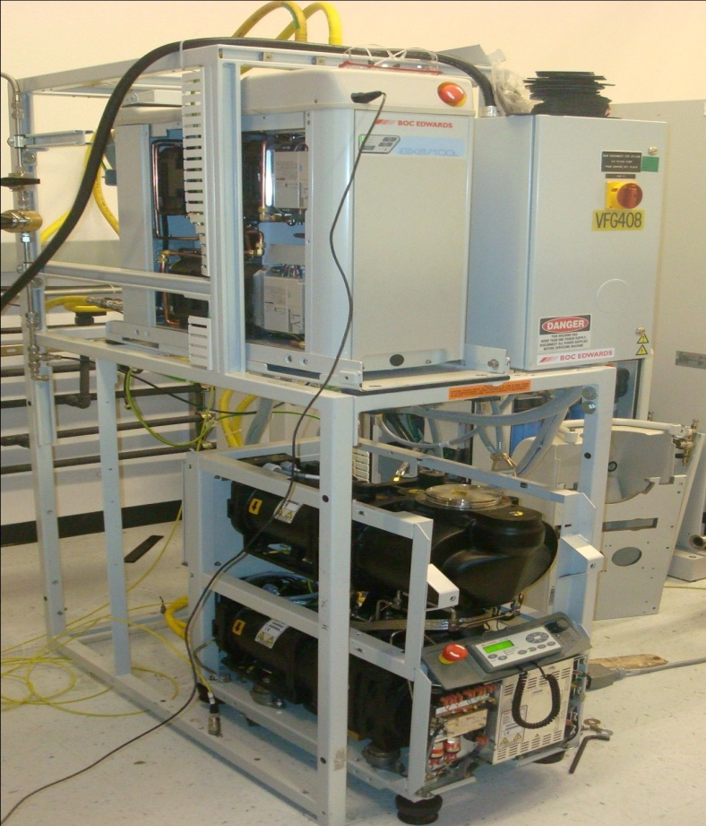

Figure : Pump-frame system from Edwards Vacuum Ltd.

Edwards wants to remain a top supplier of vacuum pumps and is anticipating Intel’s demand of further vibration reduction. The vacuum pumps are designed with vibration isolators as shown in Fig. 2. In fact, Edwards has legitimately satisfied all terms of its contract with Intel concerning vibrations. The capstone team at Portland State University expects to provide Edwards with another competing technique to reduce the overall vibration of their system.

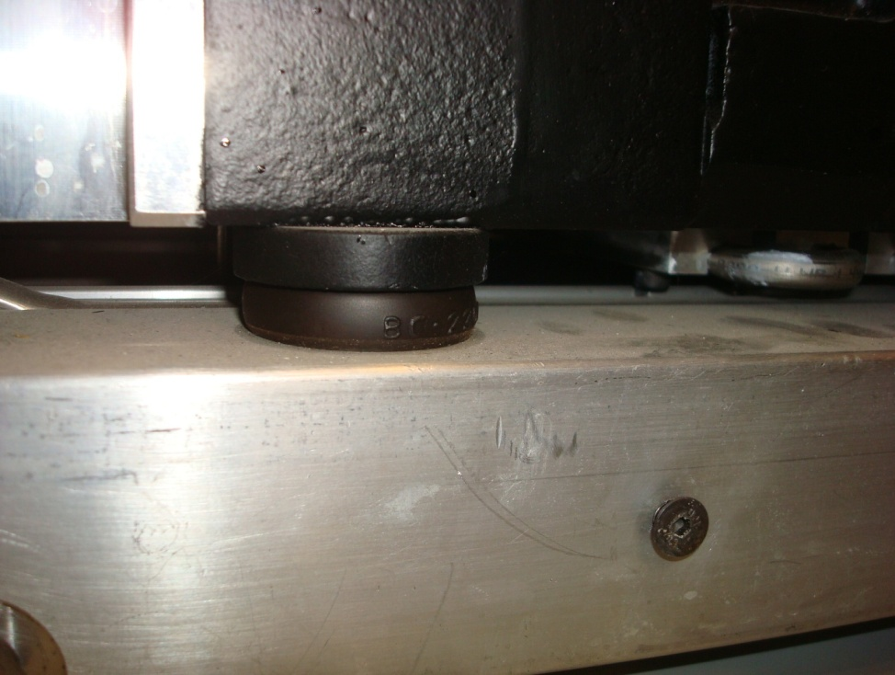

Figure : Edwards’s current vibration isolation system.

# Mission Statement

Devise a solution to minimize the vibration propagated from the pump system through the steel frame and to the surrounding workplace. This is meant to reduce any interference the pumps vibrations could have on sensitive manufacturing equipment. There are a variety of constraints that will be addressed including complex speed configurations, environmental cleanliness, and space limitations. This solution will consist of a working prototype, supporting data, detailed drawings, and a final report. Customers for this solution will be Edwards Vacuum Ltd. and its correspondents at Intel Corporation.

# Main Design Requirements

The main design requirements were established in January of 2011 with Edwards Vacuum, Ltd. These requirements are outlined in full in the Product Design Specification section in Appendix A. The requirements with the highest importance and that presented the most difficult challenge are below:

* Performance- A reduction of vibration in the frame of 25%.
* Cost- Less than 1000$ per frame.
* Perform at the four designated pump speed configurations.
* Time to assemble- Less than 15 minutes.
* Timeline- Product delivered and tested by June 6th.

# Top-Level Design Alternatives

There were many technologies considered for the solution to this project. Our external and internal search produced alternatives in four different categories; viscoelastic damping material, compound mass system, pump feet isolators, and rubber isolators. An overview of these ideas is discussed in this section.

The design selection was heavily based on diagnostic and experimental testing. Once the data was interpreted a process was used to weight the benefits and drawbacks of each method. These benefits and drawbacks generally came back to the original PDS requirements and discussions with the sponsor.

Viscoelastic Damping Material

Viscoelastic damping is a method that uses the viscoelasticity of materials to reduce vibration. This is done with a hysteresis (history dependent) stress-strain loop when under a loading and unloading cycle so energy can dissipate after each cycle in the form of heat [1]. This method can be easily applied to the existing structure by coating it with either an unconstrained layer or a constrained layer material.

Viscoelastic damping technology was tested in the form of a constrained layer tape. An outline of the testing procedure used is in Appendix B. The product details and test results are in Appendix C. The damping tape was not successful in reducing the vibration on the frame in the majority of the locations tested. It actually made most spots worse than before.

Compound Mass Approach

One prominent solution in the path of passive vibration isolation is the compound mass system [2]. In this solution, the pump-frame system can be considered a two mass system (the pump’s mass and the frame’s mass). By adjusting the mass ratio and the stiffness ratio of the elements connecting the masses, the vibration transmissibility at operating frequencies higher than the system’s resonant frequencies can be reduced considerably.

The benefit of this approach is that it would isolate the pump from the frame and the frame from the ground. In theory this would result in optimum vibration isolation and produce great results. The drawback is that it would be incredibly expensive to mount isolators at the bottom of the frame and potentially create difficulties with the sponsor’s current maintenance process to their pumps.

Pump Feet Isolators

Another design that was considered was improving the existing feet of the pumps. Airbag technology appears to be the most beneficial for this solution due to the fact that it works when small amplitudes of vibration are present. The common frequency ranges of the pumps are needed to determine the necessary characteristics of the air bags.

The benefit to this an airbag isolator approach would be its excellent performance capabilities. Unfortunately testing showed that the pump itself was already getting adequate isolation from current isolators the sponsor was using. Also, the increase in height that the airbags require would affect the placement of the pump and the pipe fittings connected to the pump.

Rubber Isolators

Inserting rubber isolators at either the frames feet or the plate that the pump sits on was considered. Due to the testing equipment available and the minimum vibration amplitude that this project entailed, it was difficult to measure the floors vibration levels. This made designing isolators for the feet of the frame impossible with the available resources.

However, diagnostic testing did show that the plate itself was not being properly isolated from the frame. The vibration was highly amplified when transmitted from the plate to the frame. This is presented in Appendix D. This approach resulted in the best test results with a clear positive outcome at most desired pump speeds and test locations. This design satisfied all of the PDS requirements outlined by Edwards and had the following benefits over other designs

* Cost effective- This design was by far the cheapest solution per frame.
* Ease of use- Once installed, there is no maintenance required.
* Performance- Only approach that was tested that showed a clear vibration reduction at desired test locations.

# Final Product Design

The final design selected was a plate isolator that prevents the plate from propagating vibrations into the frame. Diagnostic testing showed that source of vibration was amplified through the frame at proximity of 100~200 Hz (possibly due to resonance phenomenon) These results are presented in Appendix D . This is due to a lack of stiffness in the frames members and was validated through FEA. The FEA analysis is in Appendix E. The rubber pad isolator will reduce the natural frequency of the whole system and therefore shift the natural frequency out of the amplifying range. The isolator provides more damping that is needed to reduce the vibration peaks at resonant frequencies. Also, the viscoelastic property of the rubber can dissipate a small portion of energy as heat in every cycle [1]. The plate isolator design was then validated and improved through testing. An assembly diagram of the final isolator design is shown in Fig 3.

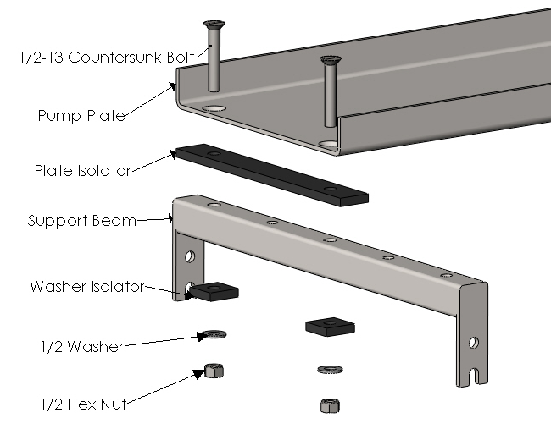

Figure : Diagram of final isolator configuration.

Material Selection

The isolator itself is manufactured from a 30A durometer (durometer is a scale to measure the hardness of rubber) neoprene rubber pad. Its soft property is essential to reduce the natural frequency of the system to below the lowest forcing frequency which means isolating the vibration source. The ideal stiffness for this isolator was calculated from using single degree of freedom model analysis with forced vibration. These calculations are in Appendix F. There are materials with similar stiffness’s that can provide more natural damping than neoprene, but the material selected for the next test did not arrive in time to be tested by the PSU team. This material can be referenced in Appendix G and will be mentioned as a suggestion for further product improvement.

Isolator Thickness

The isolator’s thickness, 3/8 in., was determined through a series of tests. An explanation of these test and their results can be found in Appendix D. Thicknesses ranging from 1/8 in. to 6/8 in. were tested in 1/8 in. increments. The 3/8 in. thickness test results showed the most reduction for the designated test points and speeds.

Isolator Geometry

Attempting to reach the ideal stiffness for the isolator, different isolator geometries were tested. In theory reducing the contact area of the isolator will make it softer. This theory is explained in Appendix F. A configuration with less contact area was tested and the results can be found in Appendix D. A reduction in isolator geometry didn’t provide improved performance when compared to an isolator that spanned the entire plate width. This was due to a need for more damping in the system. There was also concern of pump stability and the configuration of 12 in. by 1.5 in. was selected. This geometry is shown in Fig. 4.

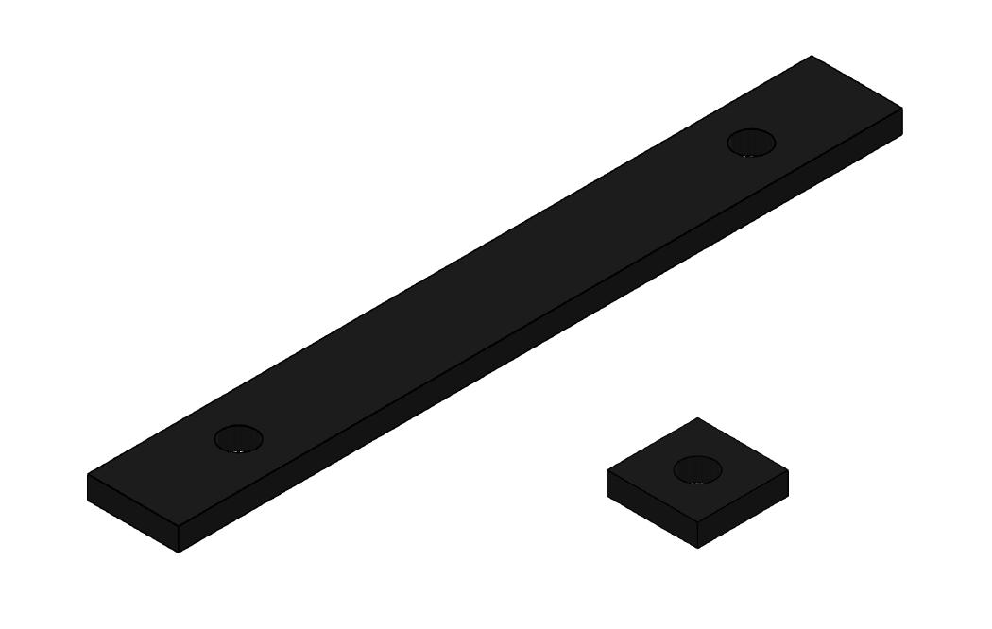

Figure : Isolator geometry selected through testing.

All of these characteristics were applied to a final plate and washer isolator system. The final prototype is shown in Fig. 5. A Bill of Materials is in Appendix H.

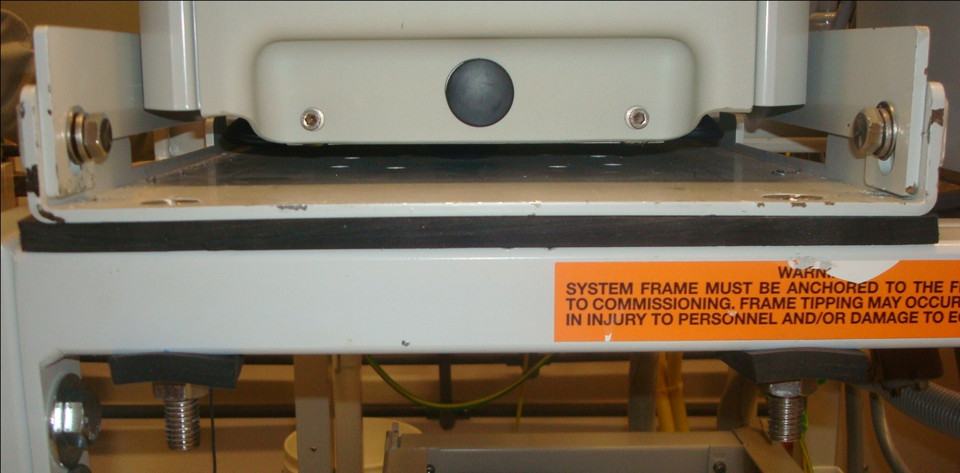

Figure : Final Plate Isolator Prototype.

Final Product Evaluation

Cost

The total cost to manufacture the plate isolator is $83.81 per frame. This includes all necessary hardware, materials, shipping and labor costs associated with manufacturing. The initial design requirements allotted the project $1000 per frame. The final cost of the product used only 8.4% of the maximum budget to design a solution for a single frame. A detailed outline of the cost of the product is in Appendix I.

Manufacturability

The isolator assembly involves cutting neoprene rubber pads and drilling new holes in the existing support beams. Edwards requested that their employees be able to manufacture the isolators in their machine shop. Complete instructions and diagrams for this process are in Appendix J.

Manufacturing of the rubber pads and rubber washers can be done with a hole-punch and knife. The process consists of measuring and marking all the necessary geometry. This geometry can be referenced in the detailed drawings in Appendix K. After marking, the pads are cut with a knife and holes are created using a 9/16 in. diameter steel hole-punch and a hammer.

For each beam of the support structure (2 beams in total), two 9/16 in. holes on the bottom surface are drilled. This can be done with a hand drill or a drill press as long as the holes on the top surface and the new holes on the bottom surface are in good vertical alignment. The diameters of new holes are calculated to give some tolerance so that the ½ in. bolt would not touch the side of the beam and transmit vibration.

Manufacturing time was determined to be 1 hour. Edwards’s labor costs are included in the cost of the product.

Structural Integrity

The modification made to the support beams could affect the structural integrity of the system. To evaluate how the two additional holes would affect the static integrity, the original and modified beams were analyzed using a Finite Element Analysis (FEA). 3D models of beams with two fixed ends that are pressure loaded were analyzed. The analysis indicated an increase in maximum Von – Mises stress, from 12.34 MPa to 12.67 MPa, which corresponds to a drop in safety factor from 20.2 to 19.7. This change is acceptable and will not critically affect the static structural integrity. A detailed explanation of this can be found in Appendix L.

Performance

On May 25th 2011, the PSU team joined with Edwards’ staff at their warehouse to conduct a test to determine the performance of the final design prototype. The test compared the RMS vibration levels before and after placing the rubber pad in between the plate and the frame. Eight test locations on the frame were agreed upon between the capstone team and Edwards to measure the performance of the isolator. A diagram of the placement of eight testing location are depicted in Appendix M. Each location was assigned a weighted factor and the percentage of vibration reduction was averaged for all locations at each speed configuration and finally averaged equally among the four different speed settings to produce the final result of vibration reduction. The concluded percentage of vibration reduction is 23%. A detailed explanation of the performance results are outlined in Appendix M.

Assembly

The isolator assembly requires no special tools and adds minimum time to assembly compared to the current assembly process.

Other (PDS)

A final review of all the PDS requirements was done at the end of the project. The requirements and their outcomes are shown in Table 1.

***Table 1:*** *PDS requirements from customer.*

|  |  |  |  |
| --- | --- | --- | --- |
| **Requirement** | **Metric** | **Target** | **Outcome** |
| Power Consumption | Watts | 0 | 0 |
| Service Life | Years | >10 |  |
| Size | Fit in Frame | Yes |  |
| Clean Room Compatible | Yes/No | Clean Room Qualified |  |
| Special Tool Requirement | N/A | None |  |
| Assembly Time | Minutes | 15 |  |
| Maintenance Frequency | Years | <10 |  |
| Mechanical Compatibility | Yes/No | Yes |  |
| Easily Manufactured | N/A | Manufactured in Edwards Shop |  |

# 

# Conclusion

The Vacuum Pump Vibration Team built and tested a plate isolator system based on their testing conclusions. This design cannot directly be applied to other vacuum pump systems at Edwards. The isolator system that was designed only applies effectively to the pump/frame system that the isolator was built and tested for at Edwards manufacturing facility. However, the general findings from this project should apply and help with devising other vibration reduction solutions for similar systems. The result of this project goes beyond the rubber isolators that were designed, which delivered 23% vibration reduction. It provides Edwards with a better understanding of the root cause of the vibration problem, which is the fact that the frame is dynamically too flexible. The prominent effect of the rubber isolator in this application shows that introducing damping to the system helps with the condition of resonance. In theory, stiffness reduction should provide improved isolation, but the team’s experiments didn’t support this theory. More suggestions for further research and improvements are available in Appendix N.

# Appendices

Appendix A- Complete PDS

In this section, all the criteria related to the product are listed with their corresponding priority level. These criteria have been discussed and developed by the team based on requirements from our customers as well as advice from experts. The PDS is outlined in Table 2.

***Table 2:*** *Applicable PDS criteria and page*

|  |  |  |
| --- | --- | --- |
| **Criteria** | **Priority** | *Page* |
| Performance | High | 13 |
| Environment | High | 13 |
| Life in service | Low | 13 |
| Cost of production per part | Medium | 14 |
| Size | Medium | 14 |
| Weight | Low | 14 |
| Maintenance | Low | 14 |
| Installation | High | 14 |
| Ergonomics (Ease of operation) | Low | 14 |
| Materials | High | 14 |
| Quality and Reliability | High | 15 |
| Documentation | High | 15 |
| Competition products | Medium | 15 |
| Timelines | High | 15 |

Legend:

High priority Medium priority Low priority

|  |  |  |  |  |  |  |
| --- | --- | --- | --- | --- | --- | --- |
| **PERFORMANCE** | | | | | | |
| Priority | Requirement | Customer | Metrics | Target | Target basis | Verification |
|  | Vibration reduction | Edwards | % in acceleration | 25> | Edwards required | Prototyping |
|  | Power consumption | Edwards | Watt | 0 | Edwards required | Prototyping |
|  | Ease of use | Edwards | N/A | Totally passive operation | Edwards required | Prototyping |
|  | Life in service | Edwards | Years | 10 | Edwards required | Design |

|  |  |  |  |  |  |  |
| --- | --- | --- | --- | --- | --- | --- |
| **ENVIRONMENT** | | | | | | |
| Priority | Requirement | Customer | Metrics | Target | Target basis | Verification |
|  | Clean room compatible | End user | Yes/No | Clean room qualified | End user required | Design |
|  | Eco friendly product | Self | Yes/No | Green material | Group interest | Design |

|  |  |  |  |  |  |  |
| --- | --- | --- | --- | --- | --- | --- |
| **SIZE, SHAPE AND WEIGHT** | | | | | | |
| Priority | Requirement | Customer | Metrics | Target | Target basis | Verification |
|  | Size | Edwards | Yes/No | Fitting within the frame | Ergonomic | Prototype |
|  | Weight | Edwards/  Self | lbs | < 100 | Product portability | Prototype |

|  |  |  |  |  |  |  |
| --- | --- | --- | --- | --- | --- | --- |
| **INSTALLATION AND MAINTENANCE** | | | | | | |
| Priority | Requirement | Customer | Metrics | Target | Target basis | Verification |
|  | Time to assemble/disassemble | Edwards | Minutes | < 15 | Product complexity/  Edwards required | Prototype |
|  | Tool requirement | Edwards | Number of special tools | 0 | Product complexity/  Edwards required | Prototype |
|  | Mechanical compatibility | Edwards | Yes/No | Yes | Edwards required | Prototype |
|  | Maintenance frequency | Edwards | Years | 10 | Edwards required | Testing |

|  |  |  |  |  |  |  |
| --- | --- | --- | --- | --- | --- | --- |
| **MATERIAL** | | | | | | |
| Priority | Requirement | Customer | Metrics | Target | Target basis | Verification |
|  | Clean room compatible materials | End user | Yes/No | Clean room qualified | End user required | Design |
|  | Reasonable price | Self | N/A | Inexpensive | Budget | Design |
|  | Easy to machine | Self | N/A | Can be machined in the machine shop | Self/Expert | Prototype |

|  |  |  |  |  |  |  |
| --- | --- | --- | --- | --- | --- | --- |
| **COST** | | | | | | |
| Priority | Requirement | Customer | Metrics | Target | Target basis | Verification |
|  | Price per pump | Edwards | $ | < 1000 | Edwards required | Design |
|  | Testing equipment | Self | $ | < 3000 | Budget/Expert | Testing |

|  |  |  |  |  |  |  |
| --- | --- | --- | --- | --- | --- | --- |
| **DOCUMENTATION** | | | | | | |
| Priority | Requirement | Customer | Metrics | Target | Target basis | Verification |
|  | PDS | PSU | Deadline |  | PSU | Report |
|  | Progress report | PSU | Deadline |  | PSU | Report |
|  | Final report | PSU/  Edwards | Deadline |  | PSU/Edwards | Report |
|  | Timeline | Self/  Edwards | Deadline |  | Self/Edwards | Report |

Appendix B- Testing Procedure

**Testing Equipment:**

* Personal laptop.
* SignalCalc ACE data logging and analysis software.
* Quattro Dynamic Signal Acquisition board from DataPhysics Corp.
* Three 100mV/g accelerometers from SAGE Technologies.
* One 20mV/g accelerometer.
* Appropriate cables included.

**Step 1:** The system Quattro – SignalCalc ACE was used with the following settings; Fspan = 5000 Hz; Lines = 3200; Overlap = 60%; Window: Hanning (see manufacturer manual for instructions on how to set up the Quattro board).

The accelerometers were placed on the frame in the locations shown in Fig. 6.

**Step 2:** The surrounding noise level of the warehouse was measured and recorded.

**Step 3:** The pump was configured to run at the desired speed. There are four speed configurations as shown in Table 3.

***Table 3:*** *Designated Speed configurations for testing.*

|  |  |  |  |  |
| --- | --- | --- | --- | --- |
| Nominal Speed | Speed I | Speed II | Speed III | Speed IV |
| Pump Speed (Hz) | 70 | 85 | 70 | 100 |
| Booster Speed (Hz) | 30 | 50 | 100 | 105 |

**Step 4:** At each speed configuration, 3 samples were taken from the vibration data stream and recorded. Each set of the 3 samples at the same speed configuration is one run.

**Step 5:** Repeat step 4 for each speed configuration and repeat the whole procedure for each vibration reduction design.

**Step 6:** After the raw data was collected at per testing procedure, LabVIEW was used to calculate the root mean squared (RMS) vibration level of the sampled data (the root mean square result of an array of number can be calculated by any software package with statistics capability, the choice of LabVIEW is simply a personal preference or a matter of convenience). The RMS results from each sample in each run were averaged to produce the RMS vibration level of each run. The RMS value represents the averaged level of vibration of each run to help detecting trend of vibration reduction in a spectrum wide perspective.

**Note:** In the test of the final design prototype, the vibration signals were measured at 7 different locations (instead of 4 locations as in the previous tests)as mentioned in the Performance section; and there are 6 samples collected for each run (instead of the 3 samples as in the previous tests)

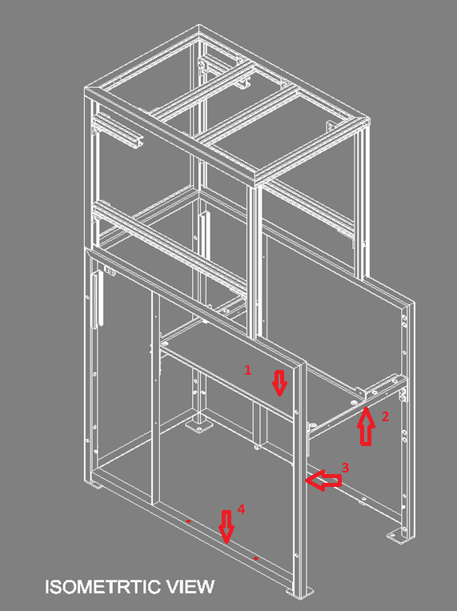

Figure : Test Locations.

Appendix C- Viscoelastic Tape Testing and Results

On May 10, 2011 a constrained layer damping tape was tested to determine its vibration reduction performance. The product tested was the 3MDamping Foil 2552*.* A picture of this product is in Fig. 7.

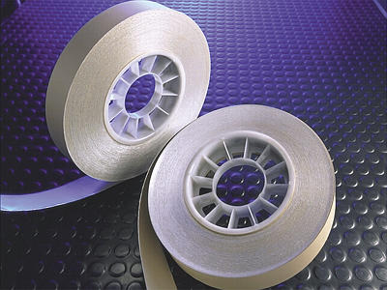

Figure : 3M Damping Foil 2552.

The data showed that the tape actually increased the vibration levels at a majority of test location and speeds. An example of these results is in Fig. 8.

Figure : The RMS results comparing the 3M Damping Foil 2552 to Edwards’s current configuration.

Appendix D- Design Improvement Testing

The following figures were used to show that plate isolation was affective. Each figure represents a speed configuration of interest. The RMS vibration amplitude results are presented in figure to figure. When comparing channel one to channels two and four in Fig. 9 and 10, there is significant reduction when using plate isolation with rubber pads. Channels two and four were determined as critical locations on the support frame. Figures 9-12 showed improved performance at channel four.

Figure : Vibration on the frame with dry pump speed of 70 Hz and booster speed of 100 Hz. Channel 4 and channel 2 show consistent vibration reduction as the rubber thickness increase.

Figure : Vibration on the frame with dry pump speed of 85 Hz and booster speed of 50 Hz. Channel 4 shows the best vibration reduction with 3 rubber layers. Consistent vibration reduction also seen at channel 2 while vibration at the source (channel 1).

Figure : Vibration on the frame with dry pump speed of 70 Hz and booster speed of 30 Hz. Channel 4 shows the most vibration reduction as the rubber thickness increased.

Figure : Vibration on the frame with dry pump speed of 100 Hz and booster speed of 105 Hz. Channel 4 shows the the best vibration reduction with 3 rubber layers while vibration at the source (channel 1) increased when it is less restricted to the frame.

Figure 13 is a comparison plot that represents the four speed configurations RMS amplitudes at location four. Location four represents a critical location on the support frame. The results showed that inserting 3 layers of 1/8 inch thick rubber in the whole contact area between the pump’s supporting plate and the frame yields the most vibration reduction of all configuration.

Figure 13: Comparison of multiple rubber configurations at a critical location on the support frame.

The spectral analysis of the vibration signals also gives valuable insight into the nature of the vibration. Figure 14 to Fig. 17 gives example of linear spectrum of the vibration signals and also the ratio between the signals.



Figure 14: Linear spectrum of vibration signal from channel 1 (the source of vibration) shows notable peaks at the proximities of 100~400 Hz. This might result from the resonance phenomenon within the frame structure. No rubber was inserted; pump speed of 100.



Figure 15: Linear spectrum of channel 2, 3 and 4 superimposed. These other channels show the same consistent peaks in the proximities of 100 ~ 400 Hz as channel 1. No rubber was inserted; pump speed of 100 Hz and Booster speed of 105 Hz.

.

Figure 16: Amplitude ratio between channel 4 over channel 1 showed large amplification of vibration at frequency of 100 ~ 200 Hz.



Figure 17: Amplitude ratio between channel 4 over channel 1 with 3/8 inch thick of rubber inserted (red solid line) and without the rubber (blue dashed line).

There is still large amplification of vibration at frequency of 100 ~ 200 Hz but the ratio of amplification was significantly reduced consistently over the spectrum range. Pump speed of 100 Hz and Booster speed of 105 Hz.

Other experiments include thicker rubber pad with smaller contact area (to lower the stiffness of the rubber pad) and viscoelastic tape. Since the damping effect was reduced with the contact area, these softer rubber pads did not successfully reduce vibration as when the rubber pad covers the entire contact area between the frame bar and the steel plate. The viscoelastic tape was built for application where plate geometry structure is dominant rather than beam geometry as in the frame structure. Therefore, the viscoelastic tape did not show any improvement of vibration absorption. Figure 18 shows one sample of data collected with these configurations and also with the viscoelastic tape on the frame.

Figure 18: RMS vibration level with reduced area rubber pad and viscoelsatic tape. Pump's speed of 85 Hz and booster speed of 50 Hz.

Conclusion: 3/8 inch thick rubber pad covering the whole contact area between the steel plate supporting the pump and the frame is the best solution to reduce vibration in the system. This solution agrees with the finite element analysis presented in Appendix E.

Appendix E- Finite Element Analysis of Pump Frame

**Scope of the solution:**

This solution creates a 3D FEA model of the steel frame that is used to support the vacuum pumps at Edwards and extract the lowest natural frequency of the frame and the mode shape of the vibration. The solution seeks to give a quantitative measure of the frame global stiffness and to decide if stronger frame is needed.

**Abaqus FEA model description:**

The model used 1145 beam (B31: A 2-node linear beam in space) and shell (S4R: A 4-node doubly curved thin or thick shell, reduced integration, hourglass control, finite membrane strains) elements.

Frame’s material in the model is structural steel: E = 200 GPa and ν = 0.29, density = 7850 kg/m3. The shell thickness is 3/16 in. and the beam profile are 1.5x1.5x0.174 in. (Hollow Structural Sections – Dimensions and Section Properties, Steel Tube Institute of North America; 2516 Waukegan Road, Suite 172, Glenview, IL 60025 • Tel: 847.461.1701 • Fax: 847.660.7981. E-mail: STINA@steeltubeinstitute.org • Website: http://www.steeltubeinstitute.org) and L shape 1.5x1.5x0.1875 in.

The model was draw to real size with simplification of the plate (the dimensions of the plate was taken as the length between the connecting bolts of the frame and the plate). Figure 19 shows the geometry frames tubing. The fours legs of the frame were restrained in 6 degrees of freedom as is the actual frame.

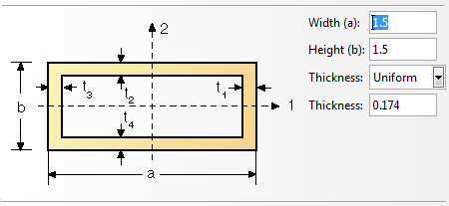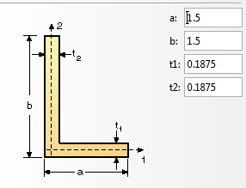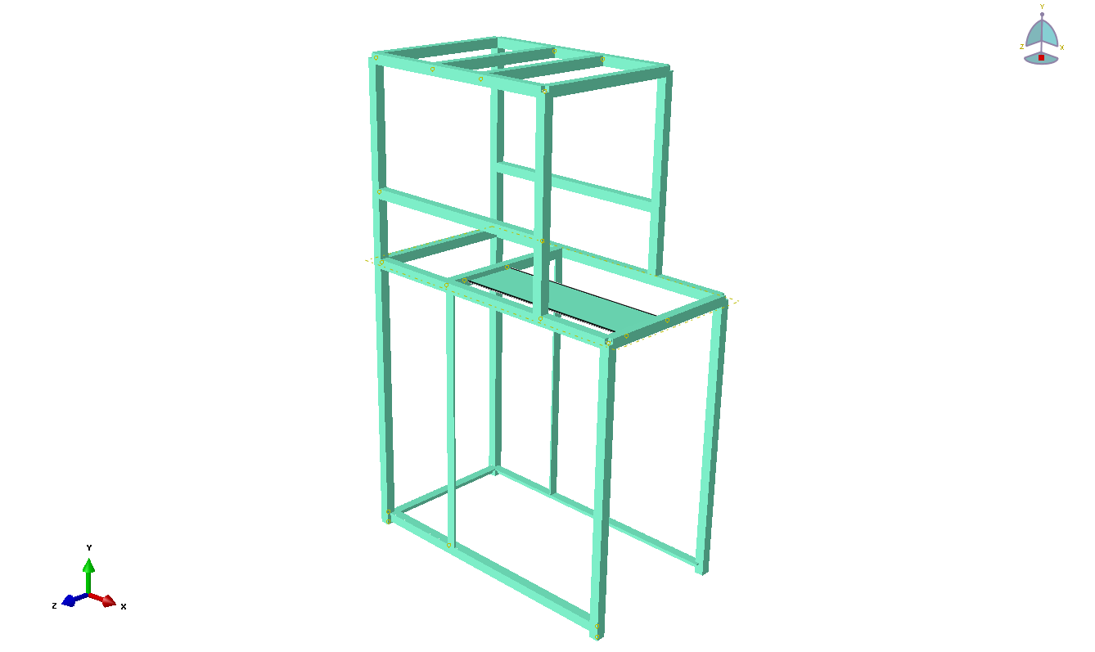

Figure 19: The geometry of the frames tubing.

**Conclusion:** The Abaqus simulation shows that the frame is a very soft structure with many resonant frequencies ranging from as low as 13 Hz and up. Figure 20 plots the distribution of these natural resonance frequencies which scatter all over the pump’s operation frequency range. In Fig. 10, only the first 100 modes were calculated, higher resonance modes still exist. The frames first natural frequency, which mode shape is shown in the Abaqus screenshot in Fig. 21*,* is such a low frequency resonance mode indicating that stronger tubing could be beneficial to the system. The dynamics of the frame makes it difficult to use traditional vibration analysis in design. The final detail design was based heavily on experimental data with theoretical prediction as insightful guidance. This analysis led to the conclusion that introducing damping to the system could yield better performance.

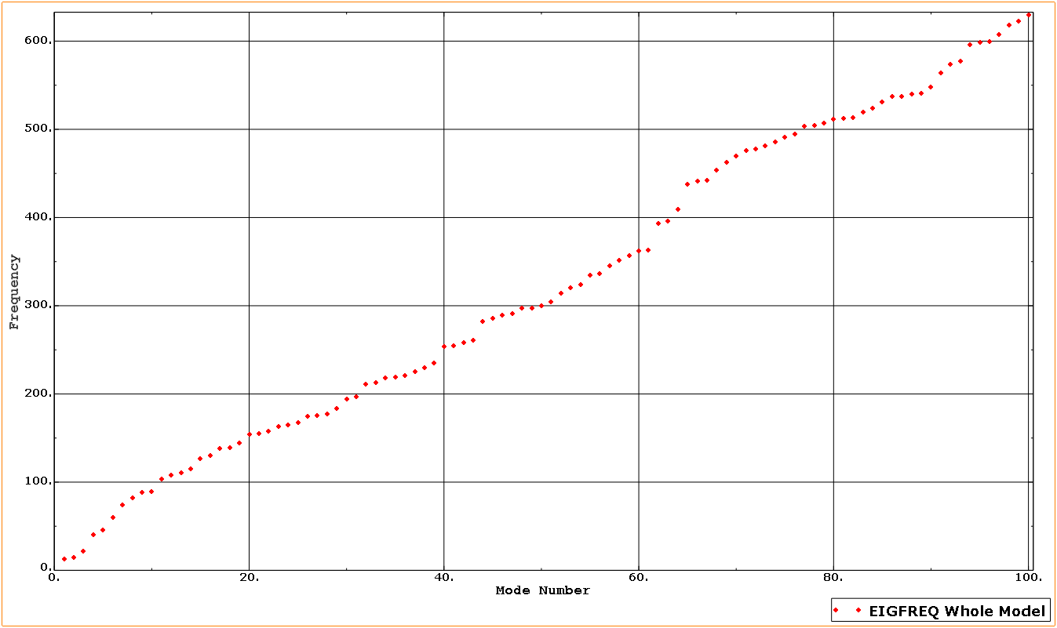

Figure 20: Natural frequencies of the supporting frame.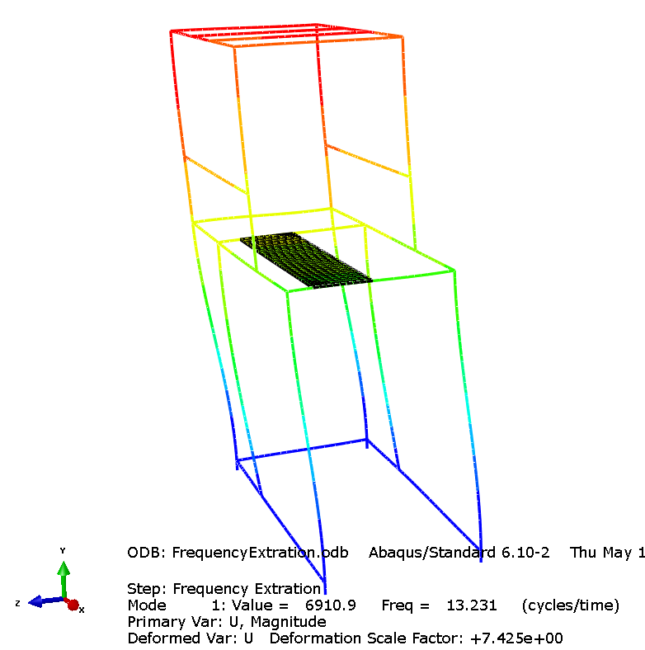

Figure 21: Abaqus screenshot of the first resonance mode shape. First natural frequency = 13.2 Hz.

Appendix F- Rubber Pad Thickness and Geometry Analysis

In this section, all the vibration system analysis and formulation to calculate stiffness of rubber pads are presented. The pump/frame system at Edwards is complicated with a lot of variables. Therefore, choosing a suitable theoretical model to apply for this system is an important step. The team had discussed with faculty advisor and decided to simplify the problem by modeling the pump and frame as a single degree of freedom system. With that model, three significant assumptions had been made: the frame is rigid enough to be considered as ground; the pump acts like a mass with vertical forcing excitation; and damping is small enough to neglect. A single-degree-of- freedom spring mass damper system is shown in Fig. 22.

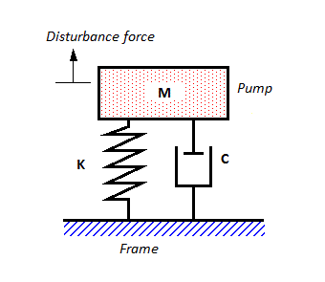

Figure 22: Single-Degree-of-Freedom Spring Mass Damper System [3].

So our isolator designs will change the stiffness K of the system. Our goal is determining the value of K that can reduce the vibration transmitted from the pump to the frame to satisfy sponsor’s requirement.

The preliminary testing shows that the forcing frequency generated from the pump ranges from 100Hz to 2000Hz. To design the isolator we need the ratio of the lowest forcing frequency/the system natural frequency $(ω/ω_{n})$ to look for the transmissibility from the frequency response characteristic graph. This graph is shown in Fig. 23.

Three testing had been conducted with three different isolators including the final product. Detail analysis for each of the isolator will be presented below.

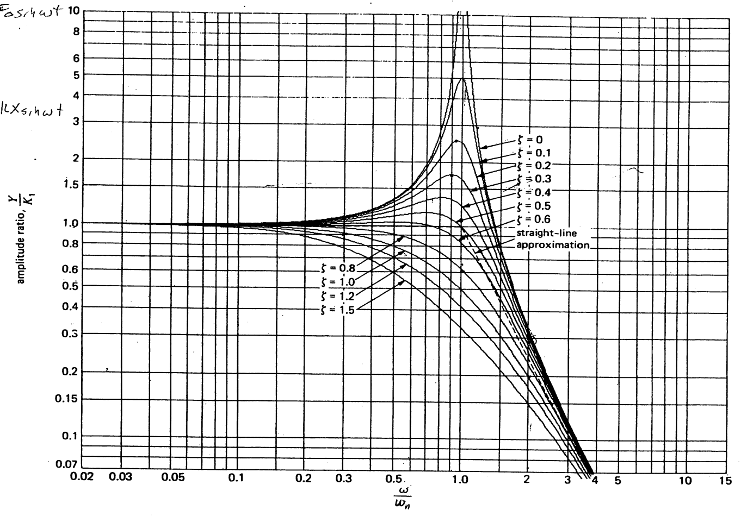

Figure 23: Frequency response characteristics of second order dynamic system [4].

**Isolator analysis #1**

1. **Summary**

This isolator is made of a stack of three layers of 1/8 in. thick Neoprene 30A durometer without any intermediate layer. In this analysis, we are going to determine the overall stiffness of isolators, the natural frequency of the system, and the vibration transmissibility theoretically with that isolator applied. Two identical 1.5 in. x 12 in. isolators are used in between the plate and the frame, one in front and one in the back. Figure 24 shows the geometry of the isolator tested and the location between the frame and plate that it was inserted.

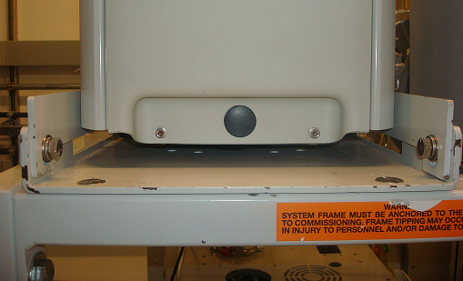

Isolator inserted in between plate and frame

Frame

Plate

Isolator

Plate



12

1.5

1.5

3x1/8”

Figure 24: System configuration and dimension of isolator #1 (all dimensions are in inch).

The result yields a stiffness of $143.88×{10}^{6} N/m$. With that stiffness, the natural frequency of the system would be 128.7Hz and the vibration transmissibility of 2.3. With this isolator, the vibration transmitted from the plate to the frame is amplified by 230%.

1. **Evaluation**

Because of the complication of the problem, we choose the simplest model to apply to the system in this analysis. Therefore, many assumptions have been made to simplify the calculation. The tradeoff is that the analytical result will not nicely describe the behavior of the system in practical.

1. **Formulation section**
2. Overall stiffness of isolators

*Given:*

* Rubber pad hardness = 30A durometer.
* Rubber pad dimensions = 1/8” x 1.5” x 12”.
* Number of layers = 3.

*Find: Overall s*tiffness Ktotal of isolators.

*Solution:*

Converting from durometer hardness to young modulus:

$E=\frac{0.0981(56+7.66S)}{0.137505(254-2.54S)}$ (1)

With S is durometer A and E is young modulus in MPa. With 30A durometer, E = 1.15 MPa.

The three layers will act like three springs in series, so the stiffness of one isolator will be three times less than the stiffness of a single pad:

$K= \frac{K_{c}}{3}$ (2)

Two identical isolators are used in parallel, so the total stiffness of them would be equal to twice the stiffness of one isolator:

$K_{total}= 2K$ (3)

Equations to calculate the stiffness Kc of a single rubber pad in compression:

$K_{c}=\frac{E_{c}A}{t}$ (4)

$E_{c}=E_{o}(1+2ks^{2})$ (5)

* A = length x width = 1.5 x 12 = 18 inch2.
* Thickness t = 1/8 inch.
* Young modulus Eo = 1.15 MPa = 166.8 psi.
* Shear modulus G = (Eo + 71)/4.5 = 52.8 psi.
* Numerical factor k = 0.444 + (23.3/G) = 0.885.
* Shape factor.

Solving for Ec from equation (4):

From equations (4), Kc is determined:

$$K_{c}=\frac{8564.6×18}{1/8}=1.23×{10}^{6}\frac{lbs}{inch}$$

From equation (2) + (3), K and Ktotal are determined:

$$K=\frac{K_{c}}{3}=411102 \frac{lbs}{inch};{ K}_{total}=2K=822204\frac{lbs}{inch}$$

**Overall stiffness of isolators: Ktotal = 822204 lbs/inch = 143 $.88×{10}^{6} N/m.$**

1. System natural frequency and vibration isolation factor

*Assumptions:*

* Frame is rigid enough to be considered as ground.
* The pump acts as a mass with vertical forcing excitation.
* Damping is small and can be neglected.

*Given:*

* Stiffness K =
* Mass of the pump M = 220 kg.
* Lowest forcing frequency:

*Find:* Natural frequency and the factor of vibration isolating.

*Solution:*

For zero damping system the natural frequency would be:

$$ω_{n}=\sqrt{\frac{K}{M}}=\sqrt{\frac{143.88×{10}^{6} N/m}{220 kg}}=808.7\frac{rad}{sec}=128.7Hz$$

Frequency ratio:

$$\frac{ω}{ω_{n}}=\frac{100Hz}{128.7Hz}=0.78$$

Look at the graph in figure **xxx**, at damping ratio = 0 and frequency ratio = 0.78 the amplitude ratio would be 2.3. So theoretically the vibration transmitted from the plate to the frame is amplified to 230%.

**Natural frequency = 128.7Hz and transmitted vibration is amplified to 230%**

**Isolator Analysis #2**

1. **Summary**

This isolator is made of two layers of 3/8” thick Neoprene 30A durometer with a 1/16” thick intermediate Aluminum plate. In this analysis, we are going to determine the overall isolator’s stiffness, the natural frequency of the system, and the vibration transmissibility theoretically with that isolator applied. Four identical 1.5” x 1.5” isolators are used in between the plate and the frame, two in front and two in the back. Figure 16 shows the geometry of the isolator tested. The location between the frame and plate that it was inserted is the same as in Fig. 25.



Isolator

Plate

3/8

3/8

13/16 in

1.5

1.5

1.5

Figure 25: System configuration and dimension of isolator #2.

The result yields a stiffness of $3.88×{10}^{6} N/m$. With that stiffness, the natural frequency of the system would be 21Hz and the vibration transmissibility of 0.07.

1. **Evaluation**

Because of the complication of the problem, we choose the simplest model to apply to the system in this analysis. Therefore, many assumptions have been made to simplify the calculation. The tradeoff is that the analytical result will not nicely describe the behavior of the system in practical.

1. **Formulation section**
2. Overall stiffness of isolators

*Given:*

* Rubber pad hardness = 30A durometer.
* Rubber pad dimensions = 3/8” x 1.5” x 1.5”.
* Number of layers = 2.

*Find: Overall s*tiffness Ktotal of isolators.

*Solution:*

Converting from durometer hardness to young modulus:

$E=\frac{0.0981(56+7.66S)}{0.137505(254-2.54S)}$ (6)

With S is durometer A and E is young modulus in MPa. With 30A durometer, E = 1.15 MPa.

The two layers will act like two springs in series, so the stiffness of one isolator will be half the stiffness of a single pad:

$K= 0.5K_{c}$ (7)

Four identical isolators are used in parallel, so the total stiffness of them would be equal to four times the stiffness of one isolator:

$K_{total}= 4K$ (8)

Equations to calculate the stiffness Kc of a single rubber pad in compression:

$K_{c}=\frac{E_{c}A}{t}$ (9)

$E_{c}=E_{o}(1+2ks^{2})$ (10)

* A = length x width = 1.5 x 1.5 = 2.25 inch2.
* Thickness t = 3/8 inch.
* Young modulus Eo = 1.15 MPa = 166.8 psi.
* Shear modulus G = (Eo + 71)/4.5 = 52.8 psi.
* Numerical factor k = 0.444 + (23.3/G) = 0.885.
* Shape factor.

Solving for Ec from equation (4):

From equations (4), Kc is determined:

$$K_{c}=\frac{462×2.25}{3/8}=2772.2\frac{lbs}{inch}$$

From equation (2) + (3), K and Ktotal are determined:

$$K=2K_{c}=5544.4 \frac{lbs}{inch};{ K}_{total}=4K=22177.7\frac{lbs}{inch}$$

**Overall stiffness of isolators: Ktotal = 22177.7 lbs/inch = 3 $.88×{10}^{6} N/m.$**

1. System natural frequency and vibration isolation factor

*Assumptions:*

* Frame is rigid enough to be considered as ground.
* The pump acts as a mass with vertical forcing excitation.
* Damping is small and can be neglected.

*Given:*

* Stiffness K =
* Mass of the pump M = 220 kg.
* Lowest forcing frequency:

*Find:* Natural frequency and the factor of vibration isolating.

*Solution:*

For zero damping system the natural frequency would be:

$$ω_{n}=\sqrt{\frac{K}{M}}=\sqrt{\frac{3.88×{10}^{6} N/m}{220 kg}}=132.8\frac{rad}{sec}=21Hz$$

Frequency ratio:

$$\frac{ω}{ω_{n}}=\frac{100Hz}{21Hz}=4.76$$

Look at the graph in figure **xxx**, at damping ratio = 0 and frequency ratio = 4.76 the amplitude ratio would be 0.07. So theoretically the vibration transmitted from the plate to the frame is reduced by 99.93%.

**Natural frequency = 21Hz and transmitted vibration is reduced by 99.93%**

**Final Design Isolator Analysis**

1. **Summary**

This isolator is made of a single layer of 3/8” thick Neoprene 30A durometer. In this analysis, we are going to determine the isolator’s stiffness, the natural frequency of the system, and the vibration transmissibility theoretically with that isolator applied. Two identical 1.5” x 12” isolators are used in between the plate and the frame, one in front and one in the back. Figure 26 shows the final prototype.

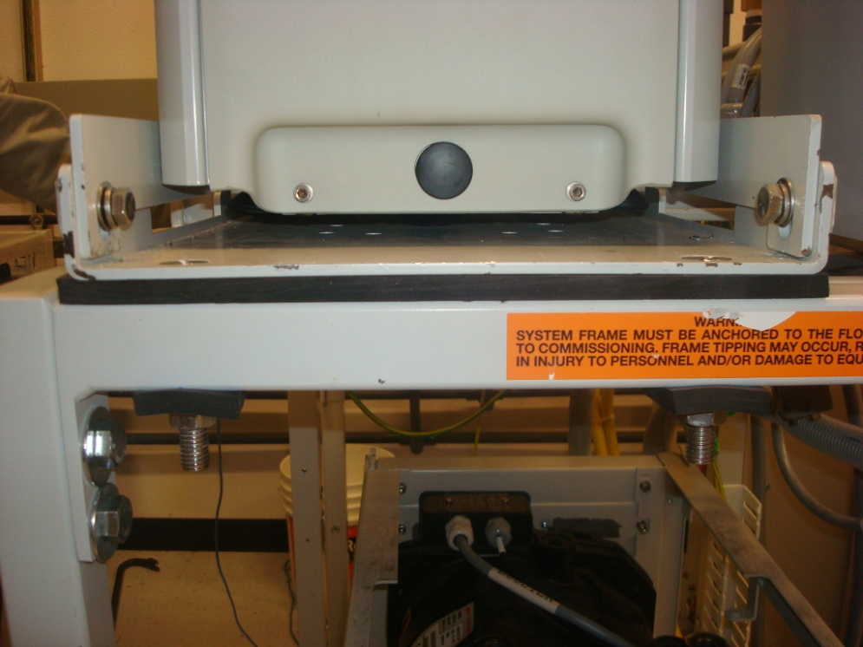

Frame

Isolator

Plate

Figure : Isolator is inserted between plate and frame.

The result yields a stiffness of $18.5×{10}^{6} N/m$. With that stiffness, the natural frequency of the system would be 46Hz and the vibration transmitted factor is 0.35. The result shows that the vibration transmitted from the plate to the frame is reduced by 65% when this isolator is applied.

1. **Evaluation**

Because of the complication of the problem, we choose the simplest model to apply to the system in this analysis. Therefore, many assumptions have been made to simplify the calculation. The tradeoff is that the analytical result will not nicely describe the behavior of the system in practical.

1. **Formulation section**
2. Stiffness of isolator

*Given:*

* Rubber pad hardness = 30A durometer.
* Rubber pad dimensions = 3/8” x 1.5” x 12”.

*Find:* Overall stiffness Ktotal of the isolator.

*Solution:*

Converting from durometer hardness to young modulus:

$E=\frac{0.0981(56+7.66S)}{0.137505(254-2.54S)}$ (11)

With S is durometer A and E is young modulus in MPa. With 30A durometer, E = 1.15 MPa.

The two isolators will act like two springs in parallel, so the overall stiffness will be twice the stiffness of a single pad:

$K_{total}= 2K_{c}$ (12)

Equations to calculate flat sandwich rubber pad’s stiffness in compression:

$K_{c}=\frac{E_{c}A}{t}$ (13)

$E_{c}=E_{o}(1+2ks^{2})$ (14)

* A = length x width = 1.5 x 12 = 18 inch2.
* Thickness t = 3/8 inch.
* Young modulus Eo = 1.15 MPa = 166.8 psi.
* Shear modulus G = (Eo + 71)/4.5 = 52.8 psi.
* Numerical factor k = 0.444 + (23.3/G) = 0.885.
* Shape factor $s=\frac{LW}{2\left(L+W\right)t}=1.78$.

Solving for Ec from equation (4): $E_{c}=166.8\left(1+2×0.885×{1.78}^{2}\right)=1102psi.$

From equations (2) + (3), Kc and Ktotal are determined:

$$K_{c}=\frac{1102×18}{3/8}=52896\frac{lbs}{inch}; K_{total}=2K_{c}=105792\frac{lbs}{inch}.$$

**Overall stiffness of the isolator: Ktotal = 105792 lbs/inch = $18.5×{10}^{6} N/m.$**

1. System natural frequency and vibration isolation factor

*Assumptions:*

* Frame is rigid enough to be considered as ground.
* The pump acts as a mass with vertical forcing excitation.
* Damping is small and can be neglected.

*Given:*

* Stiffness K =
* Mass of the pump M = 220 kg.
* Lowest forcing frequency:

*Find:* Natural frequency and the factor of vibration isolating.

*Solution:*

For zero damping system the natural frequency would be:

$$ω_{n}=\sqrt{\frac{K}{M}}=\sqrt{\frac{18.5×{10}^{6} N/m}{220 kg}}=290\frac{rad}{sec}=46Hz$$

Frequency ratio:

$$\frac{ω}{ω_{n}}=\frac{100Hz}{46Hz}=2.17$$

Look at the graph in figure **xxx**, at damping ratio = 0 and frequency ratio = 2.17 the amplitude ratio would be 0.35. So theoretically the vibration transmitted from the plate to the frame is reduced by 65%.

**Natural frequency = 46Hz and transmitted vibration is reduced by 65%**

Appendix G- Product Vendors

**Neoprene Rubber Vendor:**

**Supplier-** Grainger Industrial Supply

**Product Description-** Rubber Sheet, General Purpose, Commercial Grade, Neoprene Rubber, Thickness 3/8 In, Width 12 In, Length 12 In, Black, Smooth Finish, Plain Backing Type, Min Temp Rating -20 Deg F, Max Temp 170 F, Durometer 30A, Elongation 350%, Tensile Strength 1000 PSI, Standards ASTM D2000 BC

**Product Number-**1MUP2

**Link-** <http://www.grainger.com/Grainger/Rubber-Sheet-1MUP2?Pid=search>

**Hardware Vendor:**

**Supplier-** Boltdepot.com

**Product Description-**

-Machine Screws- Slotted flat head, Stainless steel 18-8, 1/2-13 x 3 Each Machine screws, Slotted flat head, Stainless steel 18-8, 1/2-13 x 3

-Hex Nuts- Stainless steel 18-8, 1/2-13

-Flat washers- Stainless steel 18-8, ½

**Product Numbers-**

Machine Screws- 3571

Hex Nuts- 2566

Flat Washers- 2950

**Alternative Rubber Pads:**

**Supplier-** EAR Specialty Composites

**Product Description –** Isolation material, 56A durometer, Lost factor 0.93 at 10Hz and 46F, Tensile strength 1574 psi, Tear strength 202 psi, Temperature range 55-105F. More specific descriptions are available in the link.

**Product Number-** ISODAMP C-1002

**Link-** <http://www.earsc.com/HOME/products/DampingandIsolation/IsolationMaterials/index.asp?SID=151>

Appendix H- Bill of Materials

***Table 4:*** *Bill of Materials.*

|  |  |  |  |  |
| --- | --- | --- | --- | --- |
| **Part Name** | **Quantity** | **Material** | **Drawing Number** | **Make/Buy** |
| 3/8in Plate Isolator* | 2 | Neoprene Rubber | 1 | Make |
| 3/8in Washer Isolator* | 4 | Neoprene Rubber | 2 | Make |
| 1/2-13 x 3 Counter Sunk Machine Screw | 4 | Stainless Steel 18-8 | N/A | Buy |
| 1/2 Flat washers | 4 | Stainless Steel 18-8 | N/A | Buy |
| 1/2-13 Hex jam nylon lock nuts | 4 | Stainless Steel 18-8 | N/A | Buy |

Appendix I- Product Cost

The plate isolator and washer isolator was manufactured from a 3/8in rubber pad. The cost is determined by the percentage of the rubber pad used and the material wasted in the process. The time needed for Edwards to manufacture this product is approximately one hour. The cost of labor of an Edwards employee was determined by Mark Romeo of Edwards Vacuum, Ltd. Table 5 outlines the cost of the isolator system.

***Table 5:*** *Total Cost of Plate Isolator.*

|  |  |  |  |  |
| --- | --- | --- | --- | --- |
| **Description** | **Quantity** | **Cost** | **Shipping** | **Total** |
| 3/8in Plate Isolator | 2 | $2.55 | $10.00 | $15.10 |
| 3/8in Washer Isolator | 4 | $0.57 | None | $2.28 |
| 1/2-13 x 3in Counter Sunk Machine Screw | 4 | $4.64 | $10.39 | $28.95 |
| 1/2in Flat washers | 4 | $0.18 | None | $0.72 |
| 1/2in-13 Hex jam nylon lock nuts | 4 | $0.44 | None | $1.76 |
| Edwards Labor | 1 hour | $35.00 | None | $35.00 |
|  |  |  | Total | $83.81 |

Appendix J- Manufacturing Instructions

In this appendix the detailed manufacturing instructions for modifying the support beams and making the rubber isolators is outlined.

**Equipment:**

* Hand drill with 9/16 in. steel drill bit.
* 9/16 in. RRT heavy – duty hole puncher.
* A hammer.

**Instruction:**

1. Drilling new holes in the beams:

Four new 9/16 in. holes need to be drilled on the bottom and top surfaces of each beam (eight in total). First, measure and mark the locations of these holes using the detailed drawing shown in Fig. 27. Then drill vertically through the beam. It is important that the top holes and the new bottom holes are vertically aligned.

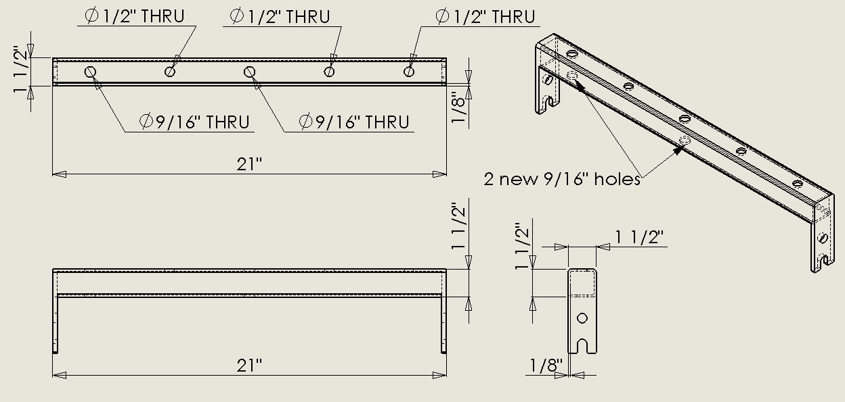

Figure 27: Drawing of a modified beam with two 9/16 in. holes drilled on the bottom face.

1. Cutting rubber pads and rubber washers:

Two long rubber pads and four rubber washers are need for each system. Edges are cut by knife and holes are created using steel hole-punch and hammer. If the holes are difficult to be punched, one can try sharpening the cutting edge of the punched using a file or create smaller concentric holes with punches of smaller sizes. Detailed drawings of neoprene pads and rubber washers are shown in Figure 28.

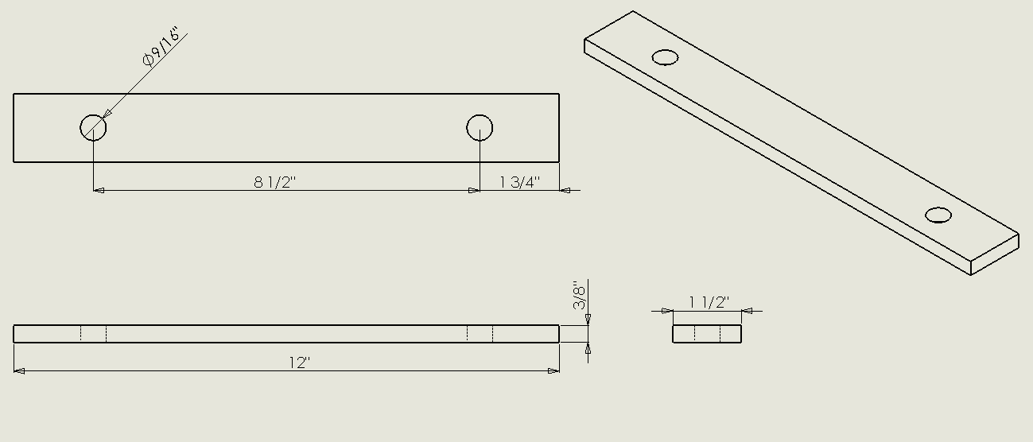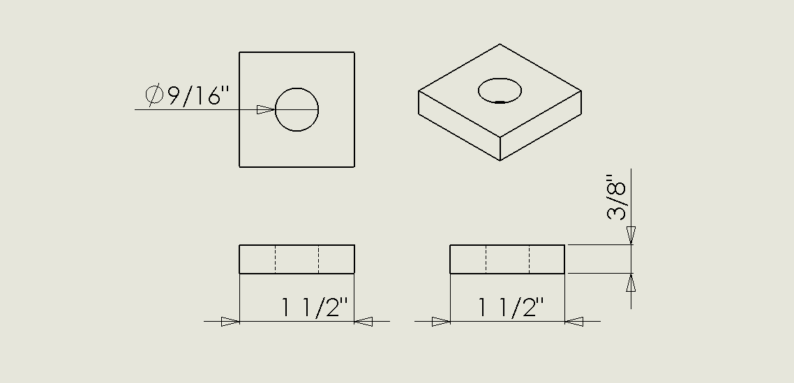

**b**

**a**

Figure 28: (a)Drawing of rubber pads (b) Drawing of rubber washers

Appendix K- Detailed Drawings and Assembly

The detailed drawings for the plate and washer isolators are shown in Figs. 29 and 30.

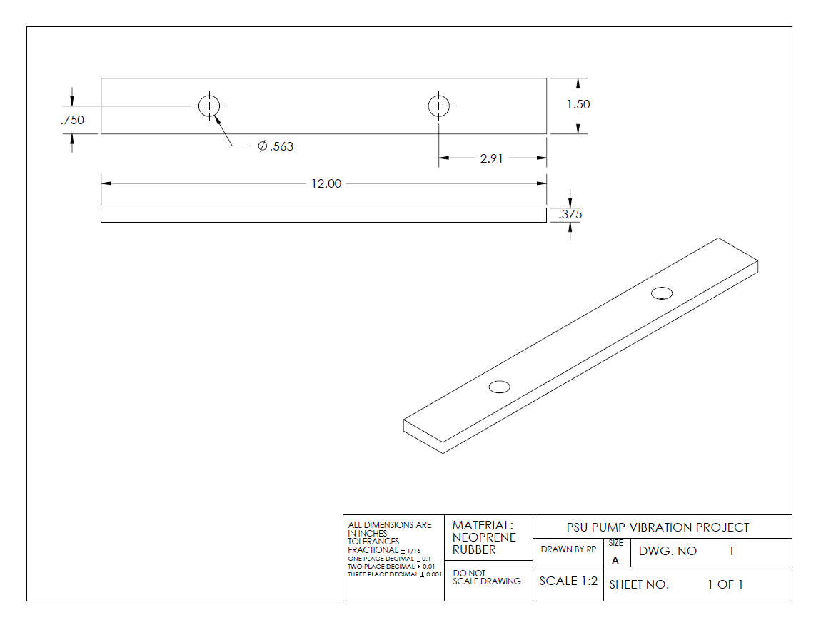

Figure 29: Detailed drawing of plate isolator.

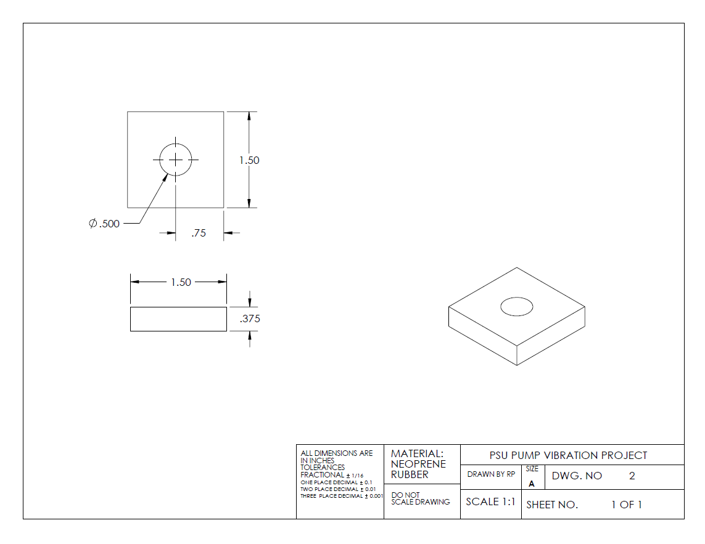

Figure 30: Detailed drawing of washer isolator.

Appendix L- Beam Strength of Material Analysis

This appendix shows the analysis for static mechanical strength of the original beams and the modified beams. The results will be used to determine if modification to the structure affects the safety factor of the system or not.

For the current pump system, the entire weight of the pump (plate’s weight is negligible compared to the pump’s weight) is supported by the two beams. In this analysis, we assume the weight is distributed equally on the two and analyze only on beam subjected to half of the weight of the pump. The two ends of the beam are bolted to the vertical side bars of the frame, so we considered it fixed at two ends. The plate – beam contact area is 1.125 in. wide and 11.24 in. long and the weight is assumed to be uniformly distributed. A free body diagram for the beam is given in Figure 31 and a 3D model is shown in Figure 32.

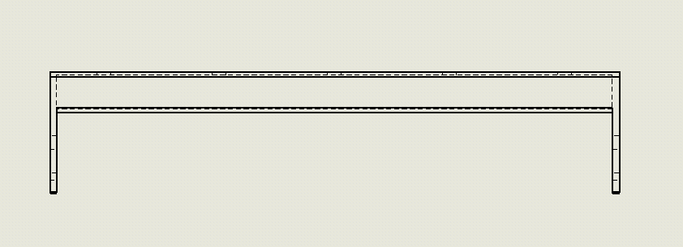

Pressure load P

Figure 31: Free body diagram of a beam.

Loaded Area A = (1.125in)(11.24in) = 12.645in2 = 8.158x10-3 m2Load W = 0.5(9.81m/s2)(500lbm)(0.454kg/lbm) = 1113 N  
Pressure load: P = W/A = 1113N/ (8.158x10-3m2) = 136.4 x 103 Pa

**Result**

Figure 32: 3D model with loads and constraints

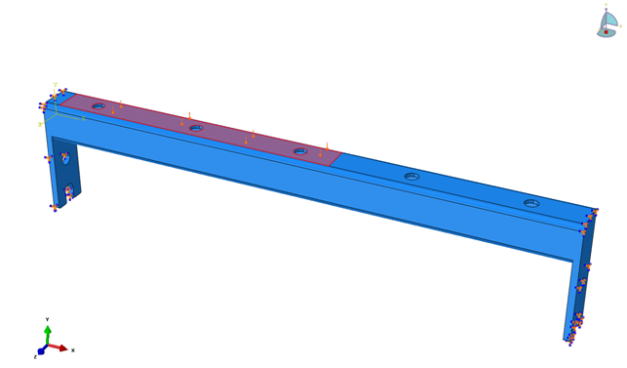

Point 1

The convergence plots for Von – Mises stresses at point 1(Figure 33) of the original structure and the modified structure are given in Figure 3. Only when the values of stress converge can we use results derived from that model. We used the results from a 6993 – element model for the original beam and results from a 6979 – element model for the modified beam. The calculated stress contour is plotted in Figure 34.

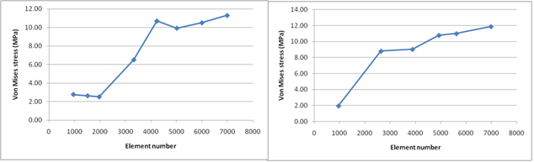

Figure 33: Convergence plot for Von - Mises stresses of the original beam and the modified beam.

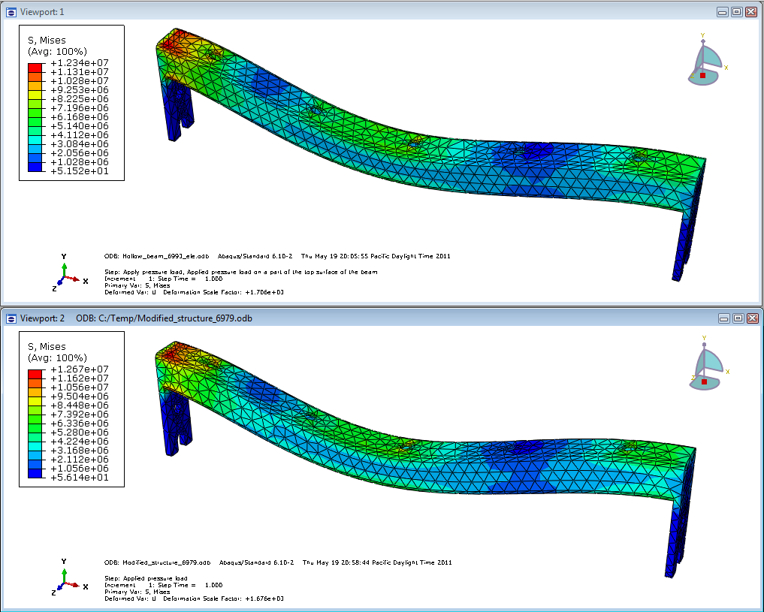

Figure 34: Stress contour plot of the original beam model (top) and the modified beam model (bottom).

The approximated tensile yield strength of steel is 250MPa. For the original structure, the maximum Von – Mises stress of 12.34MPa was observed, which correspond to a safety factor noriginal = 20.2. In the modified beam, the maximum Von – Mises stress is 12.67MPa and the safety factor is nmodified = 19.7.

Appendix M- Final Results from Prototype Testing

On May 25th 2011, PSU team joined with Edwards’ staff to conduct a final performance evaluation testing on the final design’s prototype at Edwards’ warehouse. The test compared the RMS vibration level before and after placing the rubber pad at eight locations commonly agreed between the capstone team and Edwards. The placement of eight testing location are depicted in Fig. 35. Each location was assigned a weighted factor and the percentage of vibration reduction will be average for all location at each speed configuration and finally be averaged equally among the four different speed settings to produce the final result of vibration reduction. Point 1 is where the largest vibration was found and also where the reading was most reliable, therefore it had the largest weight factor. The concluded percentage of vibration reduction is 23%. Table 6 shows a summary of the results.

***Table 6:*** *Test results summary*

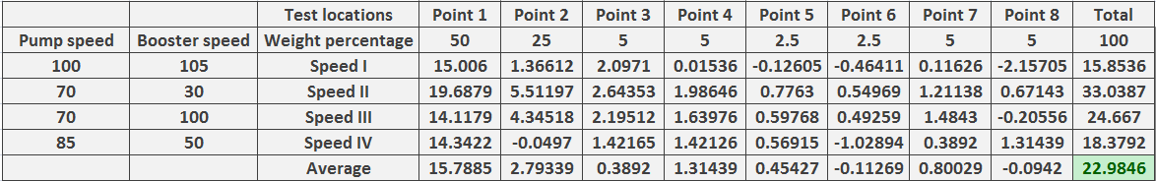

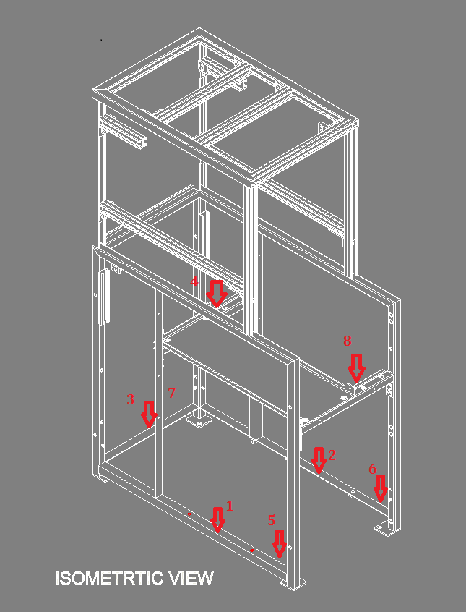

Figure 35: Testing locations.

Figures 36-39 show the results at the eight designated test location for each speed combonation.

Figure 36: Comparison of vibration level with and without rubber with pump speed of 100 Hz and booster speed at 105 Hz.

Figure 37: Comparison of vibration level with and without rubber with pump speed of 85 Hz and booster speed at 50 Hz.

Figure 38: Comparison of vibration level with and without rubber with pump speed of 70 Hz and booster speed at 100 Hz.

Figure 39: Comparison of vibration level with and without rubber with pump speed of 70 Hz and booster speed at 30 Hz.

Appendix N- Suggestion for Further Research

* The level of vibration present on the floor is too low for most accelerometer to pick up. More advance sensing technique is needed to capture these signals.
* For later improvement project, a vibration shaker should be purchased to perform frequency sweeping on the frame in conjunction with the present equipments.
* The testing facility/configuration/surrounding conditions also need to be defined and preserved strictly to minimized out-of-control factors in testing. In this project, the testing facility is subjected to surrounding condition in Edwards warehouse, which sometime are significantly rich in mechanical noise and crowded.
* The supporting frame is too soft and greatly resonates with the pump in operation. This condition does not allow theoretical simplification in solution design. As an example, most precision mechanical machines like lathe, mill and drill are overdesigned in stiffness in order to deal vibration. Edwards’s vacuum pumps supporting frame should also be built with this perspective in mind. If near absolute rigid frame could be realized, further vibration isolation might be achieved with the model of 2 masses system or at least, the effect of low stiffness rubber

# References

1. John D. Ferry, Viscoelastic properties of polymers 3rd Edition, 1980.
2. John C. Snowdon, Vibration isolation: Use and characterization (Applied Research Laboratory, Pennsylvania State 20 July 1979).
3. <http://www.mfg.mtu.edu/cyberman/machtool/machtool/vibration/intro.html>
4. Norman H. Beachley, Introduction to dynamic system analysis, University of Wisconsin-Madison, chapter 7.
5. <http://www.corryrubber.com/main/ns/62/doc/56/category/1/_id/1>
6. <http://en.wikipedia.org/wiki/Shore_durometer>