FSAE Cooling System

ME 493 Final Report –Year 2011

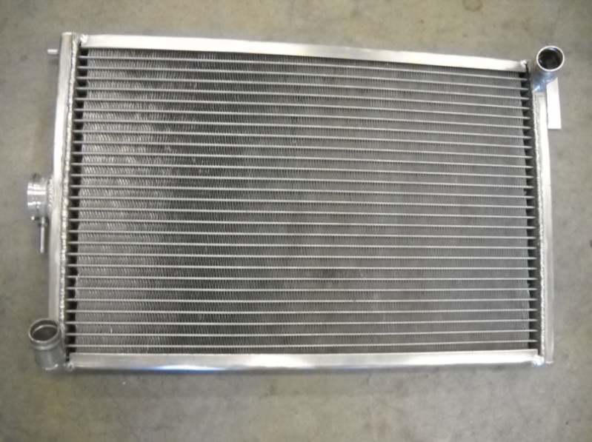

06/06/2011

Group Members

Craig Mclain

Reuben Ness

Riki Hopkins

Academic Advisor

Dr. LemmyMeekisho

# Executive Summary

The cooling system designed for the 2011 Portland State University’s FASE formula car is the first fully engineered solution to the cooling challenges faced by the teams in previous years. This cooling system for the 2011 car is specifically designed to remove the problems encountered in the 2010 car during testing and competition, such as engine starting issues due to excess temperatures, overheating at idle, or constantly running at temperatures that are beyond the ideal. In order to accomplish this, radiator and fan sizing as well as placement of the cooling system are designed specifically for the car and its application in competition. The radiator is custom built for the team.

The final cooling system consists of a radiator, an oil cooler, and a fan. A single pass radiator, custom built for the team, is matched with a Spal 10" Paddle Blade High Performance Fan and an oil cooler from a stock Honda CBR600F4i motorcycle. Through testing, the combined final cooling system is confirmed to reject the required 2hp heat load at idle, while meeting all FSAE competition regulations including size and shape limitations, which prohibit the cooling system from extending beyond the outer edge of the tires. The cooling system also displays dependability, which is, by far, the most important design requirements set for the project. The system maintained coolant temperatures of under 200°F throughout extensive track testing of the car under ambient temperatures of 90°F, and has shown no sign of overheating after being idled continuously for over 30 minutes. The final design is documented for the use of future teams of PSU’s FSAE Viking Motorsports.

Table of Contents

Executive Summary 2

Introduction 4

Mission Statement 5

Main Design Requirements 5

Top Level Alternative Solutions 7

Final Product Design 10

Final Product Evaluation 15

Conclusion 16

Appendix A: Radiator Sizing Analysis 17

Appendix B: Fan sizing analysis 20

Appendix C: Design Iterations 22

Appendix D: Current Parts 25

Appendix E: Experiments 27

Introduction 27

Theory 28

Methods 29

Results 30

Discussion 31

Conclusion 31

Error Analysis 32

References 34

Appendix EA: Raw Data 35

Appendix EB: Sample calculations 36

Appendix EC: Supplemental pictures of experimental apparatus. 38

Appendix F: Bill of Materials 39

Appendix G: Project Plan 40

Appendix H: PDS Summary 41

Appendix I: Part drawing 48

# Introduction

Formula Society of Automotive Engineers (FSAE) is an international engineering competition where students design, build, and test small-scale autocross racing vehicles. Competitions are held annually with regulations that create a real-world engineering challenge. Cooling related problems, ranging from relatively minor problems of hot starting issues and suboptimal performance of the car during competition to catastrophic engine failures due to overheating, are not uncommon amongst competitors. Portland State University’s (PSU) FSAE team in 2010 was not an exception and has experienced similar problems as a consequence of insufficient cooling. Many teams, including PSU’s FSAE team in 2010, encounter such cooling related problems in competition, because the cooling system is often addressed as an afterthought and did not receive adequate attention necessary for a thorough engineered solution.

PSU’s 2010 car had inadequate cooling capacity due to undersized radiator and fan, and improper airflow due to poor radiator positioning. The car faced challenges such as: 1) running at temperature hotter than that for optimal performance, 2) the car tended to overheat when idled for extended time or brought to an idle shortly after it was ran hard, as the undersized radiator and fan was not able to produce enough air flow in order to reject the required heat load of 2 hp, and 3) the car had difficulties starting in competition due to thermal expansion of the engine components from excessive heat.

A properly engineered solution for a cooling system will allow the car to run at the temperature for optimal performance, and prevent problems during expected and routine procedures such as overheating during idle or hot starting issues during testing and competition. Because, the radiator was an afterthought for this team, not enough time was allocated in analyzing the necessary cooling loads. The radiator design and sizing relied heavily on broad assumptions that were not well understood. Radiator placement and orientation were packaged with little consideration of the fluid dynamics of airflow, and since the team was short on resources, ducting and fan placement were neglected. In 2010, the importance of the cooling system was indeed underrated and inadequate resources were allocated to its design and build process.

# Mission Statement

The FSAE Cooling capstone team will design a new solution for the cooling of the 2011 FSAE car. The goal is to produce a solution through an understanding of the physics involved in the problem and the application of effective engineering methods. The final design will be prototyped and documented, with all of its performance characteristics quantified.

# Main Design Requirements

Here, a summary of the main design requirements is provided. For the full PDS document see the attached PDS document in the appendix. Based on the demands of the two major customers of the product, which are the PSU FSAE Viking motorsports team and the FSAE (who set the regulations), the most important design requirements for the product are defined as follows.

1. **Reliability.**It is crucial that the car with the new cooling system is reliable, dependable and consistent in maintaining a top tank temperature of under 210°F, in order to prevent difficulties encountered in the 2010 car; such as the loss in performance and difficulty starting the car due to excess temperatures, or overheating after idling for an extended time.
2. **Performance.** The target performance of the product is 2hp of heat rejection at idle, and 30hp of heat rejection at maximum heat load conditions.
3. **Service Life.** One year in service is required, as the 2011 car must serve for at least one year.
4. **Geometry.** The size and shape of the product must be such that when installed in to the car, it does not raise the center of gravity of the car by more than 0.5 inches, while meeting FSAE regulations such as the outer edge of the car with the product installed must not extend beyond the outer edge of the tires.
5. **Cost.** The total cost of the design and manufacturing of the product must be under $200.
6. **FSAE Rules.** Must meet all other competition regulations set by FSAE, such as the type of coolant fluid used in the product. The final product must use water as its coolant as set by FSAE regulations, and all fluids must be contained and shielded from the driver.

# Top Level Alternative Solutions

The scope of this project required design solutions for three different items: the radiator, radiator fan, and oil cooling.

The radiator design solutions fit into two main categories; the first is an off-the-shelf solution, and the other is a custom built radiator to our specifications. The off-the-shelf solutions consisted of Original Equipment (OE) motorcycle radiators, and other racing car radiators.

The most obvious solution would be the radiator from the motorcycle the engine came from (Honda CBR600F4i) but the radiator is curved and hard to package, besides being too small for our application, because we run the engine at higher loads and lower speeds than the motorcycle would. The stock radiator is shown in Fig. 1. We looked at a larger motorcycle radiator, such as the Honda CBR900rr radiator, but they are hard to find, and often more expensive than custom-made radiators.

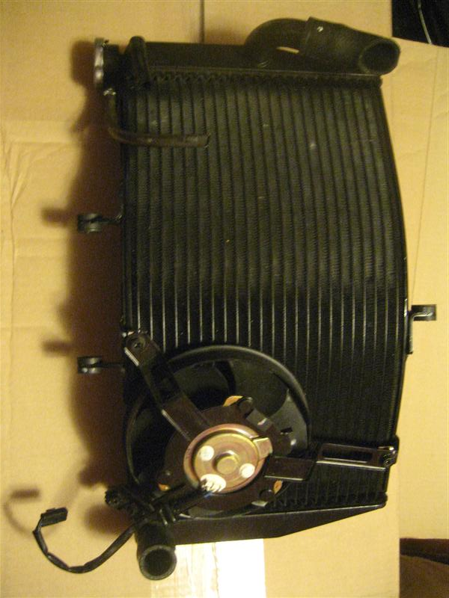

**Figure 1:** Honda CBR600F4i motorcycle radiator

There are several classes of race cars that use motorcycle engines, like D-Sports Racers (DSR), Mini-Sprint, Midgets, and Legends. These radiators are in the correct size range, but are double the thickness needed likely due to the extended racing time these cars are subject to. They are also dual-pass radiators, so they are difficult to package on our car. An example of one of these radiators is shown in Fig. 2 below.

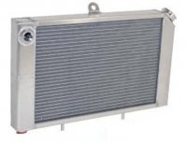

**Figure 2:** Racing radiator

After seeing what is out there and how they would not quite work in our application, we looked into custom-made radiator options. For tidiness, we looked into a dual-pass option, which would allow the hoses to be on the same side, but the tanks being on the side the radiator would not fit in the package required. Once we decided on a single-pass option, the rest of the design was over what core size was needed, and details such as mounting and outlet size and angle. We also had to decide where to purchase the radiator, and a decision matrix is shown below in Table 1.



**Table 1**: Radiator vendor decision matrix, with the light yellow being the best option

The fan solutions came in two different solutions, basically cheap and unknown, and expensive and reliable. In 2010 Viking Motorsports (VMS) ran a donated fan that was not quantified and understood. We brought in a “high-flow” no-name radiator fan, but in testing it produced only 20% of its rated output. We decided on an expensive Spal fan, which comes with a data sheet and fan curves, and was tested to actually put out its rated flow. The two different options are outlined in the decision matrix shown below in Table 2.



**Table 2**: Radiator fan vendor decision matrix, with the light yellow being the best option

The oil cooler options fit into two categories: oil-to-air, and oil-to-water coolers. The 2008 VMS car ran an oil-to-air cooler, but when we did analysis on it, it added ~4lbs. to the car, but produced only 0.2hp heat rejection. Honda has an OE (original equipment) oil-to-water cooler that transfers the heat load from the oil to the coolant, and therefore the radiator. We can get much more performance per weight by transferring the heat to the coolant, so we went with that option.

# Final Product Design

The final cooling system design breaks down into three subsystems; radiator, oil cooler, and fan. The car's engine circulates water through the radiator (via a water pump attached to the engine) and the engine's water jacket. As air passes through the fins of the radiator, heat is exchanged from the coolant to the air and the cooler water re-enters the engine. It is at this point that the cooler water enters the oil cooler. Within the oil cooler, cooler water swirls inside a jacket, while hot oil swirls on the other side of the jacket, cooling the oil. The water then re-enters the engine's water jacket, where heat from combustion is exchanged to the cool water, and the cycle starts over.

The fan is used to draw air through the fins of the radiator when there is insufficient flow, or while at idle. The engine's temperature sensor determines the temperature of water inside the water jacket. When the water is above 194°F, the fan is turned on and shuts off when the temperature is below 189°F. The entire system is shown in Fig. 3.

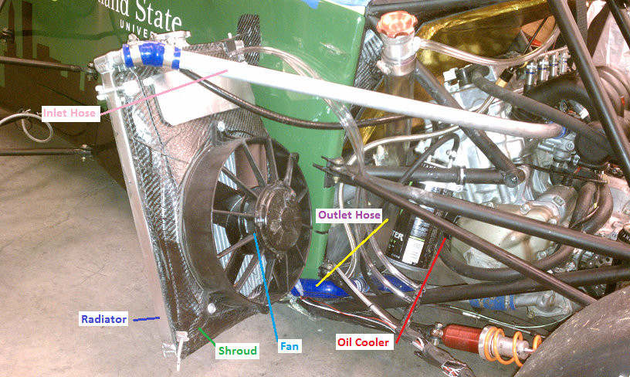

**Figure 3**: Complete Assembly, Three-quarter view.

The radiator itself, shown in Fig. 4, is a single pass design. Coolant passes through the inlet into the top tank, and flows down smaller tubes into the bottom tank. By the time the coolant reaches the bottom tank, its temperature has decreased by ~20°F. Once in the bottom tank, the coolant passes out the outlet and into the oil cooler, continuing the cycle.

The radiator cap keeps the system under pressure so that the coolant does not boil. The cap used in this system raises the pressure of the coolant by 13psi. If the cap were not a part of the system, the coolant would boil and the engine's water pump would cavitate, causing the car to fail.

The mounting tab and mounting pin combination (shown in Fig. 4), allow the radiator to be attached with only two fasteners, making the radiator itself easier to remove.

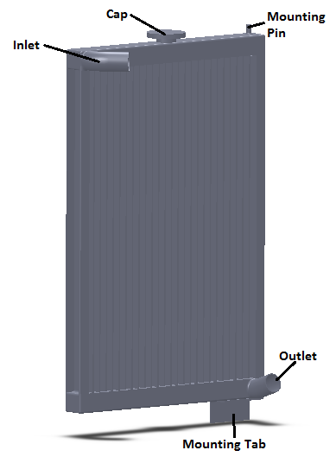

**Figure 4**: Model of Radiator

The oil cooler used is the stock Honda CBR600F4i oil cooler, shown in Fig. 5. Water passes through a jacket with fins inside for mixing, while oil passes through the inner side of the same jacket (so that the oil and water do not mix). The oil then passes through a filter and back through the same passages it entered, back into the engine. Through this process the oil is cooled.

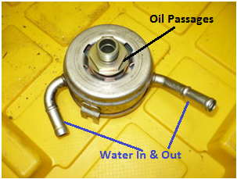

**Figure 5**: Honda CBR600F4i Oil Cooler

The fan used is a Spal ten inch high performance fan, shown in Fig. 6. This is a purchased part from Mac’s Radiator. The fan is used when there is insufficient air flow through the radiator to achieve the needed cooling.

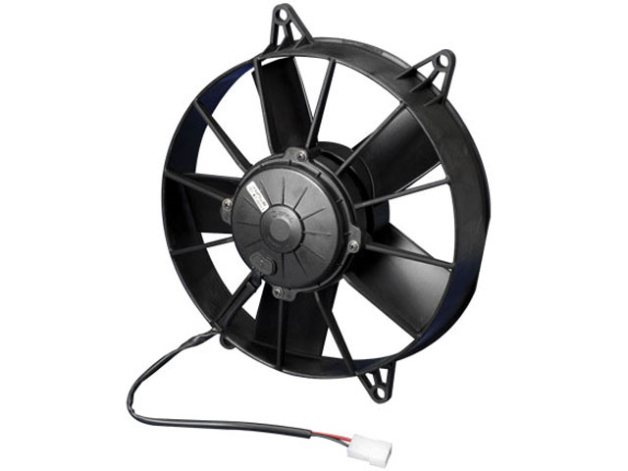

**Figure 6**: Spal 10" Paddle Blade High Performance Fan, PN:  30102057

A fan shroud was constructed, from carbon fiber, to increase the efficiency of the fan. The effective area of a fan is dependent upon fan spacing. If the fan were attached directly to the radiator, not an uncommon practice, the effective area is reduced to the ring where the blades travel (approximately the area of the fan). Using a shroud to space the fan off of the radiator, the fan can now draw from the entire area of the radiator, increasing the efficiency of the fan.

The pressure flap shown is used to ensure that there is always negative pressure on the rear side of the radiator. The flap is made in such a way, that if ANY positive pressure builds on the rear side of the radiator, the pressure is released and negative pressure is restored. When the fan turns on, the thin aluminum flap is forced closed, unless the car's velocity is greater than that of the fan. The flap also ensures that if at any point, the fan-shroud combo becomes a restriction to air flow, there is a relief.

The quick attach springs allow the fan shroud to be attached to the radiator without the need for any tools. They also allow the shroud to be attached and removed very quickly.

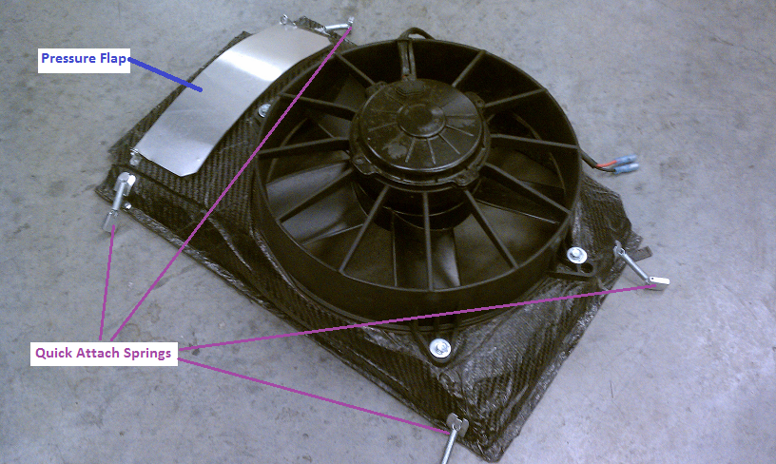

**Figure 7**: Fan-Shroud Combo

# Final Product Evaluation

The final product evaluation was performed by testing and evaluating the system. The system was system was evaluated in accordance with the Product Design Specifications (PDS) and customer input. The criteria that the system was tested under are listed in the Main Design Requirements section. The prototype system passed all of the requirements it was tested under thus far.

The finished product meets the following PDS requirements:

**Reliability**: Dependable in maintaining a top tank temperature under 210°F. During all testing thus far, the top tank temperature has not exceeded 200°F, even under 90°F ambient conditions and 2 hours of continuous run in track conditions. The system has maintained this performance even under extended idle periods of more than 30 minutes.

**Performance**: 2hp heat rejection at idle, 30hp heat rejection under track conditions. Unfortunately, quantitative tests of the cooling system were unable to be performed due to forces outside the control of this capstone team. Although, qualitative testing indicates this requirement is met due to maintained top tank temperature.

**Service Life**: One year service life. Obviously one year has not passed, but factors of safety within the design indicate this requirement will be met.

**Geometry**: The size and shape of the system does not negatively affect the center of gravity and must fit inside the outer edge of the tires. The team has not been able to determine the center of gravity of the cooling system, but the customer has approved the design. Also, the system fits inside within the envelope required by the rules.

**Cost**: Under $200. Unfortunately, the team went over budget by $100, but the customer approved the extra expenditure and was able to fund the project with extra fund raising. The reason the project went over budget was to gain the performance and reliability required by the customer.

**FSAE rules**: Must meet all other competition regulations set by FSAE. The final product only uses water as a coolant. All hot surfaces are shielded and all fluids are contained.

# Conclusion

In conclusion, the cooling system designed and prototyped meets the goals that this capstone team set out to achieve at the beginning of this project. The team set out to design a solution to the problem and develop and understanding of the physics involved and application of engineering methods. An issue of great importance to this team was to achieve this goal, document all of the methods used to design the solution and make these documents available to future Viking Motorsports teams. The final design was prototyped, but due to forces outside the control of this capstone team, the performance characteristics are still being quantified.

# Appendix A: Radiator Sizing Analysis

The object of radiator sizing analysis is to determine an effective fin area for the radiator so that core dimensions can be established. A proper core size is critical for effective cooling of the car's engine. If the cooling is insufficient, the engine's temperature will increase above the 210°F stated in the PDS and the engine will fail. There is a point at which there can be too much cooling of the engine, but this would require such a large radiator, that it would not fit the PDS criteria. The radiator must be as light, efficient, reliable and inexpensive as possible. The expected result of this analysis is an effective area in square feet.

**Result:** Aeff=723.9 ft2

This area represents an effective fin area for the radiator. This area is assuming straight (non-louvered) fins and laminar flow through the core. Both of these assumptions drive up the area needed for cooling. The only way to correlate this effective area with the true needed area is through testing. There are general guidelines that can be used to steer in the right direction from this point onward, but the final determining factor is testing.

**Given:** Average Engine RPM = 7377 (from test data), 210°F Engine/Top tank temperature, Water Flow Rate: 8gpm @ 6000rpm & 10.4gpm @ 7400rpm, Heat Rejection: Q=mCpΔT, 1HP=5.28gpm*°F, Cp,air=1.0kJ/kg*K, densityair=0.08018lb/ft3

**Assumptions:** Constant properties, Steady state, steady flow, No losses, 80HP engine (shaft power), 30HP heat to cooling system, 10-15% humidity

$$\frac{Average Shaft Power}{Max Shaft Power}*100=\% heat to cooling$$

From track simulation -> 30% cooling load

From track data -> 34.4% cooling load

**Find:** Determine an effective (fin) area for a radiator to be used under the given conditions.

**Solution:**

Using the Ɛ-NTU method:

$$ε=\frac{C_{h}(T_{h,in}-T_{h,out})}{C_{min}(T_{h,in}-T_{c,out})}=\frac{C_{c}(T_{c,out}-T_{c,in})}{C_{min}(T_{h,in}-T_{c,in})}$$

Water: C­p=(0.2388 Btu/lb*°F)*(4.184J/g*K)=1Btu/lb*°F)

Cmax=3984 Btu/h*°F

$\frac{C_{min}}{C_{max}}=0.639$ $A=NTU\frac{C_{min}}{U}$ $q_{max}=C_{min}(T_{h,i}-T_{c,i})$

Th,i=210°F, Tc,i=100°F, Cmin=2547.6 Btu/h*°F

$$q_{max}=2547.6 Btu/h*°F(210°F-100°F)=110.0HP$$

$$ε=\frac{q}{q_{max}}=\frac{60}{110}=54.5\%$$

$ε=\frac{C_{c}(T_{c,out}-T_{C,in})}{C_{min}(T_{h,in}-T_{c,in})}=\frac{T_{c,out}-100°F}{110°F}$-> Tc,out=100°F (check, good)

$$C_{c}=C_{h}\frac{T_{h,in}-T_{h,out}}{T_{c,out}-T_{c,in}}=3984\frac{210-170}{160-100}=3984\frac{40}{60}=2656 Btu/h*°F$$

$\frac{C_{min}}{C_{max}}=0.667$

(using Figure 11.14 from Fundamentals of Heat and Mass Transfer 6th by Incropera and DeWitt)

NTU≈1.2

$NTU=\frac{U_{h}A_{n}}{C_{min}}$ $U_{h}A_{h}=1.2*2656=3187.2 Btu/h*°F$

U=25~50 W/m2K 1 W/m2K=0.17611

Assuming; U=25 W/m2K≈4.403

A≈723.9 ${ft}^{2}$

# Appendix B: Fan sizing analysis

The objective of the analysis is to find the correct size and rating of the radiator fan required to meet the PDS criteria. The applicable PDS criteria are to achieve the minimum heat rejection, maintain 210°F radiator temperature, and to be reliable, light and inexpensive. The expected result of the analysis is a rating in cubic feet per minute (cfm).

**Results:** 1014cfm

For most fan manufacturers this relates to a 12 inch diameter fan, which on inspection of the many pictures we got from competition seem to be about the same size. This is also about four times the size of the fan last year that was miserably undersized.

**Given:** 30hp heat rejection (from engine); fluid properties of air: cp=1.0kJ/kgK=0.241BTU/lb°F, ρ=0.08018lb/ft3, Tambient=100°F

**Find:** Airflow required to remove 30hp of heat.

**Assumptions:** Steady-state, constant properties, no losses, reasonable air temperature increase of 65°F

**Solution:**

$$Q=m×c_{p}×∆T$$

$$m=\frac{Q}{c_{p}×∆T}$$

$$m=\frac{30hp×42.44\frac{BTU/min}{hp}}{0.241\frac{BTU}{lb℉}×0.08018\frac{lb}{{ft}^{3}}×65℉}=1014cfm$$

All numbers for fluid properties and conversion coefficients came from Fundamentals of Heat and Mass Transfer 6th Edition by Incropera and DeWitt.

# Appendix C: Design Iterations

Fig. C1 is a screen shot of the first design iteration produced by the capstone team. This design is a dual pass radiator, making it easier to package the coolant hoses to and from the engine. The radiator's fins are suppressed in this model for ease of use in SolidWorks. The core size of this radiator is 12.5-inch wide, 12.5-inches tall, 1-inch thick with 1in tanks on each side. For mounting, there are C-channels on both the top and bottom of the radiator. The dual pass design is generally more efficient, but was determined to be less efficient for the Formula SAE application. Therefore the design changed dramatically from the first iteration.

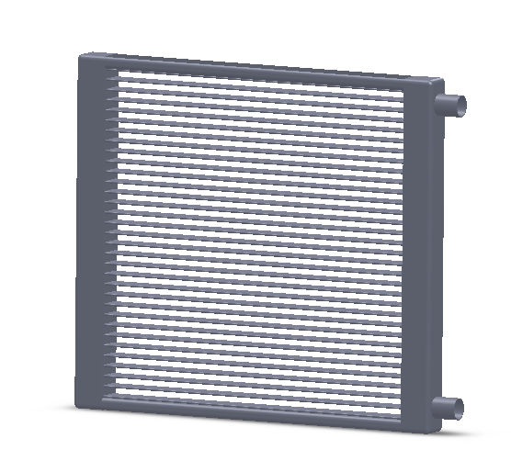

**Figure C1**: SolidWorks model, design number 1.

Fig. C2 is another screen shot from SolidWorks showing the second design iteration of the radiator. The changes from the first design iteration to this one are significant. The design changed from a dual pass system to a single pass and the geometry of the core changed. The core remained 1-inch thick because of standard core sizing, but the dimensions of the core changed because of packaging. This radiator is 16.5-inches tall and 11.5-inches wide with 1-inch tanks on either side. For mounting, there are two pins welded onto the top and bottom tanks in one corner.

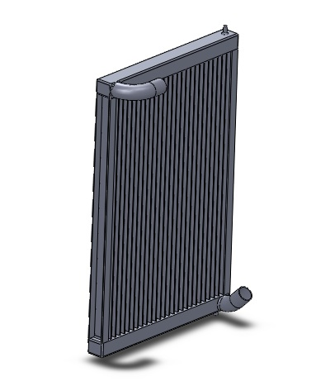

**Figure C2**: SolidWorks model, design number 2

Fig. C3 is a SolidWorks screen shot of the final design iteration of the radiator. There are very few changes from the previous design iteration to this one. The geometry remained the same, but the mounting changed. The top mount remains a pin connection, while the bottom was changed to a plate for rigidity reasons. Without the bottom mount being a plate, the radiator had the potential to pivot about the mounting pins. This would cause the airflow to no longer be perpendicular to the radiator, causing a drop in efficiency. A radiator cap was also added to this model.

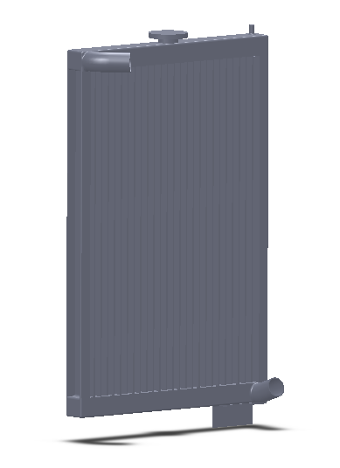

**Figure C3**: SolidWorks model, design number 3. Final Design.

# Appendix D: Current Parts

The radiator came back from manufacturing before Spring Break, and is shown in Fig. D1. It differs a little from the final solid model shown in Fig. C3 above. The tanks ended up less than the 1-inch specified, and the C-channel was turned the wrong way. These discrepancies were deemed inconsequential.

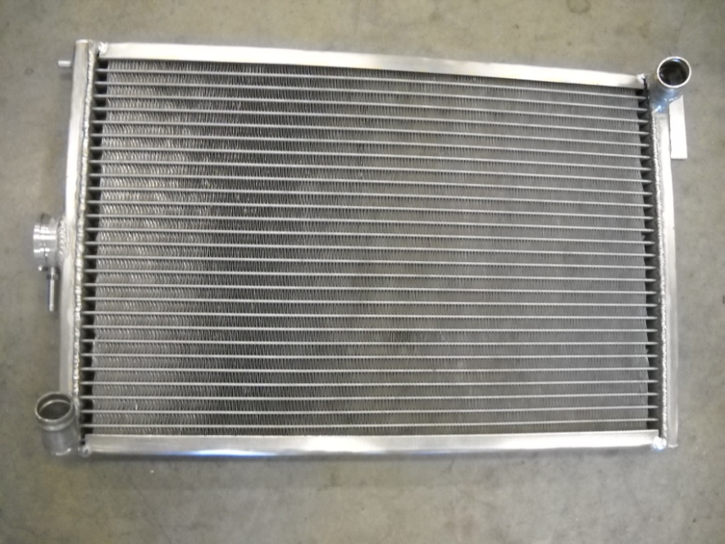

**Figure D1:** First prototype radiator, in shop.

The fan was purchased based on the decisions in Table 2 and the sizing calculations in Appendix B. The initial fan chosen was a Spal 12-inch medium-profile fan with a rated flow of 1230 cfm, and is shown in Fig. D2.

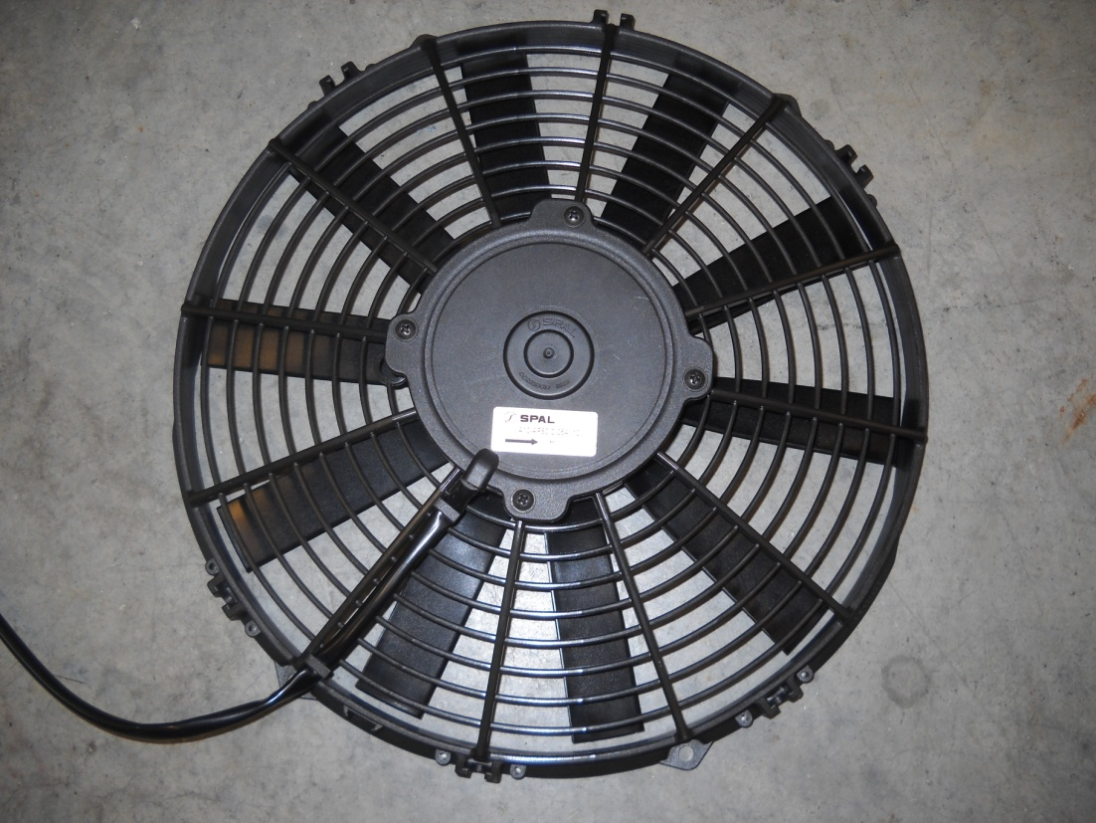

**Figure D2:** First fan solution, Spal 10" Straight Blade Medium Profile Fan, PN:  30101504

After receiving the 12-inch fan and doing rough mockup work, we came to the realization that the fan would not fit in our package. The fan fits in the solid model in Soliworks, but we did not take into account the variation and tolerance of the bodywork. Going back to our supplier, we found a 10-inch fan with 1100 cfm output. This was less than the output of the 12-inch fan above, but was still within the range indicated by the analysis in Appendix B. The final solution is shown in Fig. D3 below.



**Figure D2**: Spal 10" Paddle Blade High Performance Fan, PN:  30102057

# Appendix E: Experiments

**A Comparison of Heat Transfer Performance between Two FormulaSAE Radiators**

3/14/2011

## Introduction

In 2010, Portland State’s Viking Motorsports Formula Society of Automotive Engineers (FSAE) team was unable to complete the endurance event due to a hot start issue with the engine. The engine's hot start issue was an engine and ECU problem that would not allow the car to start when the engine was at elevated temperatures. Since the cooling system was insufficient at the time, the engine would reach an elevated temperature easily. Once the engine was shut off at this elevated temperature, it would not restart until cooled. A new larger radiator was purchased for the 2011 season to increase the [effectiveness](http://thesaurus.com/browse/effectiveness) of the cooling system. In this experiment we will be comparing the heat transfer performance of the 2010 and 2011 radiators.

## Theory

With a radiator, air is used to reduce the temperature of coolant flowing through channels inside the radiator itself. Water (the coolant in this case) flows into the top tank, where it then flows downward through small flow channels, into the bottom tank. From the bottom tank the coolant flows back into the engine at a lower temperature than that of the entrance. As can be seen in Figure E1, the fins and flow channels are very small; therefore calculating an effective area is very difficult.

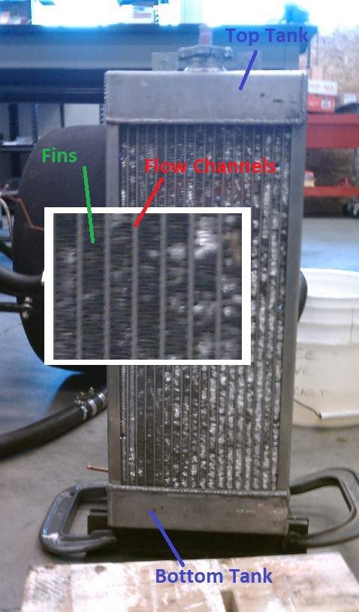

**Figure E1:** The 2010 FSAE radiator is shown. The inlet (top tank) along with the outlet (bottom tank), are on the rear side and cannot be seen in the figure. The inlet and outlet are both one inch in diameter.

The temperature change of both the air and water can be used to calculate an energy balance. Assuming all of the temperature change of the coolant goes into the air passing through the core, the following equation can be used:

|  |  |  |
| --- | --- | --- |
|  | $$Q=mͦC_{p,coolant}*∆T_{coolant}=mͦC_{p,air}*∆T_{air}$$ | (1) |

where *Cp,coolant* is the specific heat capacity of the coolant used (water in this case), *Cp,air* is the specific heat capacity of air and *m*ͦ is the mass flow rate for each respective fluid, while *Q* is the heat transfer taking place.  
Using this relationship, heat transfer from the coolant to air can be calculated. If the relationship from Equation 1 is not equal, then heat transfer is taking place elsewhere.

The following relationship is used to calculate a term for convective heat transfer coupled with effective area:

|  |  |  |
| --- | --- | --- |
|  | $$Q=h*A*∆T_{air}$$ | (2) |
|  |  |  |

where *h* is the convective heat transfer coefficient and *A* is the effective area of the radiator. For this calculation, *h* and *A* will be separated but coupled. The effective area for the radiator being tested is unknown, but the actual area of the fins is known. Therefore, with Equation 2 and the known actual area, a corrected *h* value can be determined.

With the information gained from Equations 1 and 2 it is possible to compare performance of the 2010 FSAE radiator with the new 2011 radiator. This experiment can be run with the 2011 radiator, and a corrected *h* value can be calculated.

## Methods

As can be seen in Figure E2, the 2010 radiator was first spaced off the Viking Motorsports FSAE car by the use of longer heater hoses and a short section of metal pipe. A duct was constructed with the same cross sectional area as the radiator out of cardboard and packing tape. The radiator was taped on one end and a 12 in. pull fan was sealed on the other, configured to pull air through the duct. In order to determine the mass flow rate of the air through the radiator, a slot was cut and an anemometer was inserted in to the duct. This allowed us to measure the approximate velocity of the air going through the known cross sectional area of the duct when fan was turned on. T-type thermocouples were placed on the inlet and outlet of both the water and air side of the radiator as shown in Figure E2. The thermocouples were attached to a Data Acquisition unit (DAQ) which was connected to a computer running a Labview VI programmed to record temperature using thermocouples with cold-junction compensation. The engine was started and run at idle (2000 rpm) until the temperature increased enough to allow coolant to flow at a known rate (published values) through the radiator. The VI was started; once we collected 30 to 40 seconds of steady data the VI was stopped. The same process was used for the 2011 radiator.

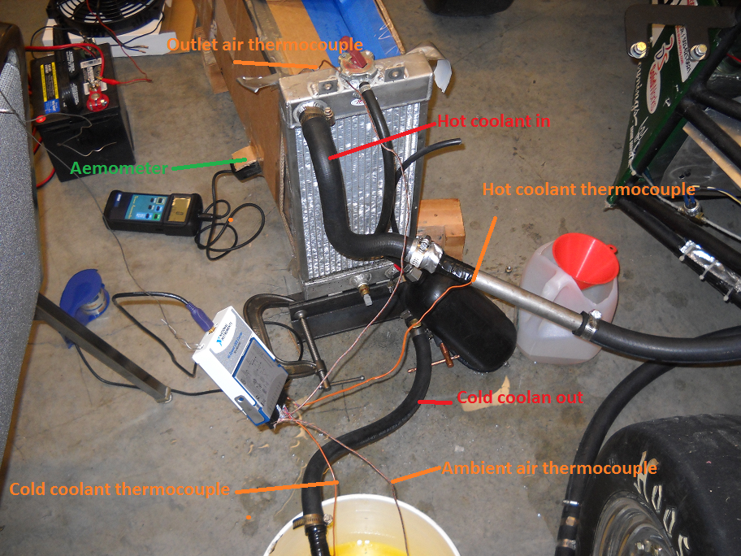

**Figure E2:** A frontal view of the experimental setup. The radiator shown is the smaller of the two being tested (2010).

## Results

After recording all the data, we entered it into Excel and processed it. The processed data is shown in Table E1 below.

**Table E1**: Summary of processed data.

|  |  |  |  |  |  |  |  |
| --- | --- | --- | --- | --- | --- | --- | --- |
| **2010 Radiator** | | | | **2011 Radiator** | | | |
| **Water side** | | **Air side** | | **Water side** | | **Air side** | |
| **Δt (°F)** | 118.4 | **Δt (°F)** | 48.0 | **Δt (°F)** | 123.0 | **Δt (°F)** | 17.5 |
| **ṁ (lbm/min)** | 22.0 | **ṁ (lbm/min)** | 29.7 | **ṁ (lbm/min)** | 22.0 | **ṁ (lbm/min)** | 62.6 |
| **Q (Btu/min)** | 2604 | **h (Btu/minft2°F)** | 1.550 | **Q (Btu/min)** | 2706 | **h (Btu/minft2°F)** | 2.580 |

The data was separated out between our two radiators, old (2010) and new (2011). For each radiator, the air side and water side were separated. The temperature differences (Δt), and mass flow rates (ṁ) were measured, while the heat rejection (Q) and convection coefficient (h) were calculated from our measurements.

## Discussion

The calculated convection coefficients for the two radiators were quite different, by a factor of about 1.6. The values should be approximately the same since both radiators utilized the same core material. However, the 2010 radiator is significantly beat up, with much of the fin area blocked, which could account for the difference. The heat rejection was approximately the same, within 3.6% of each other. This was expected since the engine was operated under approximately the same conditions, and should have the same heat rejection. The water side mass flow rates seem reasonable since the engine was operated at the same rpm for both tests. The water side temperature drop for both experiments was about 6 times larger than the expected rule of thumb of about 10-20°F temperature drop (Bohacz 2007). This could be explained by the small flow rate during testing. Under average track operation, the water pump should be pumping about 4-5 times the mass flow rate at idle. Correspondingly, the air side temperature drop was much less than the expected 60°F temperature increase. The air side mass flow rate increase of about double also makes sense since the radiator has about twice the area (1.8 times) and provides much less restriction.

## Conclusion

The two radiators tested have a significant difference in *h* values, and thereby cooling efficiency. The smaller radiator had an *h* value calculated to be 1.55 Btu/min ft2°F, while the larger radiator's h value was calculated to be 2.58 Btu/min ft2°F. The ratio of convective coefficients is 1.6. Looking at the two radiators, it is obvious that the convective coefficient of the larger radiator will be larger as well because of the fin condition. The smaller radiator's fins are no longer uniform and a lot of the fin area is ineffective due to damage. The larger radiator is pristine with no damage to the fins. This leads to much better air flow through the core of the radiator and, of course, better heat transfer. It was known before the experiment began that the larger radiator would be more effective for heat transfer, but *how much* better was unknown. This experiment led to the quantification desired; but not the expected values.

## Error Analysis

Sources of error in this experiment include, but are not limited to; unintentional secondary thermocouple junctions, non-uniformity of outgoing air temperatures, ducting leakage, defective thermostat and unaccounted heat transfer.

Once the experimental setup was dismantled, it was apparent that unintentional secondary thermocouple junctions were a possible source of error in the experiment. The thermocouple wires (for one of the thermocouples) were observed to be partially stripped and the metal wire exposed. This partially exposed wire could have made contact with the metal of the radiator or the other wire of the thermocouple. This sort of connection has the potential to create a second thermocouple on the same wire, causing an additive voltage to be read via the DAQ. An additive voltage such as this could cause the temperature readings to be off a few degrees. To counter this, the system of thermocouples was calibrated before the experiment began.

During the experiment, it was observed that the temperature gradient from top to bottom of the two radiators was drastically different. Using touch, it appeared that the smaller radiator had a fairly even temperature distribution from top tank to bottom tank. The change in temperature from inlet to outlet was measured to be 65°C, and felt like a linear distribution to the touch (though this was not measured). When the larger radiator was tested, the same procedure using touch to estimate a distribution was used. With the larger radiator, the change in temperature from inlet to outlet was measured to be 68°C. This change is only 3 degrees larger than the smaller radiator, but the change seemed to be happening largely in the first half of the radiator. When feeling the core of the radiator, the distribution of temperature was much different than the smaller radiator. The upper portion near the inlet was hot (measured to be 103°C), while the lower portion was cold to the touch. This was not the case with the smaller radiator. This sort of difference in temperature distribution could have caused errors for the measurement of outlet air temperature of the larger radiator. The thermocouple for measuring the outlet air temp was placed at approximately the middle of the duct for both tests. This would cause a smaller delta to be measured for the larger radiator, since most of the temperature change appeared to be happening in the upper portion of the radiator. This is where the air would be exiting at a higher temperature as well. A way to correct this error would be to place thermocouples at different heights within the duct, to gain a more average temperature reading of the outlet air.

The duct used in this experiment was manufactured from cardboard and held together with packing tape. While the experiment was running, the duct was tested for leakage at the seams. Any large leakages found were patched and the experiment continued. Any leaks not found could impact the results of the experiment by letting excess air into the duct system. Any leaks of this sort would cause a drop in ΔP across the radiator, leading to less air being pulled through the core. Less air being pulled through the core leads to less heat transfer and less temperature change measured. Also, the air velocity in the duct was measured using an anemometer with an accuracy of 2%. Any air leaking into the duct system would skew the reading from the anemometer and thereby skew the results of the experiment. A solution to this problem is to use different duct materials and seal the ducting with more effective methods (caulking).

For a heat and coolant pumping source, the Viking Motorsports FSAE car was used. While running the experiment, it was observed that the thermostat on the engine would randomly not open at the appropriate engine temperature (indicated from the engine temperature sensor, via the car's display). When the thermostat is not open, coolant does not flow through the radiator. Therefore, if the thermostat closed while the experiment was running, temperature readings would drop or be sporadic. This sort of even would lead to jumps in data. To solve this, runs with a large number of jumps from the opening and closing of the thermostat were redone. For runs used, temperatures were averaged over long "steady" measurements.

Heat flows from hot objects to cold objects. With this experiment, the radiators being tested are basically hot pieces of metal and heat transfer to the air flowing across them is being quantified. The issue with this is measuring all the heat transfer that is taking place. Using an energy balance, the heat lost from the coolant should be equal to the heat gained by the air, with some loss to noise and other sinks. This is not the case with calculation, because not all the heat transfer was taking place to the air in the duct only. Portions of the heat loss were from the coolant lines and edges of the radiators. The ducting was attached to the core of the radiators, since this is where the air flow was happening. The sides of the radiators and hoses to and from the engine were still at high temperature, making heat transfer to the surrounding air and objects in the room possible. To remedy this, lines to and from the engine should be insulated and the ducting expanded to enclose the entire radiator. This would reduce heat transfer from the lines themselves, and include the heat transferred to the air from the sides of the radiator.

Note: After presenting this report, we were shown many errors by our teacher and advisor. The biggest problem we had was the assumption that the coolant flowrate matched published values, which it turns out it did not. This lead to unequal values of heat rejection on each side (air and water) of the heat exchanger (which is impossible). We later determined that the thermostat does not fully open under some of our testing conditions, and also that the flowmeter we used was causing a significant restriction in our system (it is designed for oil at higher pressures). So while the experiment was valuable as a learning experience, the data was almost all useless.

## References

Bohacz, Ray T.. Engine cooling systems: cooling system theory, design and performance for drag racing, road racing, circle track, street rods, musclecars, imports, OEM cars, trucks, RVs and tow vehicles.. New York, N.Y.: HPBooks, 2007. Print.

"Engineering ToolBox ." Engineering ToolBox . N.p., n.d. Web. 13 Mar. 2011. <http://www.engineeringtoolbox.com>

## Appendix EA: Raw Data

Data sets were collected for the FSAE 2010 radiator and 2011 radiator both with 12 in. fans. For each data set, four temperature measurements were performed: coolant temperature at the inlet and out let and ambient air temperature (inlet) and air temperature exiting the cooling system (outlet). For either case, in the analysis, these temperatures were averaged over the steadiest intervals of time and used to compute the heat transfer of the coolant and air. The air flow rate for the 2010 and 2011 data sets are measured to be 475 ft/min and 600 ft/min, respectively.

**Table EA1**: Snapshot of raw data collected for the 2010 radiator

|  |  |  |  |  |
| --- | --- | --- | --- | --- |
| **Time (s)** | **Coolant Inlet Temp. (°C)** | **Coolant Outlet Temp. (°C)** | **Air Inlet Temp. (°C)** | **Air Outlet Temp. (°C)** |
| 100.29 | 98.4 | 33.7 | 23.5 | 52.6 |
| 100.64 | 98.3 | 33.6 | 23.6 | 52.6 |
| 101.00 | 98.3 | 33.7 | 23.5 | 52.7 |
| 101.35 | 98.3 | 33.8 | 23.5 | 52.7 |
| 101.71 | 98.3 | 33.8 | 23.5 | 52.7 |
| 102.06 | 98.4 | 34.0 | 23.5 | 52.7 |
| 102.42 | 98.3 | 33.8 | 23.5 | 52.8 |
| 102.77 | 98.3 | 33.6 | 23.5 | 52.8 |
| 103.13 | 98.3 | 33.6 | 23.5 | 52.8 |
| 103.48 | 98.4 | 33.6 | 23.5 | 52.8 |

**Figure EA1**: Temperature measurements on the FSAE 2010 radiator with a 12 in. fan. Temperature data was averaged over approximately 100 to 140 s.

**Figure EA2**: Temperature measurements on the FSAE 2011 radiator with a 12 in. fan. Temperature data was averaged over approximately 75 to 110 s.

## Appendix EB: Sample calculations

Calculating the correlated *h* for the 2011 radiator

Averaging the temperature data over the stable time interval 75 to 110 s, the average coolant inlet temperature, and outlet temperature are found to be 103.97 °C = 219.14°F and 35.62°C = 96.12°F, respectively. Subtracting yields a $∆T_{coolant}=123.02°F.$ Similarly, the average inlet air temperature, and outlet temperature are found to be 23.24°C = 73.83°F and 32.95°C = 91.32°F, respectively, yielding a $∆T_{air}=14.49°F.$

Using the published value of the CBR600F4i motorcycle engine used in the experiment for the coolant flow rate of 2.75gpm, the mass flow rate of the coolant is defined, $\dot{m}=22 lb/min$. The air flow rate in the duct is measured to be 600ft/min. Using the frontal area of the 2011 radiator, 1.29 ft2, the mass flow rate of air is found to be 62.58 lb/min.

From these values, the heat transfer rate for coolant and air, $Q_{coolant }$, and $Q_{air}$ respectively can be found using the following relations,

$Q_{coolant }={\left(\dot{m}C_{p}∆T\right)}_{coolant}$ (B1)

and,

$Q_{air}={\left(\dot{m}C_{p}∆T\right)}_{air}$ (B2)

where, $C_{p}$ is the specific heat capacity, ${C_{p}}_{coolant}=1 Btu/lbF$, and ${C_{p}}_{air}=0.241 Btu/lbF$ (Engineering Toolbox 2011).

From this results $Q_{coolant }=2706 Btu/min$, and $Q_{air }=263.72 Btu/min$.

Since,

$Q_{air}={\left(hA∆T\right)}_{air}$, (B3)

where *h* is the convective heat transfer coefficient, and *A* is the effective area of the radiator, known to be 60 ft2.

Thus, the correlated *h* is determined to be $h=2.58 Btu/{\min{}ft}^{2}$ for the 2011 radiator.

## Appendix EC: Supplemental pictures of experimental apparatus.

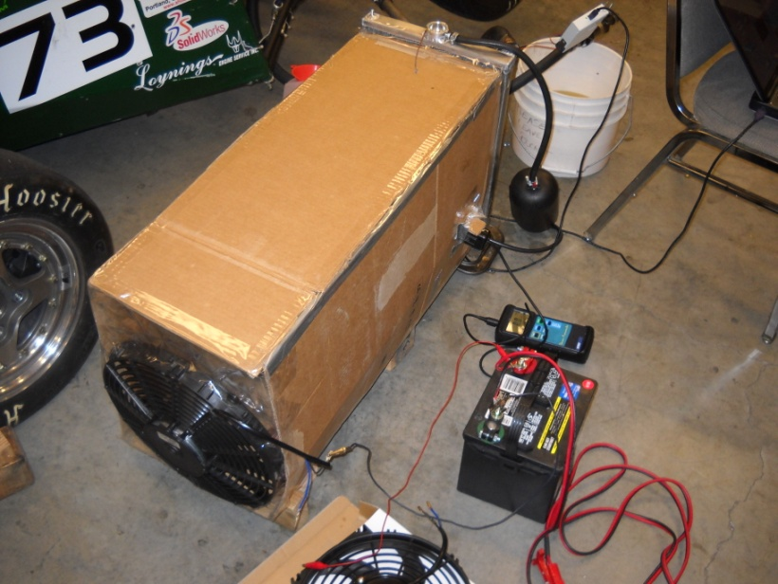

**Figure EC1**: Rear view of experimental setup, showing the puller fan and ducting.

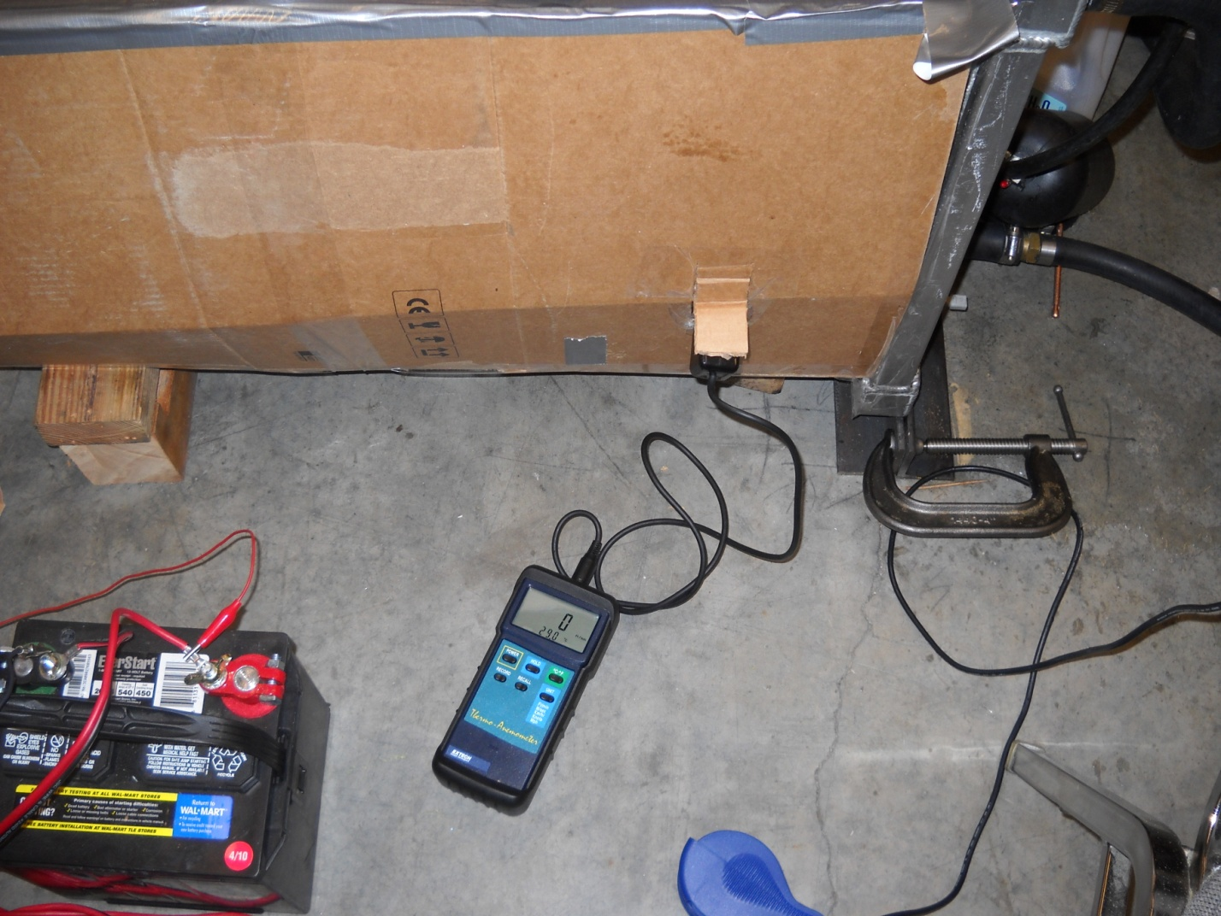

**Figure EC2**: Exotech Instruments Vane Thermo-Anemometer used to measure air speed in the duct.

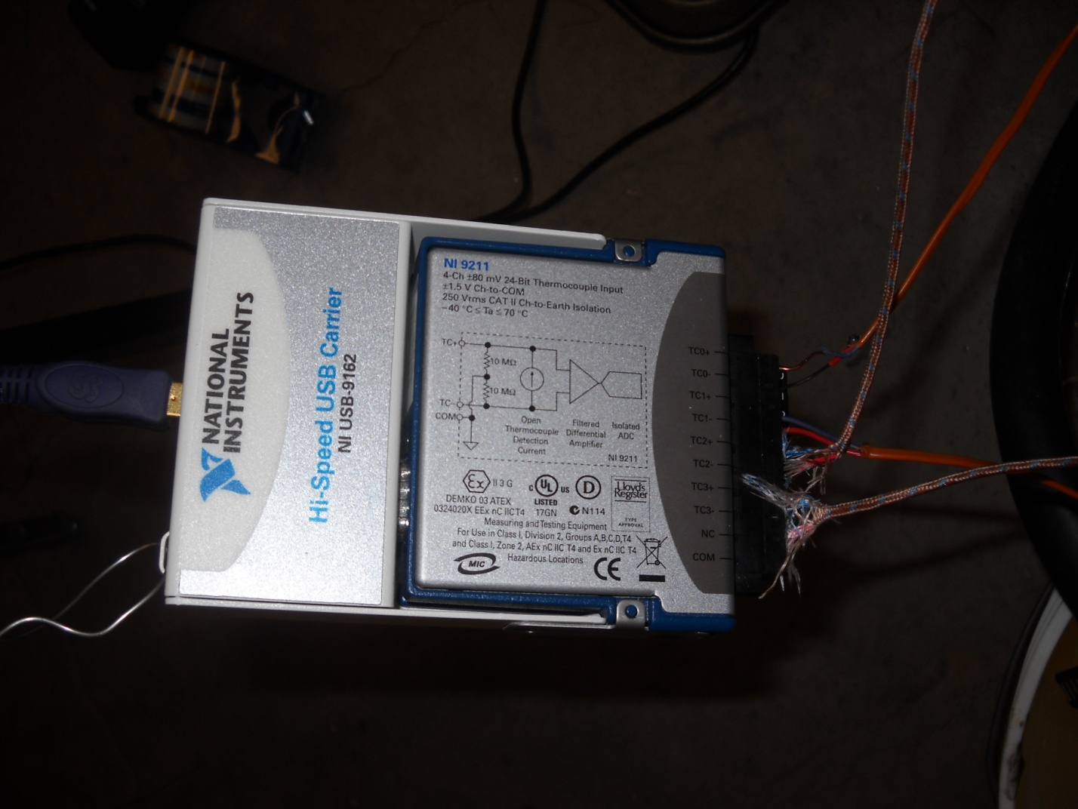

**Figure EC3**: DAQ used to collect thermocouple data. This is a National Instruments (NI) 9211 Thermocouple DAQ with a NI USB-9162 serial to USB carrier. Also shows the connection of the four thermocouples on the right.

# Appendix F: Bill of Materials



# Appendix G: Project Plan

**Table G1**: Project plan.

|  |  |  |  |  |
| --- | --- | --- | --- | --- |
| Project Milestones | | | | |
| **Task** | **Start Date** | **Finish Date** | **Due Date** | **Status** |
| Initial Brainstorming | June 22 | Sep 12 |  | Completed |
| Research Possible Solutions | June 22 | Sep 12 |  | Completed |
| Initial Design | Sep 5 | Nov 18 |  | Completed |
| PDS Report | Jan 3 | Jan 31 | Feb 9 | Completed |
| PDS Report Presentation | Jan 24 | Jan 31 | Jan 31 | Completed |
| Design Evaluation | Feb 7 | Feb 25 |  | Completed |
| External Search Presentation | Feb 7 | Feb 14 | Feb 14 | Completed |
| Design | Nov 18 | Jan 17 |  | Completed |
| Progress Report Presentation | Feb 21 | Feb 28 | Feb 28 | Completed |
| Progress Report | Feb 21 | March 7 | March 7 | Completed |
| Prototype & Test | Jan 17 | June 13 |  | Completed |
| Redesign | Jan 24 | April 29 |  | In progress |
| Manufacture | Feb 7 | Mar 22 | March 22 | Completed |
| Assemble/Install/Test | March 22 | June 13 |  | In progress |
| Final Project Presentation | May 22 | June 1 |  | Completed |
| Final Paper | May 22 | June 6 | June 6 | Completed |

The corresponding Gantt chart is shown in Fig. G1.

 **Figure G1:** Gantt chart displaying the project plan.

# Appendix H: PDS Summary

In the PDS document, customers, design requirements, and potential risks, involving the progress and design of the product, were specified.

Customers for the project were identified as follows:

Internal Customers

* Viking Motorsports
* Portland State University Capstone
* Dr. Etesami (Mechanical Engineering Capstone coordinator)
* Dr. Meekisho (Project Advisor) for internal customers.

External Customers

* FSAE regulations
* Judges of the Business Presentation
* Weekend Auto Crossers (End Users/Consumers)
* Sponsors of Viking Motorsports
* Mac's Radiator

The most important requirement for the product is reliability. It is crucial that the car with the new cooling system consistently maintains a top tank temperature of under 210°F in order to prevent difficulties encountered in the 2010 car; such as the loss in performance and difficulty starting the car due to excess temperatures, or overheating after idling for an extended time. Some other important design criterions include a heat rejection performance of 30hp, 1 year life in service, not to raise the center of gravity of the overall car by more than 0.5 inches, while meeting FASE regulations and keeping to a target budget of under $200. For the complete product design specification, see below.

|  |  |  |
| --- | --- | --- |
| **Product Design Specifications** | | |
| **Criteria** | **Priority** | **Page** |
| Performance | High | 7 |
| Quality and Reliability | High | 8  8 |
| Life in service | High | 8 |
| Size and Shape | High | 8 |
| Timelines | High | 8 |
| Applicable codes and standards | High | 9 |
| Cost of production per part (material and labor) | High | 9 |
| Materials | Medium | 9 |
| Maintenance | Medium | 9 |
| Safety | Medium | 9 |
| Testing | Medium | 10 |
| Company constraints and procedures | Medium | 10 |
| Documentation | Medium | 10 |
| Weight | Medium | 10 |
| Manufacturing facilities | Medium | 11 |
| Quantity | Low | 11 |
| Installation | Low | 11 |
| Aesthetics | Low | 11 |
| Shipping | N/A | 12 |
| Packaging | N/A | 12 |
| Legal (Related patents) | N/A | 12 |
| Disposal | N/A | 12 |
| Ergonomics | N/A | 12 |
| Environment | N/A | 12 |

|  |  |  |  |  |  |
| --- | --- | --- | --- | --- | --- |
| Performance | | | | | |
| **Customer** | **Requirements** | **Metrics** | **Targets** | **Basis** | **Verification** |
| Viking Motorsports | Adequate Heat Transfer | Horse Power | 30hp | Calculation | Testing |

|  |  |  |  |  |  |
| --- | --- | --- | --- | --- | --- |
| Quality and Reliability | | | | | |
| **Customer** | **Requirements** | **Metrics** | **Targets** | **Basis** | **Verification** |
| Viking Motorsports | Heat Transfer is Steady | BTU/min | ~1200BTU/min | Calculation | Testing |
| Viking Motorsports | Can Handle Peak Loading Condition | Top Tank Temperature | 210°F | Calculation | Testing |

|  |  |  |  |  |  |
| --- | --- | --- | --- | --- | --- |
| Life in service | | | | | |
| **Customer** | **Requirements** | **Metrics** | **Targets** | **Basis** | **Verification** |
| Viking Motorsports | Operation For Foreseeable Life of the FSAE car | Expected Life | 1 Year | Customer Feedback | Time |

|  |  |  |  |  |  |
| --- | --- | --- | --- | --- | --- |
| Size and Shape | | | | | |
| **Customer** | **Requirements** | **Metrics** | **Targets** | **Basis** | **Verification** |
| Viking Motorsports | Fits Within Size Required By FSAE Rules | Outside Edge of Tires | Inside the Tires | FSAE Rules | Cad Model |
| Viking Motorsports | Does Not Negatively Impact Center Of Gravity of FSAE car | CG Height in inches | No more than +0.5inch | Customer Feedback | Cad Model |

|  |  |  |  |  |  |
| --- | --- | --- | --- | --- | --- |
| Timelines | | | | | |
| **Customer** | **Requirements** | **Metrics** | **Targets** | **Basis** | **Verification** |
| ME 492 | Progress Report | Reports Submitted | 1 report | Course Requirements | Grade |
| ME 493 | Design Report | Reports Submitted | 1 report | Course Requirements | Grade |
| Viking Motorsports | Completed Prototype | Fully Assembled Cooling System | 1 Radiator w/ connections and Fan | Customer Feedback and Course Requirements | Customer Feedback |

|  |  |  |  |  |  |
| --- | --- | --- | --- | --- | --- |
| Applicable codes and standards | | | | | |
| **Customer** | **Requirements** | **Metrics** | **Targets** | **Basis** | **Verification** |
| Viking Motorsports/FSAE Rules and Judges | Meets FSAE Rules | Passes/Fails FSAE Rules | Passes Rules | Safety | Rule Book |

|  |  |  |  |  |  |
| --- | --- | --- | --- | --- | --- |
| Cost of production per part (material and labor) | | | | | |
| **Customer** | **Requirements** | **Metrics** | **Targets** | **Basis** | **Verification** |
| Viking Motorsports | Does Not Cost Too Much | Dollars | <200 | Budget | Cost Quote |

|  |  |  |  |  |  |
| --- | --- | --- | --- | --- | --- |
| Materials | | | | | |
| **Customer** | **Requirements** | **Metrics** | **Targets** | **Basis** | **Verification** |
| Viking Motorsports | Not Too Heavy | lbs | <10 | Weight Transfer and Overall Weight | Cad Model |
| Viking Motorsports | Can Withstand Temperatures | °F | >210 | Anti-Failure | Material Properties |

|  |  |  |  |  |  |
| --- | --- | --- | --- | --- | --- |
| Maintenance | | | | | |
| **Customer** | **Requirements** | **Metrics** | **Targets** | **Basis** | **Verification** |
| Viking Motorsports | Easy to Maintain | Minutes of Cooling Service | 10 minutes | Should Be Serviceable | Testing |
| Viking Motorsports | Easy to Maintain | Minutes Needed to Bleed Air | 4 minutes | Should be Serviceable | Testing |

|  |  |  |  |  |  |
| --- | --- | --- | --- | --- | --- |
| Safety | | | | | |
| **Customer** | **Requirements** | **Metrics** | **Targets** | **Basis** | **Verification** |
| Viking Motorsports | Meets FSAE Rules | Passes/Fails FSAE Rules | Passes Rules | Safety | Rule Book |
| FSAE Rules | If failure occurs, driver is shielded from hot liquids | Passes/Fails FSAE Rules | Passes Rules | Safety | Rule Book |

|  |  |  |  |  |  |
| --- | --- | --- | --- | --- | --- |
| Testing | | | | | |
| **Customer** | **Requirements** | **Metrics** | **Targets** | **Basis** | **Verification** |
| Viking Motorsports | Must Pass all Necessary Tests | All Tests that can Be preformed | Passes All | Group Decision | Analysis of Data |
| Project Team | Must Pass all Necessary Tests | All Tests that can Be preformed | Passes All | Group Decision | Analysis of Data |

|  |  |  |  |  |  |
| --- | --- | --- | --- | --- | --- |
| Company constraints and procedures | | | | | |
| **Customer** | **Requirements** | **Metrics** | **Targets** | **Basis** | **Verification** |
| Viking Motorsports | Weekly Updates | Percentage of Weekly Updates Met | 100% | Customer Feedback | Customer Feedback |
| Dr. Etesami | Evidence of Weekly Meetings | Percentage of Weekly Meetings Met | 100% | Course Requirements | Grade |

|  |  |  |  |  |  |
| --- | --- | --- | --- | --- | --- |
| Documentation | | | | | |
| **Customer** | **Requirements** | **Metrics** | **Targets** | **Basis** | **Verification** |
| Viking Motorsports | All Cad Drawings and Models | Undocumented Components | 0 | For Future Teams and Design Portion of FSAE Competition | Customer Feedback |
| Dr. Etesami | All Proper Documentation | Missing/ Incomplete documents | 0 | Course Requirements | Grade |

|  |  |  |  |  |  |
| --- | --- | --- | --- | --- | --- |
| Weight | | | | | |
| **Customer** | **Requirements** | **Metrics** | **Targets** | **Basis** | **Verification** |
| Viking Motorsports | Not Too Heavy | lbs | <10lbs | Weight Transfer and Overall Weight | Cad Model |

|  |  |  |  |  |  |
| --- | --- | --- | --- | --- | --- |
| Manufacturing facilities | | | | | |
| **Customer** | **Requirements** | **Metrics** | **Targets** | **Basis** | **Verification** |
| Project Team | Some fabrication in house | Cost and Ease of Manufacture | <$50 and <15Hours | Group Decision | Available Machinery at PSU |
| Mac's Radiator | Manufacturable | Lead time and Cost to Viking Motorsports | <3 weeks  <$200 | Customer Feedback | Customer Feedback |

|  |  |  |  |  |  |
| --- | --- | --- | --- | --- | --- |
| Quantity | | | | | |
| **Customer** | **Requirements** | **Metrics** | **Targets** | **Basis** | **Verification** |
| Viking Motorsports | Fits FSAE 2011 Chassis Design | Fit or No Fit | Fits | Cooling System Must be On the Car | Cad Model |

|  |  |  |  |  |  |
| --- | --- | --- | --- | --- | --- |
| Installation | | | | | |
| **Customer** | **Requirements** | **Metrics** | **Targets** | **Basis** | **Verification** |
| Viking Motorsports | Not Very Difficult to Install/Remove | Hours to Install/remove | 0.75H | In case the Cooling System needs Maintenance On Track | Testing |

|  |  |  |  |  |  |
| --- | --- | --- | --- | --- | --- |
| Aesthetics | | | | | |
| **Customer** | **Requirements** | **Metrics** | **Targets** | **Basis** | **Verification** |
| Judges of Business Presentation | Marketable | Percentage of Judges That Find the Design Marketable | 100% | Competition Points | Feedback From Judges |

|  |  |
| --- | --- |
| N/A | |
| **Criteria** | **Reason** |
| Shipping | Radiator will not be shipped. |
| Packaging | Packaging not an issue. |
| Legal (Related patents) | No unique legal constraints. |
| Disposal | Will not be disassembled. |
| Ergonomics | Does not affect driver position. |
| Environment | Coolant used is water. |

# Appendix I: Part drawing

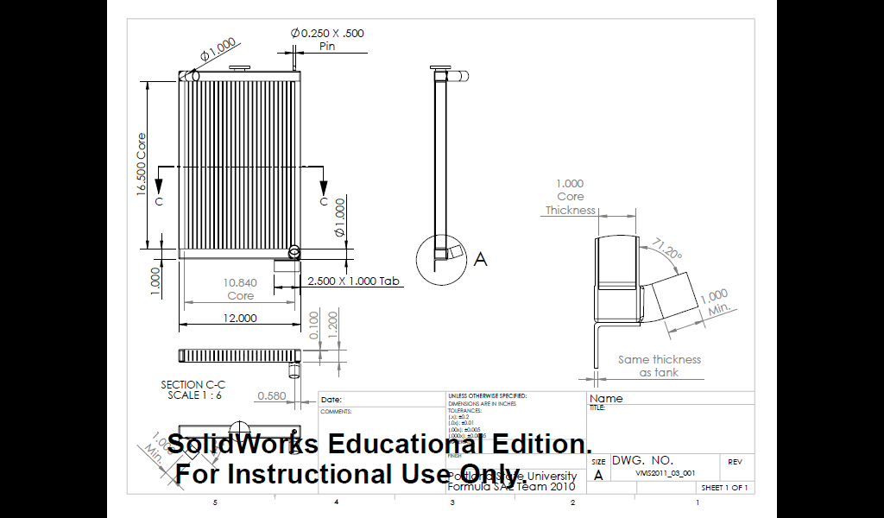

**Figure I1**: Radiator drawing