ME 493 Final Report – Year 2011
Book Corner Rounder
June 6th, 2011
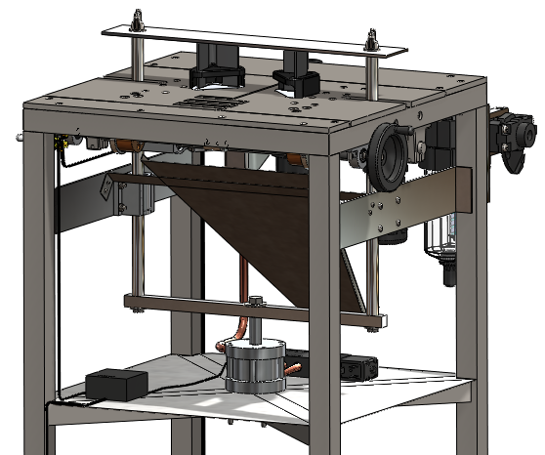
Group Members
Joshua Schmidt
Andrew Dillon
Melissa Anders
Matt Kirtley
Faculty Advisor
Dr. Huafen Hu

Executive Summary

The publishing industry has a need for a device that can quickly and accurately round two corners of various printed materials. In the industry there are devices that can round a single corner at a time, but no devices sold at the same price point that can round two corners at a time. A device that rounds two corners at a time will increase production and lower costs. The purpose of this project is to design such a device.
The design team examined the demands of the customers and identified that capacity, accuracy, and adjustability would bring the greatest value to the customer. Market research further narrowed the scope of the design to notebooks ranging in size from 5 to 7 inches wide with a corner radius of ¼ of an inch. The design that best meets these requirements has a pneumatic actuator that compresses two dies, rounding the two corners of the notebooks. Two plates hold the dies and can be adjusted over 2.5 inches to accommodate different sized notebooks and production inaccuracies. The operator adjusts the dies with a lead screw and actuates the cut with a foot switch. The foot switch signals an Arduino Controller to alternate solenoid ports. The solenoid directs the air flow to a pancake actuator. A successful prototype has been constructed that rounds a single corner of a notebook using the pneumatic actuator, a switch, and Lassco cutting die.

Table of Contents

Executive Summary 1
Table of Contents 2
Table of Figures 4
Introduction 5
Mission Statement 6
Product Design Specifications 6
Top Level Design Concepts/Decisions 6
Final Design 8
Overview 8
Actuator and Pull-Bar 9
Power and Control 10
Top Plate 10
Frame 11
Evaluation and Verification 12
Conclusion 13
Appendix A: Detailed Description of Design, Manufacturing, and Assembly A-1
Overview A-1
Actuator and Pull-Bar Assembly A-1
Power and Control A-1
Top Plate Assembly A-3
Frame A-4
Appendix B: Analysis B-1
Adjustable plate load shaft deflection analysis. B-1
Load Shaft Fatigue Analysis B-4
Pull Bar Deflection Analysis B-7
Pull Bar Buckling Analysis B-10
Pull Bar Fatigue Analysis B-13
Pressure Drop in Piping Analysis B-16
Frame Deflection Analysis B-19
Top Plate Die Support Analysis B-21
Pull Bar Wing Nut Thread Analysis B-23
Actuator Screw Failure Analysis B-25
Appendix C: Bill of Materials C-1
Bill of Materials for Full Design C-1
Bill of Material for the Prototype C-6
Appendix D: Decisions Matrices D-1
Appendix E: Product Design Specifications E-1
Appendix F: Reference Charts F-1
Appendix G: Part List and Machine Drawings G-1
Parts List G-1
Technical Drawings G-9
Appendix H: Operation Manual H-1
Appendix I: Maintenance Manual I-1
Appendix J: Project Plan J-1
Appendix K: References K-1

Table of Figures
Figure 1 Home Made Double Corner Rounder 5
Figure 2 Example of Notebooks with Rounded Corners 5
Figure 3 Top Plate Adjustability Example 8
Figure 4 Solid Works Model of Full Assembly 8
Figure 5 Solid Works Model of Pull Bar Assembly with the Top Plate and Dies 9
Figure 6 1.5" Bore Pneumatic Linear Actuator 9
Figure 7 Solid Works Model of Top Plate Assembly 10
Figure 8 Top Plate Machining for Lassco Die 11
Figure 9 Solid Works Model of Scrap Collection System 11
8
10
13
14
Figure A-1 Actuator and Pull-Bar Assembly........................………………………………………………………...…...A-1
Figure A-2 Arduino Circuit Diagram for Controlling a Solenoid Valve…………………………………………A-1
Figure A-3 Sample Code for Controlling a Solenoid Valve with an Arduino…………………………………A-3
Figure A-4 Solid Works Model of the Top Plate Assembly…………………………………………………………..A-4
Figure A-5 Solid Works Model of the Top Plate Assembly, Bottom View……………………………………..A-4
Figure A-6 Solid Works Model of the Frame………………………………………………………………………………A-4
Figure B-1 Adjustable Cutting Plate………………….……………………………………………………………………….B-1
Figure B-2: Load Shaft Free Body Diagram………………………………………………………………………………..B-2
Figure B-3 Adjustable Cutting Plate…………………………………………………………………………………………..B-4
Figure B-4 Load Shaft Free Body Diagram…………………………………………………………………………………B-4
Figure B-5 S-N Curve for Various Metals……………………………………………………………………………………B-5
Figure B-6: Pull Bar Assembly. The highlighted parts are the pull bars being analyzed………………..B-7
Figure B1: Pull Bar Free Body Diagram……………………………………………………………………………………B-8
Figure B-8: Pull Bar Assembly, the highlighted parts are the pull bars being analyzed………………B-10
Figure B-9: Pull Bar Free Body Diagram………………………………………………………………………………….B-11
Figure B-10 Pull Bar Assembly………………………………………………………………………………………………..B-13
Figure B-2 Pull Bar Free Body Diagram…………………………………………………………………………………B-13
Figure B-3 S-N Curve for Various Metals……………………………………………………………………………….B-14
Figure B-13: Plumbing Schematic from the Regulator to the Solenoid Valve……………………………..B-16
Figure B-14 Solid Works Model of the Frame…………………………………………………………………………..B-19
Figure B-15 Frame Model for Abaqus……………………………………………………………………………………..B-19
Figure B-16 Abaqus Force Model…………………………………………………………………………………………….B-20
Figure B-17 FEA of Frame………………………………………………………………………………………………………B-20
Figure B-18 Frame Model……………………………………………………………………………………………………….B-21
Figure B-19 Die Cutout for Top Plate………………………………………………………………………………………B-21
Figure B-20 Abaqus Model of Die Cutout…………………………………………………………………………………B-22
Figure B-21 FEA for Die Cutout……………………………………………………………………………………………….B-22
Figure B-22 Thumb Screw Diagram………………………………………………………………………………………...B-23
Figure B-23 Screw Diagram……………………………………………………………………………………………………B-25

Introduction
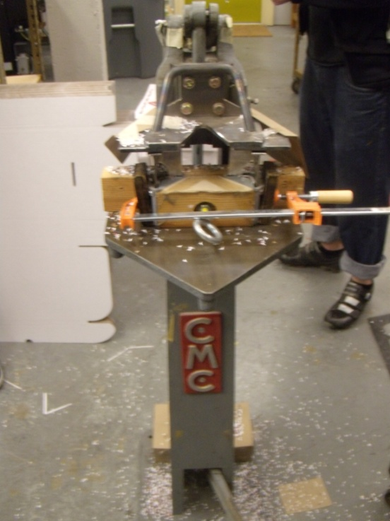
Within the greater publishing industry, there are small, independent print shops. Many of these prints shops produce small notebooks that are characterized by two rounded corners opposite the stitched spine, an example can be seen in Figure 2. Some print shops have experienced an increase in sales of these notebooks creating a need for an improved system to round the corners. The current commercially available devices are only able to round one corner at a time. Some print shops have resorted to retrofitting presses in order to cut two corners simultaneously. A shop with a retrofitted press and a single corner rounder being operated by two employees is limited to producing 2000 notebooks an hour. A small print shop confronted by such limitations would achieve significant savings using a device that could produce more notebooks with fewer employees. Market research identified that adjustability of a double corner rounder from 4.75 to 7.25 inches was a necessary feature. This feature allows for small variations between production runs of the notebook and for another sized product line. During examination of the currently available devices it was observed that during the rounding of the corners the scraps from the process are uncontrolled and results in a mess (Figure 1). The devices all utilized a commercially available die that performs an accurate, ¼ inch radius cut. The dies are easily sharpened and replaced. The Book Corner Rounder Team was formed in order to bring a device to market that will cut corners on notebooks accurately, quickly, neatly, and over a range of 4.75 to 7.25 inches.
Figure 4 Home Made Double Corner Rounder
Figure 5 Example of Notebooks with Rounded Corners
Mission Statement
The Corner Rounder Capstone Team will develop a device that will complete the final step in production for pocket sized notebooks. The device will exceed the output of the equipment currently being used, improve scrap disposal, allow adjustment for various sizes of books, automate the cutting, meet safety regulations, and stay within budget. The design and prototype will be delivered June 2011.
Product Design Specifications
The Book Corner Rounder Team identified small print shops, their employees, maintenance technicians, and government standards as the external customers. The Capstone team members, Capstone class, and the PSU Mechanical Engineering Department are the internal customers. The customer’s needs demanded that the final design meet the following requirements:
- The device must handle a capacity of at least 2000 books per hour
- The accuracy of the cut will be within 1/64 of an inch.
- Adjustability of the distance between the two corners from 4.75 to 7.25 inches.
- Scraps from the cutting process will be collected.
- The device will withstand operation times of at least 10 hours a day and maintain reliability.
- The cutting process will be semi-automated.
- The device will be safe to operate.
- The production cost will not exceed $2500.
Top Level Design Concepts/Decisions
The major design decisions that were considered by the team were how to round the corner, how to power the device, and how to make the operation adjustable. The method of actually rounding the corner was decided first as this would influence the other design decisions.
The different methods to round the corner of the notebooks were either cutting the corner off the notebook, or grinding the corners in a similar method to a router. Grinding the notebooks was considered. In grinding, it would be difficult to creating a uniform, accurate radius compared to that of a fixed radius cut. Therefore the decision was made to cut the corners. Dies and knives were comparable in performance, but the available knives were more expensive and lacked a guide. Custom built dies were cost prohibitive when compared to the commercially available dies commonly used in a corner rounding operation. Also, multiple custom built dies would be required to accommodate different sized notebooks. Commercially available ¼ inch radius dies were selected as they are within budget, have guides that prevent overcutting the corner, are easily sharpened, and replacements are readily available. Once the die was selected, the method to compress the die was considered.
To compress the two dies the team considered a stepper motor and three types of linear actuators; electric, hydraulic, and pneumatic. A decision matrix, included in Appendix D, was used to make the decision. The stepper motor requires a linkage in order to translate the rotational motion into linear motion, while the actuators supply linear motion without modification. The stepper motor was eliminated from consideration because of the added design complication due to the linkage. The actuators provided the necessary force and velocity to perform the cut, but the electric actuators were much more expensive than the others. Notebooks and fluid do not mix well, and having the possibility of the hydraulic actuator leaking removed it from consideration. Therefore a pneumatic actuator was chosen.
Two methods were compared in order to adjust the distance between the two dies. The first method required one of the dies to be fixed while moving the other die using a lead screw. The second method was moving both dies apart from each other from a central location using a lead screw with opposing threads. A pull bar assembly is being used to transfer the motion from the linear actuator across the two dies. When having one fixed die and adjusting for multiple sizes, the force is no longer applied equally to the two dies. Figure 3 shows that when both dies are moved apart from each other equally, the force on each die remains the same. Therefore the latter method was chosen for the design.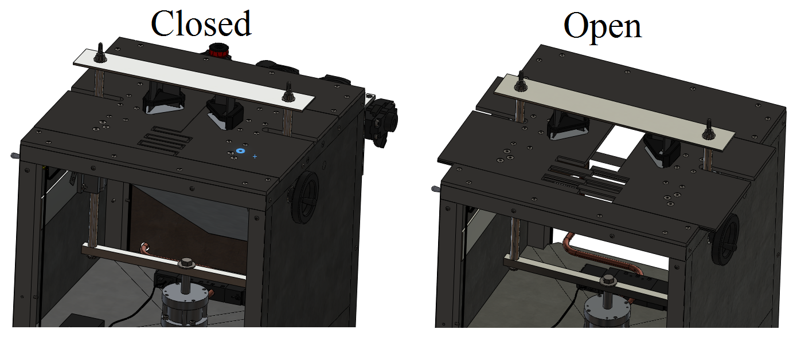
Figure 6 Top Plate Adjustability Example
Final Design

Overview
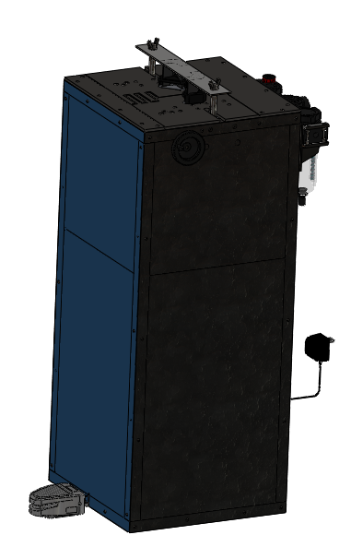
The final design of the Book Corner Rounder consists of several assemblies that will be detailed in the following sections. The corner rounder utilizes a pneumatic actuator fixed to a pull-bar assembly. The pull-bar assembly compresses two dies to perform the cut of the notebook corners. The pneumatic actuator is activated by the operator pressing a foot pedal (Figure 4 shows the placement of the foot switch relative to the device). The foot pedal sends a signal to a controller that switches a solenoid. The solenoid diverts the flow of compressed air to either side of the actuator. The pull-bar assembly (Figure 5) has a square, horizontal cross bar and has two vertical round bars attached to it. The round bars run through an adjustable top plate. The top plate has two machined recesses that the two dies fit into. A flat piece of steel is fixed to the two vertical bars and placed over the dies. The force of the actuator is transferred to the dies from the pull-bar assembly. The top plate is adjusted by turning a lead screw, moving the two top plates apart.
Figure 7 Solid Works Model of Full Assembly

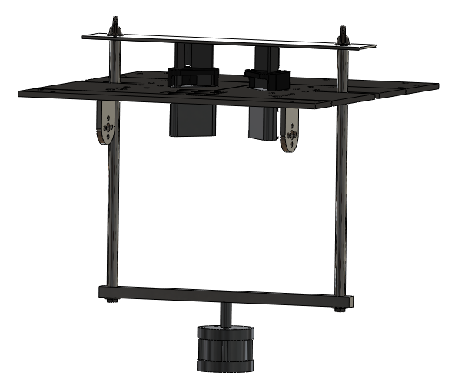
Actuator and Pull-Bar
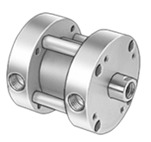
The pull-bar and actuator must transfer 150 pounds of force in a linear motion to equally compress the two dies. The actuator and pull-bar are designed to compress the dies and return them to the open configuration in order to perform another rounding cut. Since the dies routinely need to be replaced, the pull-bar assembly cannot be permanently fixed. Appendix F contains a table that shows the psi required to get a set pull force for air cylinders of varying bore sizes. This table was used in order to select an appropriate actuator. A switch-ready, double acting, pancake air cylinder with a 1.5 inch diameter bore was chosen (Figure 6). The actuator has a 1 inch stroke length, which is sufficient to fully compress the dies when performing the cut. The steel piston rod is threaded and a bolt is used to attach to the pull-bar assembly. The pull-bar assembly is ½ by ½ inch O1 tool steel (horizontal bar) fixed to ½ inch diameter O1 tool steel rods, and a 2 inch wide, 1/8 inch thick tool (load bar) steel connected to the steel rods. Steel was chosen for its strength and resistance to fatigue at the loads applied during the cutting process. The horizontal bar has a through hole located at the center. Two additional through holes drilled in the same direction are equally spaced from the center hole. Two rods are tapped at both ends to place bolts. The horizontal bar is semi-permanently fixed to both the actuator and rods using bolts and Loctite® Thread Sealant. Thumb screws are used to fasten the load bar to the rods. This allows quick loosening of the bar for plate adjustment and complete removal of the load bar in order to perform maintenance on the dies. Linear sleeve bearings and nylon bushing are attached to the frame and are used to guide the pull-bar assembly and reduce risk of binding.
Figure 8 Solid Works Model of Pull Bar Assembly with the Top Plate and Dies
Figure 9 1.5" Bore Pneumatic Linear Actuator

Power and Control
An external source of pressurized air is supplied to the system through a quick release attachment. The quick release attaches to an air filter, regulator, and lubricator that supplies air to a 4-way, 2-position solenoid valve. The electrical signal to the solenoid valve is regulated by an Arduino Controller that receives a signal from a foot switch actuated by the operator. The solenoid and controller are powered by a 24 VDC 550 mA wall adapter. An on/off switch is used so that the operator can control electrical power to the machine without having to unplug the power supply. The air filter, regulator, and lubricator are needed in order to remove particulates and moisture, regulate the pressure supply to the actuator, and lubricate the air flow to ensure long life of internal parts. ¼ inch copper tubing is run from the regulator to the inlet of the solenoid, and from the solenoid outlets to the actuator.

Top Plate
¼ inch thick steel plate is machined to create four pieces. Figure 7 shows the top view of the full assembly.
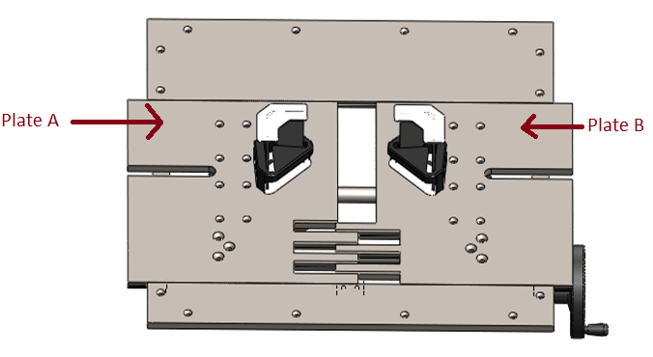
Figure 10 Solid Works Model of Top Plate Assembly
Two keyed, fixed plates provide support to the two adjustable plates. The two adjustable plates, labeled Plate A and Plate B in Figure 7, are also keyed in order to distribute the load to the frame and maintain the accuracy of the cut. Keyed fingers are cut into the two adjustable plates in order to support the notebooks when the device is set to the maximum distance between the dies. The adjustable plates are further supported by attaching four fixed-alignment linear sleeve bearings to the underside and running them along hardened precision steel shafts. These shafts are held to the frame of the Corner Rounder with iron shaft supports. A non-load bearing lead screw is used to adjust the plates. A wheel located externally on the Corner Rounder is turned and rotates the lead screw that has oppositely pitched threads. On each side of the lead screw a precision acme nut is fixed to the top plates using brackets. As the screw is turned, the plates move equidistant with respect to the center of the plate, but in opposing directions. This ensures that the load transferred from the actuator is equal at each die. The dies have lips running along there edge, as shown in Figure 8, and the top plate is machined with a recessed lip to support the die. All bolt holes are countersunk to avoid interference with the notebooks.
Figure 11 Top Plate Machining for Lassco Die

Frame
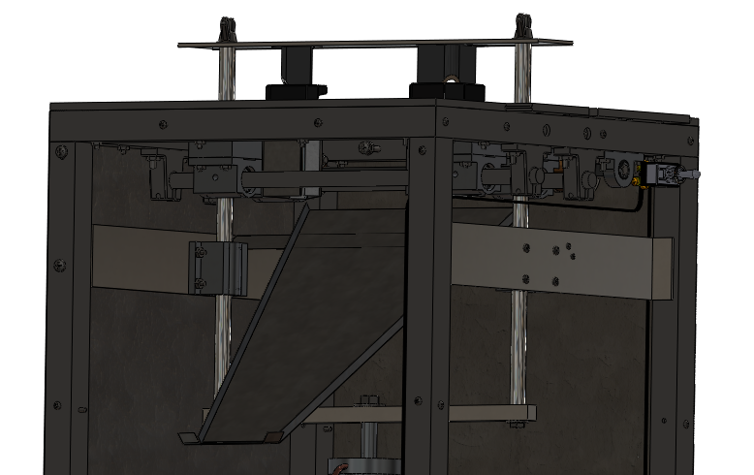
The frame is constructed of 1" X 1" X 11 gauge A513 structural steel square tube and welded together. The frame measures 3 feet high in order to place the top plate at waist height. The frame is 15 by 15 inches in order to fully support the top plate and create a cabinet area to fully enclose the actuator. Two cross member are 22 inches from the bottom of the frame. Sheet metal is placed on top of the cross members to create a shelf. The actuator is located directly above the intersection of the cross members so that the force is fully supported by the frame. The solenoid and controller are both fixed to the shelf by fasteners. The frame is enclosed with sheet metal with holes for wiring and plumbing. The front of the frame is fastened with few machine screws for easier removal during necessary maintenance. As the dies round the corners, scraps are ejected down into the cabinet of the frame. A slide was designed from sheet metal for the scraps to slide down and out the back of the Corner Rounder (Figure 9). A recycling bin can be placed below the output of the slide in order to catch the scraps.
Figure 12 Solid Works Model of Scrap Collection System

Evaluation and Verification
The full prototype was not funded, requiring a smaller, less expensive POC (Proof of Concept) prototype to be built. This smaller prototype did not perform as many functions as the larger one would have, therefore this design did not allow for testing of several of the PDS requirements. Because of this, a full evaluation of the design was not possible and is reflected by an N/A (not applicable) notation in the Evaluation column of the table below. The full PDS is included in Appendix E.
Table 1 Proof of Concept PDS and Verification
Requirement | Metric | Target | Verification | Evaluation
Capacity | Books / Hour | >2000 | Prototype Testing | N/A
Accuracy | Inches | 1/64 | Prototype Testing | N/A
Adjustable | Inches | 3.5x5 / 5x7 | Design | Yes | √
Scrap collection | Yes / No | Yes | Design | Yes | √
Operation time | Hours / Day | 10 | Prototype Testing | N/A
Semi-automated | Yes / No | Yes | Inspection | Yes | √
Life in service | Years | >5 | Analysis / Testing | N/A
Cost of production | $ | <2500 | BOM | Yes | √
Operated by 1 person | Yes / No | Yes | Inspection | Yes | √
Safety guards | Yes / No | Yes | Design | Yes | √
Reliability | % | 95 | Prototype Testing | N/A

Conclusion
The successful design of the prototype and calculations of the resulting stresses indicate that the Corner Rounder would meet the product design specifications located in the Appendix E. The team has concluded that savings in the budget could be obtained by using aluminum instead of steel on many components, as the amount of force acting on the frame and assembly is insignificant. The pneumatic actuator worked exceptionally well in this application. It was observed through testing on the prototype that an actuator with a smaller bore diameter would have met the design requirements. Clear and frequent communication between the customer and the design team in order to properly define the scope of the project is of the utmost importance.

Appendix A: Detailed Description of Design, Manufacturing, and Assembly

Overview
The entire device is broken down into four sub-assemblies: the actuator and pull-bar assembly, power and control, top plate assembly, and the frame. The manufacturing processes to be used and the assembly process for each sub-assembly are described in this Appendix. Since the full design was not manufactured, some aspects of the manufacturing and assembly are not described in full detail and are only spoken of in general terms.

Actuator and Pull-Bar Assembly
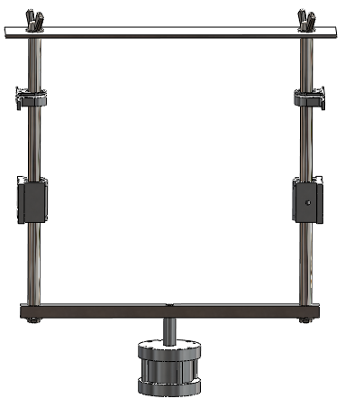
Figure A-1 Actuator and Pull-Bar Assembly
The actuator and pull-bar assembly is responsible for creating and transferring the cutting force to the dies. The actuator is attached to the horizontal pull bar with a fastener. The horizontal pull bar is then attached to the pair of vertical pull bar. This is done by putting fasteners through the thru holes of the horizontal bar and into the tapped holes along the axis of the vertical pull bars. Bushings are inserted over the vertical load bars in order to attach to the frame via the bushing holder bases. The load bar is then attached to the vertical pull bars with thumb screws.

Power and Control
The power and control system is necessary in order to supply power to the system and to control the actuation of the air cylinder. The overall system was mapped out in ORCAD and shown below in Figure A-2. The electrical schematic includes a transistor and a diode in addition to the Arduino controller, solenoid valve and power adapter. The diode is used to prevent the kickback voltage from damaging the circuit. The transistor allows the solenoid to get the amperage necessary to operate. The circuit is intended to be soldered to the mini-protoboard and stored in the controller box with the Arduino.
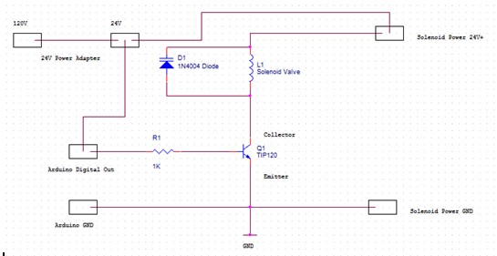
Figure A-2 Arduino Circuit Diagram for Controlling a Solenoid Valve
The Arduino micro-controller is programmed to take the signal from the foot pedal and switch the solenoid valve between two positions corresponding to the piston being all the way extended to fully contracted. The code used to program the Arduino is shown below in Figure A-3.
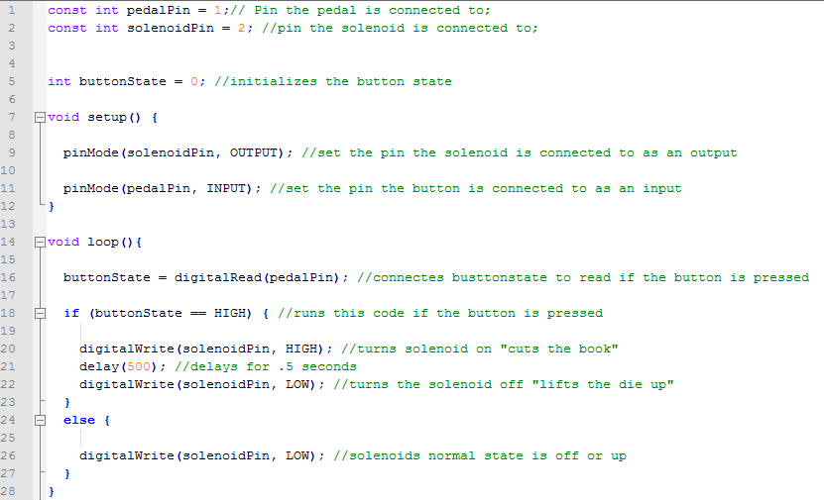
Figure A-3 Sample Code for Controlling a Solenoid Valve with an Arduino
Holes are built into the frame to allow for wiring of the various components.

Top Plate Assembly
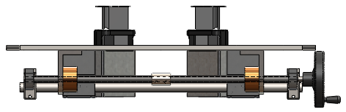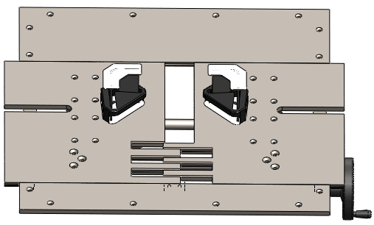
Figure A-4 Solid Works Model of the Top Plate Assembly

The top plate assembly holds the two dies and allows them to be adjusted. In addition to machining the keyways, fingers, and holes for fasteners, the cutouts for the dies need to be milled. Unlike the rest of the features, machining of the die cutouts requires using CNC software (in the manufacturing of the POC, MasterCAM x4 was used) and use of a two-axis programmable mill.

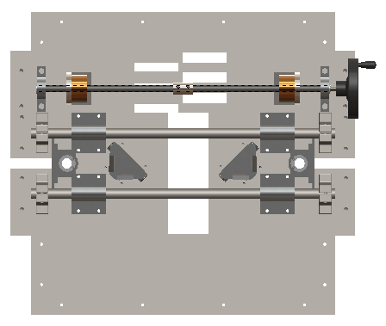
Figure A-5 Solid Works Model of the Top Plate Assembly, Bottom View

Frame
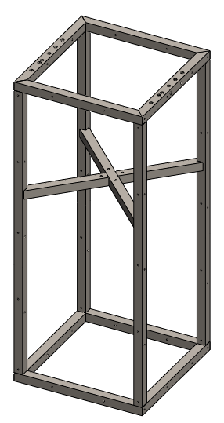
Figure A-6 Solid Works Model of the Frame
The frame supports all of the components of the device as well as enclosing the actuator and other moving parts of the corner rounder. The frame is made of 11 gauge A513 steel square tubing and covered with 24 gauge galvanized steel. The ends of the horizontal members are cut at 45 degrees and welded together and then to the vertical members. The galvanized steel panels are attached to the main frame with fasteners through the holes in the panels and vertical members.

Appendix B: Analysis

Adjustable plate load shaft deflection analysis.
Summary
The purpose of this analysis is to determine the maximum deflection of the load beams supporting the adjustable cutting plate (figure B-1). The cutting plate is supported directly above the linear actuator and needs to be able to move independently of any supports, allowing it to adjust the dies to the dimensions of the book being cut. To achieve this, two load bars are placed underneath the plate equidistant from the cutting point. These load bars are designed to support the entire cutting force of 150 lbs, minimizing the force transmitted to the screw that moves the plates.
After analyzing the load bars it was found the under worst case scenarios, the load bars would deflect 0.015 inches.

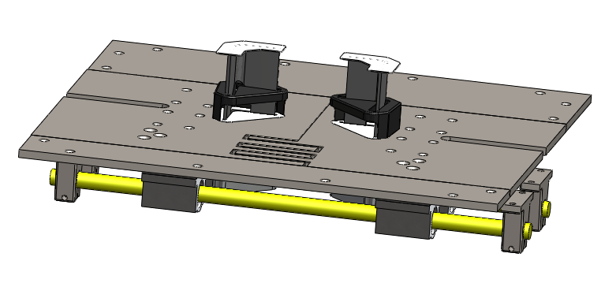
Figure B-1: Adjustable Cutting Plate

Given:
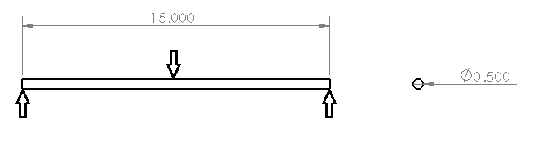
Figure B-2: Load Shaft Free Body Diagram
In the worst case scenario, the load shaft in Figure B-2 will have a center loading of 75lbs with fixed supports at each ends. The shaft has the following dimensions and properties.
L=15”
Diameter = 0.5”
Modulus of Elasticity = 190 GPa
Find:
Maximum deflection of the shaft
Assumptions:
Loading is static, and the end supports are fixed.
Solution
Using the equation for maximum yield for a shaft
$$y_{max}=\frac{Fl^{3}}{192EI}$$
Determine I for a shaft
$$I=\frac{πD^{4}}{64}=\frac{π{(0.5)}^{4}}{64}=0.003068 {in}^{4}$$

Convert Modulus of Elasticity from GPa to PSI
$$E=190GPa=27.5*{10}^{6}psi$$
Determine max deflection
$$y_{max}=\frac{Fl^{3}}{192EI}=\frac{75lbs{(15in)}^{3}}{192\left(27.5*{10}^{6}{lb}/{{in}^{2}}\right)(0.003068{in}^{4})}=-.015 in$$

Load Shaft Fatigue Analysis
Summary
The purpose of this analysis is to determine the fatigue life of the Load Shaft part of the Top Plate. Each load shaft is subjected to 75lbs of cyclical force. If the load shaft fails, production of rounded corners can be delayed or stopped all together. It is important to know how many cycles the shafts will last until they fail.
After performing a fatigue failure analysis using the Stress-Life Method, it was found that the load shaft would never fail due to fatigue
Figure B-3 Adjustable Cutting Plate
Given:
Figure B-4 Load Shaft Free Body Diagram
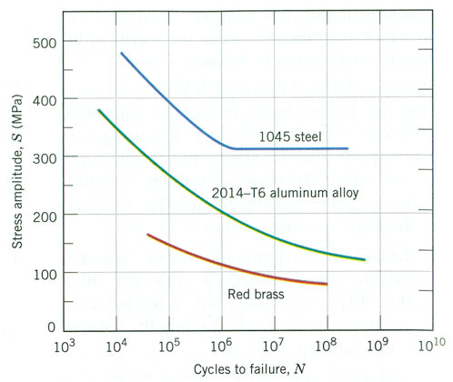
Figure B-5 S-N Curve for Various Metals
L=15”
Diameter = 0.5”
Modulus of Elasticity = 190 GPa
Find
Cycles to failure
Assumptions
Loading in cyclical. There is no static component to the load, the shaft is smooth with no notches or cracks

Solution
Determine the I of the shaft
$$I=\frac{πD^{4}}{64}=\frac{π{(0.5)}^{4}}{64}=0.003068 {in}^{4}$$
Determine the maximum amplitude stress in the shaft
$$M=F\left(L\right)=75lbs*7.5 in=562 in*lbs$$
$σ=\frac{MC}{I}=\frac{562(0.25)}{0.003068}=45.7$ ksi
Based on the amplitude stress and Figure B-5 the load shafts will not fail due to fatigue.

Pull Bar Deflection Analysis
Summary
The purpose of this analysis is to determine how far the pull bars will deflect under worst case scenario conditions. The pull bars transfer the downward force from the linear actuator to the cutting dies. Figure B-6 shows how the pull bars are connected to the linear actuator and the dies. The linear actuator is calibrated to pull with a maximum of force of 150 lbs, this load is evenly distributed between the two pull bars.
After analyzing the bars, it was found that they would deflect a maximum of 0.00001615 in. Based on these findings the selected bar will not fail for the given conditions.
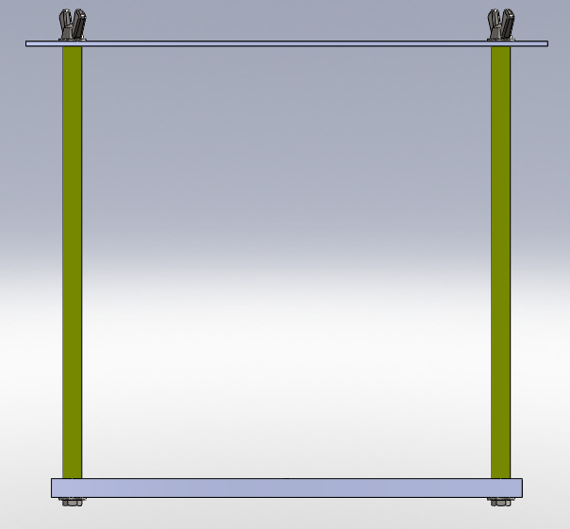
Figure B-6: Pull Bar Assembly. The highlighted parts are the pull bars being analyzed

Given:
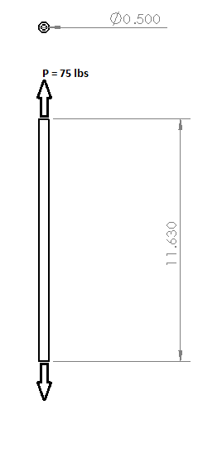
Figure B13: Pull Bar Free Body Diagram
L=11.625 in
Diameter = 0.5 in
P=75lbs
E=27.5 $*{10}^{6}$psi
Find:
Deflection of the bar
Assumptions:
Loading is static, load is concentric

Solution:
Using the equation for deflection of a shaft in pure tension
$$δ=\frac{PL}{AE}$$
Determine the cross sectional area of the shaft
$A=π*{\left(\frac{0.5}{2}\right)}^{2}=0.19635 {in}^{2}$
Plugging into the original equation
$$δ=\frac{PL}{AE}=\frac{75lbs(11.625in)}{\left(0.19635 {in}^{2}\right)27*{10}^{6}{lb}/{{in}^{2}}}=1.615*{10}^{-5}in$$

Pull Bar Buckling Analysis
Summary
The purpose of this analysis is to determine the critical load for the pull bar chosen(figure B-8). The linear actuator pushes the pull bar up with as much force as it pulls it down, 150 lbs. Should the pull bars bind on the upward motion, it is important to know if the bars will buckle should this happen.
After analyzing the bars, it was found that the critical load was 246,468 lbs. Based on these findings the selected bar will not fail for the given conditions.
Figure B-8: Pull Bar Assembly, the highlighted parts are the pull bars being analyzed

Given:
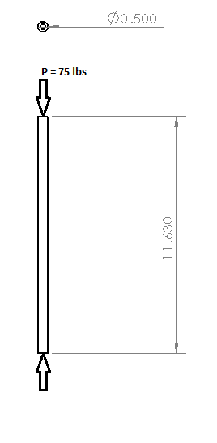
Figure B-9: Pull Bar Free Body Diagram
L=11.625 in
Diameter = 0.5 in
P=75lbs
E=27.5 $*{10}^{6}$psi
Find:
Critical loading for the bar
Assumptions:
Loading is static, load is concentric, and ends are fixed
Solution:
Using the Euler equation for critical loading
$$P_{cr}=\frac{Cπ^{2}EI}{L^{2}}$$
Determine I for a shaft
$$I=\frac{πD^{4}}{64}=\frac{π{(0.5)}^{4}}{64}=0.003068 {in}^{4}$$
Plugging into the equation with C=4 for fixed point supports on the ends
$$P_{cr}=\frac{Cπ^{2}EI}{L^{2}}=\frac{4π^{2}\left(27.5*{10}^{6}{lb}/{{in}^{2}}\right)(0.003068 {in}^{4})}{{(11.625 in)}^{2}}=246,468 lbs$$

Pull Bar Fatigue Analysis
Summary
The purpose of this analysis is to determine the fatigue life of the pull bars. The pull bars are subjected to a cyclical loading from 0 lbs to 150lbs of force per corner cut. It is important to understand the life cycle of this part because the machine needs to be able to perform many times before it fails in order for it to make fiscal sense. Figure B-10 shows the highlighted parts in question.
After performing a fatigue failure analysis using the Stress-Life Method, it was found that the pull bars would never fail due to fatigue
Figure B-10 Pull Bar Assembly
Given:

Figure B-14 Pull Bar Free Body Diagram
Figure B-15 S-N Curve for Various Metals
L=11.625 in
Diameter = 0.5 in
P=75lbs
E=27.5 $*{10}^{6}$psi
Find
Cycles to failure
Assumptions
Loading in cyclical. There is no static component to the load, the shaft is smooth with not notches or cracks

Solution
Determine the area for the shaft
$$A=π{0.25}^{2}=0.1963$$
Determine the amplitude stress in the shaft
$$σ=\frac{F}{A}=\frac{150 lbs}{0.1963{in}^{2} }=764.13 psi$$
764.13 psi is below the endurance limit shown in figure B-12, therefore the shaft has unlimited cycles to failure.

Pressure Drop in Piping Analysis
Summary
The purpose of this analysis is to determine the pressure drop across the plumbing going from the air regulator to the solenoid valve. The linear actuator requires an air supply of 100 psi to pull with enough force to cut. Determining the pressure drop in the plumbing will determine how pressure needs to be supplied to the regulator to ensure air at 100 psi enters the solenoid.
The minimum supply air was determined to be 120 psi.
Given:
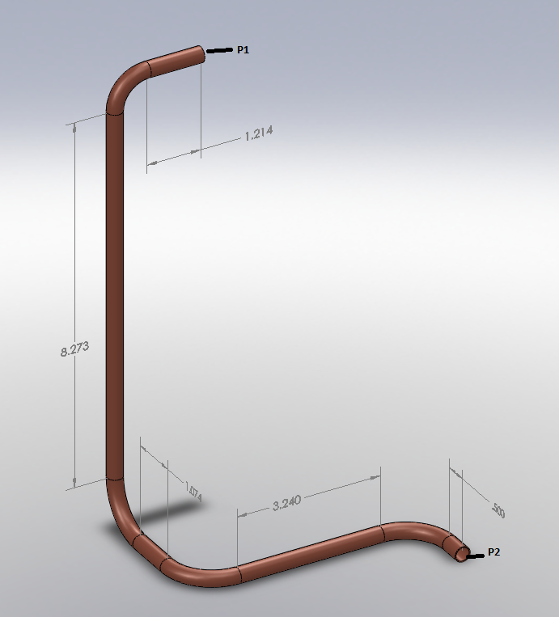
Figure B-13: Plumbing Schematic from the Regulator to the Solenoid Valve
¼” Copper Pipe
P₂ = 100 psi
Flowrate = 10 CFM
K for 90 degree bends is 0.6
Find:
- Pressure drop across the plumbing
- Pressure of the Supply air (P₁).
Assumptions:
No pressure drop across the regulator, no pressure drop across the solenoid.
Solution:
Find velocity of the air
Area = $πr^{2}=π{(0.25 in)}^{2}=.196 {in}^{2}$
$$Q=VA=10{{ft}^{3}}/{min}=288{{in}^{3}}/s$$
$$V=\frac{Q}{A}= \frac{288 {{in}^{3}}/s}{.196 {in}^{2}}=1469.388 {in}/s=122.5{ft}/s$$
Find Re
$$Re= \frac{VD}{v}=\frac{\left(122.5\right)(.0208)}{1.64*{10}^{-4}}=15530.11 (Turbulent Flow)$$
Determine friction factor of the pipe
$$For copper pipes ε=5*{10}^{-6}ft$$
$$relative roughness= \frac{ε}{D}=\frac{5*{10}^{-6}}{.0208}=.0002404$$
$$from moody chart f≈0.031$$

Determine pressure drop in all the straight pipes
$$total pipe length L=14.3 in$$
$$∆P=f\frac{L}{D}\frac{ρV^{2}}{2}=0.031*\frac{14.3in}{.25in}*\frac{0.0748{lb}/{{ft}^{3}}*({122.5{ft}/s)}^{2}}{2}=6.91 psi$$
Determine pressure drop in fittings
$$∆P_{fittings}=k\frac{ρu^{2}}{2}=0.6\frac{0.0748{lb}/{{ft}^{3}}*({122.5{ft}/s)}^{2}}{2}=2.2 psi$$
$$∆P_{fittings}*4 fittings=8.8 psi$$
Total pressure drop in the line = 15.71 psi
Supply air = 120 psi

Frame Deflection Analysis
Summary
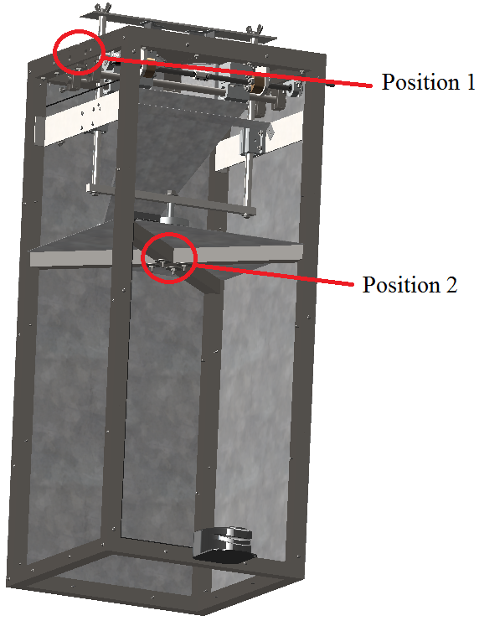
An analysis was performed on the frame to determine the amount of deflection that would occur when the pneumatic actuator is activated. The actuator pulls with a total of 150 pounds of force across various members. The frame is made of 1 by 1 inch 11 gauge structural steel tube. A finite element software package (Abaqus) was used to determine the maximum deflection of the frame at two locations of interest shown in Figure B-14. The maximum deflection is 3.2 x 10^-3 at position 1 and 1.7 x 10^-3 at position 2.
Figure B-14 Solid Works Model of the Frame
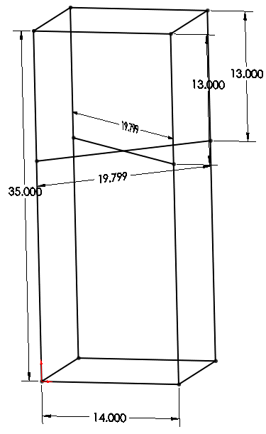
Given:
Figure B-15 Frame Model for Abaqus
Material properties of steel
E = 27.5 $*{10}^{6}$psi
v = 0.3
Cross section of the frame is 1” x 1” 11 gauge steel tube.
Frame geometry

Find:
The maximum deflection of the frame will be found at the points of interest.
Assumptions:
The applied load is static and the welds are fixed.

Solution:
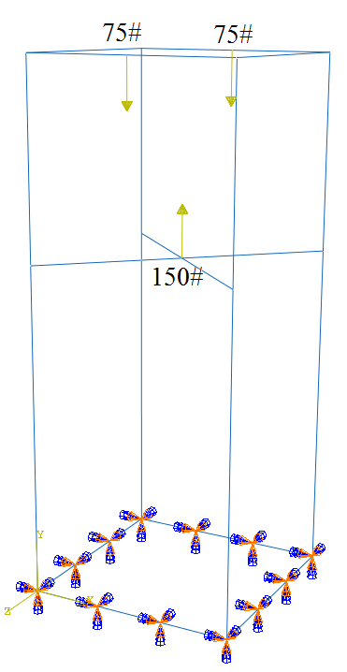
The geometry of the cross members was modeled in Abaqus, a finite element analysis software package. The material properties of steel were used as stated above. The base of the frame was fixed and three point loads were applied and shown below with their respective loads in Figure B-16.
Figure B-16 Abaqus Force Model

2 node linear elements were used to mesh the part. The analysis was run using 584 elements and resulted in a deflection is 3.2 x 10^-3 inches at position 1 and 1.7 x 10^-3 inches at position 2 as in Figure B-17.

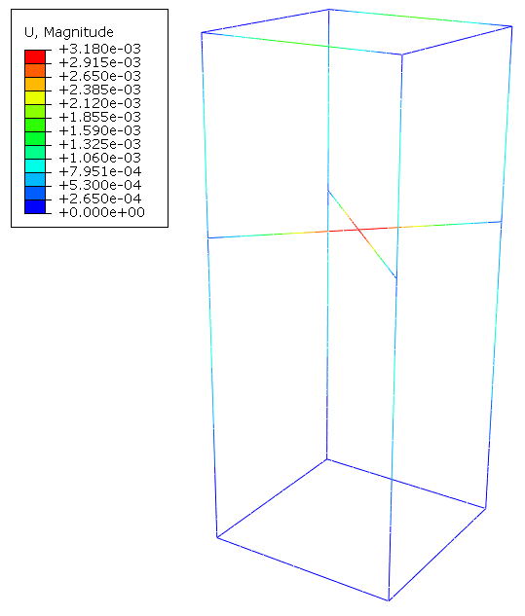
Figure B-17 FEA of Frame

Top Plate Die Support Analysis
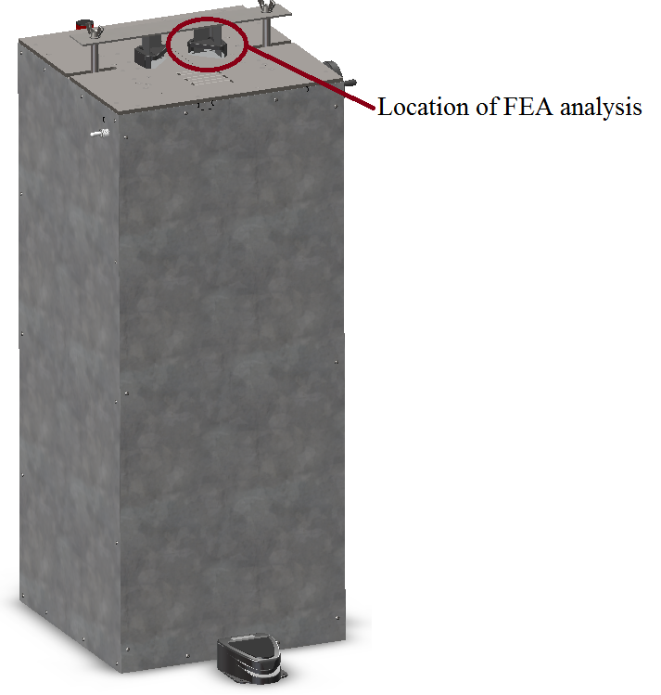
Summary
Figure B-18 Frame Model
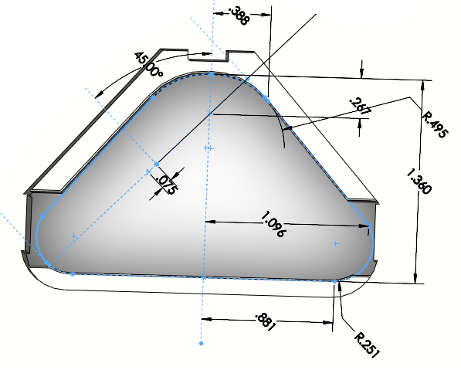
An area of concern for failure in the design is the milled area that the dies rest in. The amount of stress needs to stay well below yield. If the lip yielded the rounding of the notebook will not be accurate and the plate could fail over time. A finite element software package was used to perform the analysis. The maximum stress in the lip was found to be 472 psi, which is well below the yield stress of 24,700 psi.
Figure B-19 Die Cutout for Top Plate
Given:
Material properties of steel
E = 27.5 $*{10}^{6}$psi
v = 0.3
Yield Stress = 24,700 psi
Lip geometry

Find:
The maximum stress action on the lip will be found.
Assumptions:
The applied load is static.
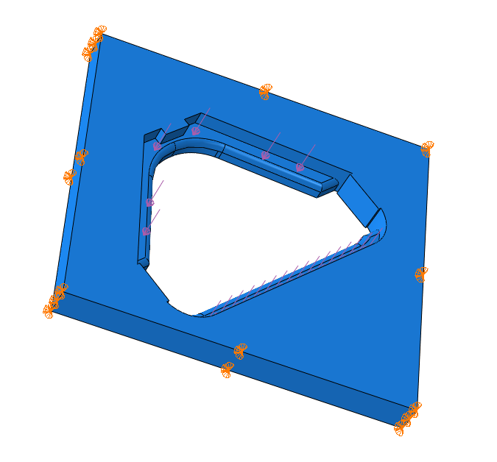
Solution:
Figure B-20 Abaqus Model of Die Cutout
The geometry of lip was modeled in Abaqus, a finite element analysis software package. The material properties of steel were used as stated above. The edge of the model had a fixed boundary condition and a pressure load was applied across the surface of the lip where the die is supported as shown in Figure B-20.

The lip was meshed using a 4 node linear tetrahedron. The final analysis ran with 2418 elements. The resulting maximum stress was found to be 472 psi and location was shown in Figure B-21.
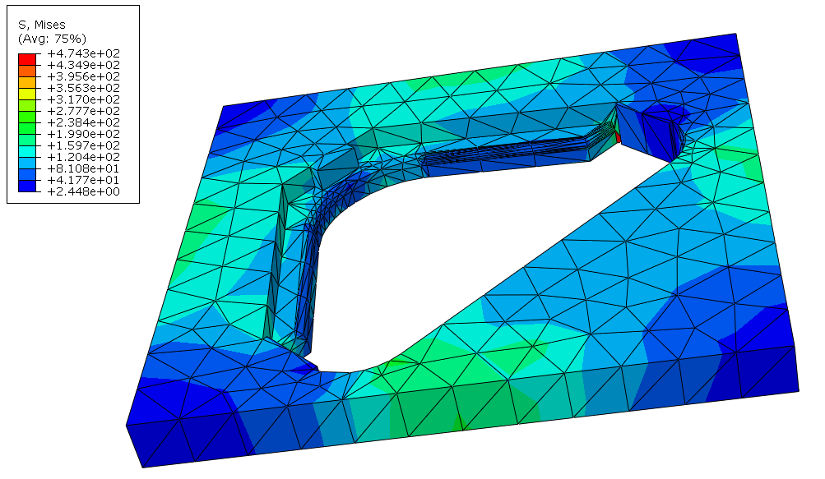
Figure B-21 FEA for Die Cutout

Pull Bar Wing Nut Thread Analysis
Summary
The top bar of the Pull Bar Assembly is held on to the pull bars by wing nuts. The threading on the end of the pull bar needs to be able withstand the stress caused by the cutting action.
After performing the analysis it was found that the bolt could with stand a force of 15,704 lbs before failure.
Given:
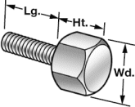
Figure B-22 Thumb Screw Diagram
Lg = 1”
Ht = 7/16”
Wd = 5/8”
Thread = ¼”- 20
Tensile Strength = 80 ksi
Find:
Maximum force before failure
Assumptions
Static Loading, failure method will be shearing of the bolt body

Solution
Find cross sectional area of the bolt
$$A=π{(0.25)}^{2}=0.1963$$
Find the max force
$$σ=\frac{F}{A}$$
$$F^{}= σ*A=80,000 psi*\left(0.1963 {in}^{2}\right)=15,704 lbs$$

Actuator Screw Failure Analysis
Summary
The bottom bar of the pull bar assembly is attached to the linear actuator by an 18-8 Stainless Steel Hex bolt. This bolt takes 150 lbs of force every time a cut is made. It is important that this bolt not fail because it is essential for the successful operation of the corner rounder.
After performing the analysis it was found that the bolt could with stand a force of 7,731 lbs before failure.
Given:
Figure B-23 Screw Diagram
Lg = 1.5”
Ht = 15/64”
Wd = 9/16”
Thread = 3/8”- 24
Tensile Strength = 70 ksi
Find:
Maximum force before failure
Assumptions
Static Loading, failure method will be shearing of the bolt body
Solution
Find cross sectional area of the bolt
$$A=π{(0.1875)}^{2}=0.11044$$
Find the max force
$$σ=\frac{F}{A}$$
$$F^{}= σ*A=70,000 psi*\left(0.11044 {in}^{2}\right)=7,731 lbs$$

Appendix C: Bill of Materials
This appendix includes the Bill of Materials for the full design and the proof of concept.

Bill of Materials for Full Design
Table C-1 Bill of Materials for Full Design
Item # | Description | Part Number | Source | Unit | Quantity | Unit Price | Price per Item #
1 | Switch-Ready Pancake SS Tie Rod Air Cylinder, 1-1/2" Bore, 1" Stroke Length | 4211K35 | McMaster-Carr | each | 1 | $67.95 | $67.95
2 | Solenoid Valve, 4 Way, 2 Pos, 1/4NPT | 3JCN6 | Grainger | each | 1 | $93.80 | $93.80
3 | Air Filter/Regulator/Lubricator, 1/4" Pipe, 45 Max SCFM, Zinc Body/Polycarbonate Bowl | 41555K51 | McMaster-Carr | each | 1 | $156.73 | $156.73
4 | Mounting Bracket for 1/4", 3/8" & 1/2 Pipe Sz Air Filter/Regulator/Lubricator | 41555K41 | McMaster-Carr | each | 1 | $4.40 | $4.40
5 | 1" X 1" X 11 GA (.120" wall) A513 Steel Structural Square Tube | T11111 | MetalsDepot | 12 | 2 | $30.24 | $60.48
6 | 1" X 1" X 11 GA (.120" wall) A513 Steel Structural Square Tube | T11111 | MetalsDepot | 4 | 1 | $12.08 | $12.08
7 | 1" X 1" X 11 GA (.120" wall) A513 Steel Structural Square Tube | N/A | OnlineMetals | each | 2 | $18.36 | $36.72
8 | Hot Roll A653 GALVANIZED Sheet, 0.024" (24 ga.) x 15" x 15" | N/A | OnlineMetals | each | 1 | $6.75 | $6.75
9 | 1-1/2 X 1-1/2 X 1/8 Steel Angle A-36 Steel Angle | A111418 | MetalsDepot | 4 | 1 | $8.60 | $8.60
10 | Lassco Wizer Die 1/4" Standard Size Cutting Unit | CU14 | Machine Runner | each | 2 | $85.00 | $170.00
11 | Single Pedal Switch,Steel Front Hinge, SPDT-NO, Springs Back | 7717K12 | McMaster-Carr | each | 1 | $17.86 | $17.86
12 | Hook-up Wire, Black, 22 AWG, 25' | PRT-08022 | Sparkfun Electronics | each | 1 | $2.50 | $2.50
13 | Hook-up Wire, Red, 22 AWG, 25' | PRT-08023 | Sparkfun Electronics | each | 1 | $2.50 | $2.50
14 | 24 VDC 550 mA Wall Transformer, Power Supply | DCTX-2451 | All Electronics Corp. | each | 1 | $6.75 | $6.75
15 | DC Barrel Power Jack/Connector | PRT-00119 | Sparkfun Electronics | each | 1 | $1.25
16 | Arduino Uno Micro-Controller | DEV-09950 | Sparkfun Electronics | each | 1 | $29.95 | $29.95
17 | USB Cable A to B, 6 ft, for Programming Arduino | CAB-00512 | Sparkfun Electronics | each | 1 | $3.95 | $3.95

Item # | Description | Part Number | Source | Unit | Quantity | Unit Price | Price per Item #
18 | Metal Enclosure for Arduino Controller | PRT-10033 | Sparkfun Electronics | each | 1 | $29.95 | $29.95
19 | ProtoBoard, 1" Square Single Sided | PRT-08808 | Sparkfun Electronics | each | 1 | $1.50 | $1.50
20 | 1k Ohm, 1/6th Watt Resistor | COM-08980 | Sparkfun Electronics | each | 1 | $0.25 | $0.25
21 | TIP-120 Transistor, NPN to-220 Darlington | TIP120 | All Electronics Corp. | each | 1 | $0.75 | $0.75
22 | Rectifier Diode, 1 Amp/ 50 PIV, #1N4001 | 1N4001 | All Electronics Corp. | Pack of 15 | 1 | $1.01 | $1.01
23 | 3 X 2 X 1/4 Steel Angle A-36 Steel Angle | A23214 | MetalsDepot | 2 | 1 | $11.26 | $11.26
24 | 3/4 X 3/4 X 1/8 Steel Angle A-36 Steel Angle | A1343418 | MetalsDepot | 2 | 1 | $2.46 | $2.46
25 | Aluminum Pillow-Block Housing for Linear Brng for 1/2" Bearing OD | 9804K1 | McMaster-Carr | each | 6 | $26.81 | $160.86
26 | Fixed-Alignment Linear Sleeve Bearing Extra Clr, Closed, 6061-T6 Alum, for 1/2" Shaft Dia | 5986K681 | McMaster-Carr | each | 6 | $14.10 | $84.60
27 | Hardened Precision Steel Shaft 1/2" Diameter, 15" Length | 6061K335 | McMaster-Carr | each | 2 | $7.94 | $15.88
28 | External Retaining Ring for Linear Bearing for 7/8" Bearing OD | 9968K24 | McMaster-Carr | each | 12 | $0.46 | $5.52
29 | Nylon Bearing Flanged, for 5/8" Shaft Dia, 3/4" OD, 3/8" Length, packs of 5 | 6389K234 | McMaster-Carr | 5pk | 1 | $5.03 | $5.03
30 | O1 Tool Steel Tight-Tolerance Rod .5000" Diameter, 3' Length | 8893K45 | McMaster-Carr | 36 in | 1 | $8.53 | $8.53
31 | O1 Tool Steel Flat Stock 1/2" Thick, 1/2" Width, 1-1/2' Length | 8151K111 | McMaster-Carr | 18 in | 1 | $12.70 | $12.70
32 | O1 Tool Steel Tight-Tolerance Flat Stock 1/8" Thick, 2" Width, 1-1/2' Length | 9516K216 | McMaster-Carr | 18 in | 1 | $18.26 | $18.26
33 | Low-Carbon Steel Sheet 1/4" Thick, 16" X 16" | 1388K161 | McMaster-Carr | 16x16 in^2 | 1 | $126.04 | $126.04
34 | 1074/1075 Spring Steel Sheet .109" Thick, 8" Width X 24" Length | 9071K51 | McMaster-Carr | 8x24 in | 1 | 54.68 | $54.68
35 | Precision-Cast Multipurpose Aluminum (MIC 6) 1-1/2" Thick, 6" X 6" | 86825K42 | McMaster-Carr | each | 1 | $45.19 | $45.19
36 | Toggle Switch SPST, on-Off, 15 Amps, Quick-Disconnect | 7343K712 | McMaster-Carr | each | 1 | $4.46 | $4.46

Item # | Description | Part Number | Source | Unit | Quantity | Unit Price | Price per Item #
37 | Toggle Switch Label Vertical Print for Horizontal Mounting, packs of 5 | 9423T12 | McMaster-Carr | 5 pk | 1 | $5.75 | $5.75
38 | 95/5 1/8 in. x 8 oz. Lead-Free Solder | 3THF3 | Grainger | each | 1 | $21.63 | $21.63
39 | Soldering Flux, Paste, 4 oz, Below 700 F | 3JXE8 | Grainger | each | 1 | $5.45 | $5.45
40 | Loctite® Thread Sealant 545, 10ml Bottle | 1810A78 | McMaster-Carr | each | 1 | $10.30 | $10.30
41 | Copper Tubing 1/4" Tube Size, 3/8" OD, .311" ID, .032" Wall | 8967K4 | McMaster-Carr | 6 | 1 | $16.43 | $16.43
42 | Solder-Joint Copper Tube Fitting Male Reducing Adapter for 1/4" Tube Size, 1/8" NPT | 5520K491 | McMaster-Carr | each | 2 | $5.37 | $10.74
43 | Solder-Joint Copper Fitting Male Adapter for 1/4" Tube Size, 1/4" NPT | 5135K18 | McMaster-Carr | each | 4 | $8.91 | $35.64
44 | Cushion Washer, Rubber, Round Hole," ID," OD," Thick |  | McMaster-Carr | Pack of 100 | 1 |  | $0.00
45 | 1/8" Adhesive Backed Padding for Top Bar and Actuator, 36" long, 4" Wide, Black | 9023K643 | McMaster-Carr | each | 1 | $13.43 | $13.43
46 | Push-in, Rubber Grommet 3/8" ID, 1" OD, 9/64" Thk for 11/16' Dia Panel Hole | 9600K65 | McMaster-Carr | Pack of 100 | 1 | $14.56 | $14.56
47 | Base Mount Shaft Support for 1/2" Shaft OD | 6068K23 | McMaster-Carr | each | 4 | $24.56 | $98.24
48 | 4140 Alloy Steel Precision ACME `ed Rod 3/8"-16 Sz, 1/16" Travel Distance/Turn, 3'L, Lh Thread | 98940A719 | McMaster-Carr | each | 1 | $38.18 | $38.18
49 | 4140 Alloy Steel Precision ACME Threaded Rod 3/8"-16 Sz, 1/16" Travel Distance/Turn, 3'L, RH Thread | 98940A619 | McMaster-Carr | each | 1 | $38.18 | $38.18
50 | Side-Mount External Retaining Ring (E-Style) Stainless Steel, for 5/16" Shaft Diameter | 98408A132 | McMaster-Carr | Pack of 25 | 1 | $6.00 | $6.00
51 | Solid Cast Iron Hand Wheel Dished, Revolving Handle, 3" Whl Dia, 1/4" Hole Dia | 6024K107 | McMaster-Carr | each | 1 | $50.36 | $50.36
52 | Self-Lubricating Alum-Mounted Bronze Bearing Base Mounted, for 5/16" Shaft Dia, 2-1/4" L | 5912K2 | McMaster-Carr | each | 2 | $9.89 | $19.78

Item # | Description | Part Number | Source | Unit | Quantity | Unit Price | Price per Item #
53 | Steel One-Piece Set-Screw Coupling 5/16" Bore, 1" Length, 5/8" OD, without Keyway | 6412K12 | McMaster-Carr | each | 1 | $2.93 | $2.93
54 | Machinable Bronze Precision ACME Round Nut 3/8"-16 Sz, 1/16" Travel/Turn, 1/4" L, RH Thread | 1343K39 | McMaster-Carr | each | 2 | $32.41 | $64.82
55 | 18-8 Stainless Steel Flat Head Sckt Cap Screw 6-32 Thread, 2" Length | 92210A160 | McMaster-Carr | Pack of 25 | 1 | $7.88 | $7.88
56 | Type 316 SS Flat Head Socket Cap Screw 10-32 Thread, 3/4" Length | 90585A991 | McMaster-Carr | Pack of 10 | 1 | $4.64 | $4.64
57 | 18-8 Stainless Steel Flat Head Sckt Cap Screw 6-32 Thread, 1-1/2" Length | 92210A157 | McMaster-Carr | Pack of 100 | 1 | $9.45 | $9.45
58 | Type 316 SS Pan Head Phillips Machine Screw 4-40 Thread, 5/16" Length | 91735A103 | McMaster-Carr | Pack of 50 | 1 | $4.62 | $4.62
59 | MIL Spec Pan Head Phillips Machine Screw 300 Series, 10-24 Thread, 3/4" Length, MS 51957-65 | 91400A245 | McMaster-Carr | Pack of 25 | 1 | $5.90 | $5.90
60 | 18-8 SS Binding Head Slotted Machine Screw 3-48 Thread, 3/4" Length | 91793A099 | McMaster-Carr | Pack of 50 | 1 | $8.14 | $8.14
61 | 18-8 SS Pan Head Phillips Machine Screw 3-48 Thread, 3/16" Length | 91772A091 | McMaster-Carr | Pack of 100 | 1 | $8.00 | $8.00
62 | 18-8 Stainless Steel Hex Head Thumb Screw 1/4"-20 Thread, 1" Length, 5/8" Head W, 7/16" Head H | 90113A166 | McMaster-Carr | each | 2 | $5.33 | $10.66
63 | 17-4 PH SS Alloy Hex Head Cap Screw 1/4"-20 Thread, 3/4" Length, Fully Threaded | 96870A204 | McMaster-Carr | each | 2 | $5.72 | $11.44
64 | Type 316 SS Large-Diameter Flat Washer 1/4" Screw Size, 9/16" OD, .05"-.08" Thick | 91525A118 | McMaster-Carr | Pack of 50 | 1 | $5.86 | $5.86
65 | 18-8 SS Fully Threaded Hex Head Cap Screw 3/8"-24 Thread, 1-1/2" Length | 92240A358 | McMaster-Carr | Pack of 10 | 1 | $6.87 | $6.87
66 | 18-8 SS Large-Diameter Flat Washer 3/8" Screw Size, 1" OD, .05"-.08" Thick | 90313A329 | McMaster-Carr | Pack of 10 | 1 | $4.86 | $4.86
67 | Type 316 SS Pan Head Phillips Machine Screw 6-32 Thread, 5/8" Length | 91735A150 | McMaster-Carr | Pack of 50 | 1 | $6.05 | $6.05

Item # | Description | Part Number | Source | Unit | Quantity | Unit Price | Price per Item #
68 | 18-8 Stainless Steel Socket Head Cap Screw 10-24 Thread, 2" Length | 92196A253 | McMaster-Carr | Pack of 25 | 1 | $6.36 | $6.36
69 | 18-8 SS Large-Diameter Flat Washer NO. 10 Screw Size, 1" OD, .03"-.05" Thick | 90313A104 | McMaster-Carr | Pack of 50 | 1 | $6.51 | $6.51
70 | 18-8 Stainless Steel Nylon-Insert Hex Locknut 6-32 Thread Size, 5/16" Width, 11/64" Height | 91831A007 | McMaster-Carr | Pack of 100 | 1 | $4.53 | $4.53
71 | 18-8 Stainless Steel Nylon-Insert Hex Locknut 10-24 Thread Size, 3/8" Width, 15/64" Height | 91831A011 | McMaster-Carr | Pack of 100 | 1 | $6.53 | $6.53
72 | 18-8 Stainless Steel Machine Screw Hex Nut 3-48 Thread Size, 3/16" Width, 1/16" Height | 91841A004 | McMaster-Carr | Pack of 100 | 1 | $3.47 | $3.47
73 | Type 316 SS Pan Head Phillips Machine Screw 10-24 Thread, 1-1/2" Length | 91735A255 | McMaster-Carr | Pack of 10 | 1 | $4.35 | $4.35
74 | Miscellaneous |  |  |  |  |  | $100.00
 |  |  |  |  |  | Total | $1,948.49

Bill of Material for the Prototype
Table C-2 Bill of Materials for the Prototype
Description | Part # | Source | Unit | Quantity | Unit Price | Total Price
Zinc-Plated Steel Barbed Hose Fitting Std-Wall Adapter, 1/4" Hose ID x 1/8" NPT Male Pipe | 5350K31 | McMaster Carr | Each | 10 | $1.71 | $17.10
Rigid White Polyproylene Tubing 1/4" ID, 3/8" OD, 1/16" Wall Thickness | 5392K14 | McMaster Carr | 25 ft | 1 | $14.75 | $14.75
Worm-Drive Hose Clamp W/Zinc Pltd Steel Screw 7/32" to 5/8" Clamp Dia Range, 5/16" Band Width | 5388K14 | McMaster Carr | Pack of 10 | 1 | $5.58 | $5.58
Hand-Operated Lever Air Control Valve Manual Return, 4-Way, 2-Positioin, 1/8" NPT Port Sz | 3368K13 | McMaster Carr | Each | 1 | $44.56 | $44.56
Air Flow Control Valve 3/8" Tube to 3/8" Tube Flow Control Direction | 62005K333 | McMaster Carr | Each | 2 | $27.70 | $55.40
Switch-Ready Pancake SS Tie Rod Air Cylinder, 1-1/2" Bore, 1" Stroke Length | 4211K35 | McMaster Carr | Each | 1 | $67.95 | $67.95
Lassco Wizer Die 1/4" Standard Size Cutting Unit | CU14 | Machine Runner | Each | 1 | $85.00 | $85.00
1/4" thick aluminum plate, 10"x12" | 8975k115 | McMaster Carr | each | 1 | $18.19 | $18.19
2-1/2" length steel spacer, female thread, 1/4"-20 thread, 5/8" thread length | 92230a340 | McMaster Carr | each | 4 | $3.89 | $15.56
1/4"-20 thread bolt, 3/4" length, flathead mach, phillips | 91099a453 | McMaster Carr | pack of 50 | 1 | $11.25 | $11.25
1/2" OD aluminum rod, 12" length | 6750k161 | McMaster Carr | each | 2 | $5.96 | $11.92
1/4"-28 steel panhead mach screws | 91400a853 | McMaster Carr | pack of 100 | 1 | $5.43 | $5.43
#10, 0.203" ID, 0.5" OD, .08"-.11" thick, steel | 98029a011 | McMaster Carr | pack of 25 | 1 | $4.49 | $4.49
#10 steel nut, 1/8" height, 3/8" width | 90480a195 | McMaster Carr | pack of 100 | 1 | $1.65 | $1.65
10-32 thread, flathead steel philips mach screw | 90273a836 | McMaster Carr | pack of 100 | 1 | $7.24 | $7.24
10-24 steel bolts, 5/32" hex, 3" length | 90128a237 | McMaster Carr | pack of 5 | 1 | $5.76 | $5.76
cannot find- 3/8"-24,1" length flathead | n/a | Winks | each | 1 | $1.00 | $1.00
10-24 steel nuts, 3/8" width, 1/8" height | 90480a011 | McMaster Carr | pack of 100 | 1 | $1.65 | $1.65
Compressor connection | n/a | Winks | Each | 1 | $2.00 | $2.00
 |  |  |  |  | Total | $376.48

Appendix D: Decisions Matrices
The selection of how to power the linear motion needed for the Book Corner Rounder was made by the team filling out the following decision matrices.
Decision Matrix for Linear Motion
Table D-1 Motion Decision Matrix
 | Josh's scoring | Linear Actuator |  |  | Electric Motor w/
Weight |  | Electric motor | Electro-Mechanical | Pneumatic | Cam, crank, linkage, etc.
3 | Force | 1 | 5 | 5 | 4
3 | Speed | 2 | 4 | 5 | 4
3 | Cost | 4 | 1 | 3 | 4
3 | Maintenance | 5 | 5 | 4 | 3
1 | Off shelf | 5 | 5 | 5 | 3
2 | Complexity | 5 | 5 | 4 | 2
 |  | 51 | 60 | 64 | 52
 | Melissa'a scoring | Linear Actuator |  |  | Electric Motor w/
Weight |  | Electric motor | Electro-Mechanical | Pneumatic/Hydraulic | Cam, crank, linkage, etc.
3 | Force | 2 | 5 | 5 | 4
3 | Speed | 2 | 4 | 5 | 4
3 | Cost | 4 | 2 | 3 | 3
3 | Maintenance | 5 | 5 | 4 | 3
1 | Off shelf | 5 | 5 | 5 | 2
2 | Complexity | 5 | 5 | 3 | 2
 |  | 54 | 63 | 62 | 48
 | Andrew's scoring | Linear Actuator |  |  | Electric Motor w/
Weight |  | Electric motor | Electro-Mechanical | Pneumatic/Hydraulic | Cam, crank, linkage, etc.
3 | Force | 2 | 4 | 5 | 4
3 | Speed | 2 | 3 | 4 | 4
3 | Cost | 4 | 2 | 3 | 3
3 | Maintenance | 5 | 5 | 4 | 3
1 | Off shelf | 5 | 5 | 5 | 2
2 | Complexity | 5 | 5 | 4 | 2
 |  | 54 | 57 | 61 | 48

Appendix E: Product Design Specifications
The PDS is shown in its entirety with the requirements identified by the team as being the highest importance being:
- Capacity (at least 2000 books an hour must be cut)
- Accuracy (the radius of the cut will be with 1/64 of an inch)
- Adjustability (variability from 4.75 to 7.25 inches)
- Reliability
- Safety
- Cost (Less than $2500 to build)
PDS
Table E-1 Product Design Specifications
Performance
Requirement | Customer | Importance | Metric | Target | Target Basis | Verification
Capacity | Pinball Publishing | *** | # of books per hour | >2000 | Customer feedback | Testing
Accuracy of corner cutting | Pinball Publishing | *** | inch | <1/64 | Customer feedback | Testing
Corner radius | Pinball Publishing | *** | inch | 1/4 | Customer feedback | Testing
Adjustable to different book sizes | Pinball Publishing | *** | inch x inch | 3.5x5 / 5x7 | Customer feedback | Testing
Accuracy of adjustability | Pinball Publishing | *** | inch | 1/16 | Customer feedback | Testing
Scraps collected | Pinball Publishing | *** | yes/no | Yes | Customer feedback | Testing
Movement during operation (Frame stability) | Pinball Publishing | *** | yes/no | No | Team | Inspection
Operation time | Pinball Publishing | *** | hours per day | 10 | Customer feedback | Testing
Product is semi- or fully- automated | Pinball Publishing | ** | yes/no | Yes | Customer feedback | Inspection

Environment
Requirement | Customer | Importance | Metric | Target | Target Basis | Verification
Temperature range | Pinball Publishing | * | °F | 40-80 | Customer feedback | Testing
Humidity | Pinball Publishing | * | % | <95 | Team | Testing
Noise | User | * | dB | <90 | Customer feedback | Testing
Life in Service
Requirement | Customer | Importance | Metric | Target | Target Basis | Verification
Expected time in service | Pinball Publishing | *** | years | >5 | Customer feedback | Analysis / Testing
Cost of Production
Requirement | Customer | Importance | Metric | Target | Target Basis | Verification
Budget (production cost) | Pinball Publishing | *** | $ | <2500 | Customer feedback | Expense sheet/ BOM
Size and Shape
Requirement | Customer | Importance | Metric | Target | Target Basis | Verification
Portability | User | * | # of people to move | 1 | Customer feedback | Inspection
Space occupied | Pinball Publishing | *** | feet x feet | <3x3 | Customer feedback | Measurement
Weight
Requirement | Customer | Importance | Metric | Target | Target Basis | Verification
Maximum weight | Pinball Publishing | * | pounds | <400 | Team | Measurement

Maintenance
Requirement | Customer | Importance | Metric | Target | Target Basis | Verification
Cost of weekly maintenance | Pinball Publishing | ** | $ per week | <10 | Team | Analysis / BOM
Replaceable parts easily available | Technician | *** | yes/no | Yes | Customer feedback | Research / Design
Specialty tools required | Technician | *** | yes/no | No | Customer feedback | Research / Design
Serviceability (Easy to access) | Technician | *** | yes/no | Yes | Customer feedback | Inspection
Unjamming time | User | *** | minutes | <3 | Team | Testing
Installation
Requirement | Customer | Importance | Metric | Target | Target Basis | Verification
Manpower to Install | Pinball Publishing | * | people | ≤2 | Team | Analysis
Amount of time to install | Pinball Publishing | * | days | 1 | Team | Analysis
Ergonomics
Requirement | Customer | Importance | Metric | Target | Target Basis | Verification
Number of operators | Pinball Publishing | *** | people | 1 | Customer feedback | Design
Can be worked at all day | User | *** | yes/no | Yes | Team | Inspection / Testing
Working position | User | ** | position | Standing | Customer feedback | Design
Safety
Requirement | Customer | Importance | Metric | Target | Target Basis | Verification
Guards | Pinball Publishing | *** | yes/no | Yes | Customer feedback | Inspection
Emergency stop | Pinball Publishing | *** | yes/no | Yes | Customer feedback | Inspection
Jam stop | Pinball Publishing | *** | yes/no | Yes | Customer feedback | Inspection
Required safety warnings and labels | Pinball Publishing | *** | yes/no | Yes | Team | Inspection

Aesthetics
Requirement | Customer |  | Importance | Metric | Target | Target Basis | Verification
Color, shape, form, finish (looks nice) | Pinball Publishing |  | ** | yes/no | Yes | Customer feedback | Inspection
Quality and Reliability
Requirement | Customer |  | Importance | Metric | Target | Target Basis | Verification
Reliability | Pinball Publishing |  | *** | % of time | 95 | Customer / Team | Analysis / Testing
Applicable Codes and Standards
Requirement | Customer |  | Importance | Metric | Target | Target Basis | Verification
Electric wiring standards | Standards |  | *** | yes/no | Yes | Regulations | Research / Requirements
Requirements mandated by government | Government |  | *** | yes/no | Yes | Regulations | Research / Requirements
Professional society's codes and standards | Professional Society's |  | *** | yes/no | Yes | Regulations | Research / Requirements
OSHA safety codes | OSHA |  | *** | yes/no | Yes | Regulations | Research / Requirements
Testing
Requirement | Customer |  | Importance | Metric | Target | Target Basis | Verification
Perform industry standard tests | Pinball Publishing |  | * | yes/no | Yes | Team | Requirements/ Testing
Tests required to verify performance | Pinball Publishing |  | ** | yes/no | Yes | Team | Testing
Company Constraints and Procedures
Requirement | Customer |  | Importance | Metric | Target | Target Basis | Verification
Compatibility with other machines | Pinball Publishing |  | *** | yes/no | Yes | Customer feedback | Design / Inspection
Documentation
Requirement | Customer |  | Importance | Metric | Target | Target Basis | Verification
Schematics & coding provided | Technician |  | *** | yes/no | Yes | Customer feedback | First Hand
Legal
Requirement | Customer |  | Importance | Metric | Target | Target Basis |  | Verification
Relevant patents violated | Legal |  | *** | yes/no | No | Legal necessities |  | Research
Timelines
Requirement |  | Customer | Importance | Metric | Target | Target Basis |  | Verification
Whole design project / milestones included |  | Capstone | *** | yes/no | Yes | Course requirements |  | First Hand
Final product to be delivered by June 2011 |  | Pinball Publishing | *** | yes/no | Yes | Customer requirements |  | First Hand
Disposal
Requirement | Customer |  | Importance | Metric | Target | Target Basis |  | Verification
Recyclable (scrap able) | Pinball Publishing |  | ** | yes/no | Yes | Customer feedback |  | Inspection

Appendix F: Reference Charts
This graph has performance data for pneumatic actuators with different bore diameters with varying air supply. The graph was used in the selection of the pneumatic actuator used in the Book Corner Rounder.

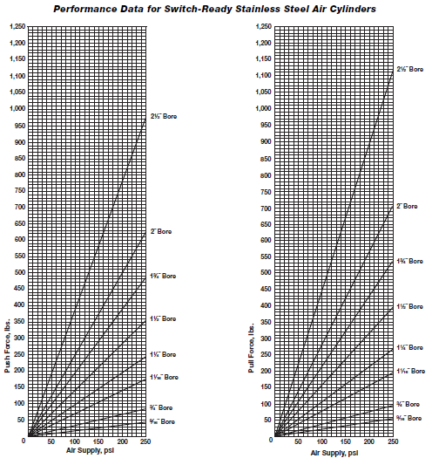
Figure F-1 Linear Actuator Performance Data

Appendix G: Part List and Machine Drawings
Appendix G contains all parts to be used in the full build of the Book Corner rounder including the part name, system, and a brief description. All parts to be manufactured by the design team are defined by technical drawings

Parts List
Table G-1 Parts List
Part Model | Part Name | Part System | Manufacturing Required | Part Description
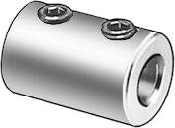 | Connecting Clamp | Adjustment | No | Steel shaft coupling connects the left and right lead screw
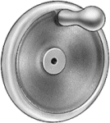 | Hand Wheel | Adjustment | No | Cast iron wheel with revolving handle used to adjust the top plates
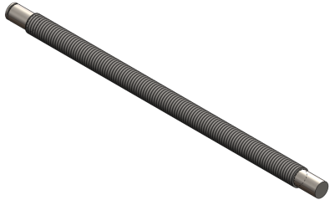 | Left Lead Screw | Adjustment | Yes | Precision steel acme threaded rod with 16TPI left hand threads. Machined ends for coupling connection and bearing support
 | Mounted Bearing | Adjustment | No | Aluminum housed sleeve bearing. Supports the left and right lead screws
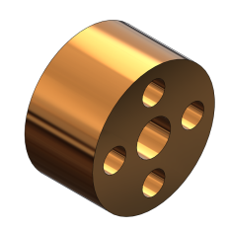 | Nut | Adjustment | Yes | Machinable bronze precision acme nut. Transfers movement from lead screw to top plate

Part Model | Part Name | Part System | Manufacturing Required | Part Description
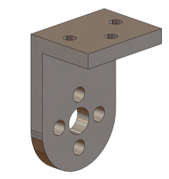 | Nut Mount | Adjustment | Yes | Steel bracket connecting the lead screw nut to the top plate
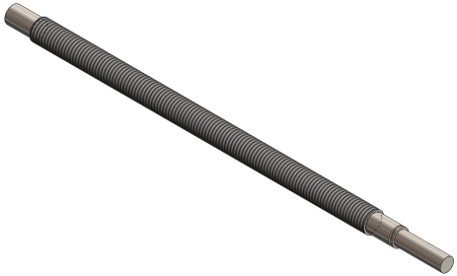 | Right Lead Screw | Adjustment | Yes | Precision steel acme threaded rod with 16TPI right hand threads. Machined ends for coupling connection and bearing support
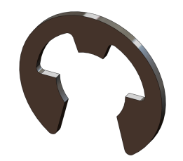 | Shaft Retaining Ring | Adjustment | No | Side-mount external retaining ring. Keeps the lead screw machined end in the mounted bearing
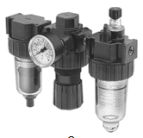 | Filter-Regulator-Lubricator | Air Power | No | Allows filtering of impurities, precise air regulation, and lubrication of internal moving parts. 150psi max pressure, 45CFM max. ¼”NPT ports
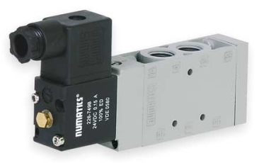 | Solenoid Valve | Air Power | No | 4-way, 2-position air valve. 1/4”NPT ports. Allows switching of air between the 2 linear actuator ports
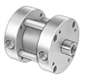 | Tie Rod Air Cylinder | Air Power | No | Switch-ready pancake actuator. 1-½” cylinder bore, 1” stroke length, 1/8”NPT ports

Part Model | Part Name | Part System | Manufacturing Required | Part Description
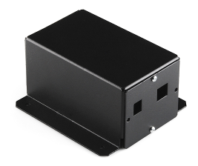 | Controller Package | Electrical | No | Metal enclosure containing Arduino micro-controller, Protoboard, 1k ohm resistor, transistor and 1A/50PIV diode. Controls solenoid valve operation
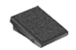 | Foot Pedal | Electrical | No | Single pedal switch with spring back. Sends signal to controller package
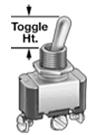 | Switch | Electrical | No | On/Off toggle switch cuts controller power. 15amps
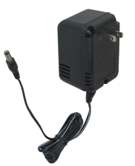 | Wall Transformer | Electrical | No | 24VDC, 550mA wall transformer. Powers controller package from standard 110volt outlet
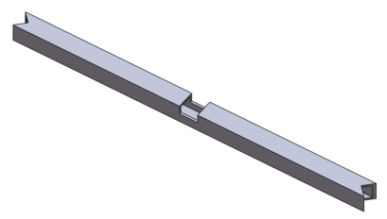 | Cross Member | Frame | Yes | 11gauge steel square tube. Provides structural support to the linear actuator. Supports sheet metal shelf
 | Front Panel | Frame | Yes | 24gauge galvanized sheet metal. Slot at bottom for foot switch cord. Fastens to frame with few machine screws for easy access

Part Model | Part Name | Part System | Manufacturing Required | Part Description
 | Horizontal Member | Frame | Yes | 11gauge steel square tube used for the top and bottom horizontal support members
 | Left Panel | Frame | Yes | 24gauge galvanized sheet metal. Hole at corner for power switch. Fastens to frame with machine screws
 | Rear Panel | Frame | Yes | 24gauge galvanized sheet metal. Cutouts for power cord, air supply from regulator, and scrap slide. Fastens to frame with machine screws
 | Right Panel | Frame | Yes | 24gauge galvanized sheet metal. Hole at top for hand wheel. Fastens to frame with machine screws
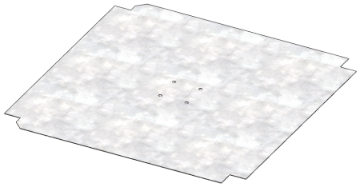 | Shelf | Frame | Yes | 24gauge galvanized sheet metal. Provides mounting surface for solenoid and controller
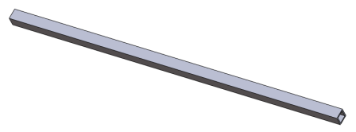 | Vertical Member | Frame | Yes | 11gauge steel square tube used for the vertical support members

Part Model | Part Name | Part System | Manufacturing Required | Part Description
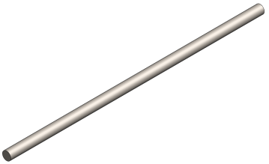 | Linear Shaft | Linear Motion | No | Hardened precision steel shaft. Supports top plate under loading
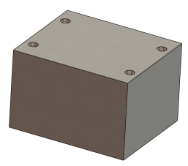 | Mount Spacer | Linear Motion | Yes | Machined aluminum block provides mounting surface to connect the pillow block to the plate
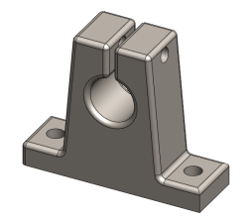 | Shaft Mount | Linear Motion | No | Steel shaft mounts support the linear shaft
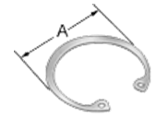 | Bearing Retaining Ring | Linear Motion / Power Transmission | No | Retaining ring keeps the linear plain bearing in the pillow block housing
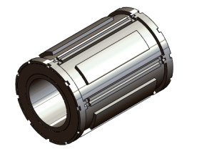 | Linear Plain Bearing | Linear Motion / Power Transmission | No | Linear plain bearing provides maintenance free motion on linear shaft and vertical pull bar
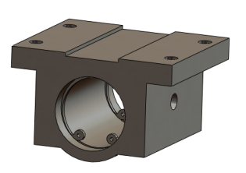 | Pillow Block | Linear Motion / Power Transmission | No | Aluminum housing provides mounting of linear plain bearing
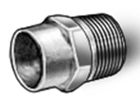 | 1/4NPT Pipe Adapter | Plumbing | No | Solder-joint copper tube fitting allows the joining of the copper piping to the regulator and solenoid ports

Part Model | Part Name | Part System | Manufacturing Required | Part Description
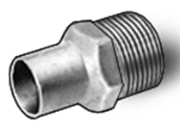 | 1/8NPT Pipe Adapter | Plumbing | No | Solder-joint copper tube fitting allows the joining of the copper piping to the air cylinder ports
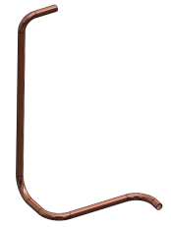 | Pipe-In | Plumbing | No | Copper tubing provides air supply from the regulator to the solenoid
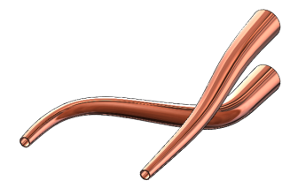 | Pipe-Out | Plumbing | No | Copper tubing provides air supply from the solenoid to the air cylinder
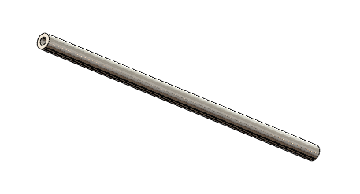 | Vertical Pull Bar | Power Transmission | Yes | Steel rod transmits actuator motion to the load bar
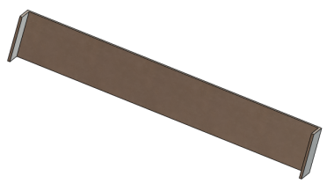 | Bearing Bracket | Power Transmission | Yes | Steel sheet metal bracket provides support to the pillow block for the vertical pull bar
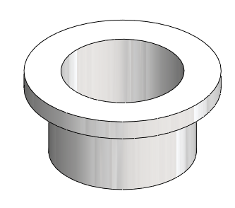 | Bushing | Power Transmission | No | Nylon bushing guides and protects the vertical pull bar
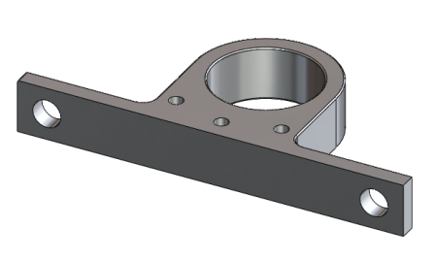 | Bushing Holder Base | Power Transmission | Yes | Machined aluminum bushing housing mounts to the frame

Part Model | Part Name | Part System | Manufacturing Required | Part Description
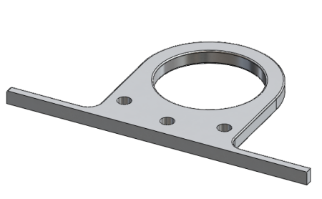 | Bushing Holder Clamp | Power Transmission | Yes | Machined aluminum clamps the bushing to the base
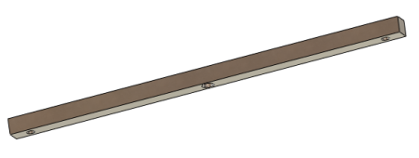 | Horizontal Pull Bar | Power Transmission | Yes | Steel square bar transmits actuator motion to the vertical pull bars
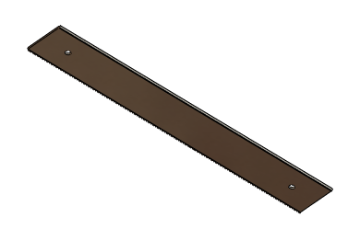 | Load Bar | Power Transmission | Yes | Steel flat stock transmits actuator motion to the cutting dies. 2 thumb screws allow easy removal from pull bars
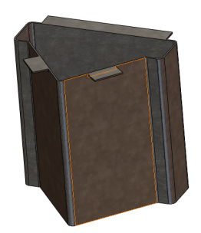 | Scrap Container | Scrap Disposal | Yes | 24gauge galvanized sheet metal guides scraps into the scrap slide. Mounts to the bottom of top plate
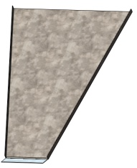 | Scrap Slide | Scrap Disposal | Yes | 24gauge galvanized sheet metal transports the scraps from the scrap container to the outside of the device assembly
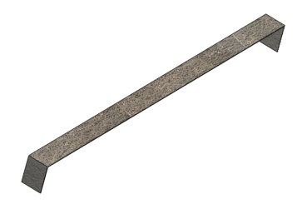 | Top Slide Mount | Scrap Disposal | Yes | 24gauge galvanized sheet metal mounting bracket supports the scrap slide. Mounts to the bearing bracket

Part Model | Part Name | Part System | Manufacturing Required | Part Description
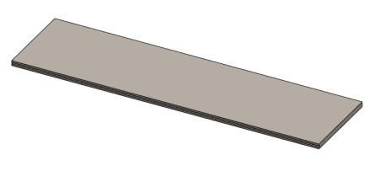 | Back Stationary Plate | Table Top | Yes | Machined ¼” steel plate with keyed edge to provide support to the left and right adjustment plate. Mounts to the frame with countersunk socket screws
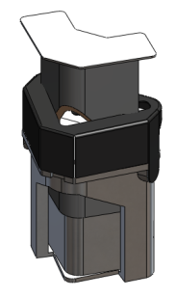 | Cutting Die | Table Top | No | Lassco cutting die with ¼” radius blade. Sheet metal guard contains scraps and protects fingers of operator
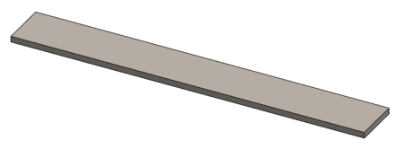 | Front Stationary Plate | Table Top | Yes | Machined ¼” steel plate with keyed edge to provide support to the left and right adjustment plate. Mounts to the frame with countersunk socket screws
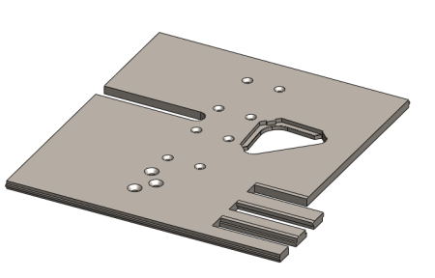 | Left Adjustment Plate | Table Top | Yes | Machined ¼” steel plate with keyed edge supported by the front and back stationary plates. Chamfered fingers in front are keyed and mesh with the right plate. CNC’ed die cutout provides support to cutting die. Slot allows for free movement of vertical pull bar. Countersunk holes allow mounting of lead screw and bearings

Part Model | Part Name | Part System | Manufacturing Required | Part Description
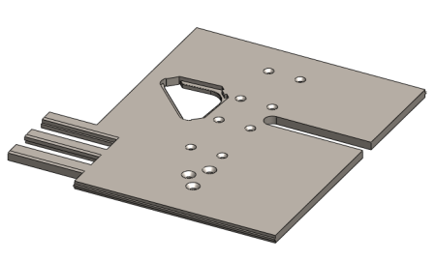 | Right Adjustment Plate | Table Top | Yes | Machined ¼” steel plate with keyed edge supported by the front and back stationary plates. Chamfered fingers in front are keyed and mesh with the left plate. CNC’ed die cutout provides support to cutting die. Slot allows for free movement of vertical pull bar. Countersunk holes allow mounting of lead screw and bearings

Technical Drawings

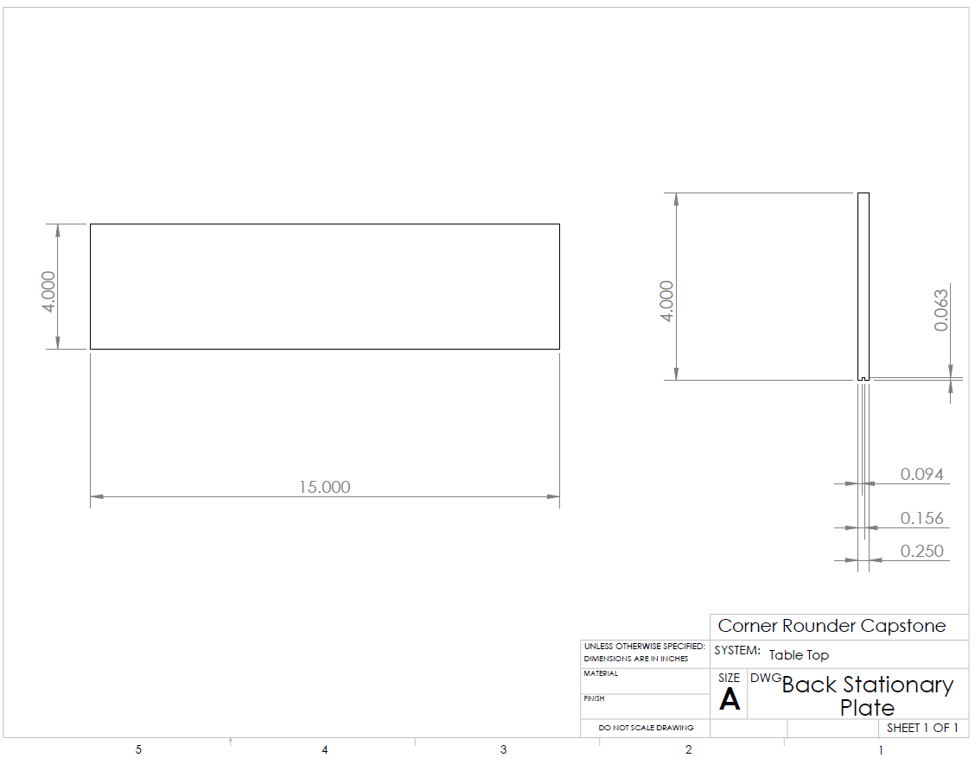
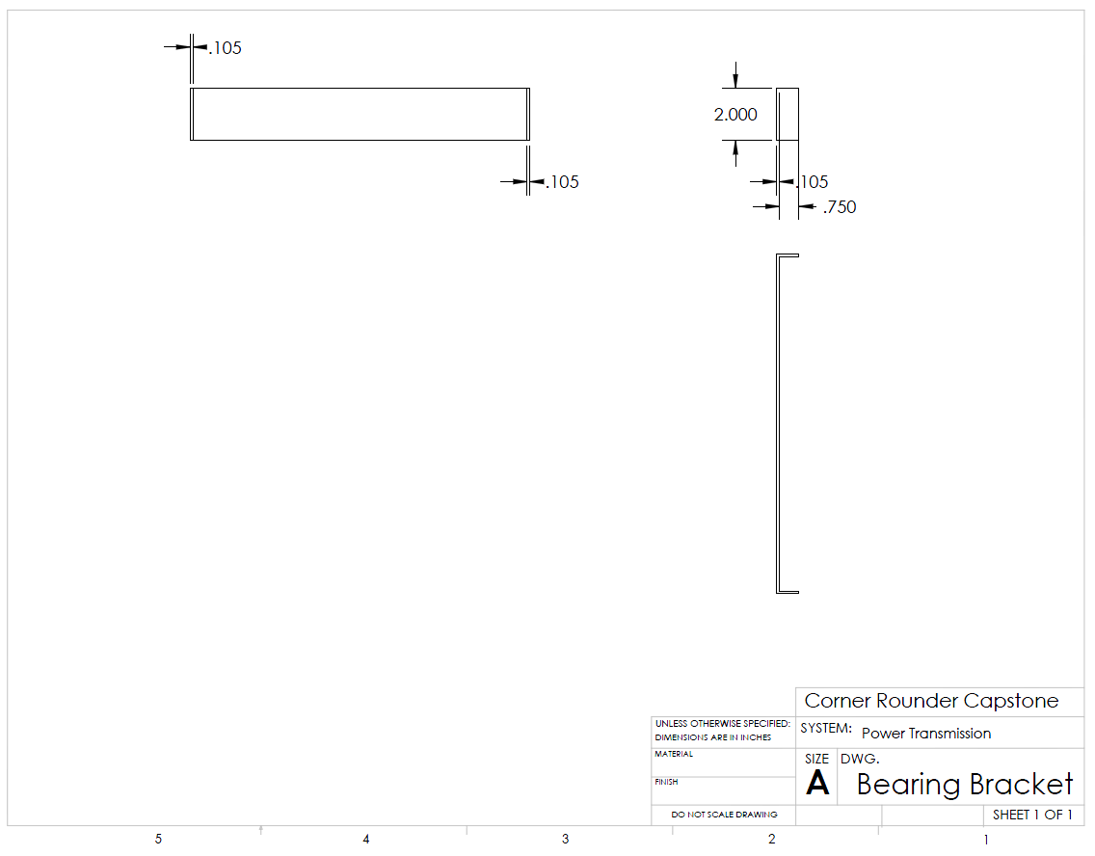
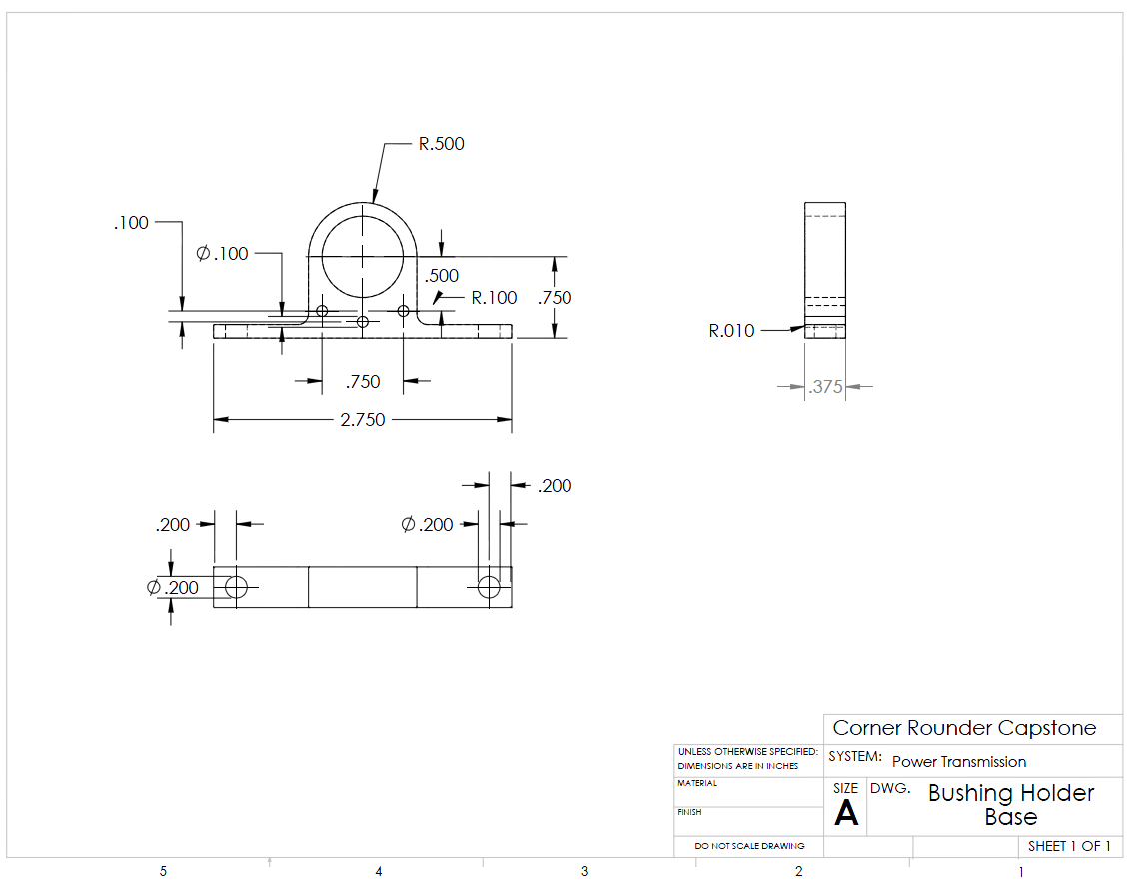
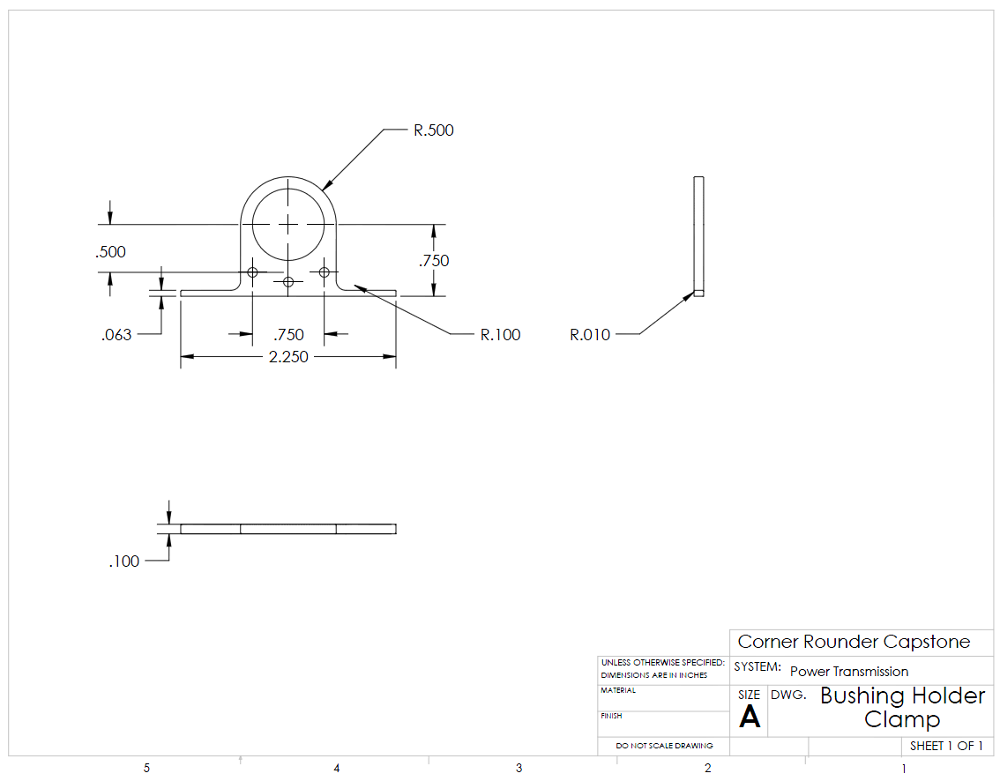
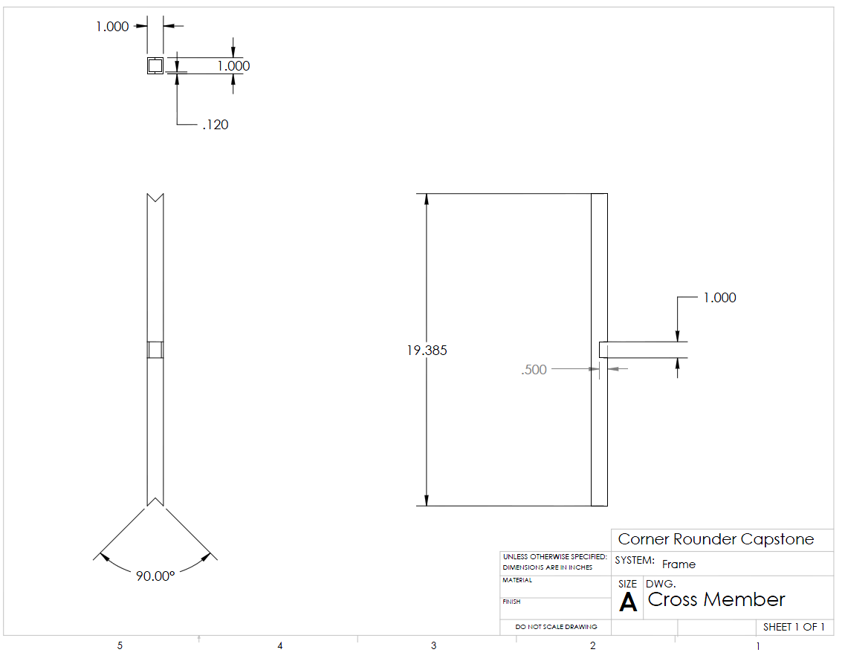
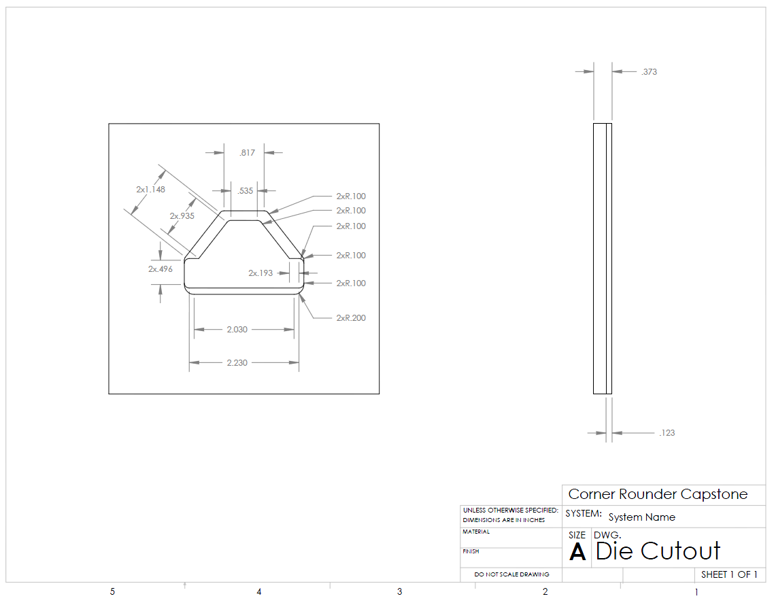
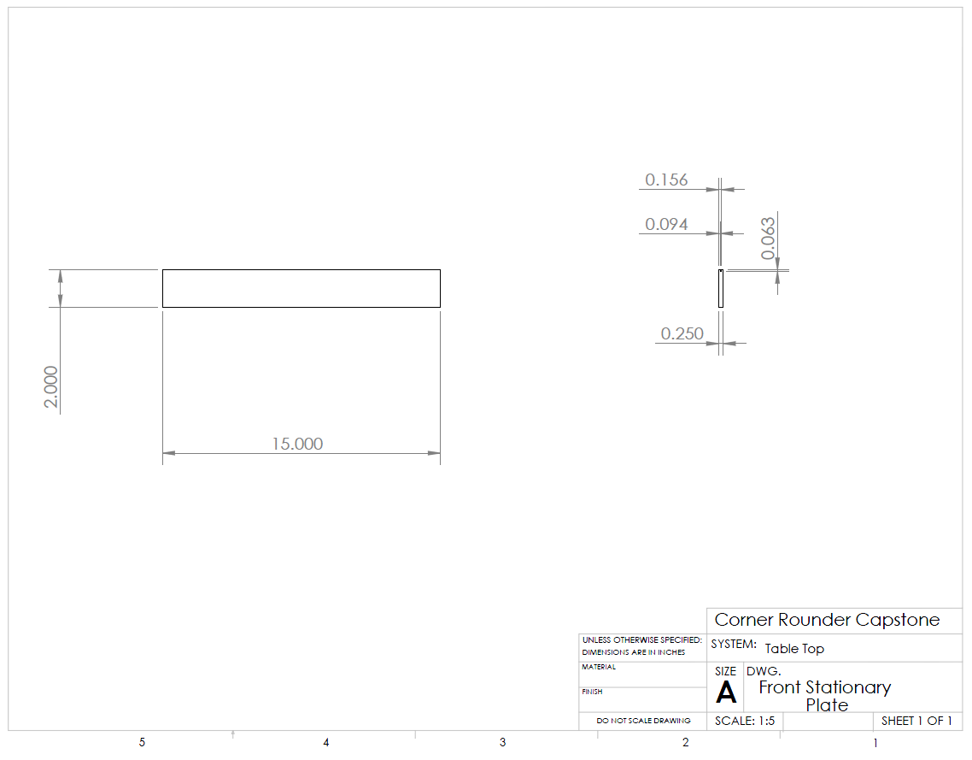
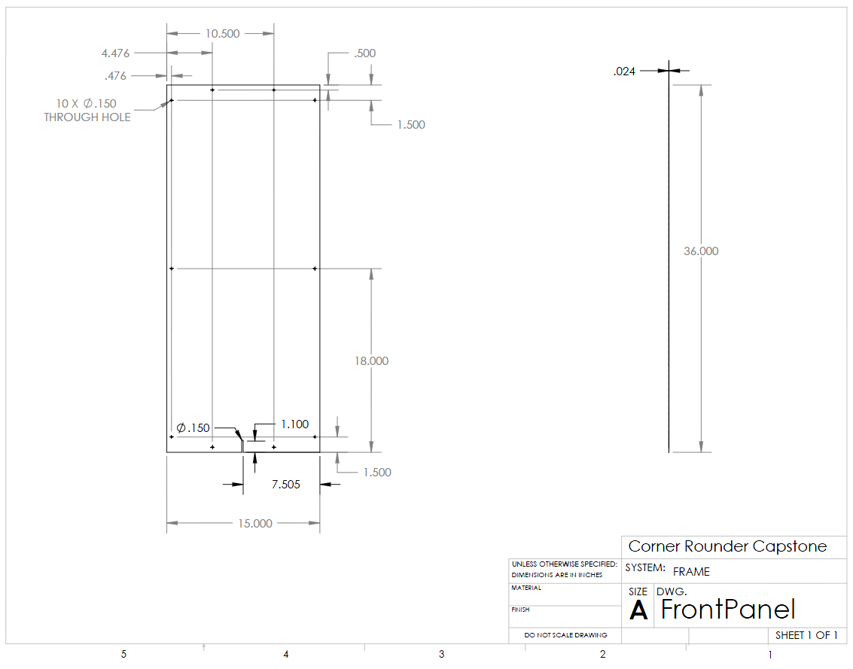
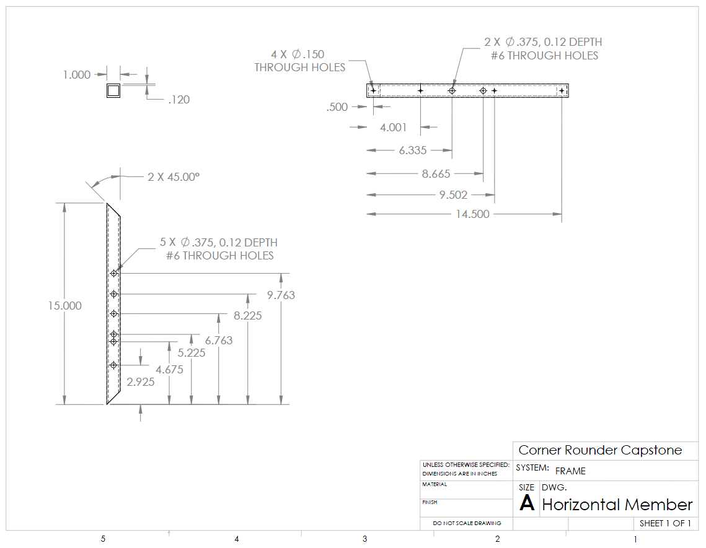
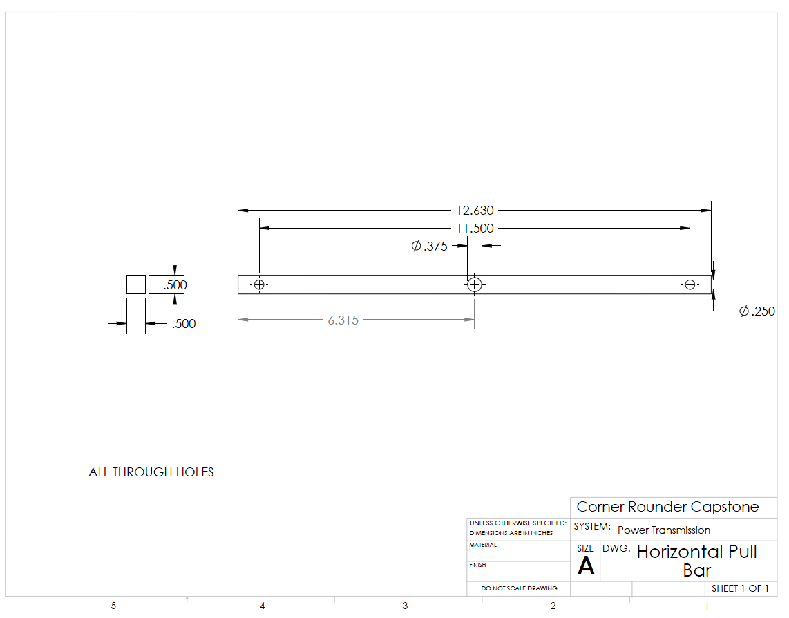
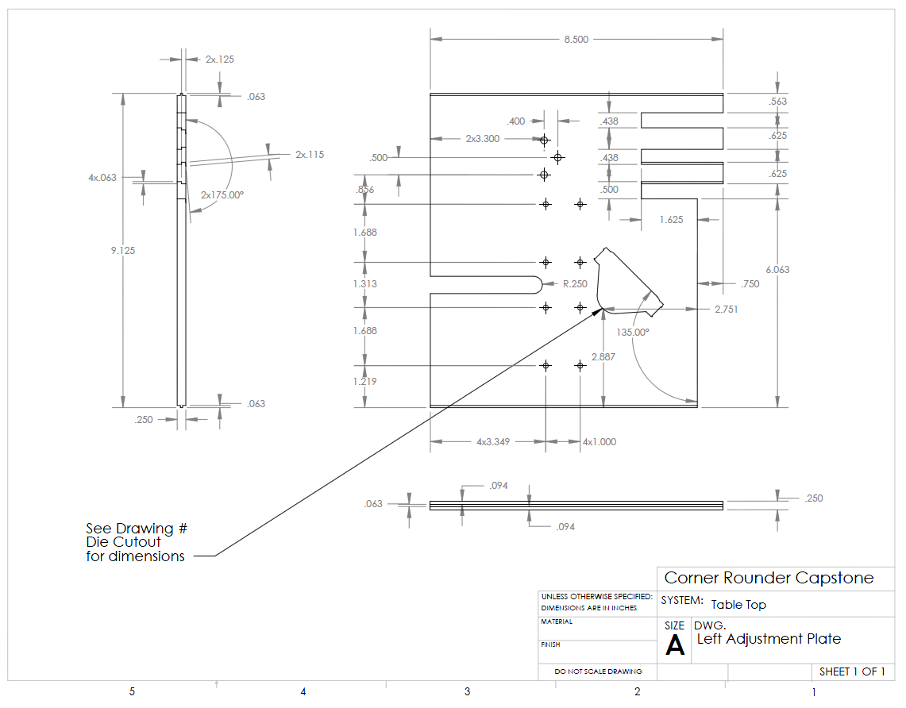
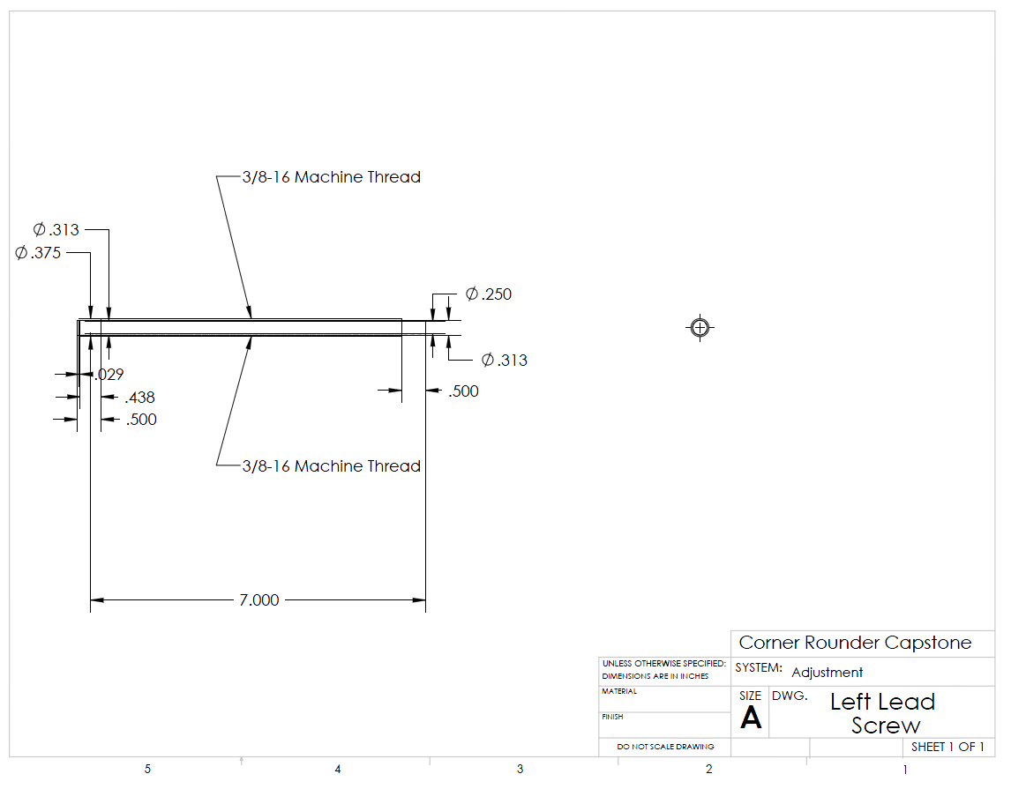
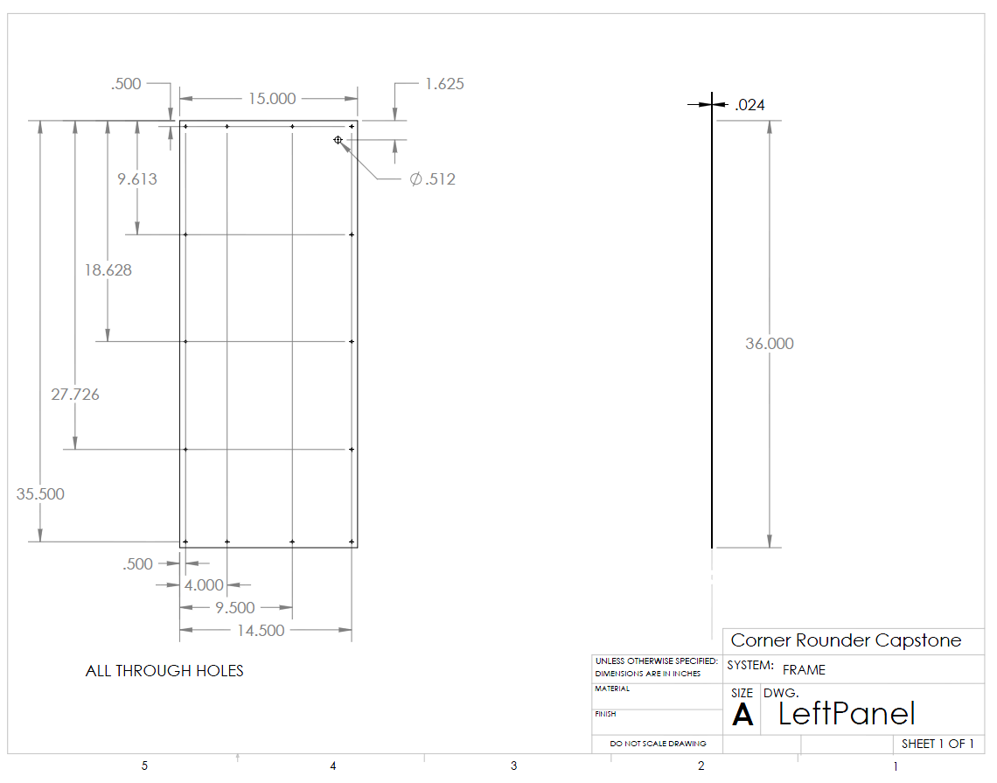
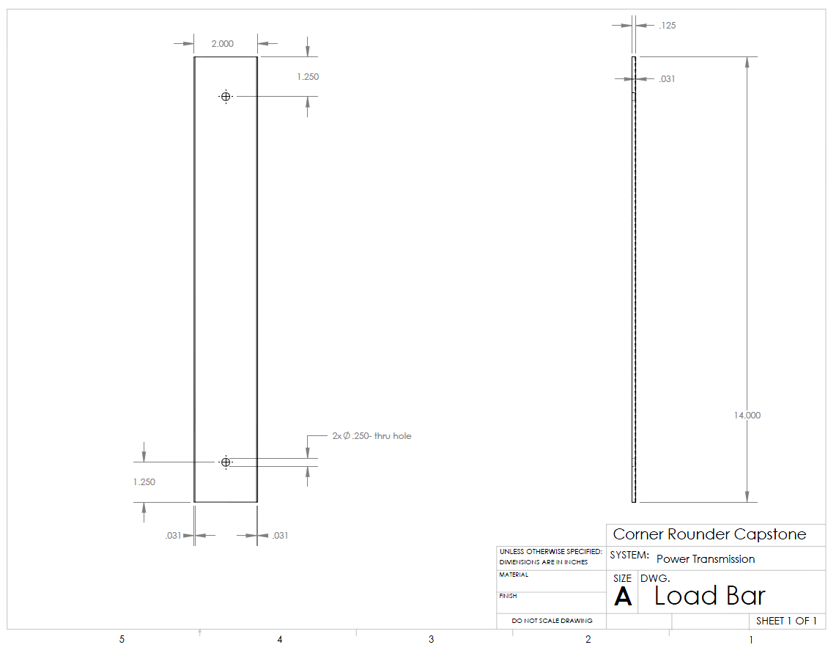
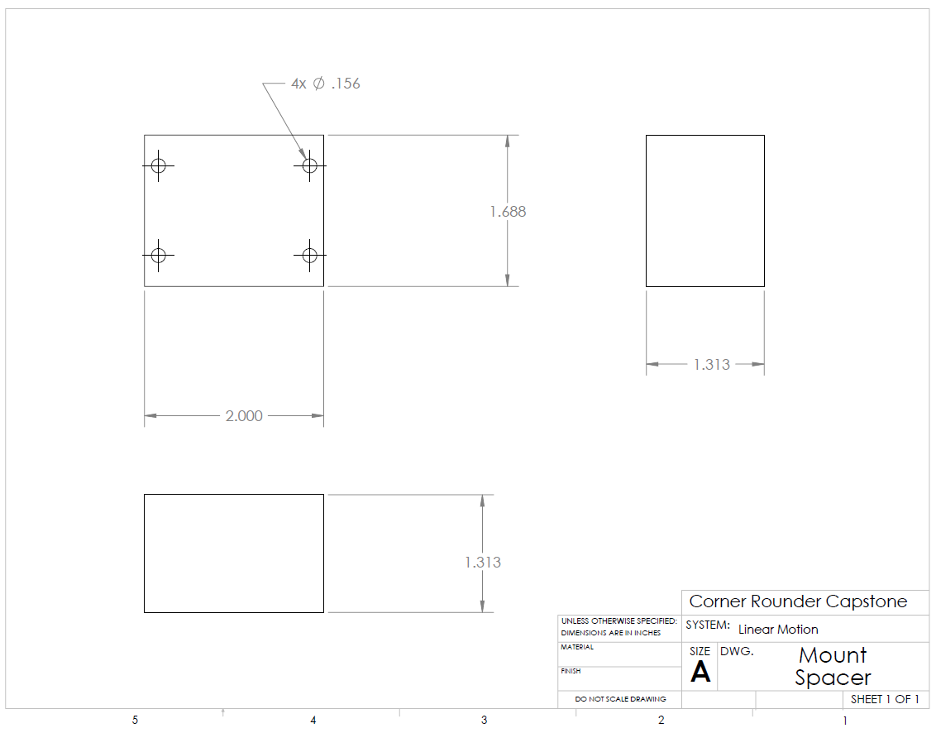
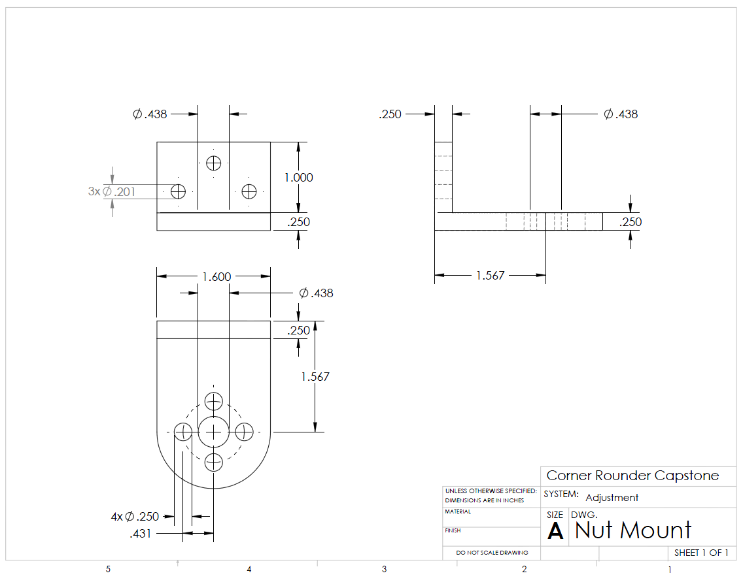
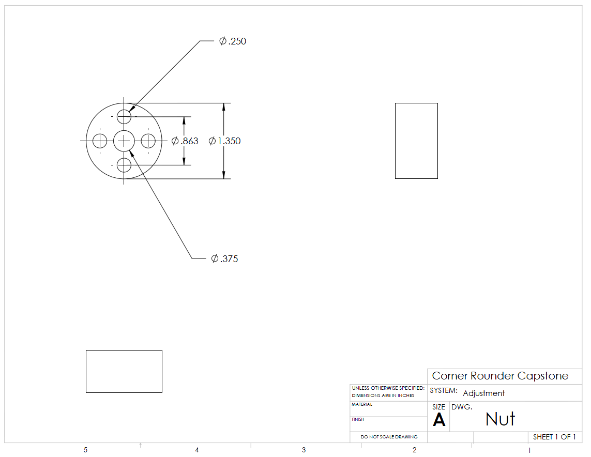
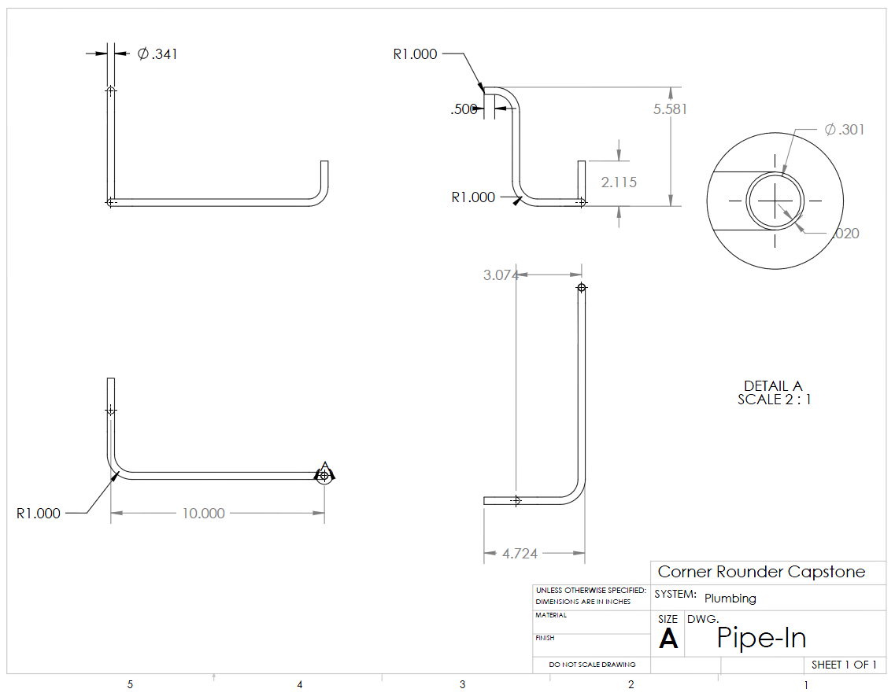
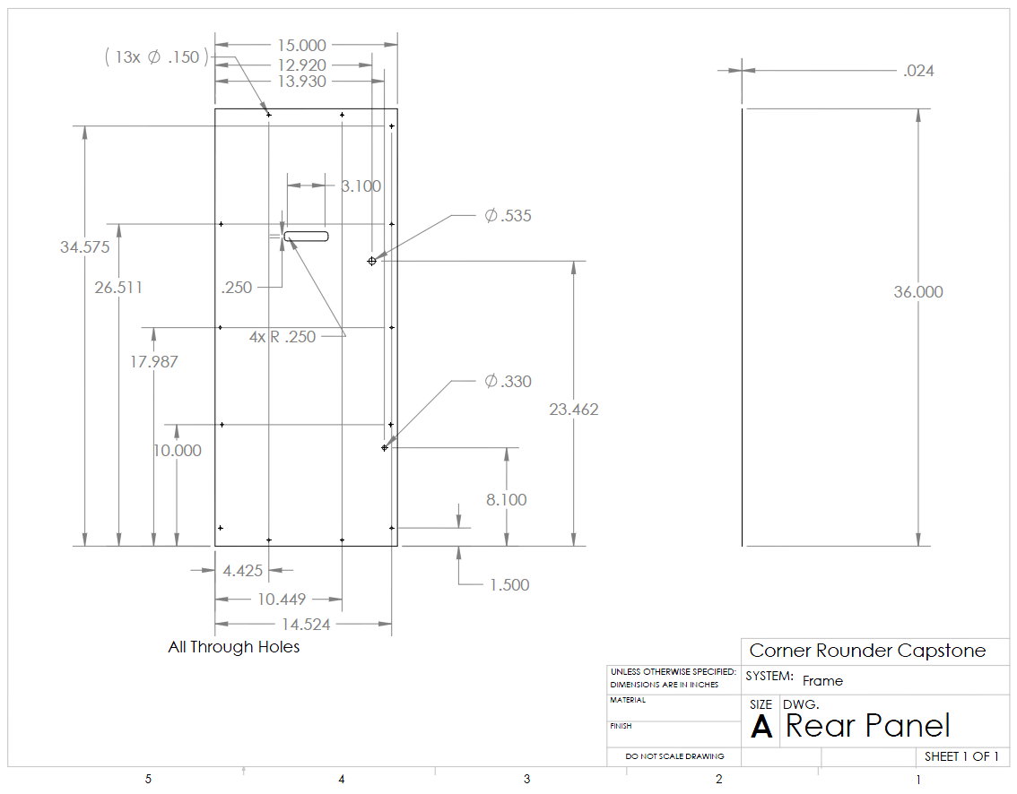
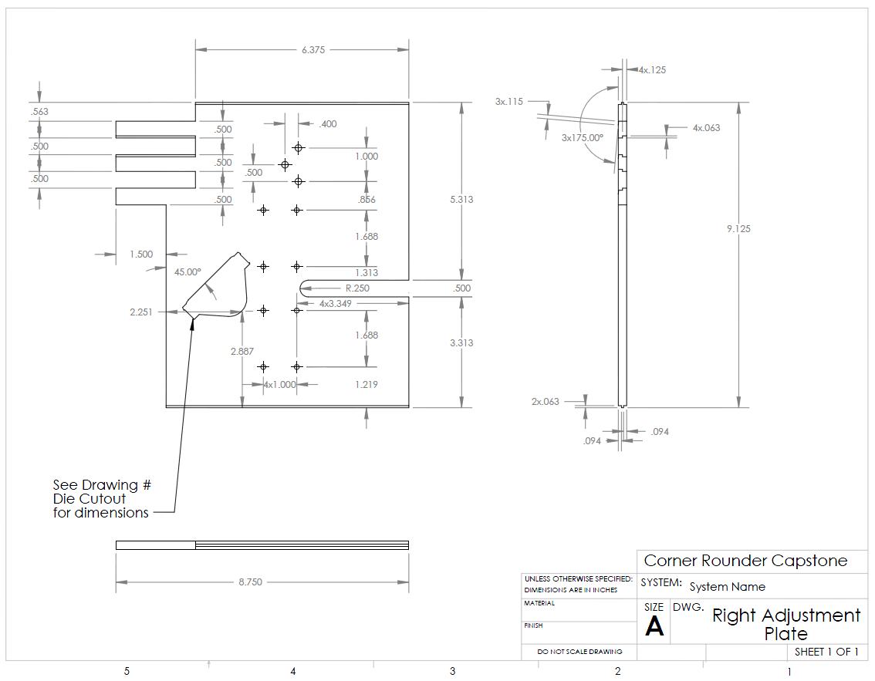
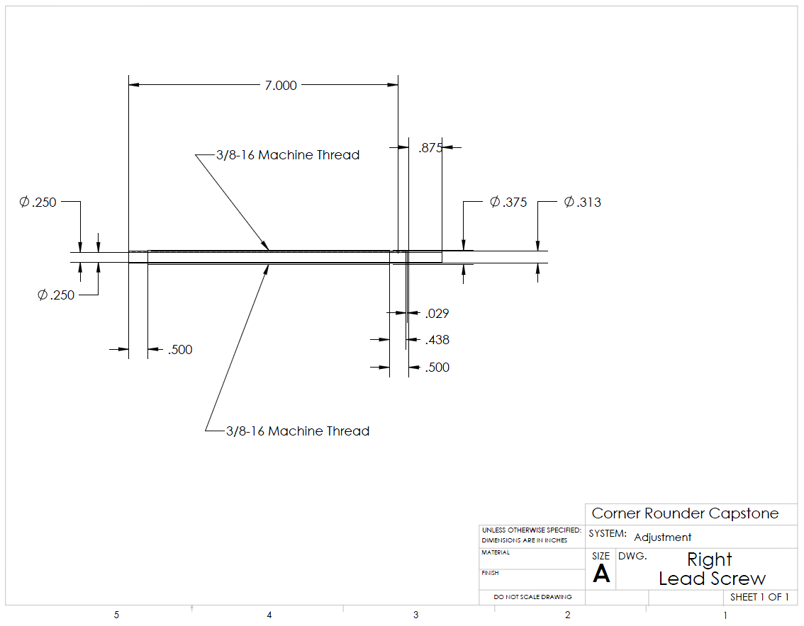
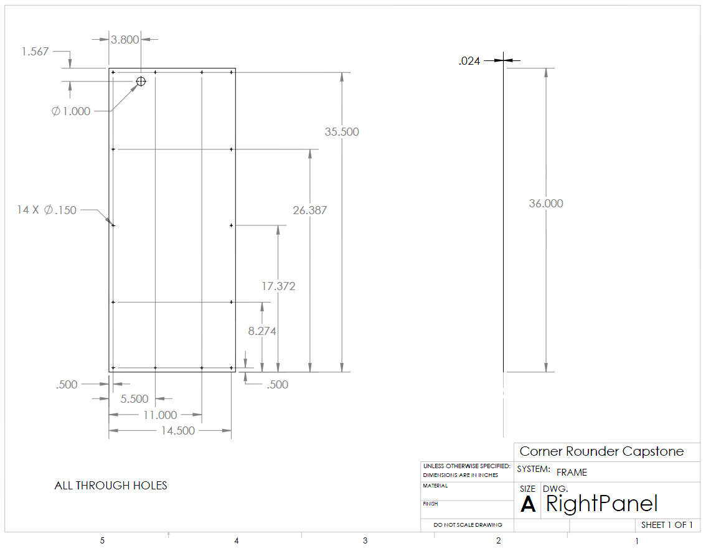
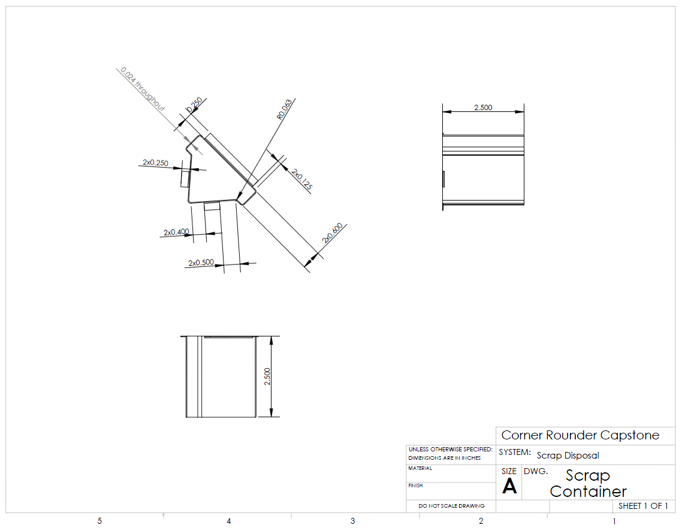
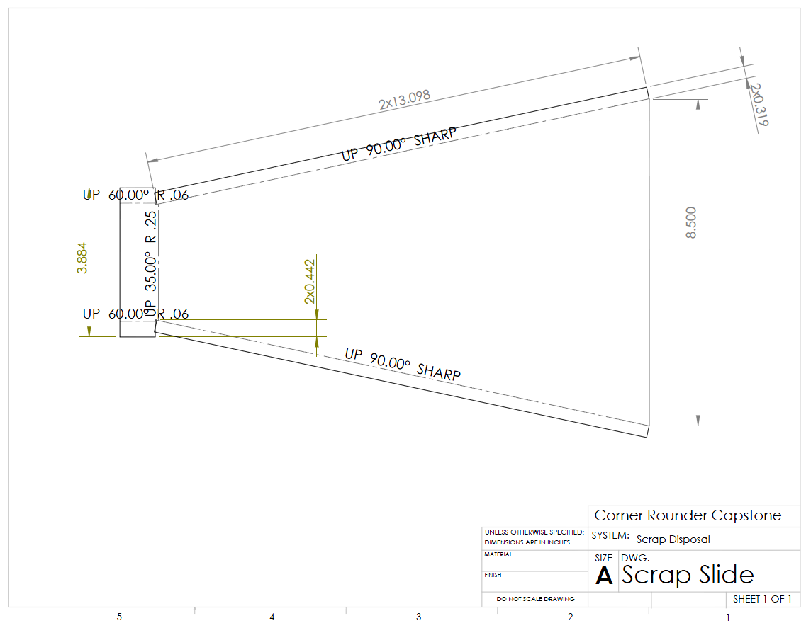
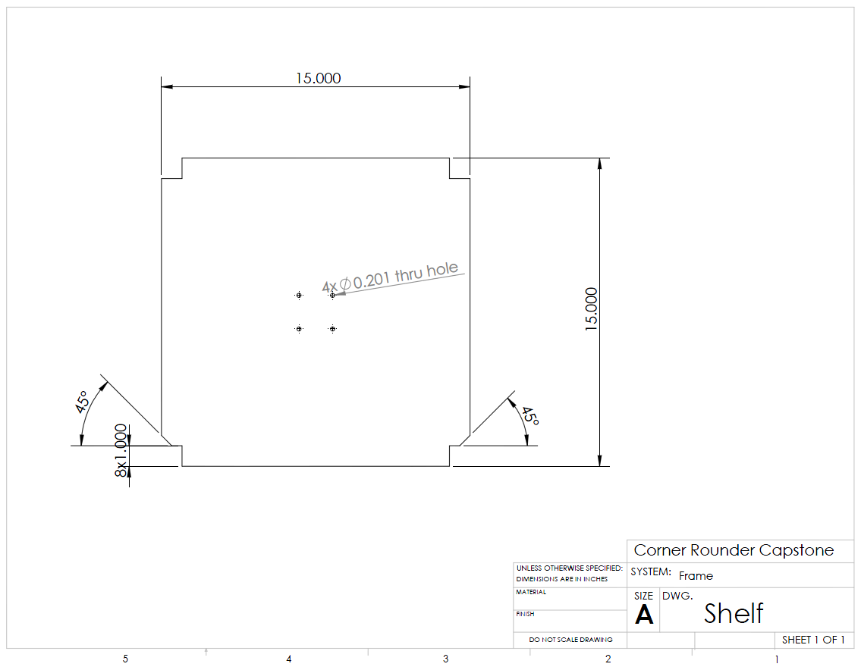
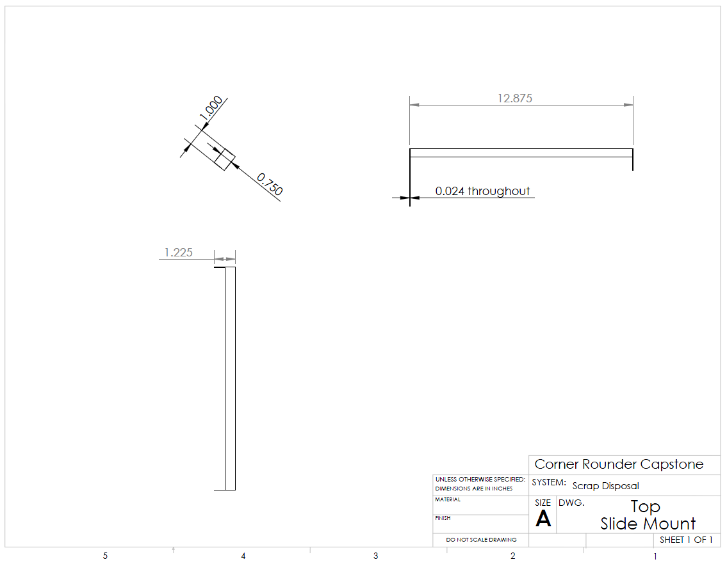
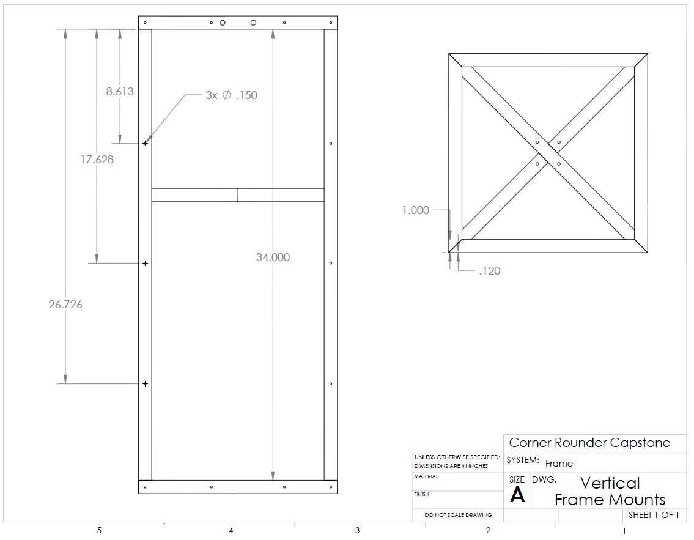
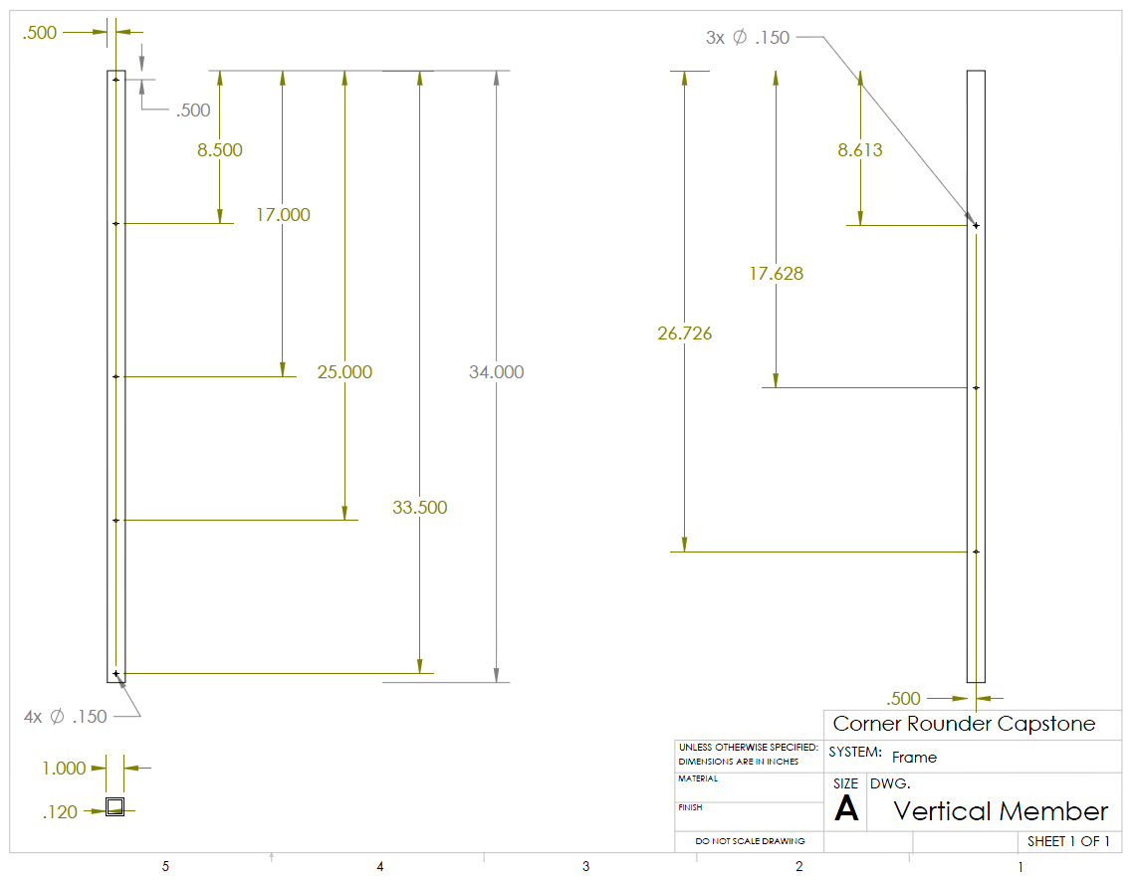
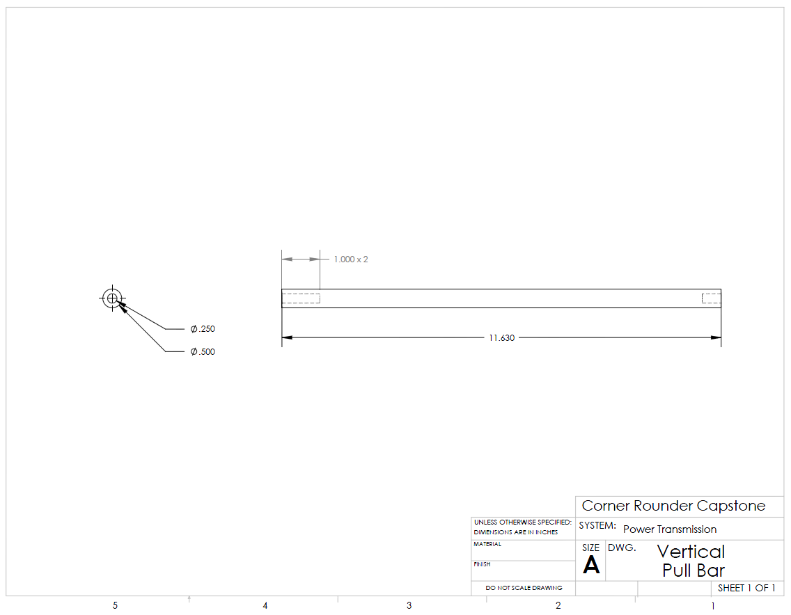

Appendix H: Operation Manual

How to use the Book Corner Rounder
- Plug the power supply into a 110V wall outlet.
- Attach an air supply hose of at least 120 psi into the air regulator.
- If the supply air is greater than 120 psi, adjust the regulator to step the feed down to 120 psi.
- Place the book, bound side out, on the top plate and push it forward in between the dies.
- Loosen the thumbscrews that hold the load plate to the vertical pull bars. This allows free movement of the dies.
- Unlock the plate adjustment hand wheel and rotate it to set the dies to the width of the book.
- Make sure that the book does not bow up in the center when inserted between both dies.
- Take the book out of the dies.
- Turn the machine on by activating the switch on the side of the machine WARNING: As soon as the machine is powered, accidentally hitting the foot pedal will activate the dies. Make sure the cutting plate is free and clear of scraps, fingers, etc. prior to turning the Corner Rounder on.
- Place the book to be rounded on the top plate.
- Push the book with both hands into the dies.
- Gently apply pressure forward and down on the book with both hands from the back of the book WARNING: The die blades are very sharp and the linear actuator will put out 150lbs of force no matter what is in the way, do not put your fingers in or near the dies as this could cause serious injury.
- Press the foot pedal.
- Remove the book.
- Repeat steps 10-14 for each run of books to be cut.
- Periodically turn the machine off and check the scrap collecting equipment for build ups of paper scraps.
- When the machine is not in use power it off by flipping the switch on the side of the frame to the off position. Also remove the air supply from the regulator.
Warnings
- The dies are extremely sharp; keep hands and fingers out of the cutting area at all times.
- Do not unlock the adjustment hand wheel when the machine is in operation, this could bring the dies out of alignment and affect the quality and accuracy of the cut.
- When powering down, always remove the air supply first and hit the foot pedal to bleed the lines, air left in the pneumatic lines could cause an accidental cut when the machine is powered up next.
- When adjusting the top plate, keep hands free of the gap between the left and right plate. The lead screw can supply enough pressure to cause injury if not careful.

Appendix I: Maintenance Manual

Mechanical:
Dies: Sharpen as necessary, replace as needed. Note: Dies can be sharpened by hand and replacements can be purchased from Lassco-Wizer or other printing equipment suppliers.
Electrical
Wiring: Replace as needed.
Arduino: If the controller stops functioning, or stops functioning properly go to the Arduino website, http://www.arduino.cc/. The website is also helpful if changes in programming are needed.
Pneumatic
Hose fittings: Remove and reapply silicon-sealing tape as needed.
Hoses: Replace as needed.
Regulator: Check lubrication levels regularly and fill when needed.

Appendix J: Project Plan
This section contains a Gantt chart detailing the schedule for major milestones and the length of time for completion.
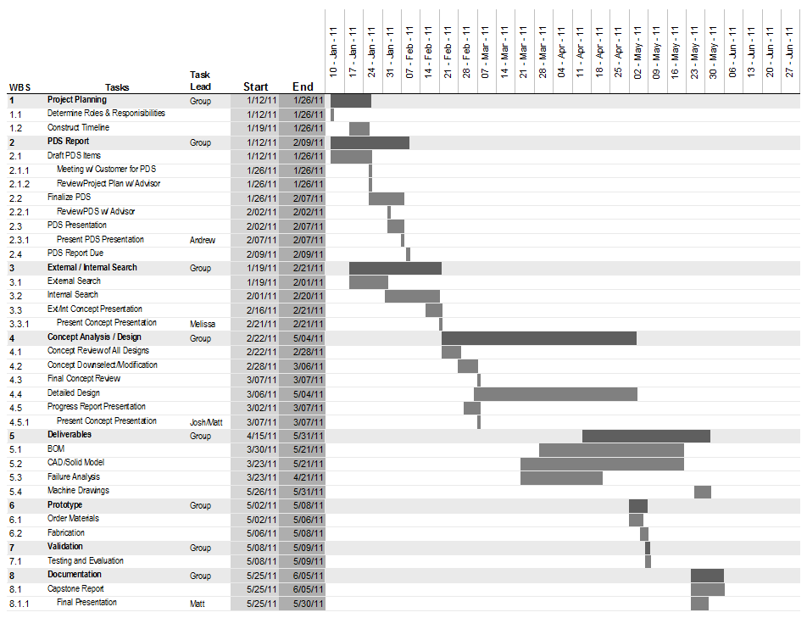
Figure J-1 Gantt Chart

Appendix K: References

jts3k, . "Controlling Solenoids with Arduino." Instructables 27 April 2011: n. pag. Web. 5 Jun 2011. <http://www.instructables.com/id/Controlling-solenoids-with-arduino/>.
Budynas, Richard, and Keith Nisbett. Shigley's Mechanical Engineering Design. Eighth. New York, New York: McGraw-Hill, 2008. Print.
"Arduino Playground." Arduino. Arduino, 21 April 2005. Web. 5 Jun 2011. <http://arduino.cc/en/>.
"More About Compact Extruded-Aluminum Switch-Ready Air Cylinders." Mcmaster-Carr. N.p., 6/5/2011. Web. 5 Jun 2011. <http://www.mcmaster.com/#standard-air-cylinders/=cmc3o7>.
Martin, Cliff. "Air Cylinders, Solenoids and Plumbing." Scary Guys. N.p., 6/5/2011. Web. 5 Jun 2011. <http://www.scaryguys.com/aircyl.htm>.
"About Air Compressors." About Air Compressors. N.p., n.d. Web. 5 Jun 2011. <http://www.about-air-compressors.com>.
“ENGR322: Homework set 7.” W.H. Warnes. Oregon State University, 25 May 2011. Web. 5 Jun 2011 <http://oregonstate.edu/instruct/engr322/Homework/S11/ENGR322HW7.html>

