FSAE **Formula Society of Automotive Engineers**

**Intake Manifold**

**ME 493 Final Report – Year 2010**

**Members**

Rob Brown

Scott Cone

Thuc Li

Brandon Wilen

David Winkleman

6/7/10

**Portland State University Advisor**

Dr. David A. Turcic

**Executive Summary:**

The intent of the following document is a final project report for the production of an intake manifold for a Formula SAE car. The goal was to produce an intake manifold for a Honda F4I engine currently mounted in a FSAE car that is owned by Viking Motorsports.

The student design team has progressed from researching intake manifolds, developing their own design, and prototyping/testing of an intake manifold.

The Product Design Specification (PDS) document was developed in conjunction with Viking Motorsports. The purpose of the document was to specify the design criteria and requirement. The document has had a few minor revisions, due to updated requirements from VMS. Notably the adding of a faring to shield the driver from any high pressure fuel lines, and the sizing of fuel injectors not previously the design teams responsibility.

An external searchwas conducted to identify different types of intake designs and possible combinations of runners, plenums, and throttle body locations. The search concluded that there were two prominent designs of how air entered the plenum and a multitude of different possibilities as to the packaging into the framework. The search additionally produced an improved throttle body that was purchased. The internal search produced several design possibilities. The concepts were discussed, compared and evaluated based on how they fulfilled the PDS document.

The final design was selected based upon its ability to be effectively packaged, its easily tunable performance, and the rapid turnaround in production. The detailed design contains the current runner lengths, plenum size and material selection.

The final design was rapid prototyped using the Selective laser sintering (SLS) process. The inside was coated with an **isophthalic High-Strength Resin to prevent fuel absorption. Viking Motorsports has installed the finished intake manifold on the race car, and are pleased with the results.**

**Table of Contents**

**Introduction 3**

**Mission Statement 4**

**Main Design Specifications Summary 4**

**Top Level Final Design Considerations 7**

**Detailed Design Considerations 9**

**Conclusion 11**

**Appendix A: Gantt Chart A-1**

**Appendix B: FSAE Regulations B-1**

**Appendix C: Acoustic Analysis C-1**

**Appendix D: PDS Chart D-1**

**Appendix E: FEA Analysis E-1**

**Appendix F: Choked Flow F-1**

**Appendix G: Heat to HP comparison G-1**

**Appendix H: Material Properties H-1**

**Introduction**

The Society of Automotive Engineers conducts an annual student design competition referred to as Formula SAE (FSAE). Universities around the world compete as design teams working for a hypothetical corporation, producing a marketable automotive race vehicle. To help promote creativity the design teams are limited to a 610cc engine that is restricted by a 20mm restrictor. The restrictor limits the power output of the engine to ensure the safety of the participating teams.

According to FSAE regulations, all air entering the engine is to pass through the restrictor with no throttling allowed downstream. Complexities of the restricted flow and the overlapping of valve timing produce airflow problems. It is beneficial to design an intake manifold that best utilizes the available airflow for increased performance. Teams strive to modify the intake system around the 20mm restrictor to maximize the air flow to the engine cylinders. Increasing air flow to the engine will allow the engine to produce more power and provide an advantage to the team during competition.

Originally there were several issues with Viking Motorsports intake system. They included lack of proper analysis and documentation, excessive weight from incomplete design, and improper fuel injector selection. No documentation of design considerations and calculations for the current intake manifold can be obtained. Therefore, the team does not have a baseline of performance/design to improve upon.

Viking Motorsports, the project sponsor had multiple concerns about the current intake design such as fluid flow efficiency. Improper airflow can leave excess air in the plenum of the intake manifold, causing less airflow through the restrictor. An intake manifold in proper resonance generates an air spring effect to force more flow to the engine cylinders, resulting in a dramatic rise in performance and power output of the engine. The intake team will do acoustical modeling to increase the effectiveness of the airflow. Without any documentation of current design, the team does not have any understanding of the flow characteristics through the current intake manifold. All flow calculations and analysis must be done by the team using flow requirement and desired characteristics of the engine.

The restrictor used in the 2008/2009 intake system consisted of an oversized throttle body, with a heavy billet aluminum adaptor. The 2008/2009 manifold was built of welded aluminum pieces, and was overbuilt for the pressures seen by the manifold. With proper material selection and strength analysis the wall thicknesses for the new manifold was optimized and the weight of the manifold was decreased. The fuel injectors on the 2008/2009 intake were incorrectly sized and do not maintain a steady idle. Viking Motorsports will be providing the intake team with the injectors necessary. The injectors provided will be incorporated as part of the design.

**Mission Statement**

The goal of the intake team is to experiment, design, optimize, and produce an improved intake manifold for the Viking Motorsports FSAE team. Main constraints are adhering to the size restrictions from the Viking Motorsports team, and the official rules of the FSAE competition. The design is also to weigh less and have better performance characteristics then the existing design.

**Main Design Specifications Summary**

Viking Motorsports is the primary sponsor for the intake manifold. The intake team will design, test, and manufacture a new intake manifold to be used by Viking Motorsports. The product design specifications are imposed to develop an intake manifold that conforms to the FSAE rules and regulations for competition, and also to the goals set by the sponsor to advance and improve the formula car. Based on FSAE competition rules, and working with Viking Motorsports, the following major design specifications were developed:

▪ **Conform to FSAE regulations.** The main restrictions on the air intake manifold is that it has to have a 20mm restrictor, and no throttling downstream of the restrictor. See appendix B

▪ **Fits into the current chassis of the car.** The air intake manifold must fit into the current chassis without obstructing other main components of the car. If any fuel lines extend beyond the current shield, there must be an addition of extra shielding per FSAE regulations.

▪ **Improve the performance.** Viking Motorsports desires the new air intake to improve the horsepower output of the car over the previous air intake. Testing and benchmarking information will be provided to Viking Motorsports regarding the airflow and performance characteristics.

▪ **Reduce the weight of the car.** A five pound reduction in weight was desired by Viking Motorsports. This is accomplished by material selection and the size and geometry of the new air intake manifold.

**Top-level design considerations**

During the brainstorming sessions, there were several designs developed that meet the packaging requirements of Viking Motorsports. One design used a symmetrical center entry with a 4x1 entering the plenum and the throttle body located behind the drivers head. This design could be a hybrid of welded aluminum and Selective Laser Sintered (SLS) material or purely SLS material and can be seen in Figure 1.

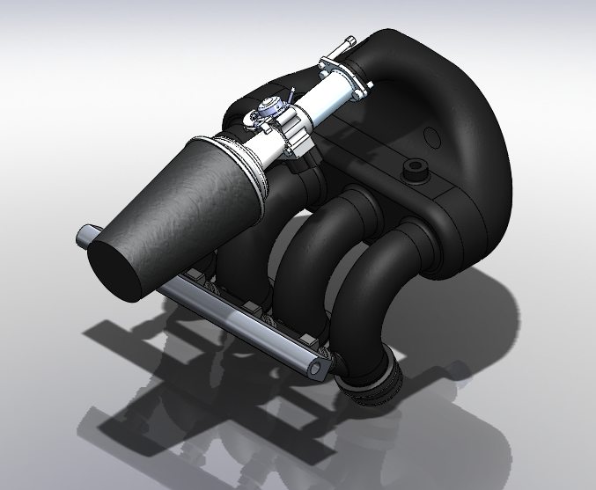

Figure 1: Center entry 4x1 plenum with the throttle body behind the drivers head

The second design was another symmetrical center entry, utilizing a 2x2 runner profile with one plenum and the throttle body located above the differential. Due to the complexity of the runner shape this design would have been full SLS and can be seen in Figure 2.

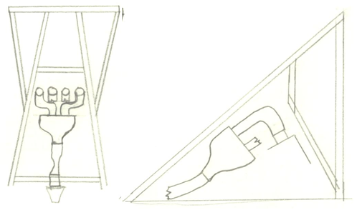

Figure2: Center entry 2x2 plenum with the throttle body above the differential.

The third and final design consisted of a symmetrical center entry 4x1 plenum with the throttle body located above the differential. This design would have also been a hybrid of SLS and Aluminum and can be seen in Figure 3.

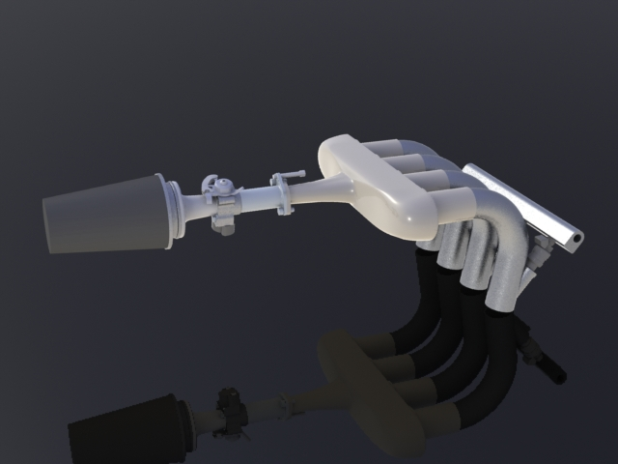

Figure 3: 4x1 Center entry plenum with throttle body above the differential

**Top-level final design evaluations**

A concept evaluation matrix was generated and used to evaluate the designs produced during the internal search and brain storming sessions. Some of the top priorities in this evaluation matrix consisted of fitting the current chassis, following FSAE requirements and having sufficient strength.

**Table 1: Concept evaluation matrix**

|  |  |  |  |  |
| --- | --- | --- | --- | --- |
| **Requirement** | **Priority** | **4x1 Behind** | **4x1 Diff** | **2x2 Diff** |
| Runner length | *** | *** | *** | ** |
| Center of gravity location | ** | * | *** | *** |
| Packaging in current chassis | *** | *** | *** | ** |
| Fuel injectors | ** | *** | * | * |
| Mounted per FSAE requirements | *** | *** | *** | *** |
| Strength and heat considerations | *** | *** | *** | ** |
| Aesthetics | * | ** | *** | ** |
| Installation/Bracketing | ** | ** | ** | * |

The concept evaluation table showed that most of the designs worked well with the initial requirements. The team originally chose the 4x1 Plenum with the throttle body above the differential as we felt it was extremely aesthetically pleasing, and packaged well. However after additional calculations of performance loss, due to low density air caused by the heat from the engine the 4x1 Plenum with the throttle body located behind the head was chosen. Appendix G shows the effects of the density on engine performance.

The team decided to build the plenum out of a SLS Fine Polyamide material to allow for an accurate and fast production of the model designed. The entire manifold was prototyped in one piece by Northwest UAV. The materials selection was made due to its relatively high strength to go along with its high manufacturability as seen in Table 2.

Table : Materials selection matrix

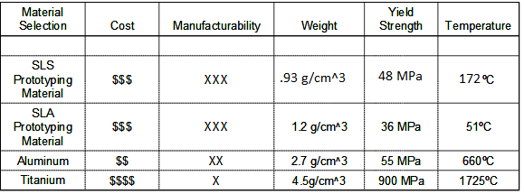

**Detailed Design**

After arriving at a final design concept more detailed design decisions were made by using an acoustical model, finite element analysis and further material investigation.

The acoustical model consisted of an impedance transform model that predicted the resonance and anti-resonance of various shapes and sizes of plenums and runners. The Matlab code (see appendix C, findres.m) was written such that desired impedance occurred between 9000 and 10000 RPMs due to the complimentary characteristics of the runners and plenum. Figure 4 shows the impedance of the designed manifold.

C:\Users\wilenbj\AppData\Local\Microsoft\Windows\Temporary Internet Files\Low\Content.IE5\MLRK84Y0\acoustical%20Impedance[1].tiff

Figure 4: Acoustical Impedance of an intake designed for max power between 9000 and 10000 RPM

The suggested plenum cross sectional area is estimated to be 3.5 in2, total plenum length 12.7 inches and a total runner length of 13 inches including the 4.095 inches from the engine to the valves. The projection drawings of the intake can be seen in Figure XXX.

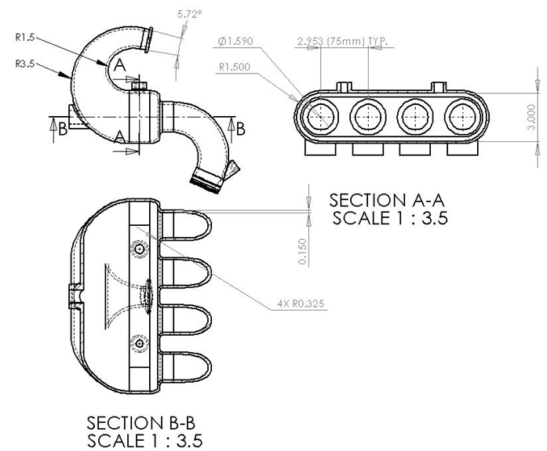

Figure 5: Projection Views of intake manifold sized according to Impedance Transform Model

After the geometry of the intake was decided upon, the location of ports and mounting brackets needed to be addressed. Some of the ports consisted of manifold absolute pressure sensor, air intake temperature sensor, and backfire release valve. These locations can be seen in figure 6.

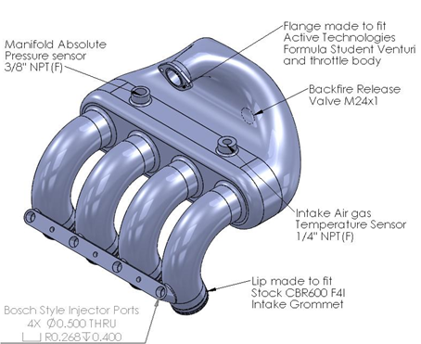

Figure 6: Mounting geometry and sensor port Locations

Once all of the geometry modeling had taken place finite element analysis was conducted to determine the proper wall thickness. The FEA was completed using material specs from Electro Optical Systems that can be seen in Appendix H. The results in Figure 7 show that the intake deflects .075” under a vacuum pressure of 10PSI when using a wall thickness of .2”.

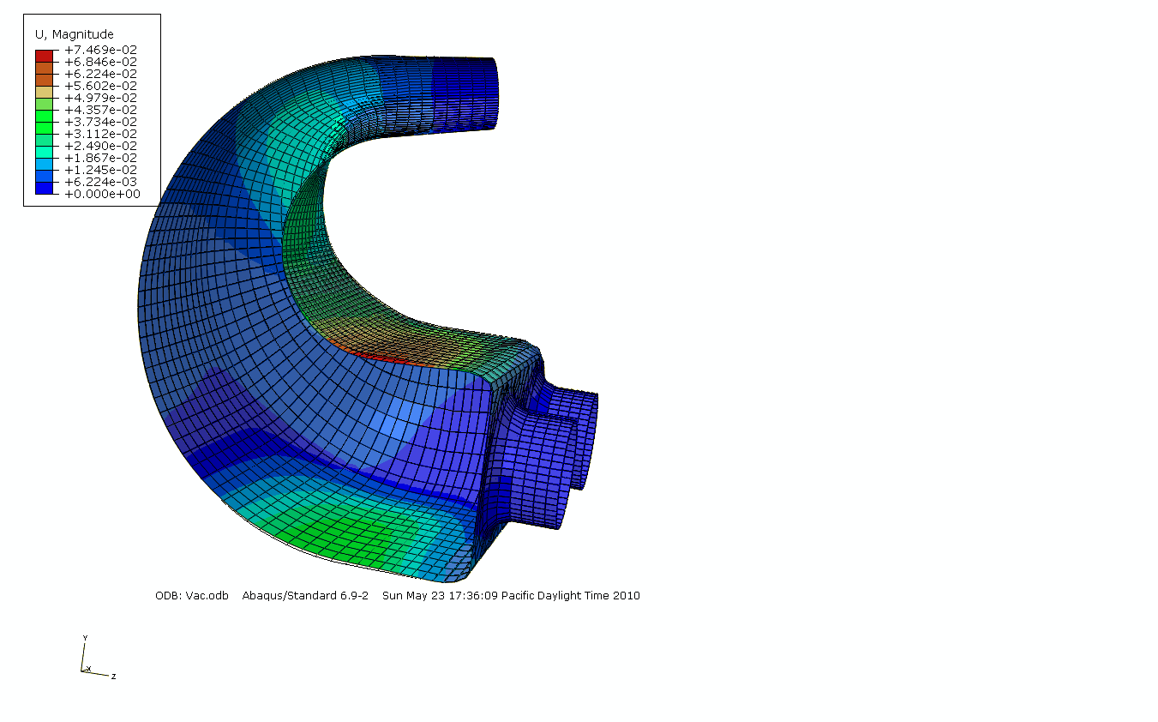

Figure 7: Finite Element Analysis Displacement results using a 10 PSI internal vacuum.

**PDS Evaluation:**

The highest requirements set forth in the PDS were for the intake manifold to fit within the current Viking Motorsports chassis, adhere to all FSAE rules, and improve performance while reducing weight. Each requirement mentioned was successfully met. The intake weighed significantly less the 2008/2009 with a final assembly weighing in at 5.75lbs; the 2008/2009 manifold weighted 11lbs, meeting our goal of over 5lbs of weight loss. It has the correct fuel injectors, and is mounted per SAE regulations. Figure 8 shows the Intake properly mounted in the current chassis.

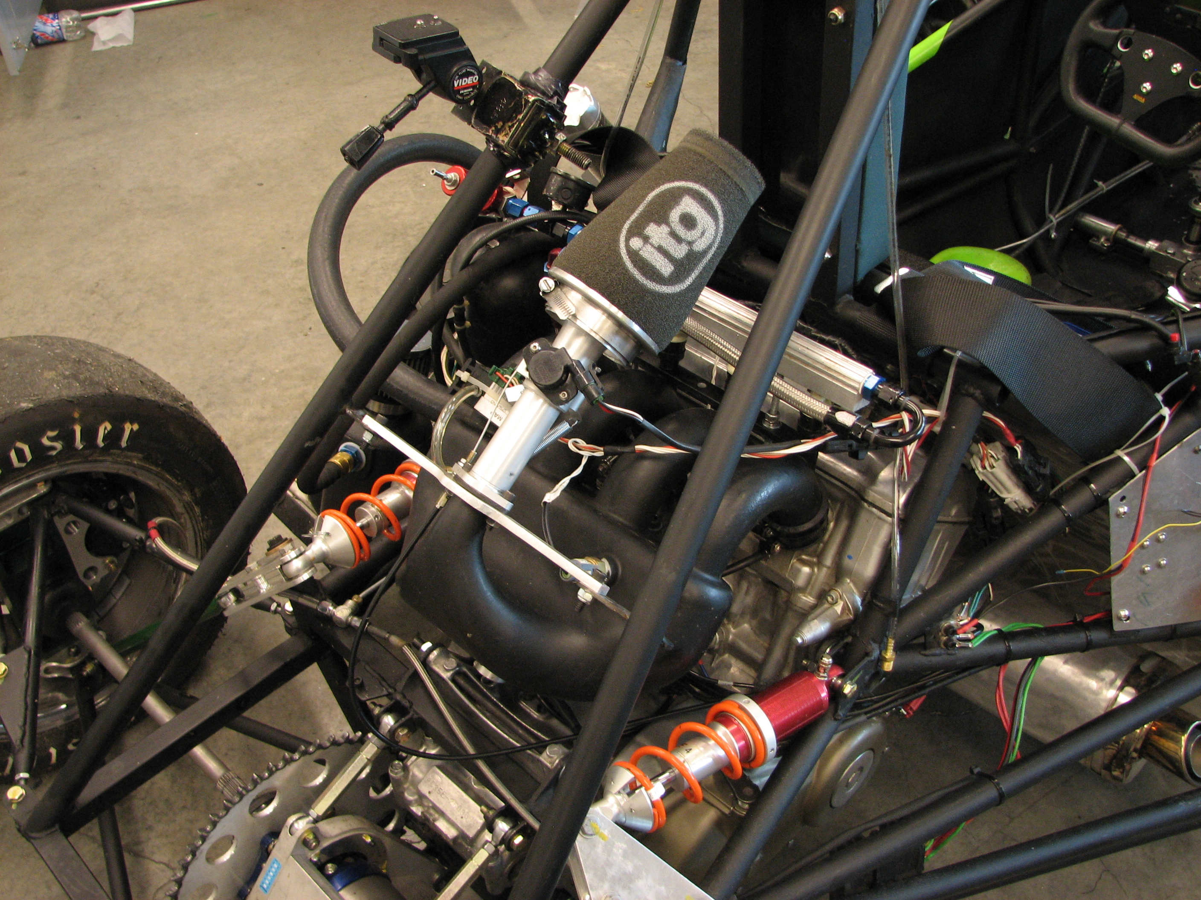

Figure 8: Intake Manifold mounted in Viking Motorsports 2010 FSAE car

After the final design was produced testing was conducted to verify our goals were met. By testing the acoustical properties of the intake, it can be seen that the resonance of the 2010 intake has a longer range of frequency and higher amplitude then the previous intakes. This would be beneficial due to the range of RPMs at which above greater than 100% efficiency occurs for a longer period of time.

Figure 9: Intake Acoustic resonance testing

By looking at the dyno graphs produced from a short period of time, it can be seen that the air fuel ratios and engine timing could use some work. Based on the fall off of fuel injection as the power starts to increase on the dyno it can be speculated that the acoustics of the intake are not being used at their full potential. Since the power starts to take off again at 8500 RPMs while fuel injection is still being reduced it is suspected that the acoustical resonance is starting to occur. This resonance can be correlated to the complimentary lack of impedance shown in our impedance model for the 2010 intake.

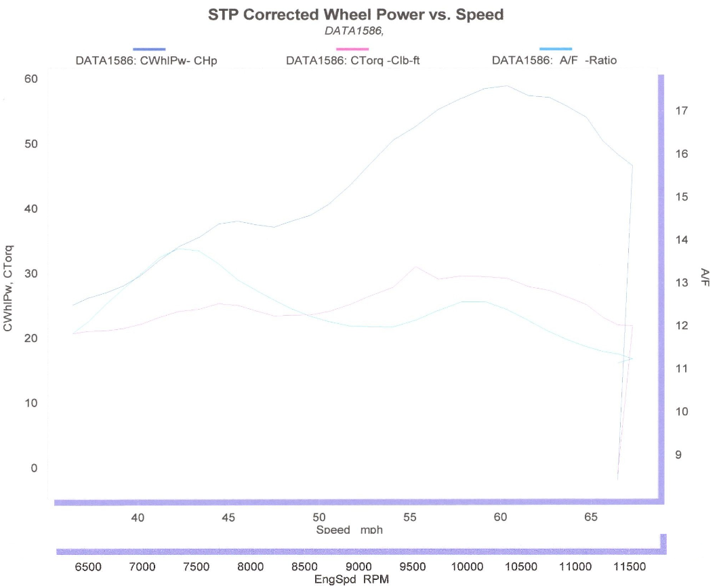

Figure 9: Dyno Graph of 2010 Viking Motorsports FSAE car.

Viking motorsports is pleased with this correlation and has plans to fix a parasitic frictional loss in the sprocket before spending further time on the dyno. Over the summer VMS plans to reduce friction loss in the drive train by 15%, change the final drive ratio and spend further time tuning the engine. With these changes made by VMS the intake should accomplish their goals and meet the requirements they requested.

**Conclusion**

The teams successfully provided Viking Motorsports with a new and improved intake manifold for Formula SAE. The manifold is an improvement to the 2008/2009 design in every aspect. The manifold fulfilled all requirements set forth in the PDS. It fits within the current chassis of the car, provided an improved performance, and has great esthetics. The engine idles smoothly and has good power through the RPM range with max power in the 9500 to 11,000RPM range. The intake also met the targeted weight loss of 5lbs, with an assembled weight of just 5.75lbs.

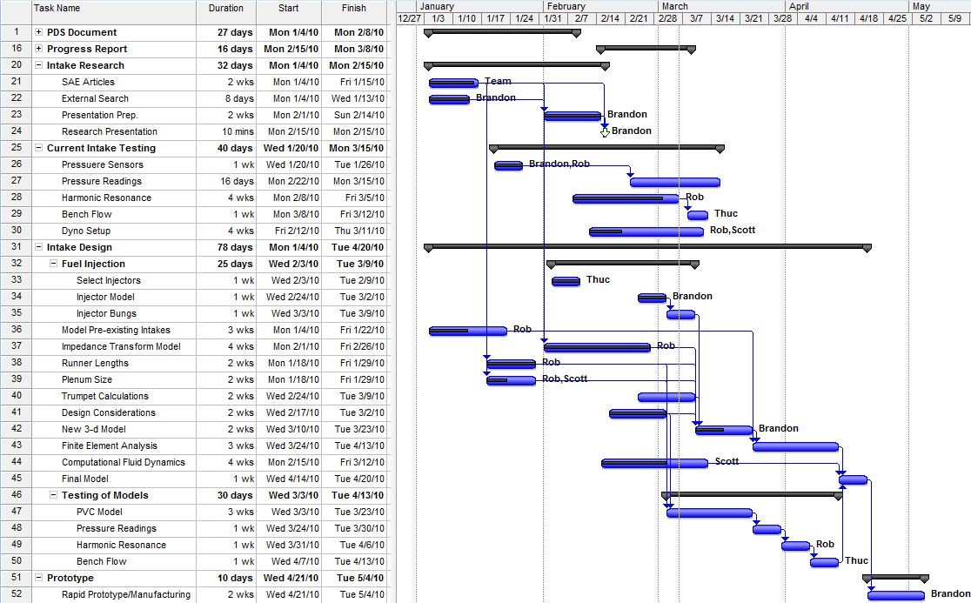

**FSAE - Rules and Regulations  
  
ARTICLE 8: POWERTRAIN**

**B8.1 Engine Limitation**

B8.1.1 The engine(s) used to power the car must be four-stroke piston engine(s) with a displacement not

exceeding 610 cc per cycle.

B8.1.2 The engine can be modified within the restrictions of the rules.

B8.1.3 If more than one engine is used, the total displacement cannot exceed 610 cc and the air for all

engines must pass through a single air intake restrictor (see B.8.6, “Intake System Restrictor.”)

B8.1.4 Hybrid powertrains utilizing on-board energy storage are not allowed.

**B8.2 Engine Inspection**

The organizer will measure or tear down a substantial number of engines to confirm conformance to

the rules. The initial measurement will be made externally with a measurement accuracy of one (1)

percent. When installed to and coaxially with spark plug hole, the measurement tool has dimensions

of 381 mm (15 inches) long and 30 mm (1.2 inches) diameter. Teams may choose to design in access

space for this tool above each spark plug hole to reduce time should their vehicle be inspected.

37

© 2009 SAE International. All Rights Reserved. Printed in USA. 2010 Formula SAE Rules

***B8.3 Starter***

Each car must be equipped with an on-board starter *which, during the competition, must be used to*

*start the car at all times. Push starts, or the use of a remote starter, are prohibited.*

**B8.4 Air Intake System**

B8.4.1 Air Intake System Location

All parts of the engine air and fuel control systems (including the throttle or carburetor, and the

complete air intake system, including the air cleaner and any air boxes) must lie within the surface

defined by the top of the roll bar and the outside edge of the four tires. (See Figure 13).

B8.4.2 Any portion of the air intake system that is less than 350 mm (13.8 inches) above the ground must be

shielded from side or rear impact collisions by structure built to Rule B.3.24 *or B.3.31* as applicable.

**B8.5 Throttle and Throttle Actuation**

B8.5.1 Carburetor/Throttle Body

The car must be equipped with a carburetor or throttle body. The carburetor or throttle body may be of

any size or design.

B8.5.2 Throttle Actuation

The throttle must be actuated mechanically, i.e. via a cable or a rod system. The use of electronic

throttle control (ETC) or “drive-by-wire” is prohibited.

B8.5.3 The throttle cable or rod must have smooth operation, and must not have the possibility of binding or

sticking.

B8.5.4 The throttle actuation system must use at least two (2) return springs located at the throttle body, so

that the failure of any component of the throttle system will not prevent the throttle returning to the

closed position.

**Note:** Throttle Position Sensors (TPS) are NOT acceptable as return springs.

B8.5.5 Throttle cables must be at least 50.8 mm (2 inches) from any exhaust system component and out of

the exhaust stream.

B8.5.6 A positive pedal stop must be incorporated on the throttle pedal to prevent over stressing the throttle

cable or actuation system.

**B8.6 Intake System Restrictor**

B8.6.1 In order to limit the power capability from the engine, a single circular restrictor must be placed in the

intake system between the throttle and the engine and all engine airflow must pass through the

restrictor.

B8.6.2 Any device that has the ability to throttle the engine downstream of the restrictor is prohibited.

B8.6.3 The maximum restrictor diameters are:

- Gasoline fueled cars - 20.0 mm (0.7874 inch)

- E-85 fueled cars – 19.0 mm (0.7480 inch)

B8.6.4 The restrictor must be located to facilitate measurement during the inspection process.

38

© 2009 SAE International. All Rights Reserved. Printed in USA. 2010 Formula SAE Rules

B8.6.5 The circular restricting cross section may NOT be movable or flexible in any way, e.g. the restrictor

may not be part of the movable portion of a barrel throttle body.

B8.6.6 If more than one engine is used, the intake air for all engines must pass through the one restrictor.

**B8.7 Turbochargers & Superchargers**

B8.7.1 Turbochargers or superchargers are allowed if the competition team designs the application. Engines

that have been designed for and originally come equipped with a turbocharger are not allowed to

compete with the turbo installed.

B8.7.2 The restrictor must be placed upstream of the compressor but after the carburetor or throttle valve.

Thus, the only sequence allowed is throttle, restrictor, compressor, engine.

B8.7.3 The intake air may be cooled with an intercooler (a charge air cooler). Only ambient air may be used

to remove heat from the intercooler system. Air-to-air and water-to air intercoolers are permitted. The

coolant of a water-to-air intercooler system must comply with Rule B.8.10.

**B8.8 Fuel Lines**

B8.8.1 Plastic fuel lines between the fuel tank and the engine (supply and return) are prohibited.

B8.8.2 If rubber fuel line or hose is used, the components over which the hose is clamped must have annular

bulb or barbed fittings to retain the hose. Also, clamps specifically designed for fuel lines must be

used. These clamps have three (3) important features, (i) a full 360 degree (360°) wrap, (ii) a nut and

bolt system for tightening, and (iii) rolled edges to prevent the clamp cutting into the hose. Worm-gear

type hose clamps are not approved for use on any fuel line.

B8.8.3 Fuel lines must be securely attached to the vehicle and/or engine.

B8.8.4 All fuel lines must be shielded from possible rotating equipment failure or collision damage.

**B8.9 Fuel Injection System Requirements**

The following requirements apply to fuel injection systems.

B8.9.1 Fuel Lines – Flexible fuel lines must be either (i) metal braided hose with either crimped-on or

reusable, threaded fittings, or (ii) reinforced rubber hose with some form of abrasion resistant

protection with fuel line clamps per B.8.8.2. Note: Hose clamps over metal braided hose will not be

accepted.

B8.9.2 Fuel Rail – The fuel rail must be securely attached to the engine cylinder block, cylinder head, or

intake manifold with brackets and mechanical fasteners. This precludes the use of hose clamps, plastic

ties, or safety wire.

B8.9.3 Intake Manifold – The intake manifold must be securely attached to the engine block or cylinder headwith brackets and mechanical fasteners. This precludes the use of hose clamps, plastic ties, or safety

wires. The use of rubber bushings or hose is acceptable for creating and sealing air passages, but is not

considered a structural attachment.

**Find:**

The appropriate runner length and plenum parameters where resonance of each part is complementary in the 10000 rpm range.

**Solution [See 1 for analysis method]:**

****Where ω is the input frequency, and c is the speed of sound.

**Characteristic Impedance:**

 Where ρ is the density of air, c is the speed of sound, and s is the cross sectional area of the pipe.

**Impedance across an open pipe:**

 Where is the impedance at the unknown end of a pipe, is the known impedance at the other end of the pipe, j is imaginary, and L is the length of the pipe.

**Impedance for a closed pipe:**



**Summing impedance at the t intersection of a pipe:**

Where Z1 and Z2 are the impedance values of two sides in the t intersection.

Since the impedance relates to the engine speed, calculations must be taken across a large range, MATLAB was used to create a function program and plot the results.

The impedance values were calculated assuming one cylinder was open with three other runners having closed valves. While there is a short time of overlap with one valve opening and the other closing potentially causing interference this was ignored. Since the time at which valve overlap decreases as the speed of the engine increases and the range of interest is at about 10000 rpm’s it is considered a decent assumption.

To find the most optimal solution where resonance is complimentary in the desired range another MATLAB file was written containing while loops to test for the distance between minimums of various components of the intake system.

impedance10.m

function imp = impedance10(f,L)

%Sound Qualities

c = 13503.937; %in/sec

rho = 0.000043714; %lb/in^3

omega = 2*3.14*(2*f/60);

k = omega/c;

%Cross sectional area

scyl = 5.46; %in^2

splenum = 3.5; %in^2

srunner = 1.37; %in^2

sintake = 3; %in^2

%Lengths

Lcyl = .835; %in

Lpend = 1.85; %in

Lpmiddle = 3; %in

Lrunner = L; %in

Lintake = 3.625; %in

%Characteristic Z values

Zcyl = (rho*c)/scyl;

Zplenum =(rho*c)/splenum;

Zrunner = (rho*c)/srunner;

Zintake = (rho*c)/sintake;

%Effective Z values for closed ends

Zcyle = Zcyl/(j*tan(k*Lcyl));

Zrunnere = Zrunner/(j*tan(k*Lrunner));

Zpende = Zplenum/(j*tan(k*Lpend));

Zrunnercyle = (Zcyle + j*Zrunner*tan(k*Lrunner))/(1+j*(Zcyle/Zrunner)*tan(k*Lrunner));

%Effective Z values at points

Z3 = 1/(1/Zpende+1/Zrunnere);

Z4 = (Z3 + j*Zplenum*tan(k*Lpmiddle))/(1+j*(Z3/Zplenum)*tan(k*Lpmiddle));

Z6 = 1/(1/Z4+1/Zrunnercyle);

Z7 = (Z6 + j*Zplenum*tan(k*Lpmiddle/2))/(1+j*(Z6/Zplenum)*tan(k*Lpmiddle/2)); %Middle 1

Z13 = 1/(1/Zpende+1/Zrunnere);

Z12 = (Z13 + j*Zplenum*tan(k*Lpmiddle))/(1+j*(Z13/Zplenum)*tan(k*Lpmiddle));

Z10 = 1/(1/Z12+1/Zrunnere);

Z9 = (Z10 + j*Zplenum*tan(k*Lpmiddle/2))/(1+j*(Z10/Zplenum)*tan(k*Lpmiddle/2)); %Middle 2

Z8 = 1/(1/Z7 + 1/Z9);

Z15 = (Z8 + j*Zintake*tan(k*Lintake))/(1+j*(Z8/Zintake)*tan(k*Lintake));

zcyl = 1/(1/Zpende+1/Zrunnercyle);

A = log(abs(zcyl));

B = log(abs(Z15));

imp = [A B];

fullplot10.m

function fullplot10(L)

x = 0;

cyl = [];

int = [];

rpm = [];

while x<12000

A=impedance10(x,L);

cyl = [cyl;A(1,1)];

int = [int;A(1,2)];

rpm = [rpm;x];

x=x+5;

end

hold on

plot(rpm,cyl,'-b')

plot(rpm,int,'--r')

axis([0 12000 -8 6])

set(gca,'xtick',0:1000:12000)

set(gca,'ytick',-8:2:6)

title('Impedance of Viking Motorsport 2009 Intake','interpreter','LaTeX')

xlabel('Engine Speed (RPM)','interpreter','LaTeX')

ylabel('Acoustic Impedance (dB/Hz)','interpreter','LaTeX')

Findres.m

function optub=findres(a,b)

%Initializing Parameters

L = 8;

Lpendst = 1.5;

cast = 10;

%Initialize Power Band Bounds

bottomub = a;

topub = b;

%State Variables

x = 0;

iter = 5;

optval = 3000;

while L < 15

Lpend = Lpendst;

while Lpend < 5

ca = cast;

while ca < 12

%initialize for impedance calculation

x = 0;

%cyl = [];

int = [];

run = [];

rpm = [];

c = 0;

i = 0;

m = 0;

%impedance calculation

while x<12000

A=impedanceres(x,L,Lpend,ca);

%cyl = [cyl A(1,1)];

int = [int A(1,2)];

run = [run A(1,3)];

rpm = [rpm x];

x=x+iter;

end

%mincyl = findminima(cyl);

minint = findminima(int);

minrun = findminima(run);

[m,n] = size(minint);

if m > 2

minintub = minint(3,1);

if topub > minintub*iter

if minintub*iter > bottomub

if abs((minintub-minrun)*iter) < optval

optub = [L, Lpend, ca];

optval = abs((minintub-minrun)*iter);

end

end

end

end

ca = ca + 0.5;

end

Lpend = Lpend + 0.5; %Iteration of Lpend

end

L = L + 1; %Iteration of L

end

**Conclusion:**

An appropriate plenum cross sectional area is estimated to be 3.5 in2, total plenum length 12.7 inches and a total runner length of 13 inches including the 4.095 inches from the engine to the valves.

**Project Design Specification**

|  |  |  |  |  |  |  |
| --- | --- | --- | --- | --- | --- | --- |
| **Requirement** | | **Priority** | **Customer** | **Metric** | **Target** | **Verification** |
| **Performance:** | |  |  |  |  |  |
| Keep steady Idle | | *** | VMS | RPM | 800-1000 | Testing |
| Sealed / no air leaks | | ** | VMS | Yes/No | Yes | Testing |
| Ports sized for VMS injectors | | *** | VMS | Measurement | Fit w/ tolerance | Design |
| Allows maximum Airflow | | *** | VMS | Airflow | 150-200 CFM | Testing |
| Allow ports for all sensors | | ** | VMS | Yes/No | Yes | Design |
| Mounted per FSAE requirements | | *** | SAE | Yes/No | Yes | Referencing Codes |
| Withstand pressure of engine | | *** | VMS | Pressure | 2 bar | Pressure sensor |
| Withstand heat from engine | | *** | VMS | Temperature | 500°F | Temperature probe |
| Withstand pressure of backfire | | *** | VMS | Pressure | 5 | FEA on model |
|  |  |  |  |  |  |  |
| **Weight** | |  |  |  |  |  |
| 5lbs less than current intake manifold | | * | VMS | Yes/No |  | Scale |
|  | |  |  |  |  |  |

*** - High Priority ** - Medium Priority * - Low priority

|  |  |  |  |  |  |  |
| --- | --- | --- | --- | --- | --- | --- |
| **Aesthetics** | |  |  |  |  |  |
| No sharp edges | | * | VMS | Radius | 0.125 | Touch |
| Matching color to chassis | | * | VMS | Yes/No | Match Color | Visual |
| Matching finish to new throttle body | | * | VMS | Yes/No | Finish | Visual |
|  |  |  |  |  |  |  |
| **Installation** | |  |  |  |  |  |
| Removable | | ** | VMS | Time | <10mins | Time |
| Removal Tools | | * | VMS | Yes/No | Common tools | Engine tools |
|  |  |  |  |  |  |  |
| **Size** | |  |  |  |  |  |
| Fit in current chassis | | *** | VMS | Yes/No | Yes | Design |
| Allow access for maintenance | | * | VMS | Yes/No | Yes | Design |
|  |  |  |  |  |  |  |
| **Documentation** | |  |  |  |  |  |
| Torque Curve | | ** | VMS | Yes/No | Yes | Production |
| Horsepower curve | | ** | VMS | Yes/No | Yes | Production |
| CFD Models | | ** | VMS | Yes/No | Yes | Design |
| Solidwork Models | | *** | VMS | Yes/No | Yes | Design |

*** - High Priority ** - Medium Priority * - Low priority

**Summary Section**

The objective of this analysis was to determine the required thickness of plenum material under a normal vacuum condition while the engine is running. Too small of a thickness could result in the plenum imploding, and to large of a thickness adds unneeded weight.

**Formulation Section**

By using finite element analysis the stress and deflection can be calculated by using a system of linear equations to find the values at each node of the elements applied to the surface.

**Schematic**

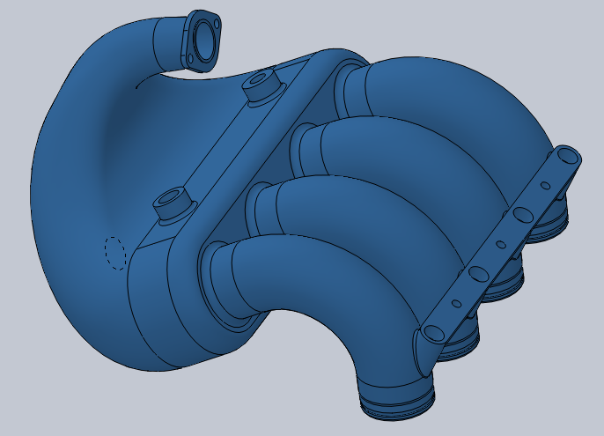

**Given:**

Absolute Pressure at choked flow: 7.237 psi

Average barometric pressure in Fontana California, June 17-21 2009: 13.8 psi

Material used: PA 2200 (Nylon SLS powder)

Elastic Modulus: 247 kpsi

Poison’s Ratio: 0.3

**Find:**

An optimal thickness based on the deflection and stress which occurs under normal running conditions.

**Solution**

Due to the symmetric nature of the plenum half of the model was analyzed to reduce calculation time. A symmetry boundary condition fixing displacement in the x direction along the edge of symmetry was applied, as well as fixing the runners and inlet of the plenum. A pressure load of -10 psi was applied as shown below. A thickness of 0.2 inches was applied to the whole shell surface.

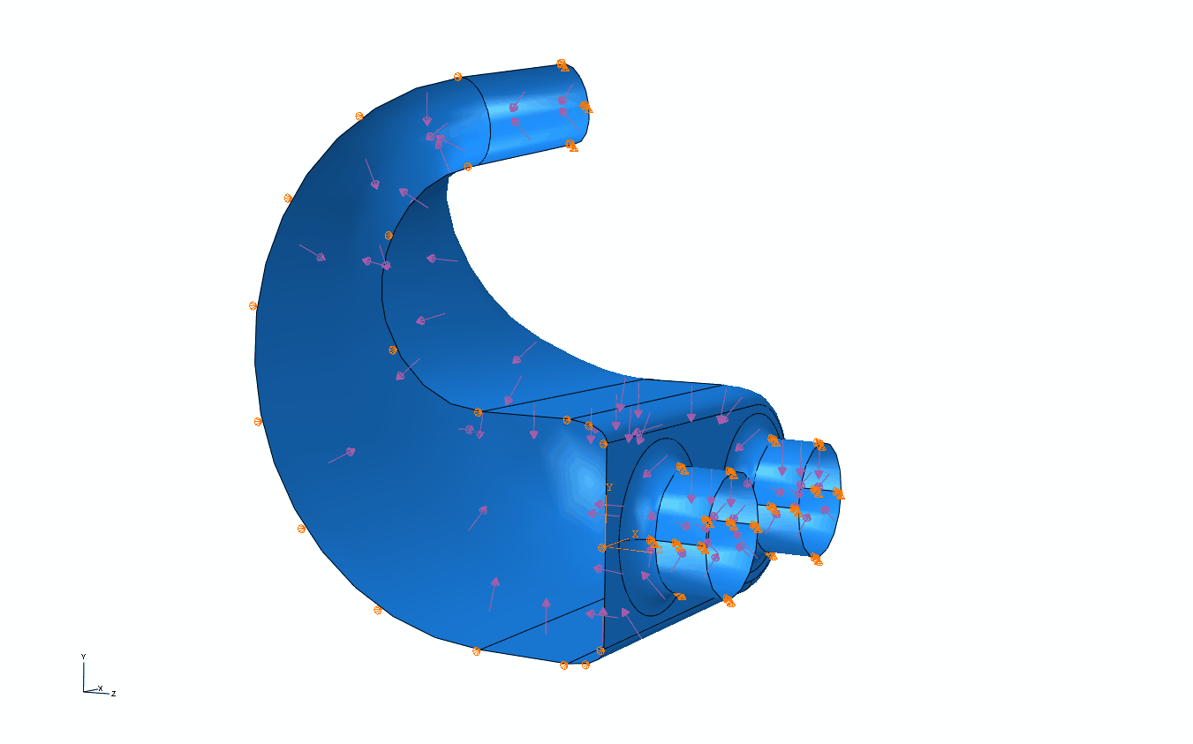

As seen below the mesh where the runners meet the plenum contains some sharp angles and less than ideal elements, since this area is not likely to be the main area of concern this mesh was considered to be appropriate.

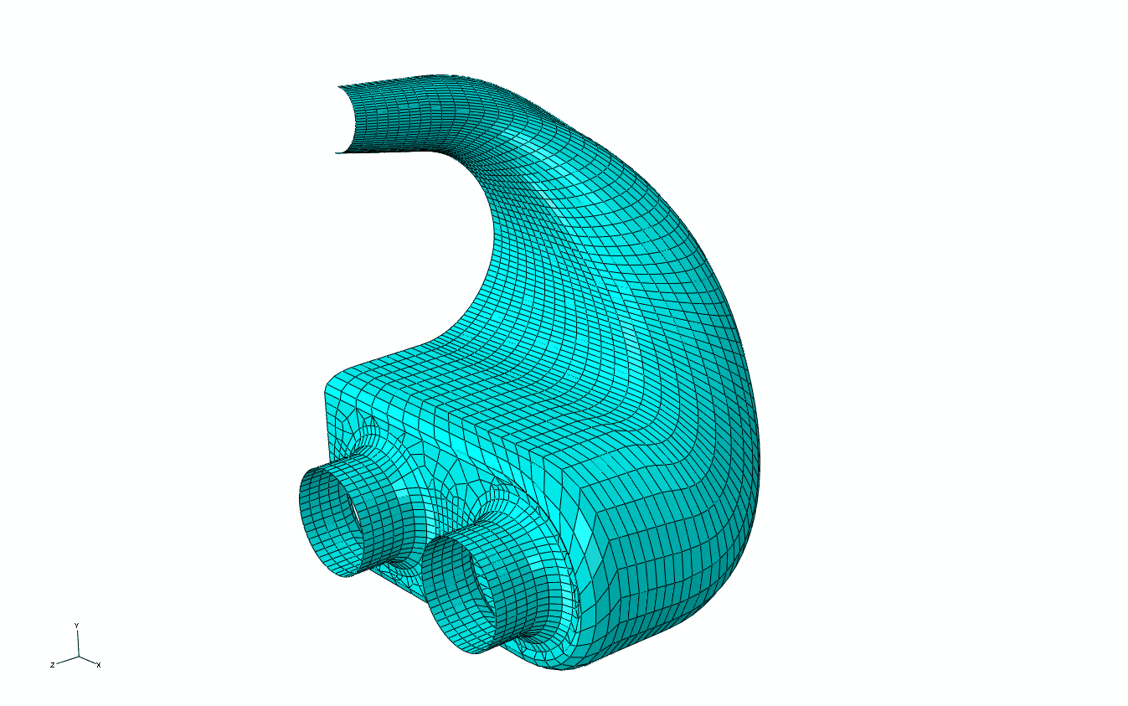



It can be seen that the maximum deflection is 0.075 inches in the center of the large flat surface on the plenum. The displacement between the unloaded and loaded model shown on the right is to scale.

Looking at the von misses stress it can be seen that the largest area of stress is under the two inside runners. To be sure that the stress is not due to a stress concentration factor the number of elements in that area were increased. As it can be seen the stress remains fairly close to the same and the change in stress along the elements is less than 200 psi.

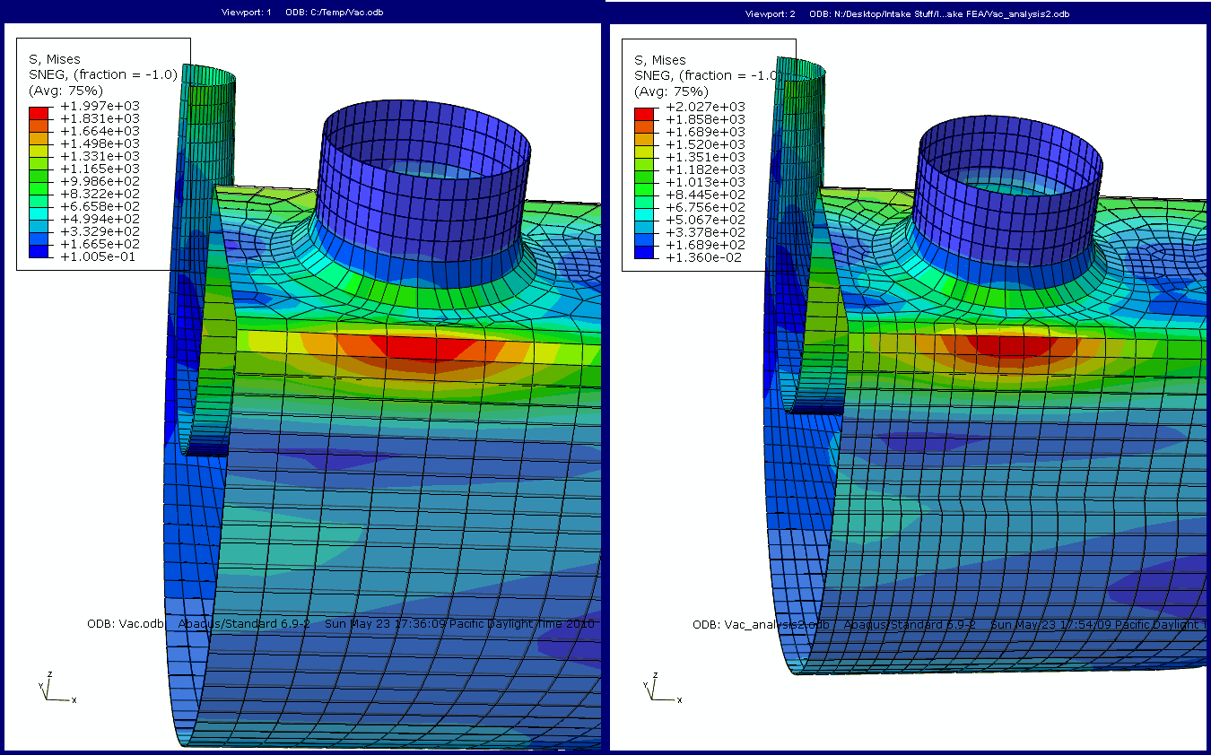

With a stress of 2000 psi and a tensile strength of 6962 psi, a thickness of 0.2 inches provides a factor of safety of 3.

**References:**

[1]: Material Data Sheet: PA 2200, NWUAV Propulsion systems. <http://www.nwuav.com/rapid_manufacturing.html>

**Summary Section**

The objective of this analysis was to determine rpm and mass flow rate at which choke flow occurs. Since the possibility of flow being choked off before the maximum rpm of the engine is achieved it is important to know where choke flow occurs and what conditions at which it occurs for various design decisions.

**Formulation Section**

By relating critical pressure, mass flow rate, density and temperature, the pressure and mass flow rate at choke flow can be found, as well as volumetric flow rate and rpm at which choke flow occurs.

**Given:**

Average Barometric Pressure in Fontana California, June 2009: 13.8 psi

Average Temperature in Fontana California, June 2009: 80ºF

Venturi Restriction Size: 20 mm

**Find:**

Find the pressure, mass flow rate, after the restrictor and rpm when choke flow occurs.

**Solution**



It can be seen that at choke flow the mass flow rate is 124 grams/sec with an absolute pressure of 7.237 psi which occurs at 13930 rpms, assuming a volumetric efficiency of 35 percent.

**References:**

[1]: Munson, Young, Okiishi, Fundamentals of Fluid Mechanics Fifth Edition Page 633-637.

**Analysis of Air Temperature Effects on Horsepower**

**Summary**

The objective of this analysis to shows the effects of the increase in air temperature on the horsepower output of the engine. The horsepower output of the engine is linearly related the density of the air that is pulled into the cylinders. The higher the density of air that is in the cylinder, more fuel will be able to combust in the reaction. This causes an increase in the force exerted on the piston, and therefore a higher output of torque.

**Analysis**

We relate the density of air through the ideal gas law

Pν = RT

Where P is absolute pressure, ν is the specific volume, R is the is the gas constant for air given as 0.287 KJ/Kg·K, and T is the air temperature in absolute.

The specific volume is equal to 1/ρ, where ρ is the density of air.

Based on this relationship of air temperature to density, we can create a graph showing how the increase in air temperature will cause a decrease in air density.

**Conclusion**

Based on this relationship, we concluded that in order to maximize the horsepower output of our engine, we needed to shape the geometry of the air intake in such a way to allow for the maximum flow of the coolest air. Our original design of having the air intake mounted behind the engine and radiator would have caused an unnecessary loss of horsepower. Our final design corrected this problem by mounting the air intake well above the motor and in the fresh stream of air coming over the car.

