**Netbook Passive Cooling**

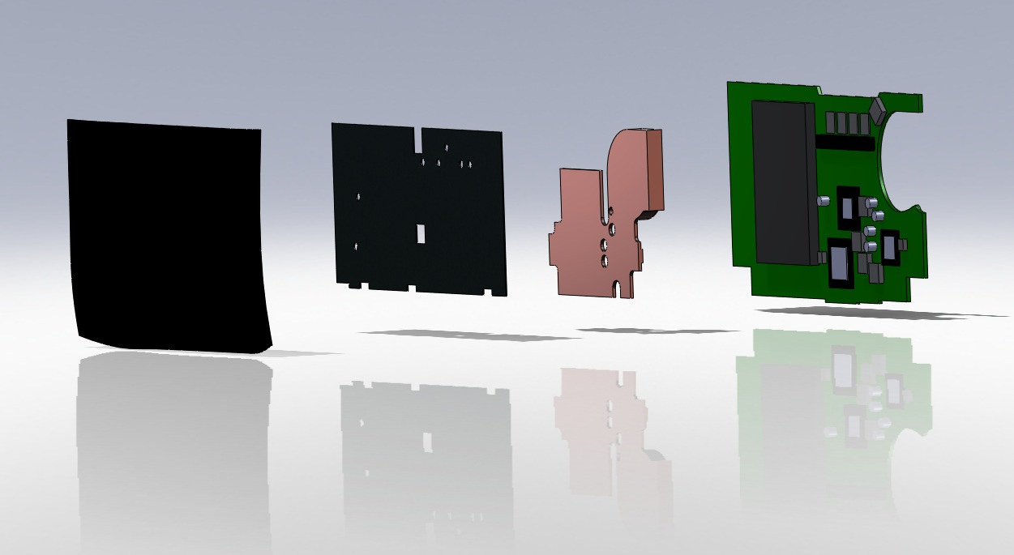ME 493 Final Report - 2010

|  |  |
| --- | --- |
| **Team Members:** Jesse Crutchfield  Eduardo Guerrero  Ronald Payne  Gerard Stabley  Jeremy Tucker | **Academic Advisor:**  Dr. Raul Cal  **Industry Advisor:** Jered Wikander  **Industry Sponsor:** Intel Corporation  June 7, 2010 |

**Executive Summary**

The design and selection of components to be used for a Passive Netbook Cooling System has been completed by the Portland State University design team. Intel provided the design specification for the system and the final prototype will be used in their research of alternative cooling solutions for electronic devices.

A thorough research and review of several design concepts was completed. A decision matrix, based on the original design criteria, was used to evaluate the candidate design concepts and select a primary design. The final design incorporates a copper heat sink with a graphite heat spreader to effectively cool the Netbook without additional power requirements. A detailed analysis of the final design was completed and compared to the baseline test results. The temperature of the CPU and GMCH increased by 2°C and 3°C, respectively, with the passive cooling solution installed. The skin temperature of the netbook increased by up to 11.4°C, but remained within the acceptable comfort range.

**Table of Contents**

Introduction 3

Mission Statement 3

Main Design Requirements 3

Selection Process 4

Pulse Thermal Loop 4

Loop Heat Pipes 5

Case Integrated Heat Sink 6

Final Design 7

Copper Heat Sink 7

Graphite Heat Spreader 9

Final Design Evaluation 9

Conclusion 12

References 13

Appendix A: Product Design Specifications 14

Appendix B: Manufacturing and Assembly 15

Appendix C: Component Research 17

Appendix D: Calculations 18

Appendix E: Experimental Results 31

Appendix F: Detailed Drawings and BOM 37

# Introduction

As electronic devices have shrunk in size over the years, removal of waste heat has become increasingly important and challenging. Processor density and complexity have increased, requiring more sophisticated cooling techniques to remove heat from critical components and maintain safe skin temperatures. The issue is most apparent in personal computers where devices have become smaller, faster, and increasingly integrated into people's lives.

The majority of the cooling solutions currently employed are actively powered, such as fans.  Such solutions have several disadvantages that are undesirable to both device manufacturers and users.  Fans add complexity, are often noisy, and reduce battery life.

An ideal passive system would provide the required cooling while eliminating noise, reducing power consumption, and extending battery life.  Current passive technologies like heat sinks and heat pipes have been well integrated with fans; however, the ideal solution would dissipate waste heat without the aid of a powered component.  Such a solution would particularly benefit portable devices with limited battery power.

# Mission Statement

The design team will design, fabricate, and test a passive cooling solution which will replace the actively cooled system of an MSI Wind netbook computer. The passive solution will provide similar cooling capability as the current active solution and its performance will be measured by component temperatures, total heat dissipation, and skin temperatures. The final product is to be delivered on June 2, 2010 during the final week of classes as part of the final Capstone presentations. An analysis and comparison of the thermal performance of the actively and passively cooled solution will also be completed. The final design may provide Intel with a possible passive cooling solution candidate for further research, development, and optimization.

# Main Design Requirements

A detailed description of the Product Design Specifications can be found in Appendix A. The main requirements of this design project are:

* The design must not consume any power from the netbook.
* Component temperatures must not exceed their maximum junction temperatures (Tj) which range from 90°C to 100°C [Appendix C].
* The surface, or skin, temperature of the netbook must not exceed comfortable levels, generally considered to be 55°C.
* The form factor, exterior dimensions and appearance, of the netbook should be modified as little as possible.

# Selection Process

In addition to the main design requirements above, the customer indicated a desire for a design or implementation of technologies that are not currently used to passively cool a netbook. Given the above criteria, the internal and external searches led to the following concepts.

## Pulse Thermal Loop

One of the early solutions considered was the Passive Thermal Loop (PTL) design by Dr. Mark Weislogel. The PTL belongs to a class of heat transport devices that are capable of transporting higher heat loads over greater distances than traditional heat pipes. shows a schematic of the PTL with all main components including control valves, check valves, evaporators and condensers. The check valves ensure that the working fluid flows only one way. Such systems are able to transport maximum heat fluxes of approximately 5.9W/cm2 which would easily meet the design criteria [1].

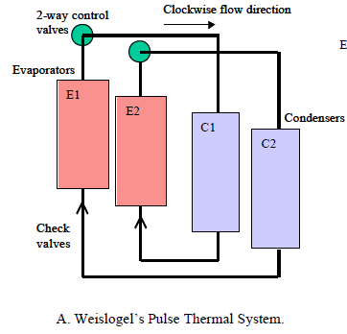

Figure Schematic of main components of the Weislogel Pulse Thermal Loop (courtesy Dr. Mark Weislogel)

While the design would be novel, further investigation revealed some disadvantages with PTLs. Passively controlling valve switching has not been reliably demonstrated and the use of actively controlled solenoids would violate one the main design requirements. Also reported were pulse induced pressure waves which have resulted in vibration or noise.

## Loop Heat Pipes

Also considered were loop heat pipes which utilize thermal conductivity and phase change to transport heat from one location to another. Heat pipes effectively transfer heat but they are not generally capable of dissipating it from the condenser without assistance from another device. A design coupling the condenser section of the heat pipe to a chimney stack on the back of the netbook screen was considered. Figure 2 shows a model of the stack. The design would require a heat pipe with a flexible section to deal with the netbook lid hinge, which was not deemed to be feasible.

# 

Figure Screen chimney stack array coupled to a condenser or heat sink

## Case Integrated Heat Sink

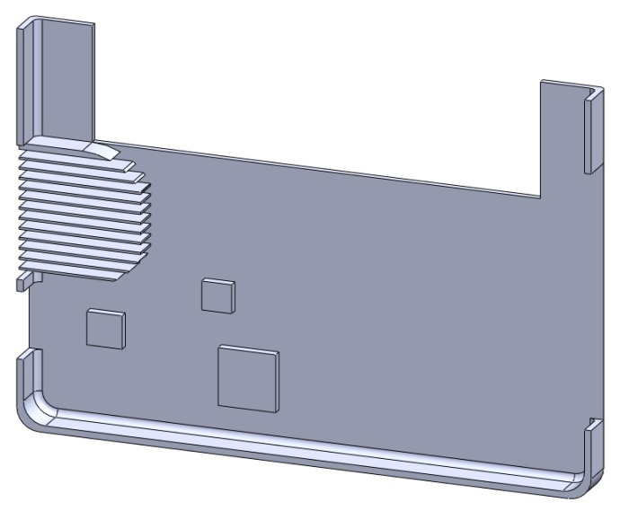Converting the base of the case into a heat sink was another option that was explored. An aluminum shell that directly connects to the components would provide convective surfaces on the exterior, interior of the case, and a fin array in the area previously occupied by the fan. Initial finite element analysis results showed greater effectiveness than the internal heat sink. However, changes to the product’s appearance, difficulty of manufacturing, and increased surface temperatures ruled out the case integrated heat sink in our selection process.

Two key areas of the passive cooling solution were defined by the design team; heat dissipation and heat transportation. The two areas of design were combined into four possible passive cooling solutions as defined in the decision matrix summarized in Table 1. Design parameters and their importance were defined using the PDS [Appendix A], which were then used to rate the possible solutions.

Figure Solid model of case-integrated heat sink

Table Decision Matrix for candidate design solutions

|  |  |  |  |  |  |
| --- | --- | --- | --- | --- | --- |
| **Criteria** | **Weight** | **Pulse Thermal Loop w/ Screen Stacks** | **Graphite Heat Spreader w/ Copper Heat Sink** | **Heat Pipe**  **w/Chimney Stacks** | **Case Integrated Heat Sink** |
| **Cooling Capacity (efficiency)** | 5 | 5 | 5 | 5 | 5 |
| **Size of Solution Envelope** | 4 | 4 | 4 | 3 | 3 |
| **Manufacturability** | 3 | 1 | 3 | 3 | 2 |
| **Implementation** | 3 | 1 | 3 | 2 | 3 |
| **Aesthetics** | 2 | 2 | 2 | 2 | 2 |
| **Cost** | 3 | 1 | 1 | 3 | 1 |
| **Novelty** | 4 | 4 | 3 | 1 | 2 |
| **Total** | 24 | 18 | 21 | 16 | 18 |

The decision matrix defined the best possible solution to be the copper heat sink with the graphite heat spreader. This design was chosen primarily due to its simplicity and its relative ease of manufacturing.

# Final Design

The final design concept consists of a copper heat sink, (Figure 4, item 2) which interfaces with the previously uncoupled heat sources, and a graphite heat spreader (Figure 4, item 3). The thermo-physical properties of the graphite heat spreader are highly anisotropic, with thermal conductivity differing by orders of magnitude from one direction to the other. The final design concept requires no power, does not rely on a working fluid, is easy to manufacture, and does not significantly alter the netbook appearance.

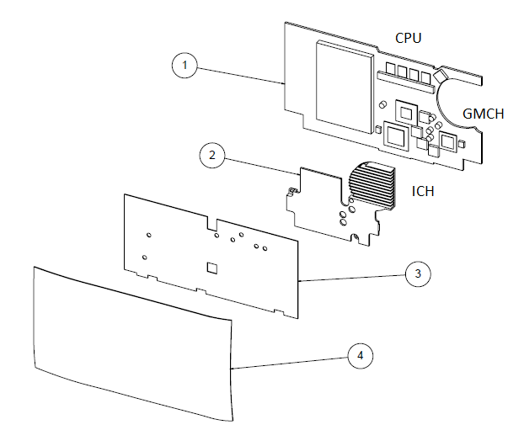

Figure Assembly drawing of the final design concept

There are 3 primary heat sources on the netbook motherboard (Figure 4, item 1): the Central Processing Unit (CPU), the Graphics and Memory Controller Hub (GMCH), and the I/O Controller Hub (ICH). These 3 chips are at different locations on the motherboard, each having a different height relative to the motherboard surface.

## Copper Heat Sink

The physical design of the copper heat sink is a function of the locations of the heat sources on the motherboard.  The large area previously occupied by a fan was used to increase the thermal mass and surface area of the heat sink.  Dimensions were taken directly from the motherboard using a Coordinate Measuring Machine (CMM) and modeled using a solid modeling package.  As seen in Figure 5, the heat sink has multiple pads designed to contact the heat sources on one side while the opposite side is completely flat to maximize thermal contact with the graphite heat spreader. Copper was chosen as the heat transport medium due to its high thermal conductivity of 388 W/m-K [6].

To refine the dimensions of features that affect the mating of the heat sink to the motherboard, plastic prototypes of multiple design revisions were machined and tested for fit. Finite Element Analysis (FEA) was used to optimize the dimensions of non-mating features of both the heat sink and heat spreader for maximum heat transport and dissipation [Appendix D].

Figure Solid model of copper heat sink bottom (left) and top (right)

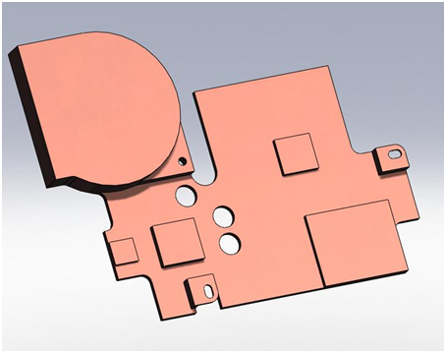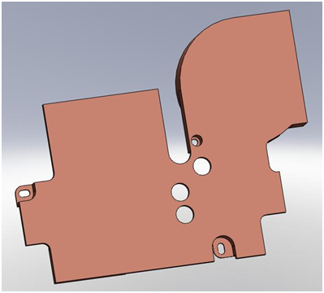

Initially, the design included an array of fins on the section of the heat sink that fits where the fan had previously resided.  This fin array was designed for several reasons.  FEA modeling indicated that the greater surface area of the fins would dissipate the heat more efficiently [Appendix D].  The fin array was also much lighter due to the greatly reduced mass of this area.  Unfortunately, manufacturing the fins proved impractical with the available manufacturing resources.  Although the final prototype was made without fins, the ideal final prototype would have included a fin array.

## Graphite Heat Spreader

The graphite heat spreader is anisotropic, with thermal conductivities of 500 W/m-K in the X-Y plane, and only 3 W/m-K in the Z direction [7]. This anisotropy allows the graphite heat spreader to dissipate heat in the X and Y directions while effectively shielding the case of the netbook from the transported heat, thus minimizing the increase in skin temperature.

The graphite used for the heat spreader was eGraf ™ SS500-0.76-P1GP1A1. This material is available in 8” x 11” sheets and has a peel-back adhesive layer on one side. After the copper heat sink was installed on the motherboard, the adhesive side of the heat spreader was applied to the entire flat surface of the heat sink to maximize the thermal contact area.

Softtherm 86/600 foam from Keratherm® was used as the thermal interface material (TIM) between the heat sink and the components on the motherboard. The gap between the heat sink contact pads and the motherboard components varies due to the modest level of precision in both the motherboard measurements and the heat sink manufacturing. The .75 mm thickness of this TIM can accommodate large gaps and be compressed by up to 40% while still maintaining its relatively high thermal conductivity of 6 W/m-K.

Both the copper heat sink and graphite heat spreader were manufactured by the design team using the resources available at Portland State University [Appendix B]. Detailed drawings of both components can be found in Appendix F.

# Final Design Evaluation

With the final design installed, the netbook was stress-tested in the same manner as the original baseline testing [Appendix E]. Intel’s Thermal Analysis Tool (TAT) software was used to stress the CPU and ICH, while Glaze 3D software was used to stress the GMCH. Running these applications in conjunction is intended to simulate the maximum simultaneous usage the individual components would see in real world applications. This method is considered more accurate in determining the maximum power consumption of the system, and corresponding heat output of the components, than simply summing the theoretical maximum power values for each component. The baseline testing ran for 3 hours. However, due to the increased thermal mass of the copper heat sink, the final design testing ran for 20 hours to ensure that all components reached steady-state. Three different methods were used to collect temperature data: on-board digital thermal sensors (DTS), thermocouples (TC) attached to the heat sources, and infrared (IR) thermography.

The CPU and the GMCH each have an on-die DTS that can be read using TAT. According to the DTS on the CPU, the temperature increased by only 2°C with the passive cooling solution (Figure 6). This resulted in a maximum CPU temperature of 64°C, well below the maximum junction temperature of 90°C [Appendix C]. The DTS on the GMCH indicated a maximum temperature increase of 3°C (Figure 6). This resulted in a maximum CPU temperature of 78°C, still well below the maximum junction temperature of 90°C [Appendix C].

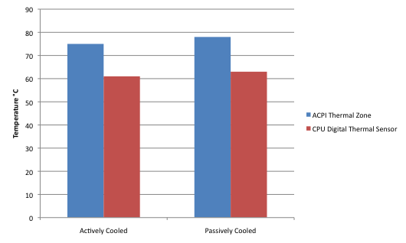

Figure Digital thermal sensor temperatures for the CPU and GMCH with both the active and passive cooled solutions

As shown in Figure 7, thermocouple data indicates the CPU temperature increased by 3.8°C, the ICH by 1.1°C, the GMCH by 21.8°C and the RAM by 11.4°C with the passive solution. The discrepancy between the TC and DTS data for the GMCH can be attributed to the placement of the TC in the original baseline data collection. During the baseline testing the TC for the GMCH was not placed directly on the surface of the chip, as in the final testing, but directly above the GMCH on the heat spreader attached to it. The temperature increase in the RAM is due to no component of the passive solution being coupled to it. The original active solution pulled air across the RAM modules while the passive design leaves them exposed and untouched. All components measured by thermocouples stayed below their maximum junction temperatures (90-100°C).

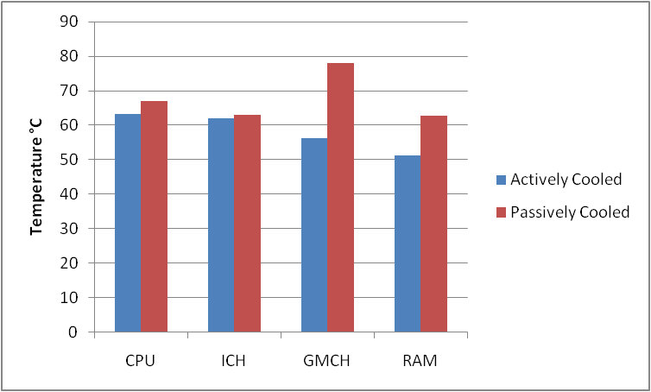

Figure Thermocouple temperatures of the primary heat sources with both active and passively cooled solutions

IR thermography indicated that the maximum skin temperature of the netbook increased by 7.4°C on the top surface (Figure 8) and 11.4°C on the bottom surface (Figure 9). The images also reveal that, while the overall skin temperature increased, the localized hot spots were minimized.

Figure IR images of the top surface of the netbook with the active solution (left) and passive solution (right)

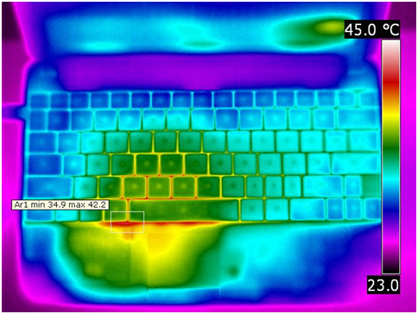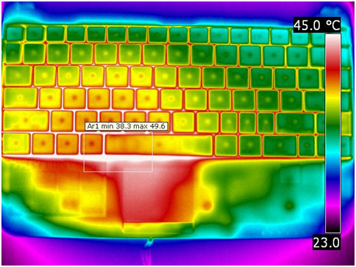

Figure IR images of the bottom surface of the netbook with the active solution (left) and passive solution (right)

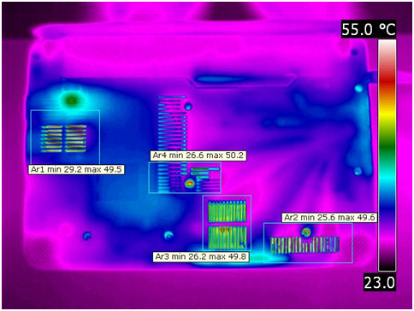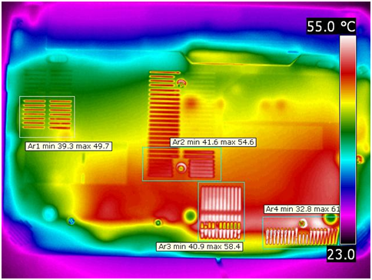

The maximum temperatures recorded by IR thermography are not indicative of the actual maximum skin temperature of the netbook. As can be seen in the images, the highest values occur between the keys, actually under the keyboard, on the top surface. On the bottom surface the highest values occur between the air intake vents, actually inside the case. The actual skin temperatures remained below the required 55°C comfort level.

# Conclusion

The final design, consisting of a copper heat sink with a graphite heat spreader, successfully met all of the main design requirements. There was no change to the netbook case dimensions and no visible change to its outward appearance. The component and skin temperatures remained within acceptable limits and the design consumes no power. This passive cooling solution cools the netbook with a similar effectiveness as the actively powered solution.

# References

[1] http://web.cecs.pdx.edu/~mmw/134A08.pdf

[2] Chipsets. Intel. March 2010 <http://ark.intel.com/chipset.aspx?familyID=35553&code=Mobile+Intel%C2%AE+945GSE+Express+Chipset>

[3] Processor Spec Finder. Intel. March 2010 <<http://processorfinder.intel.com/details.aspx?sSpec=SLB73>>

[4] Products. Intel. March 2010 <<http://ark.intel.com/Product.aspx?id=27680>>

[5] Frank P. Incropera, David P. Dewitt, Theodore L. Bergman, & Adrienne S. Lavine, *Fundamentals of Heat and Mass Transfer*, 6th edition, John Wiley & Sons, 2007.

[6] Copper-110. Bohler Uddeholm. April 2010 <<http://www.buau.com.au/english/files/110.pdf>>

[7] Technical Bulletin 321. eGRAF Thermal Solutions. April 2010 <<http://www.graftechaet.com/getattachment/a9834111-918f-43a3-bbd1-6800557a19dd/eGRAF%C2%AE-SPREADERSHIELD%E2%84%A2-products-Typical-Properties.aspx>>

[8] Softtherm 86/600. Keratherm Catalog. April 2010 <<http://www.kerafol.com/fileadmin/user_upload/Thermalmanagement/downloads/englisch/Keratherm_05_2010_eng_kl.pdf>> Page 27.

[9] Omega k-type TC 36 gauge. February 2010 <http://www.omega.com/ppt/pptsc.asp?ref=5TC>

# Appendix A: Product Design Specifications



# Appendix B: Manufacturing and Assembly

**[B.1] Heat Sink**

A solid model (SolidWorks) was constructed with the aid of a CMM and careful measurements of both the board and previous heat spreader.

•       The copper spreader SolidWorks models was rotated so that the top view would match that of Mastercam. Besides redefining the view labels, a suitable coordinate origin needs to be redefined for the purposes of locating the piece in a 2-axis mill. The new origin location must be some feature that can be easily located with an edge finder.

Solid model views and coordinates were redefined for purposes of importation into Mastercam.

•       Once the solid model and origin were redefined, the file is saved as an IGES file and opened into Mastercam. The program allows for the selection of several different types of machine tools with their respective communications protocols.

Toolpaths for all features were defined using various machining operations (contour, pocket, etc.)

•       Cutter diameter, type of cutting, entry and exit paths are all defined at this point to ensure proper manufacturing of features and that no other previously machined feature is affected by subsequent machining operations.

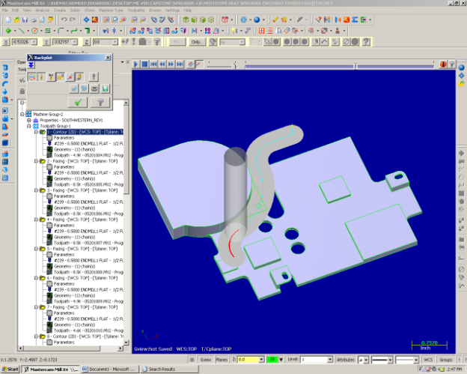

**Figure B.1.1:**

**Example of a Toolpath representation in Mastercam used to eliminate errors that would occur during manufacture.**

Toolpaths were translated into G-code for use in a Trek 2-axis CNC mill and loaded into the mill’s controller.

•       Once programs were loaded, the raw material was carefully located using an edge finder. About 22 toolpaths were necessary and they were all run sequentially.

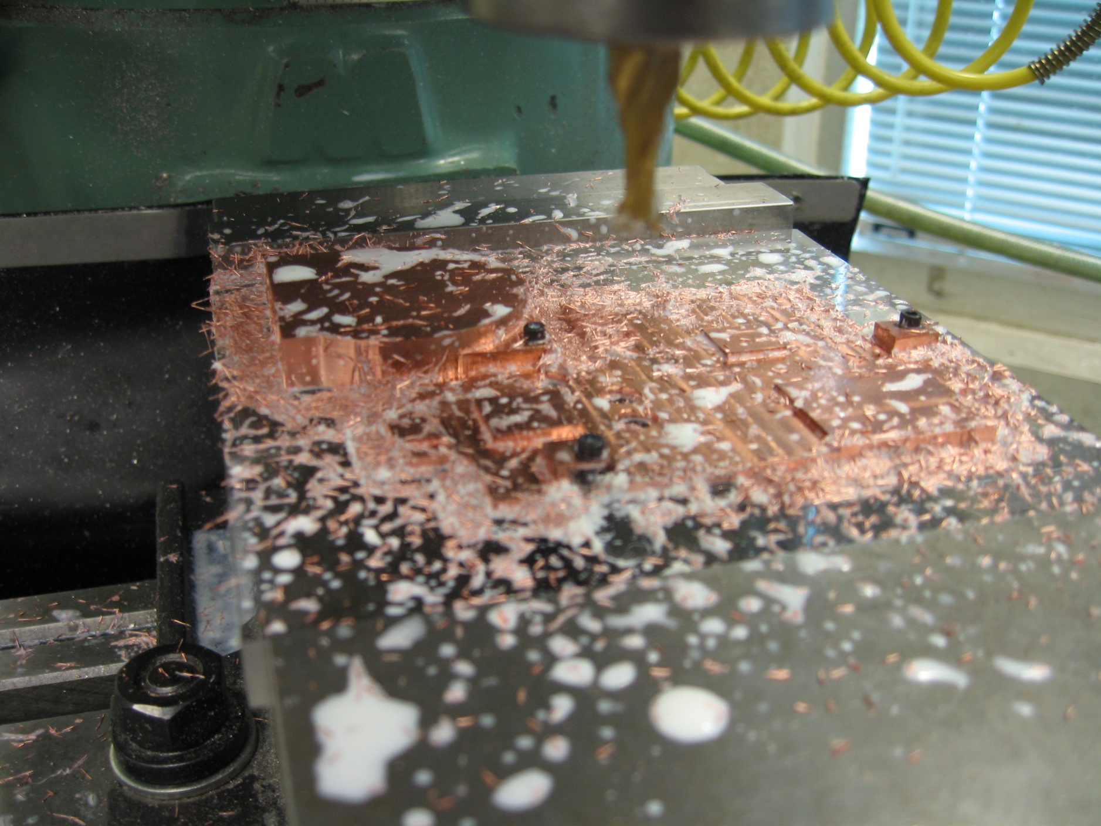

**Figure B.1.2:**

**Manufacturing of the final copper heat sink with a 2-axis mill using the toolpaths created in Mastercam.**

**[B.2] Heat Spreader**

The heat spreader was modeled in solid works as a three dimensional object. A two dimensional representation was then created. This two dimensional representation was printed out to scale on a standard laser printer. The print out was affixed to a sheet of graphite, and the edges were cut out using a straight edge and a sharpened utility knife. The holes were made using the correct size punch and a hammer.

**[B.4] Parts List**

|  |  |
| --- | --- |
|  | **Product:** Heat Sink  **Description:** Machined out of Copper-110; used as a heat sink and to transport heat to the heat spreader. |
|  | **Product:** Heat Spreader  **Description:** Cut from eGraf thermal management spreadershield SS500-0.76-P1GP1A1; used as a heat spreader and a heat sink. |

# Appendix C: Component Research

1. GPU (Graphics Processing Unit): **Intel GMA950** [1]
   1. Thermal Specification: not provided
   2. Thermal Design Power: 2.7W
2. CPU (Central Processing Unit): **Intel Atom Processor N270** [2]
   1. Thermal Specification: 90°C
   2. Thermal Design Power: 2.5W
3. ICH (I/O Controller Hub): **Intel 82801GBM I/O Controller** [3]
   1. Thermal Specification: 99-108°C
   2. Thermal Design Power: 3.3W

# Appendix D: Calculations

**[D.1] Copper Fin Heat Sink**

**Summary**

The purpose of this analysis is to determine the possible convection coefficients and heat fluxes achievable by a buoyancy cooled heat sink for various temperature differences between the surroundings (air) and the fin surface. These calculations will be used for a finite element analysis of the desired prototype.

**Given**

Vertical parallel plates are cooled by buoyancy driven flow of air at room temperature (20°C). The surface temperatures and the resulting air properties are presented in table (D.6.1).

The 8mm tall fins are part of an array that is 45mm in width and an average depth of 50.06mm. The final heat sink solution offers a total surface area of 7208.32 ${mm}^{2}$. Although thinner fins are desirable in natural convection applications, because it is easier to keep the fins up to temperature, 1.5mm thick fins are used because of issues in the fabrication process.

**Find**

1. Determine the optimal fin spacing for the given temperature differences.
2. Determine the convection coefficients for the given temperature differences.
3. Determine the heat flux for the given temperature differences.

**Assumptions**

1. Uniform temperature distribution through the fin and the heat sink (FEA analysis shown in appendix [D.5] shows temperature differences between 3.88 and 0.39°C).
2. Constant properties.
3. Radiation is negligible.

**Solution**

The convection coefficient for isothermal parallel vertical plates can be calculated using equation (D.1.1) where $C_{1}$ and $C_{2}$ are constants given as 576 and 2.87 respectively.

$$\overline{{Nu}_{S}}=\frac{\overline{h}S}{k}={\left[\frac{C_{1}}{{\left({Ra}_{S}S/L\right)}^{2}}+\frac{C_{2}}{{\left({Ra}_{S}S/L\right)}^{1/2}}\right]}^{-1/2} (D.1.1)$$

The desired spacing S is defined by equation (D.1.2) and the Rayleigh number is defined by equation (D.1.3) where the gravitational constant g is assumed to be $9.81m/{s^{2}}$.

$$S_{opt}=2.71{\left({Ra}_{S}/S^{3}L\right)}^{-1/4} (D.1.2)$$

$${Ra}_{S}=\frac{gβ(T_{s}-T_{∞})S^{3}}{υα} (D.1.3)$$

Equation (D.1.4) is used to calculate the maximum heat flux possible with the given temperature difference. Originally, the area of the array is calculated using equation (D.1.5).

$$q=\overline{h}A\left(T_{s}{-T}_{∞}\right) (D.1.4)$$

$$A=\frac{0.045}{S_{opt}+t}2Lt (D.1.5)$$

*The following procedure shows the convection coefficient calculations and heat flux for a surface temperature of 30°C and outlines all the steps taken to calculate all of the convection coefficients determined in table (D.1.2).*

1. Equations (D.1.2) and (D.1.3) are solved simultaneously to find the optimum spacing.
$$S_{opt}=2.71{\left(\frac{\left(9.81\right)\left(0.003356\right)\left(30-20\right)}{\left(15.712e-6\right)\left(22.236e-6\right)\left(.008\right)}\right)}^{-1/4}=0.004626 m$$

2. Equations (D.1.1) and (D.1.3) are solved to determine the convection coefficient for the calculated optimum spacing and the temperature difference.
$${Ra}_{S}=\frac{\left(9.81\right)\left(0.003356\right)\left(30-20\right){\left(0.004626\right)}^{3}}{\left(15.712e-6\right)\left(22.23e-6\right)}=93.3$$

$$\overline{{Nu}_{S}}={\left[\frac{576}{{\left(\left(93.3\right)\left(0.004626\right)/\left(0.008\right)\right)}^{2}}+\frac{2.87}{{\left(\left(93.3\right)\left(0.004626\right)/\left(0.008\right)\right)}^{1/2}}\right]}^{-1/2}=1.303$$

$$\overline{h}=\frac{\left(1.303\right)\left(26.14e-3\right)}{0.004626}=7.36W/m^{2}K$$

3. Equations (D.1.4) and (D.1.5) are used to calculate the maximum heat flux achievable using the optimum spacing in the array.

$$A=\frac{0.045}{0.005119+.0015}2\left(.05006\right)\left(.008\right)=0.005884 m^{2}$$

$$q=\left(7.36\right)\left(0.005884\right)\left(30-20\right)=0.433W$$

|  |  |  |  |  |  |  |
| --- | --- | --- | --- | --- | --- | --- |
| $$T_{s}\left(℃\right)$$ | $$S_{opt} (m)$$ | $${Ra}_{S}$$ | $$\overline{{Nu}_{S}}$$ | $$\overline{h} (W/{m^{2}K})$$ | **A $\left(m^{2}\right)$** | **q $\left(W\right)$** |
| $$30$$ | $$0.004626$$ | $$9.33E+01$$ | $$1.303225$$ | $$7.36E+00$$ | 0.005884 | 0.433286 |
| $$40$$ | $$0.003967$$ | $$1.09E+02$$ | $$1.303225$$ | $$8.71E+00$$ | 0.006593 | 1.149054 |
| $$50$$ | $$0.003655$$ | $$1.18E+02$$ | $$1.303225$$ | $$9.59E+00$$ | 0.006991 | 2.010838 |
| $$60$$ | $$0.003468$$ | $$1.24E+02$$ | $$1.303225$$ | $$1.02E+01$$ | 0.007256 | 2.973728 |
| $$70$$ | $$0.003341$$ | $$1.29E+02$$ | $$1.303225$$ | $$1.08E+01$$ | 0.007445 | 4.01238 |
| $$80$$ | $$0.003251$$ | $$1.33E+02$$ | $$1.303225$$ | $$1.12E+01$$ | 0.007587 | 5.110446 |
| $$90$$ | $$0.003184$$ | $$1.36E+02$$ | $$1.303225$$ | $$1.16E+01$$ | 0.007696 | 6.256024 |
| $$100$$ | $$0.003127$$ | $$1.38E+02$$ | $$1.303225$$ | $$1.20E+01$$ | 0.00779 | 7.464805 |
| $$110$$ | $$0.003087$$ | $$1.40E+02$$ | $$1.303225$$ | $$1.23E+01$$ | 0.007857 | 8.690471 |

**Table D.1.2: Optimum spacing, convection coefficient, and heat flux possible for the provided surface temperatures.**

**Conclusion**

These calculations show the order of heat dissipation we can expect for a fin array and the optimum spacing required to achieve maximum convection within the fin array. These calculations will allow for analysis of the cooling solution within finite elemental analysis software (FEA).

**[D.2] Fin Spacing**

**Summary**

In appendix [D.1] the optimum fin spacing was found for a range of surface temperatures. However, the netbook and its components will not always function at its maximum design power and at reduced temperatures we will desire a heat sink that works optimally. Therefore, the spacing of the fins will require additional consideration.

**Discussion**

Results from our FEA on the passive cooling solution in appendix [D.5] shows that the CPU temperature is the deciding factor in whether or not the cooling solution will work. At the CPU’s cut off temperature of 85.2°C the average temperature of the convective surface of the heat sink is 78.2°C which is a difference of 7°C. For a temperature of 78.2°C the optimum fin spacing is interpolated from table (D.1.2) to be 0.003267m.

Optimum fin spacing is calculated by setting the spacing equal to the distance at which the velocity of the buoyancy driven flow is at a maximum. Table (D.1.2) shows that as the temperature of the fins decreases the fin spacing increases. Therefore, to optimize the fin spacing for lower temperatures the spacing would have to be increased which is ideal even for higher temperatures, because of the velocity profile of the buoyancy driven flow caused by a heated vertical plate which can be extracted from figure (D.2.1) where u is the velocity in the x direction (parallel to the plate) and y is the distance perpendicular to the plate.

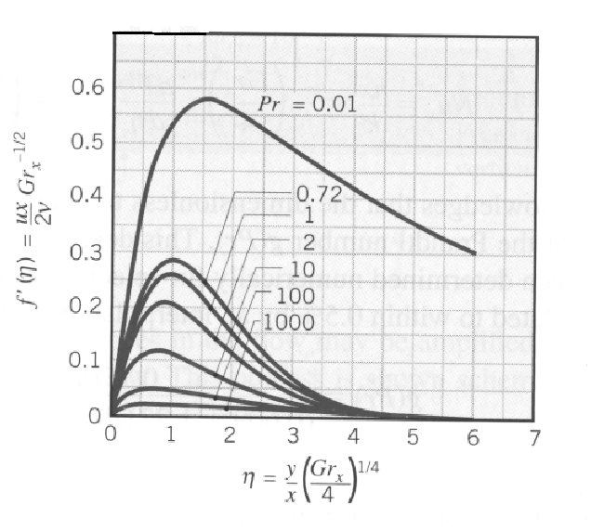

**Figure D.2.1: Similarity solution for a flat vertical plate showing the relationship between the velocity of the buoyancy driven flow with respect to the distance away from the plate.**

It must be first understood that the optimum fin spacing is decided by making the spacing equal to the distance from the plate at which the velocity of the flow is at a maximum. Therefore, by increasing the fin spacing for a given temperature will cause the velocity imposed on the opposite fin to be reduced. However, as seen in figure (D.2.1) reducing the fin spacing causes the velocity imposed on the opposite fin to be reduced much more rapidly than if the fin spacing were increased beyond the optimum spacing.

**Conclusion**

In the analysis used to determine the temperature difference between the heat sink and the CPU the only convection applied to the model was at the fins and on the bottom surface of the heat spreader. However, in real application the cooling solution will experience additional cooling through upper sections of the heat sink and heat spreader which will reduce the temperature of the heat sink with respect to CPU surface temperature. Impurities in the copper and graphite sheet may also cause reductions in conductance which would also reduce the temperature of the heat sink with respect the CPU’s surface temperature. Therefore, it is ideal to choose a larger fin spacing than calculated previously to take advantage of the characteristics of the velocity profile of the buoyancy driven flow.

**[D.3] Graphite Sheet Convection**

**Summary**

The purpose of this analysis is to determine the convection coefficient associated with the heat spreader that will be located inside the netbook in contact with the CPU, GPU, and ICH. The convection coefficient will allow for a more accurate FEA of the system.

**Given**

An isothermal horizontal plate is cooled by buoyancy driven flow from the bottom. The plate has a surface area of 25721.5 ${mm}^{2}$ and a perimeter of 711 *mm*. The surrounding air temperature is assumed to be room temperature (20°C). The surface temperature of the horizontal plate is analyzed at a range of temperatures between 30 and 180°C. Table (D.6.1) contains the properties of air for the average temperatures between the surrounding air and the plate temperature.

**Find**

1. The convection coefficient at the plate’s surface for the given surface temperatures.
2. The heat flux off the plate for the given surface temperatures.

**Assumptions**

1. Uniform temperature across the heat spreader (FEA analysis shown in appendix [D.5] shows temperature differences between 7.4 and 0.75°C).
2. Constant Properties.
3. Radiation is negligible.

**Solution**

The convection coefficient for the lower surface of a hot horizontal plate can be calculated using equation (D.2.1) where ${10}^{5}≤{Ra}_{L}≤{10}^{10}.$

$$\overline{{Nu}_{L}}=\frac{\overline{h}L}{k}=0.27{Ra}_{L}^{1/4} (D.2.1)$$

The Rayleigh number can be calculated using equation (D.2.2) where the characteristic length of a horizontal plate is defined in equation (D.2.3) where $A_{s}$ is the area of the horizontal surface and P is the perimeter of the surface.

$${Ra}_{L}=\frac{gβ\left(T_{s}-T_{∞}\right)L^{3}}{υα} (D.2.2)$$

$$L=\frac{A_{s}}{P} (D.2.3)$$

Equation (D.2.4) is used to calculate the heat flux from the horizontal plate.

$$q=\overline{h}A\left(T_{s}{-T}_{∞}\right) (D.2.4)$$

*The following procedure shows the convection coefficient calculations and heat flux for a surface temperature of 30°C and outlines all the steps taken to calculate all of the convection coefficients determined in table (D.2.2).*

1. Equations (D.2.1) through (D.2.3) are solved to find the convection coefficient.
$$L=\frac{25721.5{mm}^{2}}{711mm}=0.036m$$

$${Ra}_{L}=\frac{\left(9.81\right)\left(0.003356\right)\left(30-20\right){\left(.036\right)}^{3}}{\left(15.712e-6\right)\left(22.236e-6\right)}=4.46e4$$

$$\overline{h}=\frac{0.27{\left(4.46e4\right)}^{1/4}\left(26.14e-3\right)}{0.036}=2.84 W/{m^{2}K}$$

2. Equation (D.2.4) is solved to calculate the heat flux off the heat spreader.

$$q=\left(42.84\right)\left(0.0257\right)\left(30-20\right)=0.729W$$

|  |  |  |  |  |
| --- | --- | --- | --- | --- |
| $$T_{s} \left(℃\right)$$ | $${Ra}_{L}$$ | $$\overline{{Nu}_{S}}$$ | $$\overline{h} (W/{m^{2}K})$$ | $$q\left(W\right)$$ |
| $$30$$ | $$4.46E+04$$ | $$3.92E+00$$ | $$2.84E+00$$ | $$0.729304$$ |
| $$40$$ | $$8.25E+04$$ | $$4.58E+00$$ | $$3.35E+00$$ | $$1.725917$$ |
| $$50$$ | $$1.14E+05$$ | $$4.97E+00$$ | $$3.69E+00$$ | $$2.848431$$ |
| $$60$$ | $$1.41E+05$$ | $$5.23E+00$$ | $$3.94E+00$$ | $$4.058841$$ |
| $$70$$ | $$1.64E+05$$ | $$5.43E+00$$ | $$4.15E+00$$ | $$5.337069$$ |
| $$80$$ | $$1.83E+05$$ | $$5.58E+00$$ | $$4.32E+00$$ | $$6.670727$$ |
| $$90$$ | $$1.99E+05$$ | $$5.70E+00$$ | $$4.47E+00$$ | $$8.050828$$ |
| $$100$$ | $$2.14E+05$$ | $$5.80E+00$$ | $$4.61E+00$$ | $$9.490312$$ |
| $$110$$ | $$2.25E+05$$ | $$5.88E+00$$ | $$4.73E+00$$ | $$10.95349$$ |
| $$120$$ | $$2.34E+05$$ | $$5.94E+00$$ | $$4.84E+00$$ | $$12.45018$$ |
| $$130$$ | $$2.42E+05$$ | $$5.99E+00$$ | $$4.94E+00$$ | $$13.97756$$ |
| $$140$$ | $$2.44E+05$$ | $$6.00E+00$$ | $$5.02E+00$$ | $$15.48289$$ |
| $$150$$ | $$2.48E+05$$ | $$6.02E+00$$ | $$5.10E+00$$ | $$17.0402$$ |
| $$160$$ | $$2.50E+05$$ | $$6.04E+00$$ | $$5.17E+00$$ | $$18.61989$$ |
| $$170$$ | $$2.51E+05$$ | $$6.04E+00$$ | $$5.24E+00$$ | $$20.22079$$ |
| $$180$$ | $$2.52E+05$$ | $$6.05E+00$$ | $$5.31E+00$$ | $$21.8419$$ |

**Table D.2.2: Convection coefficient and heat flux possible for the provided surface temperatures.**

**Conclusion**

This solution provides additional parameters for our FEA on the system. Although the Rayleigh number falls out of the limitations of the correlation at lower temperatures, our main concern is the effectiveness of the heat spreader at the higher realistic working temperatures which fall within the correlation parameters for surface temperatures above 50°C. Furthermore, the heat spreader has a more complicated geometry than defined in this problem which may lead to different results in testing. Experimentation will be required to determine effectiveness of the heat spreader (Appendix [E.2] contains the results from testing the heat spreader). However, the calculations show that the graphite must reach a temperature between 90 and 100°C in order to cool the netbook. The addition of fins will significantly drop the temperature requirement and make this a reasonable solution; however, further analysis will need to be done (appendix [D.5] shows further analysis of the proposed solution).

**[D.4] Heat Sink & Heat Spreader Thicknesses**

**Summary**

The purpose of this analysis is to determine an ideal thickness for the copper and the graphite components for a passive cooling solution on a scale applicable to the surface areas achievable under the guidelines outlined in the progress report in appendix [A].

**Given**

The eGRAF graphite SS500 sheets with a conductivity of $500 W/{m^{2}K}$ in plane and $2.8 W/{m^{2}K}$ out of the plane are available in two thickness, 0.127mm and 0.76mm. Copper-110 is used as the intermediary of the components and the graphite sheet and has a conductivity of $388 W/{m^{2}K}$. The thickness of the copper can range from 0.5mm to 3mm which is limited by the available space in the netbook. Three components are attached to the heat spreader, the CPU, GPU, and ICH which have maximum design powers of 2.5W, 2.7W, and 3.3W respectively.

The air properties as a result of the surface temperatures are shown in table (D.6.1) and are used to calculate the converged convection coefficients shown in table (D.1.2).

**Find**

Determine the minimum and maximum temperatures experience on the surface heat spreader and the surface of the 3 interface components for all possible combinations of graphite and copper thickness.

**Assumptions**

1. Uniform temperature distribution across the heat spreader when calculated convection coefficients.
2. Constant properties.
3. Radiation is negligible.

**Results**

Four node tetrahedral elements were used to determine the temperature distribution through the copper and graphite components of the cooling solution. The surface heat fluxes are applied to resemble the configuration and heat flux loads applied by the CPU, GPU, and ICH into the cooling solution.

The resulting component and convective surface temperatures for various thickness combinations are shown in table (D.4.1).

|  |  |  |  |  |  |  |  |  |
| --- | --- | --- | --- | --- | --- | --- | --- | --- |
| **Spreader** | **Sink** | **Temperature** | | | | | | |
| **t (mm)** | **t (mm)** | **CPU** | **GPU** | **ICH** | **Max** | **Min** | **Avg** | **Delta T** |
| 0.127 | 0.5 | 105.351 | 106.991 | 108.07 | 108.019 | 74.6041 | 91.31155 | 33.4149 |
| 0.127 | 1 | 104.356 | 105.304 | 106.024 | 105.99 | 74.98 | 90.485 | 31.01 |
| 0.127 | 1.5 | 103.935 | 104.604 | 105.141 | 105.11 | 75.1385 | 90.12425 | 29.9715 |
| 0.127 | 2 | 103.444 | 102.675 | 102.471 | 104.618 | 75.2257 | 89.92185 | 29.3923 |
| 0.127 | 2.5 | 103.344 | 102.718 | 102.55 | 104.304 | 75.2806 | 89.7923 | 29.0234 |
| 0.127 | 3 | 103.276 | 102.749 | 102.606 | 104.086 | 75.3177 | 89.70185 | 28.7683 |
| 0.76 | 0.5 | 96.3611 | 97.2872 | 97.188 | 96.8094 | 88.9831 | 92.89625 | 7.8263 |
| 0.76 | 1 | 96.0381 | 96.7276 | 96.7338 | 96.4138 | 89.1109 | 92.76235 | 7.3029 |
| 0.76 | 1.5 | 95.8487 | 96.4038 | 96.4494 | 96.1631 | 89.1876 | 92.67535 | 6.9755 |
| 0.76 | 2 | 95.5753 | 94.9175 | 94.9178 | 95.9885 | 89.2388 | 92.61365 | 6.7497 |
| 0.76 | 2.5 | 95.5107 | 94.9489 | 94.9443 | 95.8599 | 89.2753 | 92.5676 | 6.5846 |
| 0.76 | 3 | 95.4631 | 94.9725 | 94.9654 | 95.7611 | 89.3023 | 92.5317 | 6.4588 |

**Table D.4.1: FEA temperature results for various heat sink and heat spreader thickness combinations.**

The difference in temperature across the heat spreader’s convective surface was plotted in figure (D.4.1) to find points of optimization that fit within space available in the case.

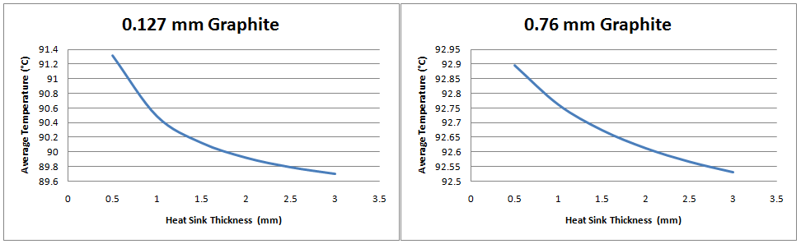

**Figure D.4.1: Average graphite heat spreader surface temperatures at different copper heat sink thicknesses.**

**Conclusion**

The reduced temperatures in the components using the 0.76mm thick graphite when compared to the 0.127mm graphite make it the better of the two graphite options available to us. The copper heat sink shows reduced temperatures in the components the thicker the heat sink is. However, we are limited by the space available in the MSI Wind’s case. Figure (D.4.1) shows a reduction in the temperature change relative to thickness of the heat sink at 1mm. Therefore, in order to optimize our cooling solution, the thickness of the heat sink should have a minimum thickness of 1mm.

**[D.5] Passive Cooling Solution Analysis**

**Summary**

The purpose of this analysis is to determine the temperature distribution and get an estimate of the temperature experienced at the major components (CPU, GPU, & ICH) in a fully stressed situation using a cooling solution without and with fins. Both designs are analyzed, because of complications in the manufacturing of the fin array.

**Given**

The dimensions of the copper heat sink and the graphite heat spreader are outlined in appendices [F.1] and [F.2]. The heat sink is modeled with copper-110 which has a thermal conductivity of $388 W/{m^{2}K}$ [1]. The heat spreader is modeled with eGRAF SS500 Graphite with a conductivity of $500 W/{m^{2}K}$ in plane and $2.8 W/{m^{2}K}$ out of the plane [2]. The thermal interface between the chips and copper heat sink were ensured with Keratherm softtherm 86/600 1mm thick TIM (thermal interface material) with a conductivity of $6 W/{m^{2}K}$ [3]***.*** The resulting model with and without fins are shown in figures (D.5.1) and (D.5.2) respectively.

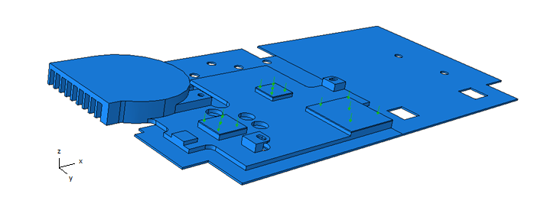

**Figure D.5.1: Model of cooling solution in Abaqus with component induced heat fluxes on the surfaces of the thermal interface.**

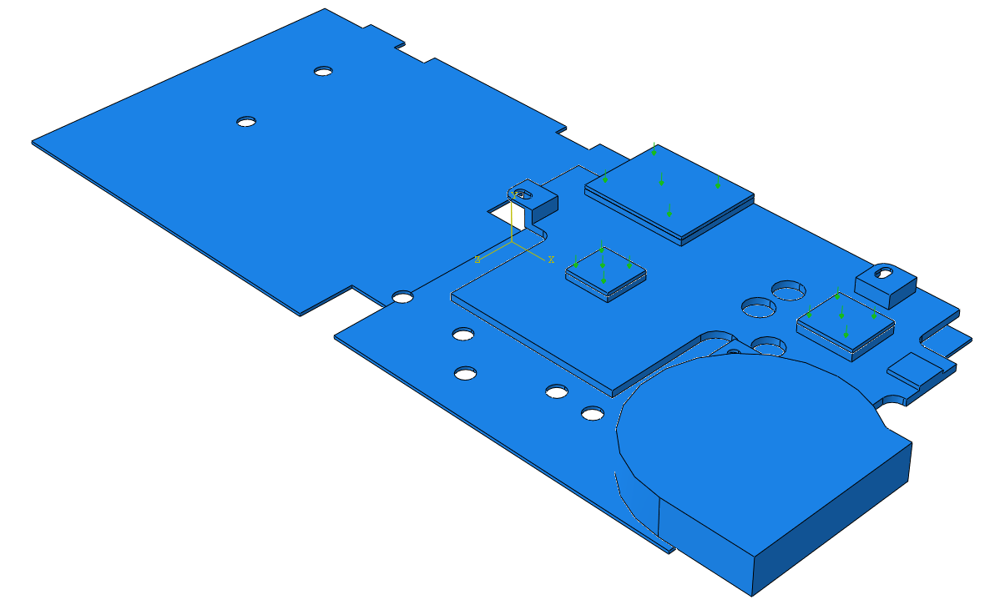

**Figure D.5.2: Model of the proposed cooling solution in Abaqus without fins.**

The convection coefficients used are shown in tables (D.1.2) and (D.2.2) for the heat sink fins and the heat spreader surface respectively (a greater number of values were calculated than shown in order to converge on the proper convection coefficient).

**Find**

1. Maximum temperature at each component; the CPU, GPU, and ICH.

**Assumptions**

1. Uniform temperature distribution across convective surfaces.
2. Constant properties.
3. Radiation is negligible.
4. Convection only occurs at the bottom surface of the heat spreader and on the fin array.

**Results**

The areas and resulting heat flux per unit of area are calculated in table (D.5.1) to determine the parameters to be applied to the FEA models shown in figures (D.5.1) and (D.5.2).

|  |  |  |  |
| --- | --- | --- | --- |
| **Component** | $$A \left(mm×mm\right)$$ | $$\ddot{q} \left(W\right)$$ | $$q \left(W/{{mm}^{2}}\right)$$ |
| CPU | 13x13.5 | 2.7 | 0.045584 |
| GPU | 15x16 | 2.5 | 0.010417 |
| ICH | 30x30.4 | 3.3 | 0.003618 |

**Table D.5.1: Surface heat fluxes used in the FEA.**

Four node tetrahedral elements were used to determine temperature distribution at the systems steady state. The parts were meshed to achieve equal mesh densities at points of contact to avoid errors and discrepancies in the analysis. Between the thermal interface and the copper heat sink it was possible to create identical meshes which will ensure identical nodal alignment. Convergence of the mesh was also achieved to ensure accurate results as demonstrated in figure (D.5.3) for the FEA of the solution without fins.

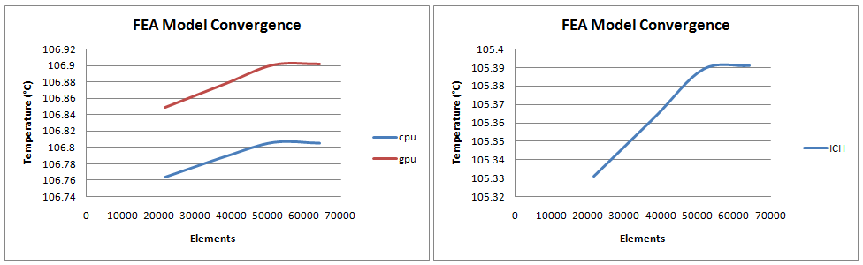

**Figure D.5.3: Temperature convergence of the FEA model shown by the maximum surface temperatures at the CPU, GPU, and ICH.**

Figures (D.5.4) and (D.5.5) show the resulting temperature distributions and element mesh for the thermal solutions without and with fins, respectively, in Abaqus FEA software.

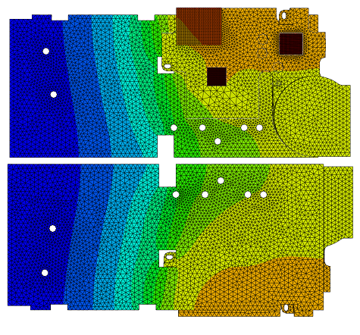

**Figure D.5.4: Temperature distribution of the proposed passive cooling solution with no fins**.

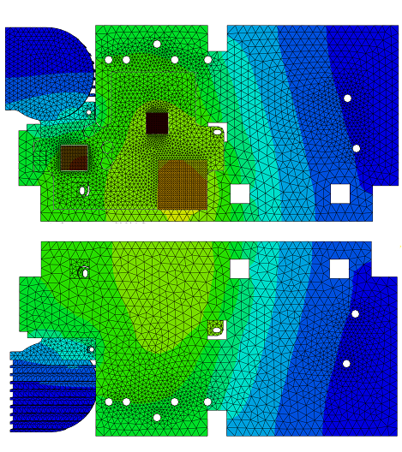

**Figure D.5.5: Temperature distribution of the proposed passive cooling solution with fins.**

The resulting maximum surface temperatures of the components for the passive thermal solution without and with fins are shown in tables (D.5.2) and (D.5.3) respectively at maximum thermal design power and in steady state.

|  |  |  |
| --- | --- | --- |
| **Temperature (°C)** | | |
| **CPU** | **GPU** | **ICH** |
| 106.805 | 106.902 | 105.391 |

**Table D.5.2: Maximum surface temperatures with no fin array.**

|  |  |  |
| --- | --- | --- |
| **Temperature (°C)** | | |
| **CPU** | **GPU** | **ICH** |
| 69.9279 | 68.8125 | 68.3099 |

**Table D.5.3: Maximum surface temperatures with fin array.**

**Conclusion**

The analysis showed that maximum component temperatures, with our proposed thermal solution with no fins, exceeds the thermal specifications of the components and the solution with a fin array fall below the thermal specifications of the components. However, our assumptions assume the that the surrounding air temperature remains at 20°C when in reality it may heat up as the netbook heats up, because of air flow being restricted by the netbook’s case which would result in higher temperatures. On the other hand, the analysis does not take into account all possible factors of heat dissipation. The heat spreader will be connected to other components such as the wireless network card and the hard drive which reduces the additional surface area available. However, there is still a great deal of surface area that could contribute to heat dissipation resulting in lower component temperatures.

**[D.6] Tables**

|  |  |  |  |  |  |
| --- | --- | --- | --- | --- | --- |
| $$T_{s} \left(℃\right)$$ | $$T_{avg} (℃)$$ | $$β (K^{-1})$$ | $$α\left({10}^{6}\right) ({m^{2}}/s)$$ | $$υ\left({10}^{6}\right) ({m^{2}}/s)$$ | $$k\left({10}^{3}\right) (W/{m K})$$ |
| 30 | 25 | 0.003356 | 2.22E-05 | 1.57E-05 | 2.61E-02 |
| 40 | 30 | 0.0033 | 2.29E-05 | 1.62E-05 | 2.65E-02 |
| 50 | 35 | 0.003247 | 2.37E-05 | 1.67E-05 | 2.69E-02 |
| 60 | 40 | 0.003195 | 2.44E-05 | 1.72E-05 | 2.73E-02 |
| 70 | 45 | 0.003145 | 2.52E-05 | 1.77E-05 | 2.76E-02 |
| 80 | 50 | 0.003096 | 2.59E-05 | 1.82E-05 | 2.80E-02 |
| 90 | 55 | 0.003049 | 2.66E-05 | 1.87E-05 | 2.84E-02 |
| 100 | 60 | 0.003003 | 2.72E-05 | 1.92E-05 | 2.87E-02 |
| 110 | 65 | 0.002959 | 2.79E-05 | 1.97E-05 | 2.91E-02 |
| 120 | 70 | 0.002915 | 2.86E-05 | 2.02E-05 | 2.95E-02 |
| 130 | 75 | 0.002874 | 2.93E-05 | 2.07E-05 | 2.99E-02 |
| 140 | 80 | 0.002833 | 3.04E-05 | 2.12E-05 | 3.02E-02 |
| 150 | 85 | 0.002793 | 3.12E-05 | 2.18E-05 | 3.06E-02 |
| 160 | 90 | 0.002755 | 3.21E-05 | 2.23E-05 | 3.10E-02 |
| 170 | 95 | 0.002717 | 3.29E-05 | 2.29E-05 | 3.14E-02 |
| 180 | 100 | 0.002681 | 3.38E-05 | 2.34E-05 | 3.17E-02 |

**Table D.6.1: Air properties for an average temperature based on surrounding sink temperature of 20°C.**

# Appendix E: Experimental Results

**[E.1] Baseline Testing**

**Summary**

The stock MSI Wind netbook employs an active cooling solution that consist of a fan and a heat spreader that interfaces with the CPU and GPU. Airflow across particular components is ensured by the strategic placement of vents through the base of the case. Baseline testing is done to compare the effectiveness of the current active solution with our passive cooling solution under stressed conditions.

**Procedure**

The baseline testing is concerned with the surface temperature of seven components; (1) CPU, (2) GPU, (3) ICH, (4) RAM, (5) HDD, (6) WNIC, and (7) power rail. Omega k-type 36 gauge thermocouples were used to take the temperatures at each of the seven components [1]. The thermocouple data is monitored using a National Instruments compact DAQ and LabVIEW express. The thermocouple data is used to determine the fully stressed steady state component surface temperatures and to adjust the infrared (IR) images.

Infrared images of the netbook are taken with a FLIR ThermaCAM SC660 Wes and viewed using FLIR QuickReport 1.2 software. The infrared images are used to determine the temperature distribution across components, internal and external hot spots, and to indentify components that need consideration. Infrared images are taken at the end of testing prior, but while the stress applications are still running. Another infrared image is taken just after the testing with the base of the case removed. The netbook is handled with silicon gloves to minimize heat dissipation prior to image capture.

In order to stress the netbook constantly for extended periods of time Glaze 3D and Thermal Analysis Tool (TAT) were used to stress the GPU and CPU respectively. As defined by our product design specifications (PDS) in appendix [A] the testing is performed on a flat surface with the screen at a 90 degree angle. Testing is performed until the test has run for a minimum of 60 minutes and the components have reached steady state surface temperatures.

**Results**

The resulting temperature rise and steady state temperatures of the three components of primary concern, CPU, GPU, and ICH, are shown in figure (E.1.1).

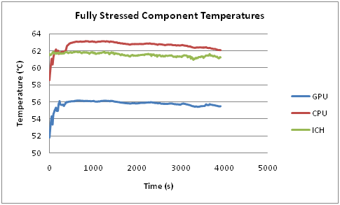

**Figure E.1.1: Maximum surface temperatures under fully stressed conditions of the CPU, GPU, and ICH.**

Figures (E.1.2) and (E.1.3) show the temperature distribution on the keyboard surface and the component surfaces respectively.

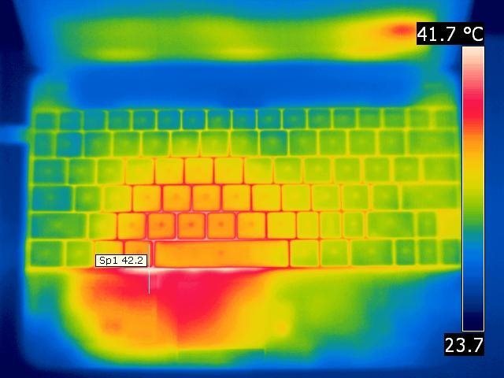

**Figure E.1.2: Temperature and temperature distribution of on the surface of the keyboard.**

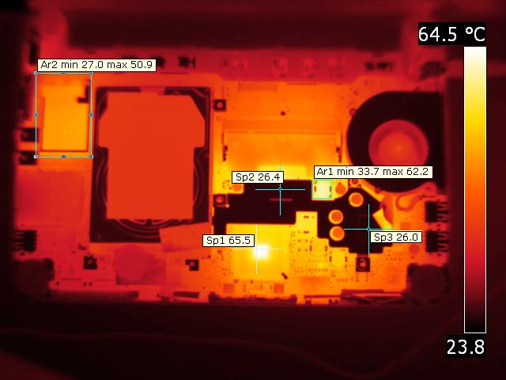

**Figure E.1.3: IR image of bottom of Netbook with cover removed showing temperatures of critical components indicated by the crosshairs and area box in the upper left corner**

**[E.2] Graphite**

**Abstract**

The graphite heat spreader in the proposed solution will not be in the same environmental conditions assumed in the correlation calculations in appendix [D.3]. Therefore, the thermal dissipation capabilities of the graphite under conditions similar to those that would be found in the netbook case required experimentation to determine the feasibility of utilizing the graphite as a thermal transport and dissipater within the netbook case.

**Procedure**

Three resistive heaters are attached to a 0.76mm thick sheet of eGRAF SS500 Graphite Spreadershield on the adhesive side. The resistive heaters are placed in an orientation that mimics the size and scale of the CPU, GPU, and ICH locations in the MSI Wind U100. T-type thermocouples were attached to the side of the resistive heater in contact with the graphite to monitor their temperatures as shown in figure (E.2.1).

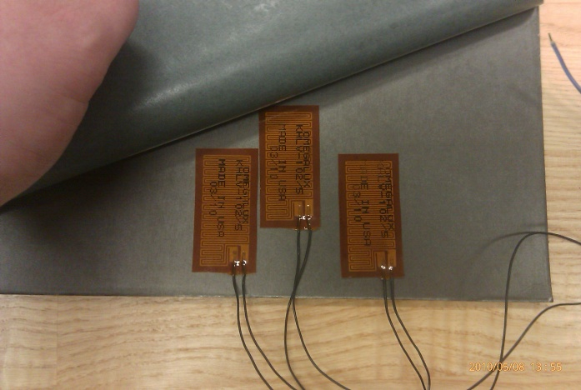

**Figure E.2.1: Resistive heater and thermocouple orientation on graphite sheet.**

The heaters are attached in parallel to a power source with a display of voltage and current as shown in figure (E.2.2). The digital thermometer and thermocouple were calibrated to the lab’s ambient temperature of 22°C and a digital clock was used for time measurements.

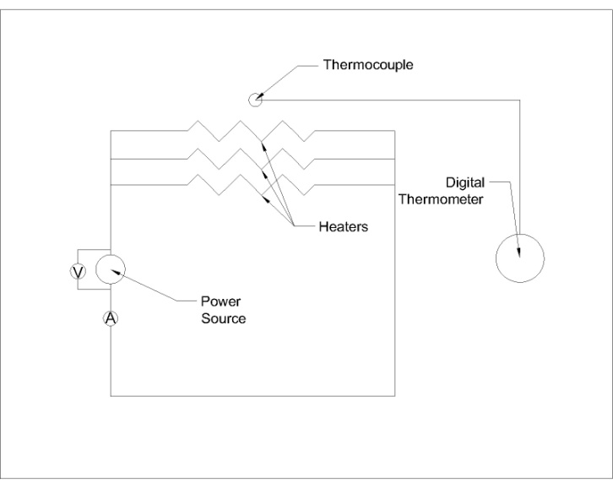

**Figure E.2.2: Representation of resistive heater circuit.**

To find the approximate power draw of the heaters the electrical power formula, equation (E.2.1) was used.

*P = VA* (E.2.1)

The graphite sheet is tested within the fully enclosed in the netbook case to mimic the conditions that would be experienced by a fully prototyped thermal solution as shown in figures (E.2.3) and (E.2.4). The testing is performed on a flat surface with the screen open at a 90 degree angle to resemble the parameters the baseline testing and the conditions set forth by the PDS shown in appendix [A]. Adjustments to the power will be required as the temperatures of the resistive heaters increases. At regular intervals the time, voltage, current, and temperature of the heaters are recorded. Testing was performed until a change in temperature less than ± 0.5 °C/min is experienced.

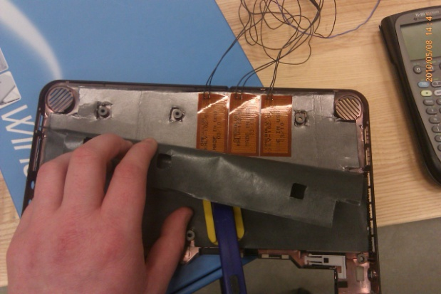

**Figure E.2.3: SS500 eGRAF sheet within the base of the netbook.**

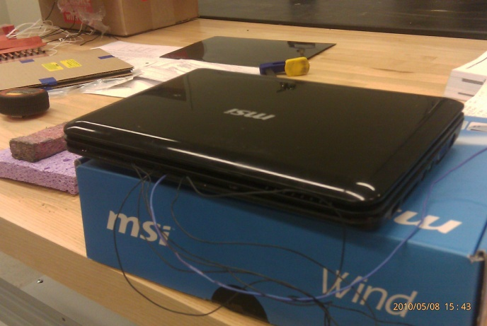

**Figure E.2.4: Fully enclosed netbook with SS500 eGRAF Spreadershield inside.**

**Results**

Figure (E.2.5) shows the temperature at the interface of resistive heater and the graphite sheet as a function of time until the temperature reaches a steady state as defined in procedure (ΔT < ± 0.5 °C/min). Test results are shown for a thermal power input of 10 and 12W.

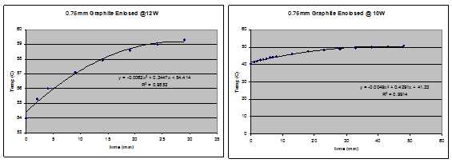

**Figure E.2.5: Temperature vs. time results of the graphite sheet.**

**Analysis**

In analyzing the data the temperature is graphed as a function of time from start of wattage setting. This should produce a roughly logarithmic increase curve. However, the software used did not allow a logarithmic recession due to low R values. A polynomial recession was used in its stead.

To find the approximate temperature that the heater would reach given more time the maximum of the 2nd order polynomial was found for each test. This maximum was found by the standard of finding the derivative of the function and setting it equal to 0 and solving for time and then temperature.

Example

The polynomial regression from Microsoft Excel for the enclosed .76mm cut graphite sheet with 12 Watts of power added is calculated using equations (E.2.2) through (E.2.6).

*y = -0.0062x^2 + 0.3447x + 54.414* (E.2.2)

dy/dx = -0.0124x + .3447 = 0 (E.2.3)

x = 27.8 min (E.2.4)

y = -.0062(27.8^2) + .3447(27.8) + 54.414 (E.2.5)

y = 59.2°C (E.2.6)

The steady state temperature calculated for the maximum graphite temperature is shown in table (E.2.1) for a thermal power input of 10 and 12W.

|  |  |
| --- | --- |
| Thermal Power (W) | Temp (°C) |
| 10 | 50.7 |
| 12 | 59.2 |

**Table E.2.1: Calculated steady state temperatures for the graphite sheet under 10 and 12W of thermal load.**

**Conclusion**

The maximum thermal power that will be produced by the CPU, GPU, and ICH into the heat dissipation solution is 8.5W. The test showed that the graphite portion of our solution has the capability to dissipate heat from thermal loads greater than 8.5W while keeping the maximum temperature below the cut off temperatures of the components. However, the devices will connect to the graphite heat spreader through a heat sink which and will have smaller contact patches which will increase the temperatures at the interface locations. Despite these differences in out proposed solution with the testing apparatus, the proposed graphite heat spreader design showed the capability to dissipate the required levels of heat at lower surface temperatures than those present in the active cooling solution.

# Appendix F: Detailed Drawings and BOM

**[F.1] Copper Heat Sink**

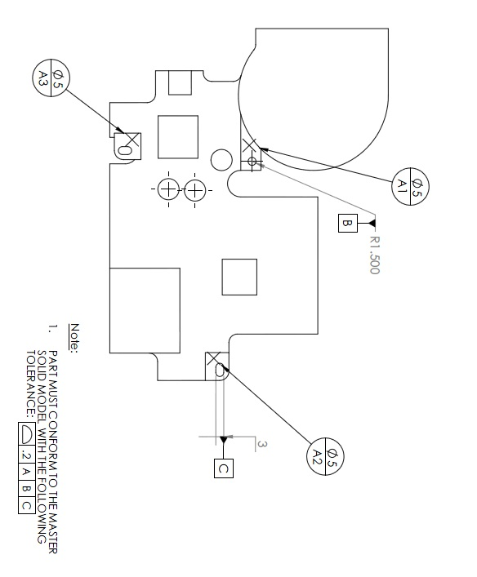

**[F.2] Graphite Heat Spreader**

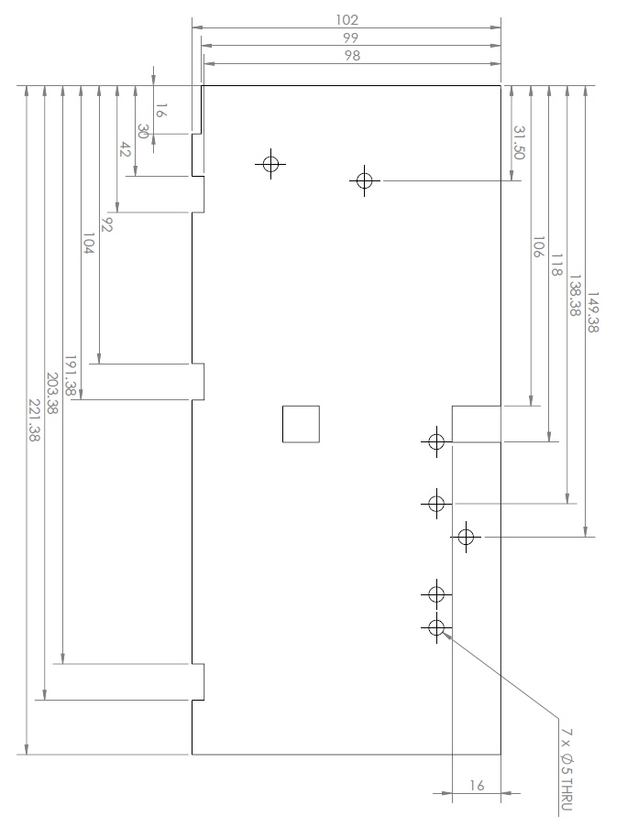

**[F.3] Assembly Drawing with BOM**



