Solution of HW2

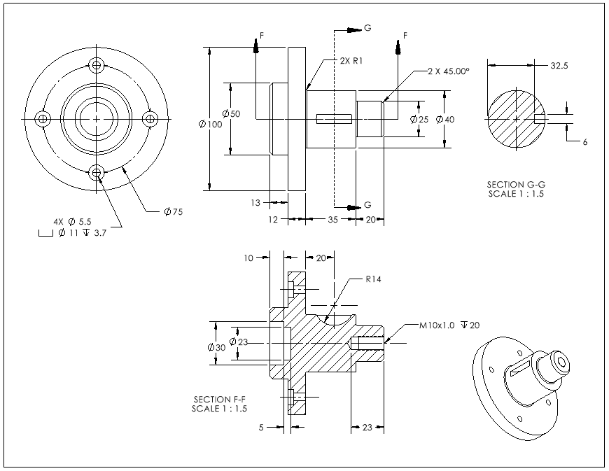
Problem #1 Consider the pin shown
A pin with size and straightness tolerance specifications

Determine:
- The MMC and LMC sizes of the shaft
- The size of the shaft’s fit boundary
- The amount of bending allowed when the feature is 14.6 mm
- The equivalent size limits for ZGT format

Solution
- MMC size = F_{max} = 15 mm LMC size = F_{min} =14 mm
- FB_{F} = (Fmax + T) = (15 + 0.5) = 15.5 mm
- Bending = 0.5 + (15 – 14.6) = 0.9 mm
- F_{0max} = F_{max} + T = 15.0 + 0.5 = 15.5 mm

Problem #7. A rectangular key is to fit a keyway as shown. The key is desired to have an unconstrained fit to the keyway.

Fit of a key and a keyway

The fit tolerances are specified as shown in the figure. Determine:
- The MMC and LMC sizes of the key and keyway
- The size of the key and keyway fit boundaries
- The amount of center plane bending allowed when the key is made at 4.95 mm
- The amount of center plane bending allowed when the keyway is made at 5.05 mm
- The equivalent size limits for key and keyway in ZGT format
- When the key and the keyway fit, what is the minimum and maximum possible play in the fit?

Solution
- Key: MMC size = F_{max} = 4.95 mm LMC size = F_{min} = 4.90 mm
Keyway: MMC size = H_{min} = 5.05 mm LMC size = H_{max} = 5.12 mm
- FB_{F} = 4.95 + 0.05 = 5.00 mm FB_{H} = 5.05 – 0.05 = 5 mm
- Bending of key allowed at MMC = 0.05 mm
- Bending of the keyway allowed at MMC = 0.05 mm
- Key: 4.9 – 5.0 Keyway: 5.00 – 5.12
- P_{min} = FB_{H} – FB_{F} = 5 – 5 = 0 mm
P_{max} = H_{max} – F_{min} = 5.12 – 4.9 = 0.22 mm

