ME 481/581 Class Exercise #1 - Unconstrained Fits
- What is an unconstrained fit between two fit features of two parts?

- What kind of features (called features of size) participate in unconstrained fits?

- What are the most common applications of unconstrained fits?

- What are the two parameters that characterize the fit quality?

- What tolerance statement(s) are needed to accomplish an unconstrained fit?

- Syntax of tolerances of size (how it is specified):

Note: other than features of size that get size tolerance (in one of the forms above) no other features get size tolerances (that means your drawing would not have any dimension limits or +/- tolerances). This is somewhat unfortunate but I am sure in the next release of standards they will have another format for specifying size tolerances. Example from the standard.

Some terminology:
MMC: Maximum Material Condition:
LMC: Least Material Condition:
Nominal Size:
H_{min} = H_{max} =
F_{min} = F_{max} =

- What is the exact standard meaning of 10 +/-1 for a shaft (or boss) feature?
  - Means if we measure each cross-section the measured value is between 9 and 11 (TRUE FALSE)

MMC size (F_{max}) is: LMC size (F_{min}) is:
- What is the meaning of size tolerance for a cylindrical hole feature (10 +/- 1)?

MMC (H_{min}) size is: LMC size (H_{max}) is:
- What is the meaning of size tolerance for a slot feature (10 +/- 1)?

MMC size (H_{min}) is: LMC size (H_{max}) is:
- What is the meaning of size tolerance for a rail feature (10 +/- 1)?

MMC size (F_{max}) is: LMC size (F_{min}) is:
Application: Fit between a collar and a shaft. The objective of the collar is to fix the gear axially in place. Dimension the two parts . As you see the collar has a chamfer (to easily center it) and a set screw threaded hole (not modeled). The shaft has a shoulder for the gear and is to be fixed in place by the set screw. Nominal size of the shaft/collar is 10 mm.
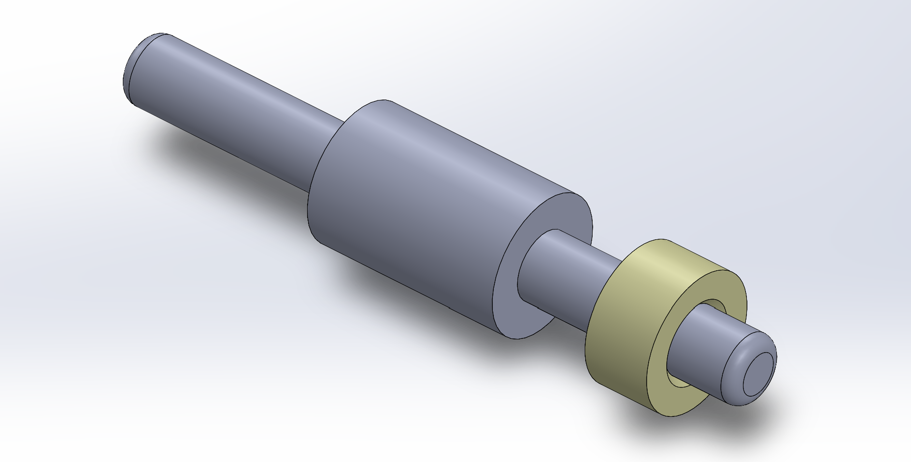
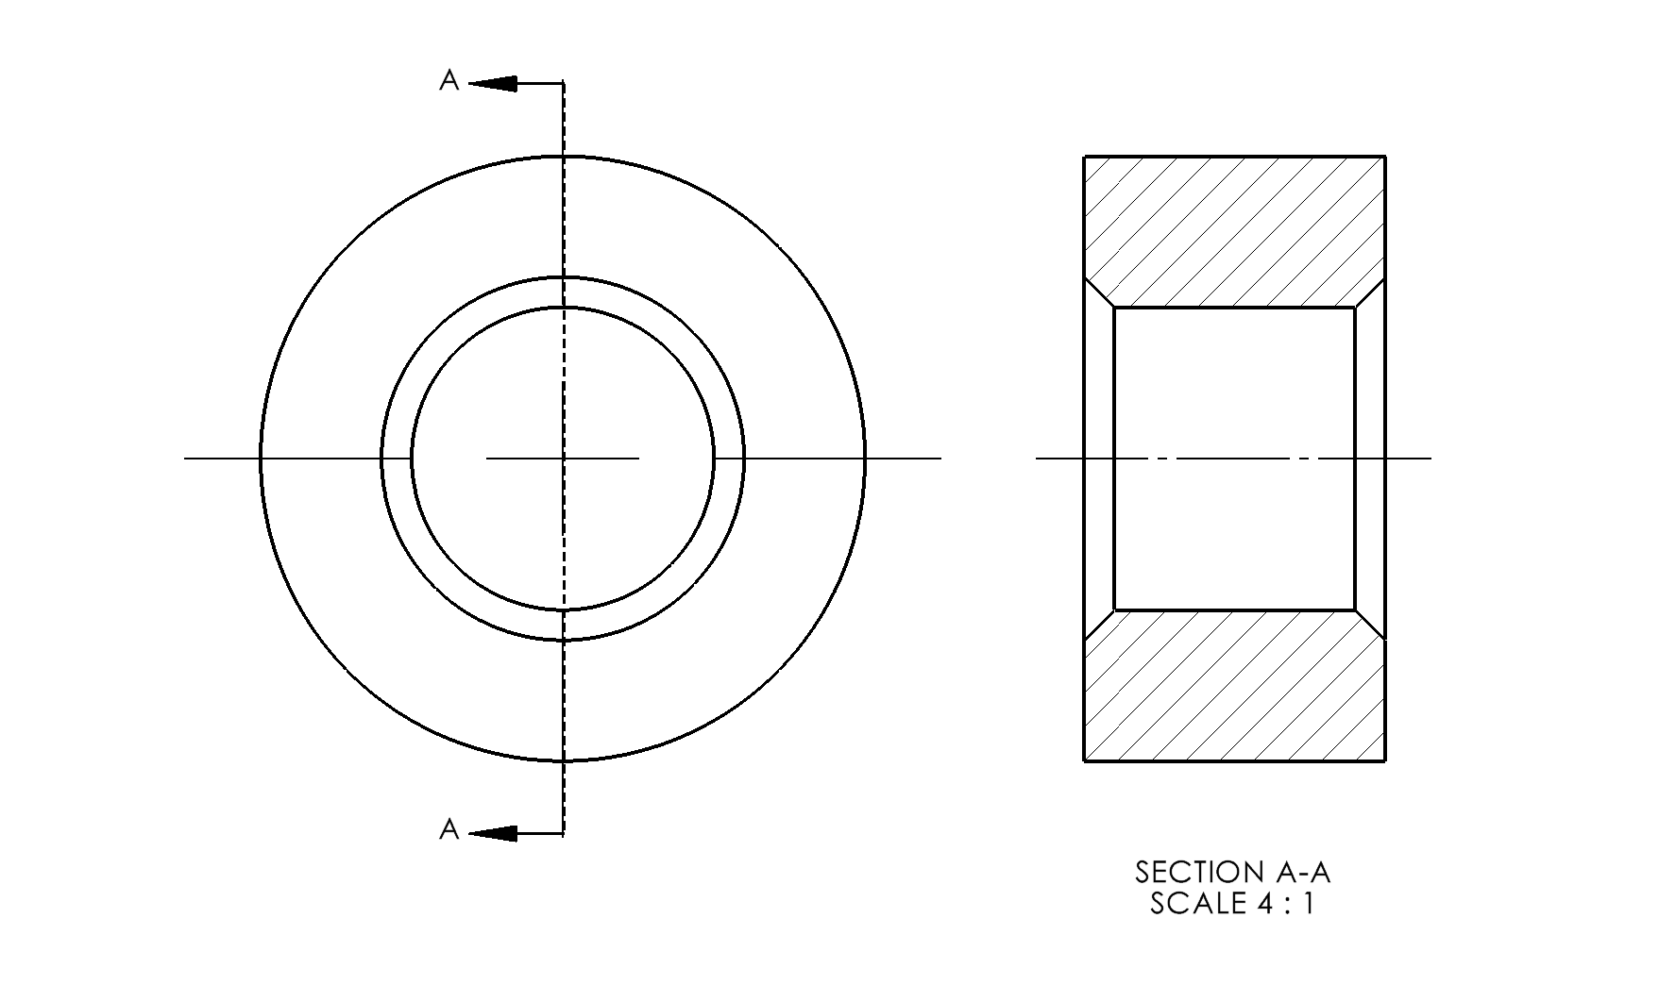

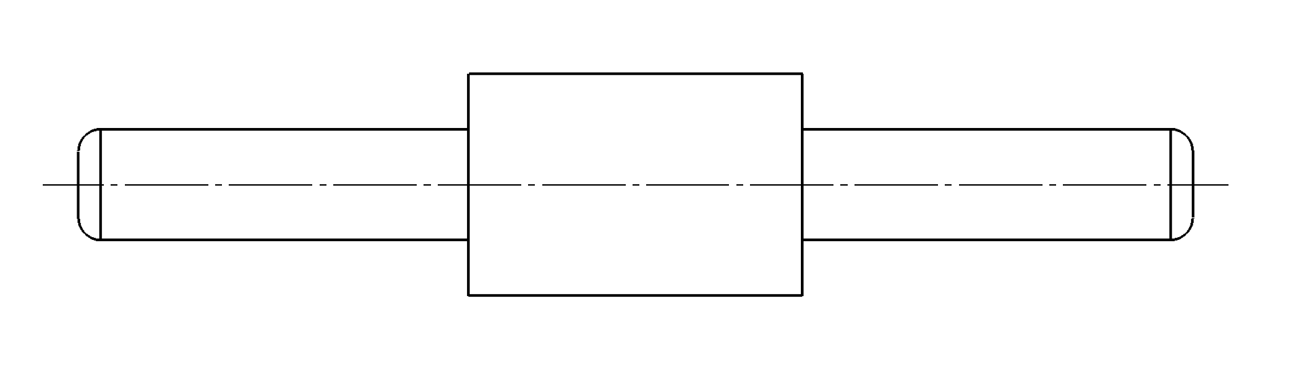
Use the tolerance of size and tolerance the two parts (only those related to the fit) such that:
- The collar is guaranteed to fit the shaft
- The collar/shaft fit minimum play (P_{min}) is zero
- The collar/shaft fit maximum play (P_{max}) is 1 mm

