**For All Problems: Create necessary views. For dimension values use xx.**

1. **Create drawings and dimension the plate with a boss. The boss fits another plate with a mating hole feature.**

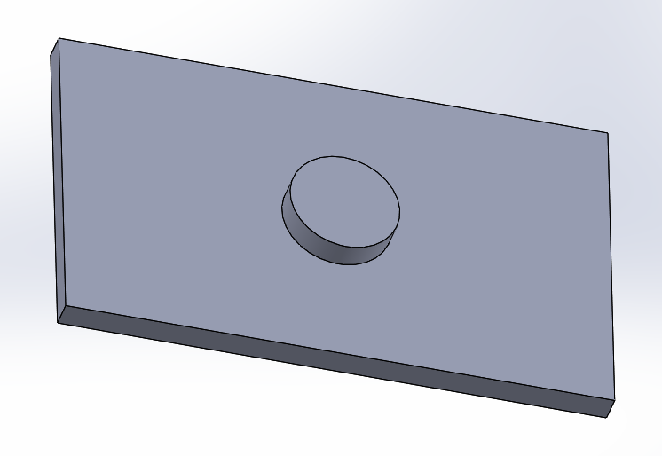

1. **Create drawings and dimension the plate with hole pattern. The holes fit a plate with four matching studs.**

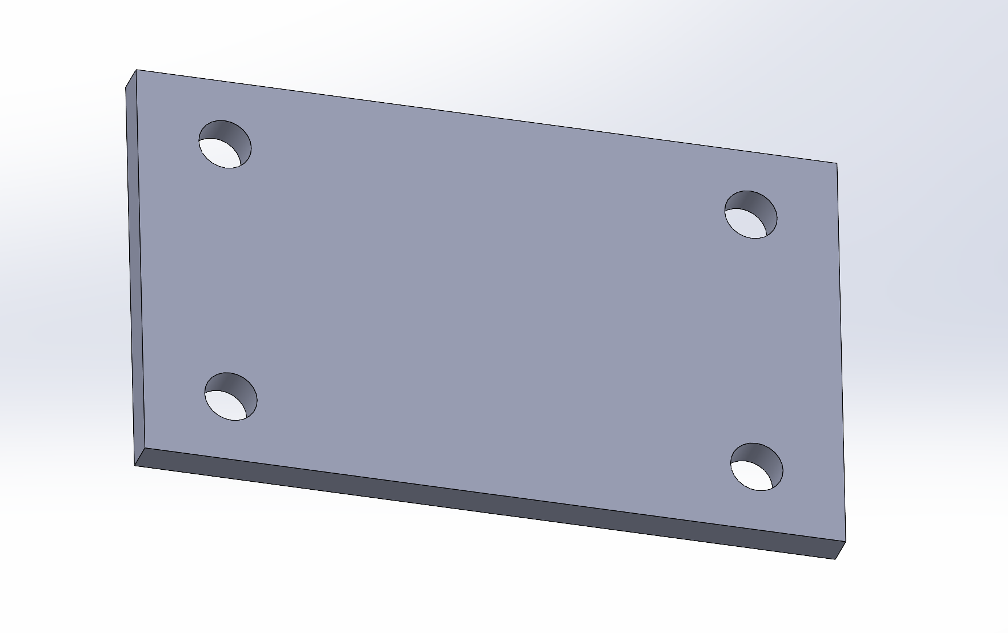

1. **Create drawings and dimension the plate with a boss and four studs. The boss and studs fit another plate with mating hole features.**

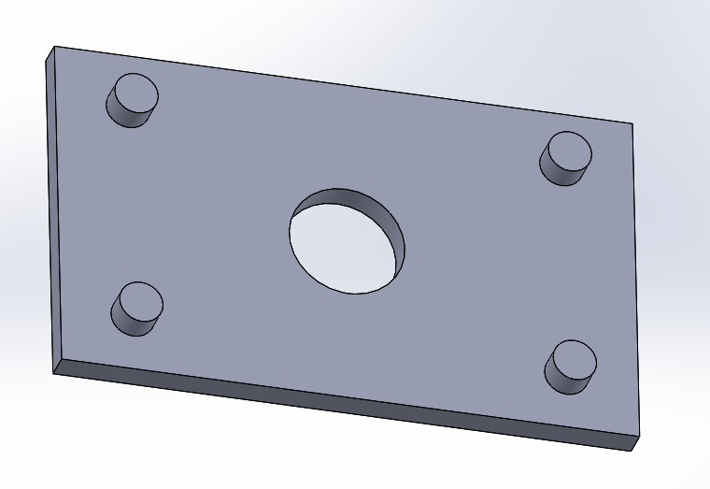

1. **Create drawings and dimension the disk with boss. The boss fits a disk with a mating hole feature.**

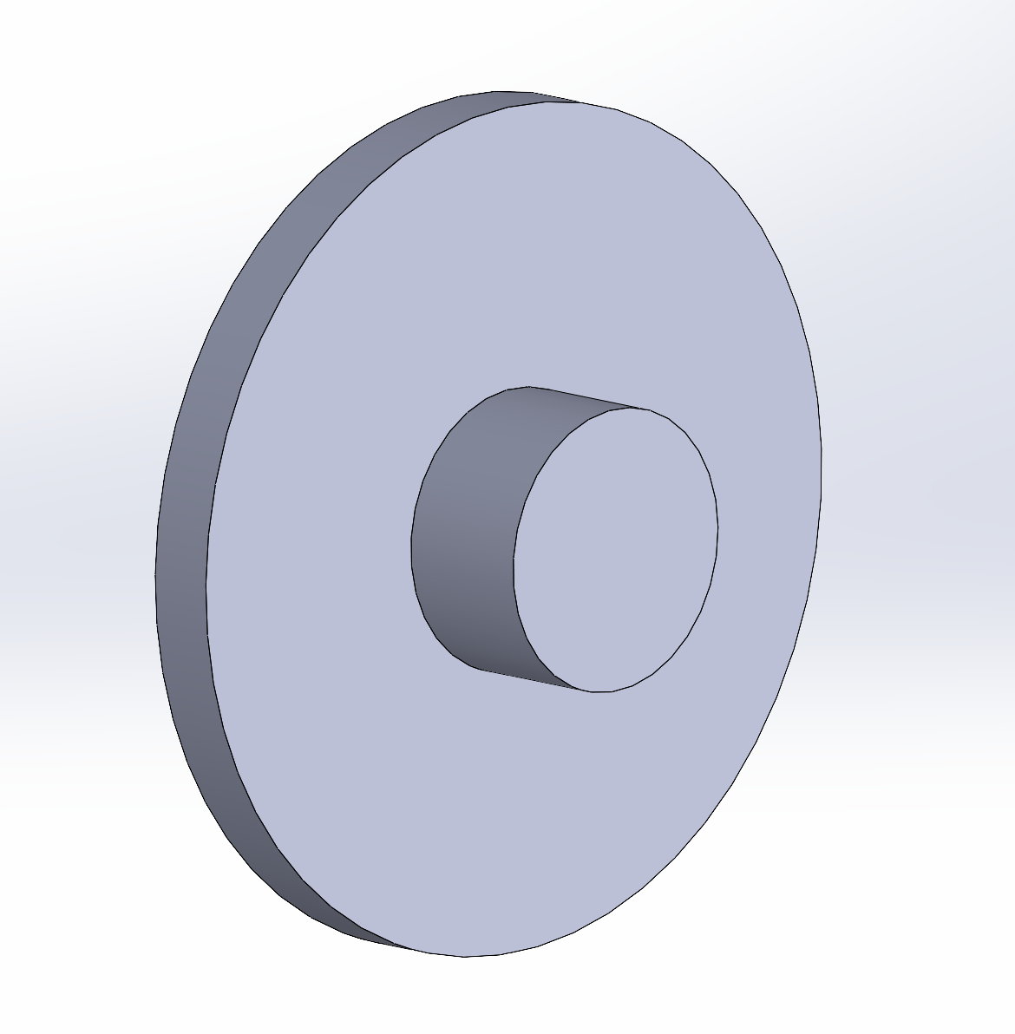

1. **Create drawings and dimension the disk with boss and hole. The boss fits a disk with a mating hole feature.**

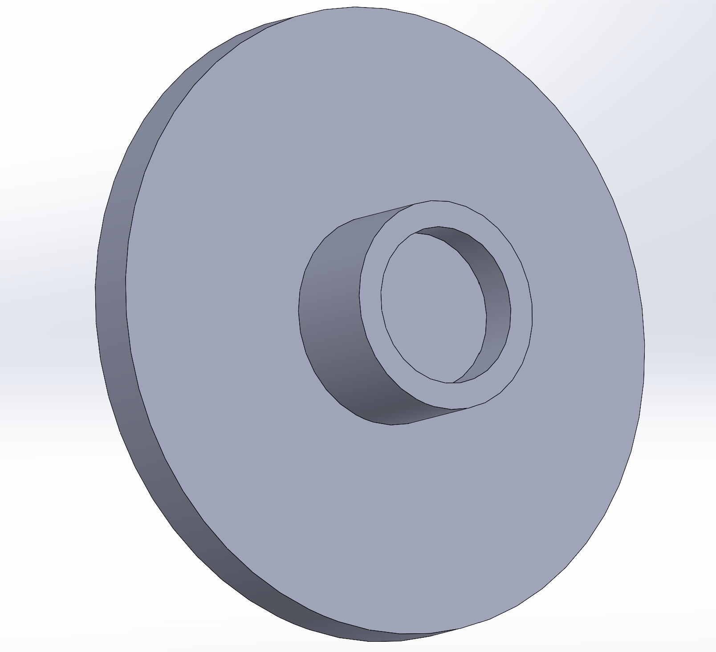

1. **Create drawings and dimension the disk with boss and hole pattern. A mating part has a hole fitting the boss and three studs fitting the three holes.**

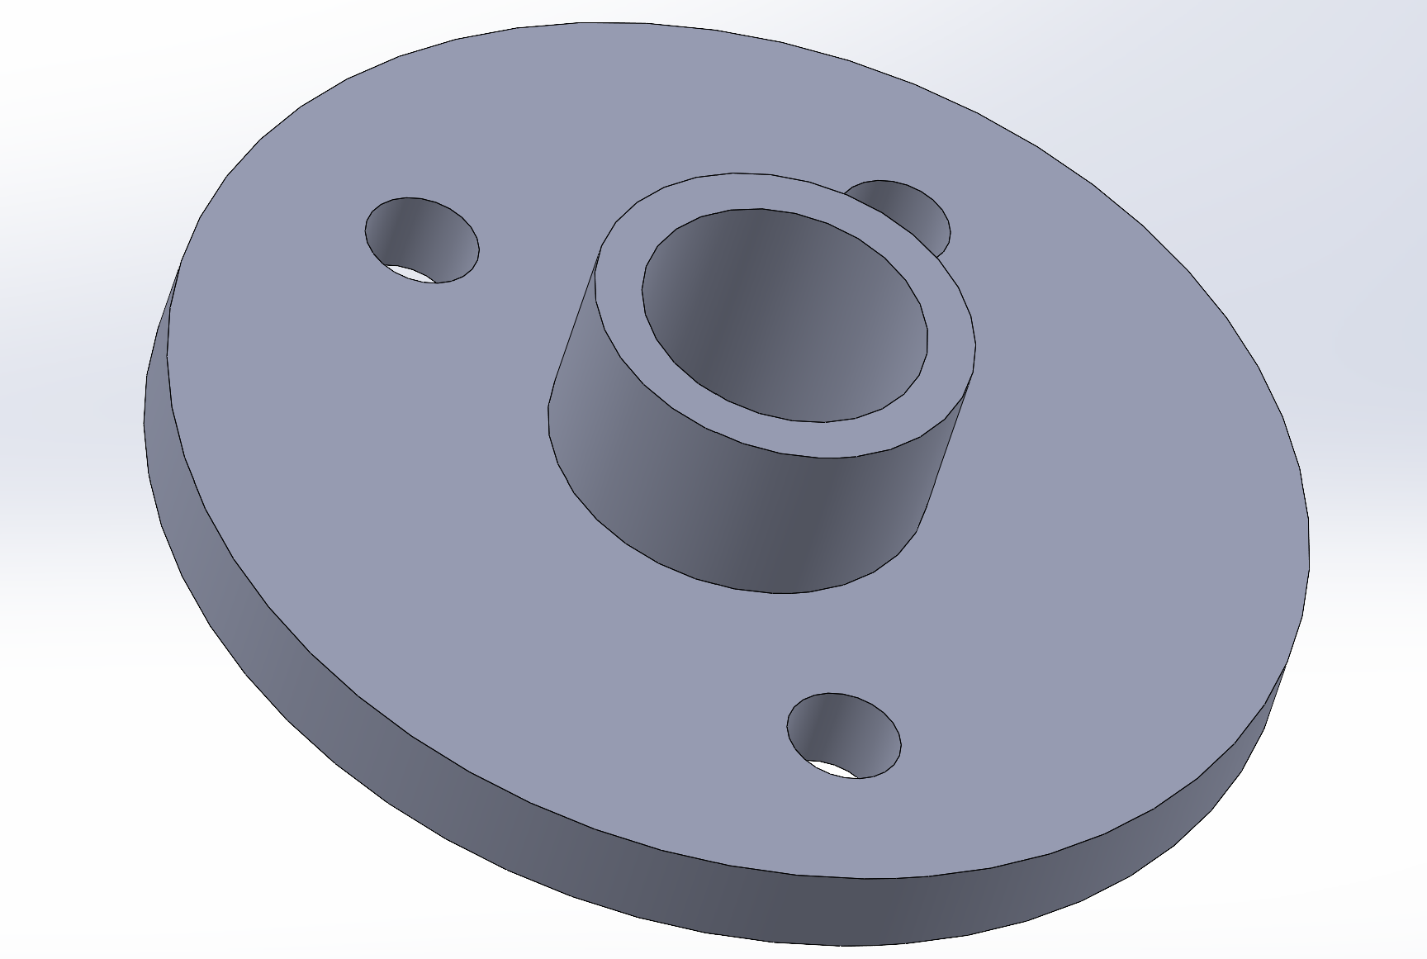

1. **Create drawings and dimension the plate with hole pattern and slots.** 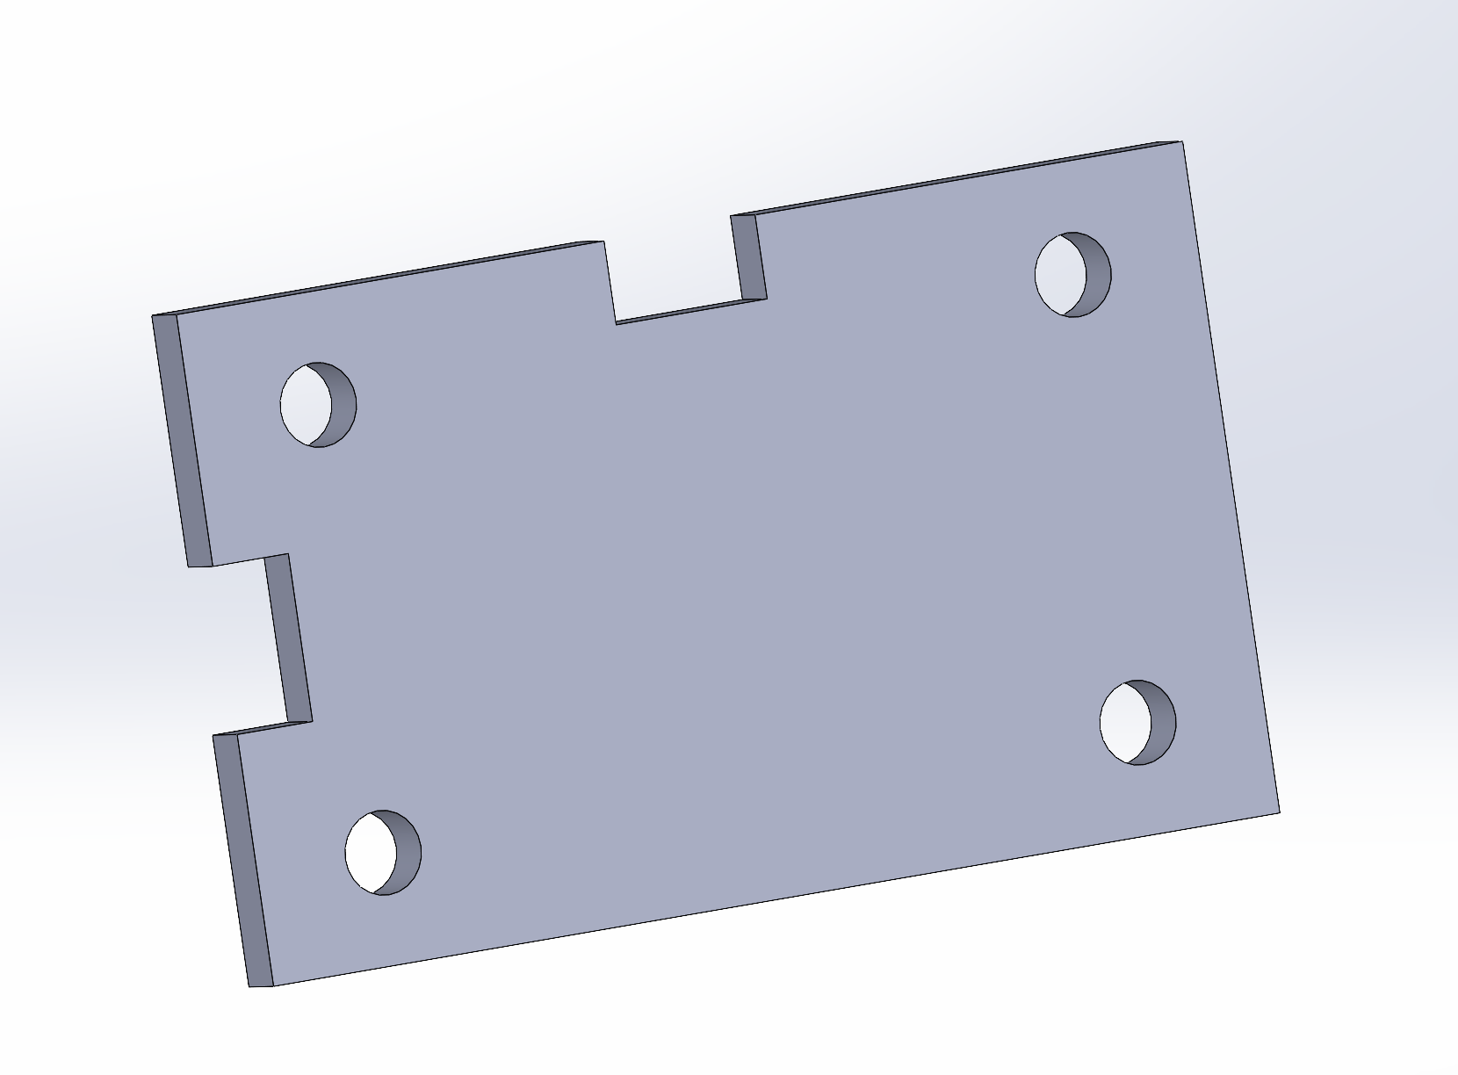
2. **Create drawings and dimension the shaft with 2x2 mm chamfers and 2 mm fillets**

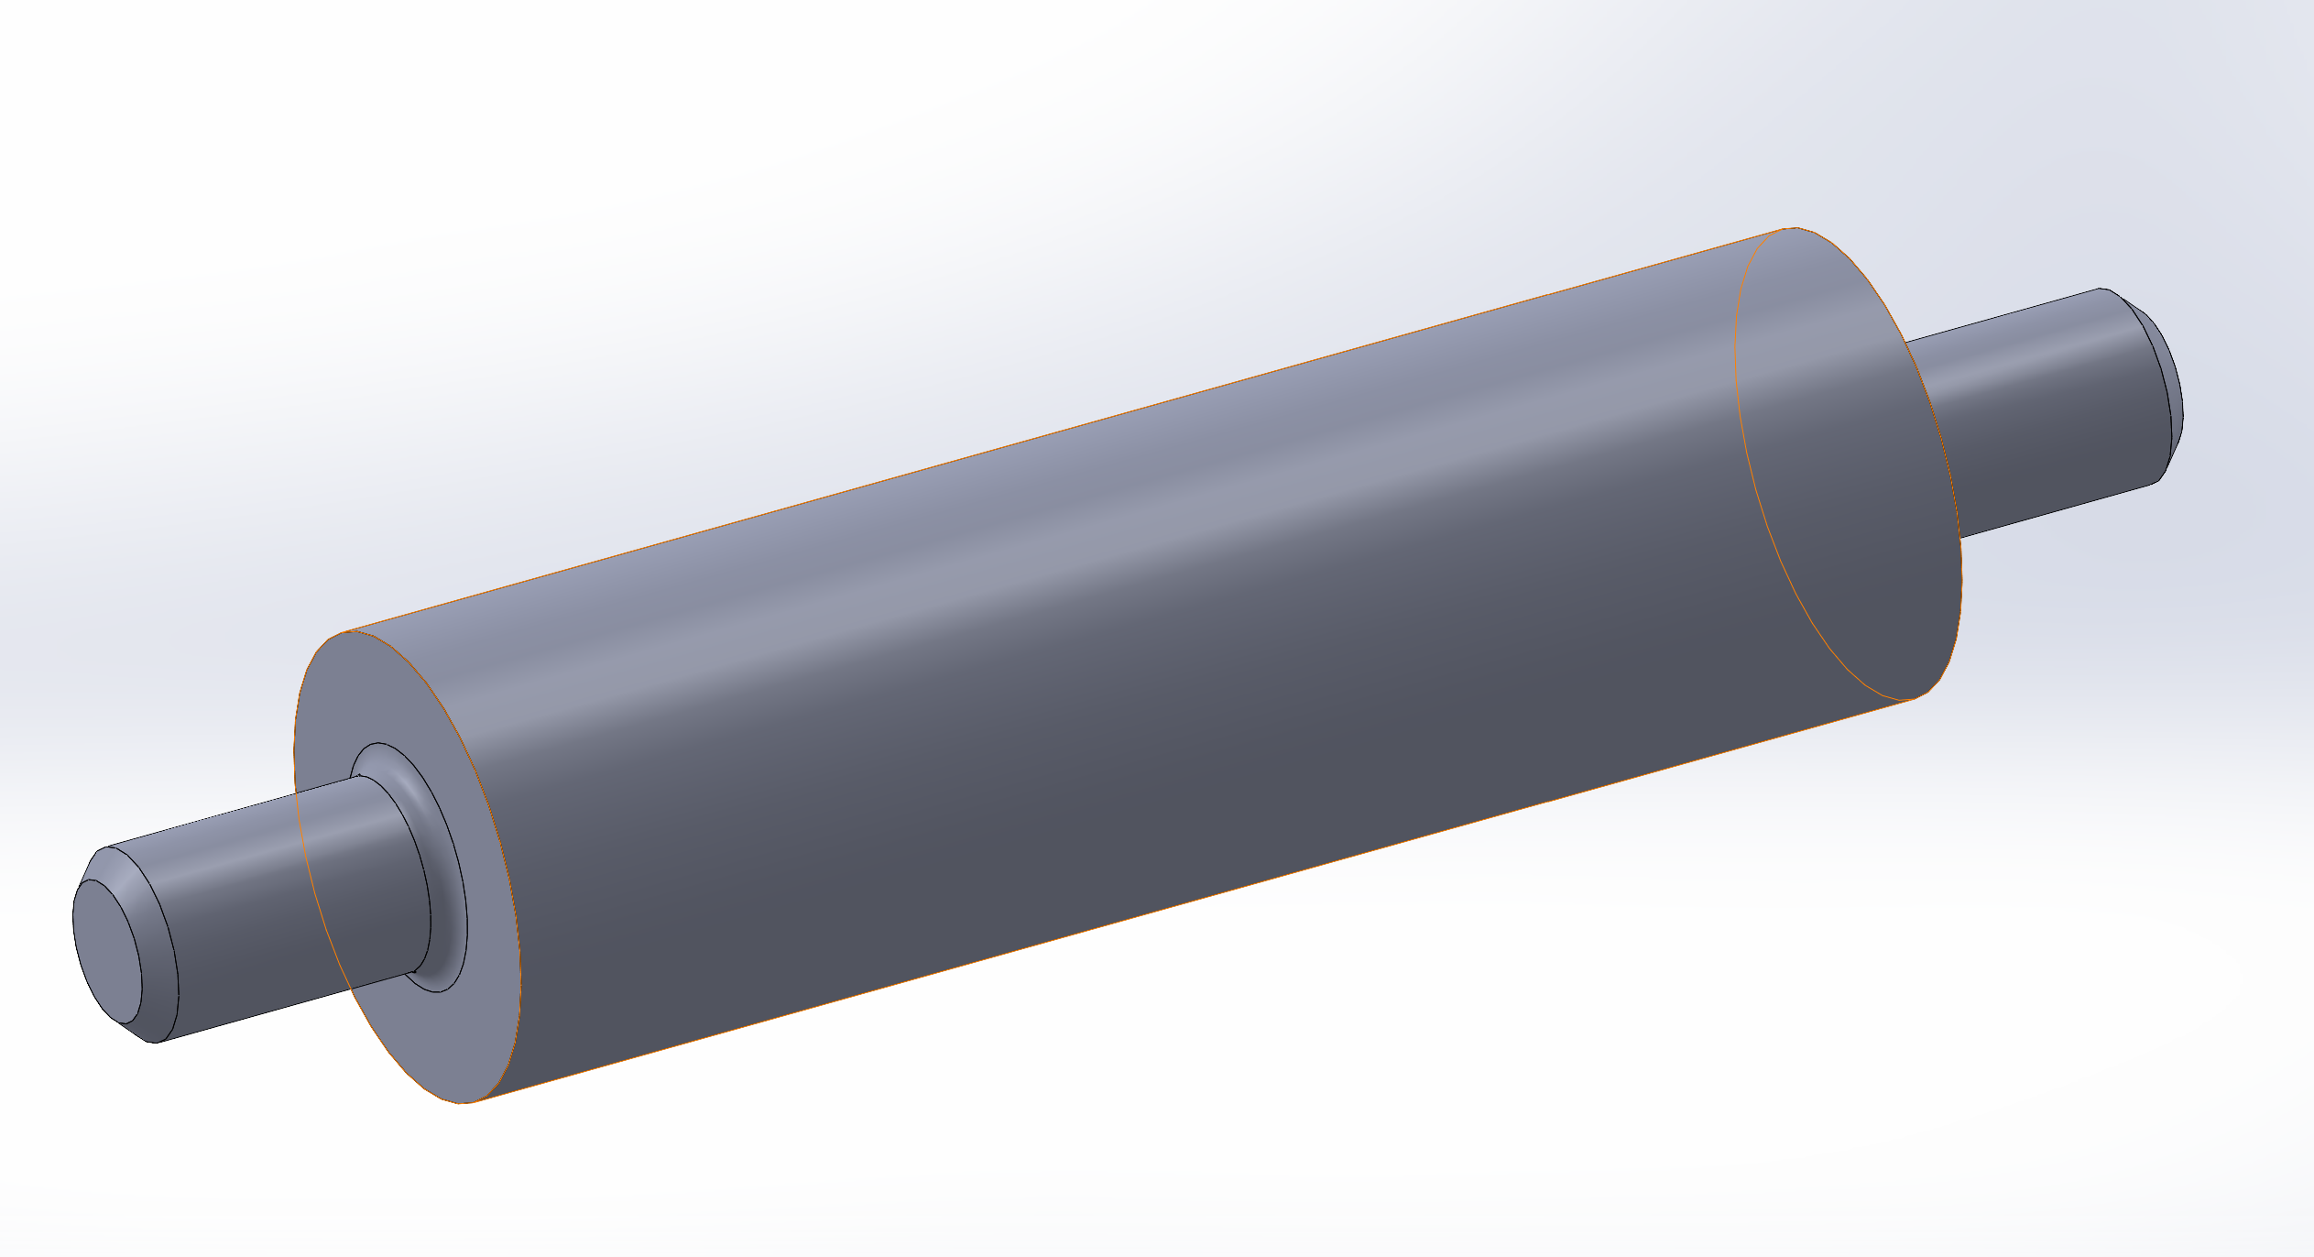

1. **Create drawings and dimension the shaft with rectangular keyway. The two end fit bearings. The keyways fit keys.**

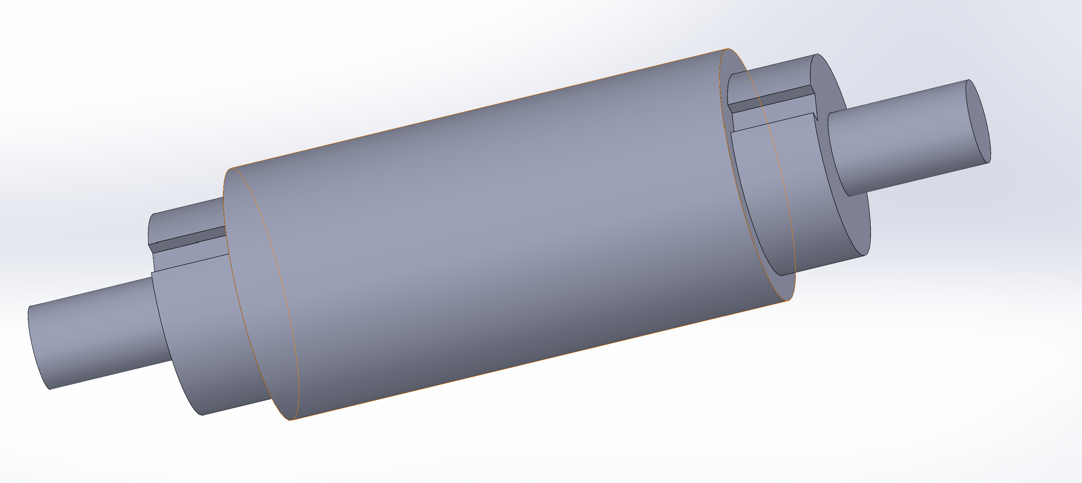

1. **Create drawings and dimension this part. The pair of countersunk holes fit a part. A shaft simultaneously fits the center hole and gets fixed by a set screw. The slot does not fit anything.**

