1. Two plates with clearance holes are to be attached using a pattern of 10 mm loose bolts. Select the smallest standard drill size that will be adequate for the application. Assume the hole size tolerances to be 0.06 mm and the position tolerances to be 0.25 mm. Determine whether free assembly is assured. If free assembly is not assured, select drill that is 0.25 mm larger and repeat the procedure. What are the final acceptable size limits and position tolerances for the holes when size and position tolerances are specified separately? What are the hole size tolerances when zero position tolerances are used.

**Solution**

Let us consider a 10.25 mm drill capable of creating clearance holes in the size range of 10.25-10.31 mm. Using the floating fastener formula:

TH = Hmin – Fmax

Substituting for Fmax = 10 mm and TH = 0.25 mm we get:

0.25 = Hmin – 10 🡺 Hmin = 10.25 mm

This means a 10.25 mm drill is adequate for this application. The final specification for the clearance holes using separate size and position tolerance is:

10.25 – 10.31 mm with T = 0.25 mm

Using ZGT format we have

10.00 – 10.31 mm

1. Solve Exercise Problem#1 assuming the plates are to be fastened using tapped holes and M10 screws. What are the final acceptable size limits and position tolerances of the clearance holes and the position tolerance of the tapped holes when size and position tolerances are specified separately? What are the hole size tolerances when zero position tolerances is used?

**Solution**

Let us again consider a 10.25 mm drill capable of creating clearance hole in the size range of 10.25-10.31 mm and holding a position tolerance of 0.25 mm for both the clearance hole and the tapped hole. Using the fixed fastener formula:

TH = ½ (Hmin – Fmax)

Substituting for Fmax = 10 mm and TH = 0.25 mm we get:

0.25 = ½ (Hmin – 10)🡺 Hmin = 10.5 mm

This means a 10.25 mm drill is not adequate for this application. Changing the drill size to 10.50 leads to clearance hole size limits of 10.50 – 10.56 mm. This drill would be adequate for the application. The final specification for the clearance hole using separate size and position tolerance is:

10.50 – 10.56 mm with T = 0.25 mm

For the tapped hole:

M10 with T = 0.25 (must be used with projected tolerance zone specification)

Using ZGT format for the clearance hole we get

10.25 – 10.56 mm

1. The slot feature of the turning support is to fit to the rail of the base and be fixed to the base using a pair of 12 mm loose bolt. Figure below shows the turning support.

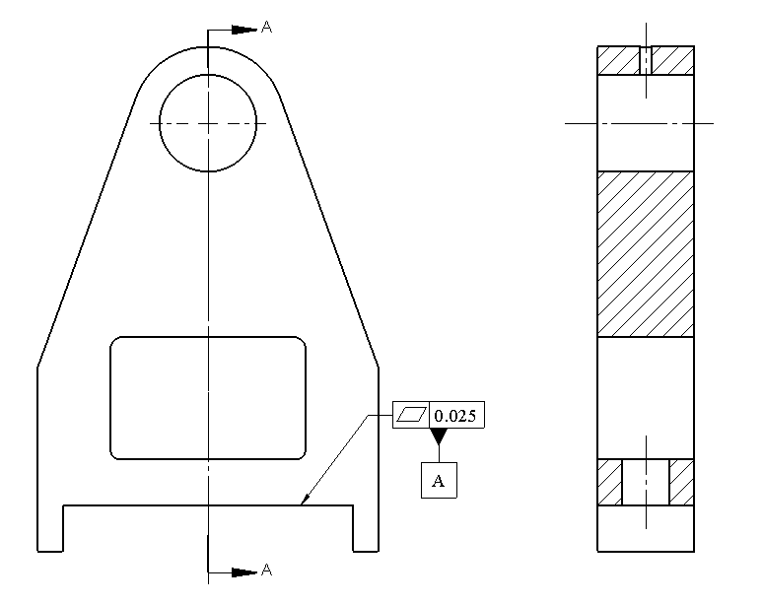

**Turning support**

Show the necessary tolerance statements for the fit of the slot and rail as well as the 12 mm loose bolt holes. The play in the slot and rail fit should not exceed 0.40 mm. The bolt holes are to be drilled. The basic width of the slot and rail are 76 mm. The drills can hold a size tolerance of 0.06 mm and a position tolerance of 0.3 mm. Use ZGT format for holes.

**Solution**

Since the fit of the slot and rail is supposed to have a max play of 0.4 mm, the slot size limits with ZGT format is 76.0 – 76.2 mm. The rail size would be 75.8 – 76.0 mm with the ZGT format. The formula for floating fastener is

H0min – F0max = 0

Using F0max = 12 mm we get:

H0min = 12.0 mm

The combined size and position tolerance for the drilled holes is 0.36 mm, therefore the clearance hole size limits become 12.00 – 12.36 mm. The figure shows the tolerances of the part holder. The rail tolerances are similar.

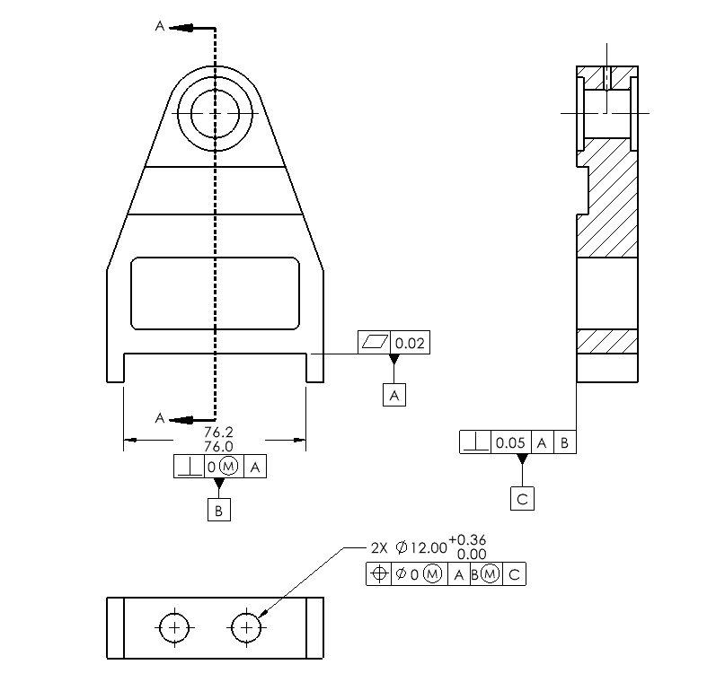

1. Consider a plate with six clearance holes fitting a plate with six threaded holes using 10 mm cap screws as shown. The center boss has a nominal size of 40 mm and fits a center hole on the mating part. Use a 40H9/h9 fit with ZGT format for the center pin and hole. Similarly use 20H9/h9 for the slot and rail fit. The clearance holes for the screws are to be created by drilling. The screws are M10. Use a combined tolerance of 0.3 mm for the clearance holes and 0.25 mm for the position tolerance of the threaded holes. The thickness of both plates is 10 mm. Check the specifications to assure the screws will fit. Model the assembly on a CAD system and fully tolerance the two parts for proper fit.

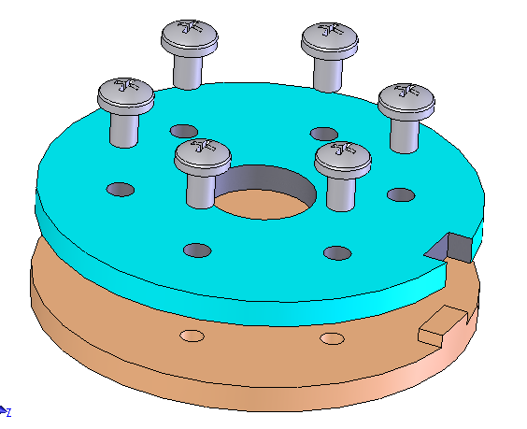

**Assembly of two plates using a pattern of cap screws**

**Solution**

The following figure shows the part with the needed tolerances:

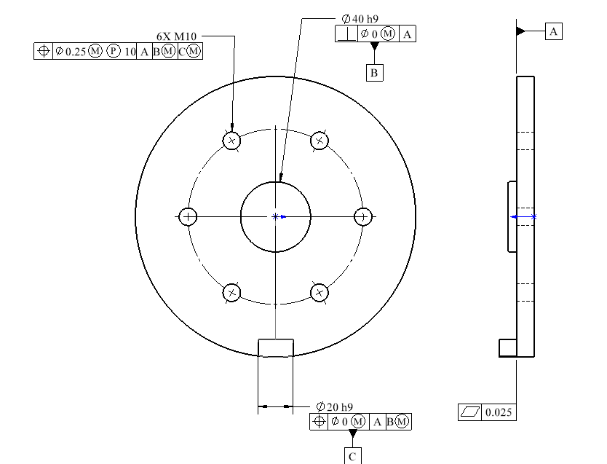

The mating part tolerancing is similar with clearance holes instead of threaded holes. The clearance holes use a ZGT format with 0.3 mm of combined tolerance. We can find H0min to assure the fasteners will assemble. For a fixed fastener case:

H0min – Fmax = TF

We can then solve for the clearance hole size H0min as:

H0min = 10 + 0.25 = 12.5 mm

The combined size and position tolerance for the clearance hole is 0.3 mm. The maximum or LMC size of the clearance hole Hmax becomes:

Hmax = 12.8 mm

1. Consider the post-holder and base plate shown. A partially dimensioned drawing of the post holder is shown in the following figure. A lip on the mounting surface of the post-holder fits tightly into the base part. The four clearance holes are to align with tapped holes in the base for M8 cap screws. Use the size limits of 50 H9 and 50d9 for the lip fit features. Both parts are to be made by machining. Create a model of this assembly along with fully dimensioned and toleranced drawings of the parts. The position tolerance for the drilling for fastener holes is 0.22 mm. The drilled clearance hole size tolerance is 0.05 mm. Check the specifications to make sure the screws will fit.

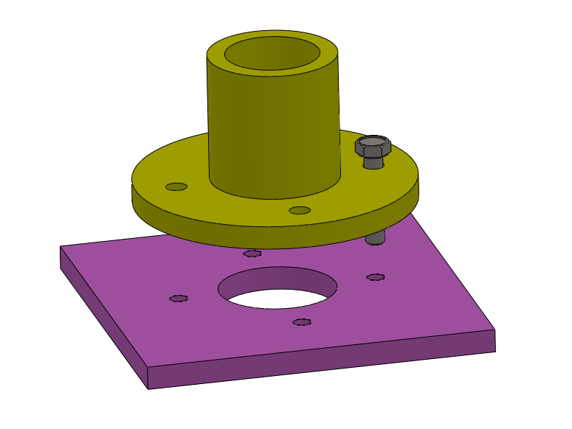

**Assembly of post holder and base plate using a pattern of cap screws**

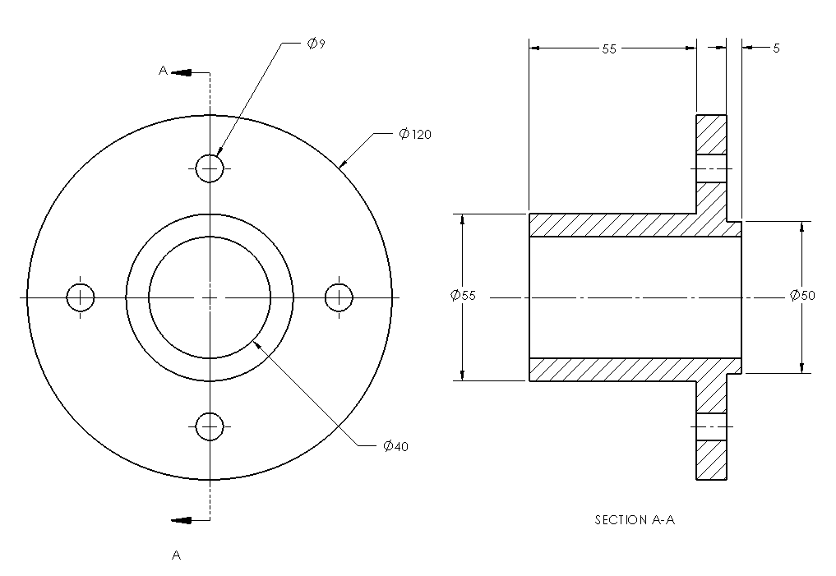

**A partially dimensioned drawing of the post holder**

**Solution**

The drawing of the plate with relevant tolerances

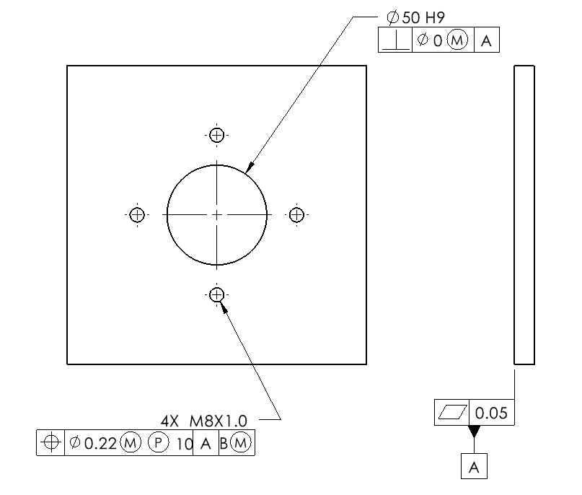

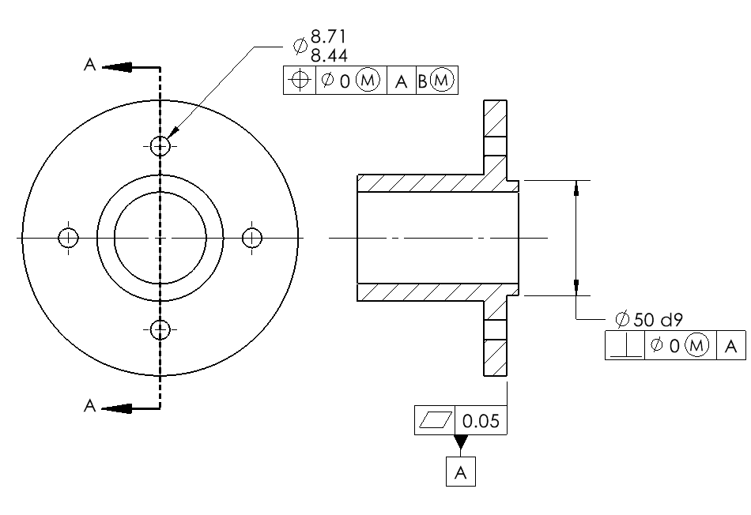

For this fixed fastener assembly

½ (H0min – Fmax) = TF

Substituting for Fmax and TF

H0min = 8 + 2(0.22) = 8.44 mm

Using the combined tolerance of (0.22+0.05) = 0.27, Hmax becomes:

Hmax = 8.44 + 0.27 = 8.71 mm