- Consider a plate with a center hole and two pins as shown.
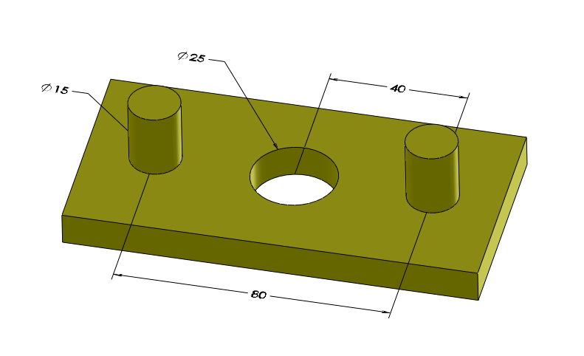
A plate with a center hole and two pins

Model this part on a CAD system and create a drawing. Specify the center hole to have size limits of 25H9. Specify the two pins to have size limits of 15h12. This plate is fitting a plate with a center pin and two holes as shown in the following figure.

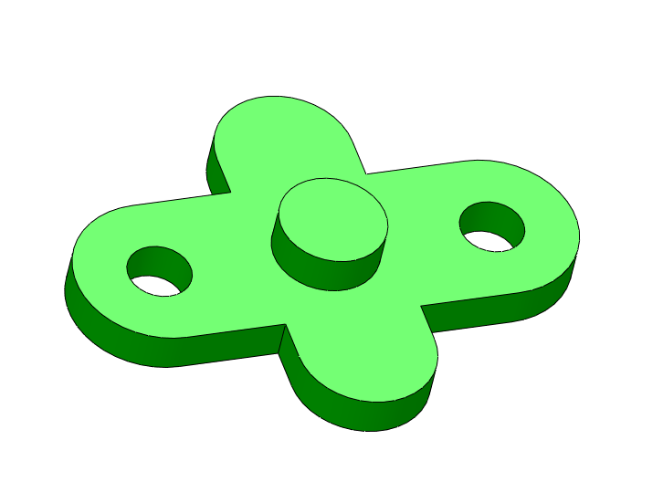
A plate with a center pin and two holes

For this plate use size limits of 25h10 for the center pin and 15H12 for the two holes. Model the two parts on your CAD system and complete the tolerancing information for the fitting features including identification and control of datum features. Use the ZGT format for all fit features.

Solution

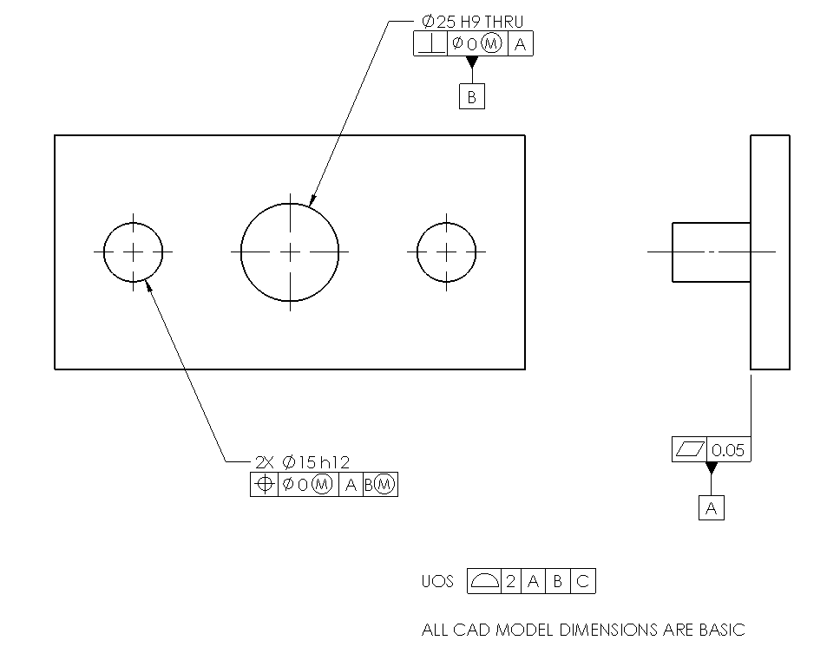

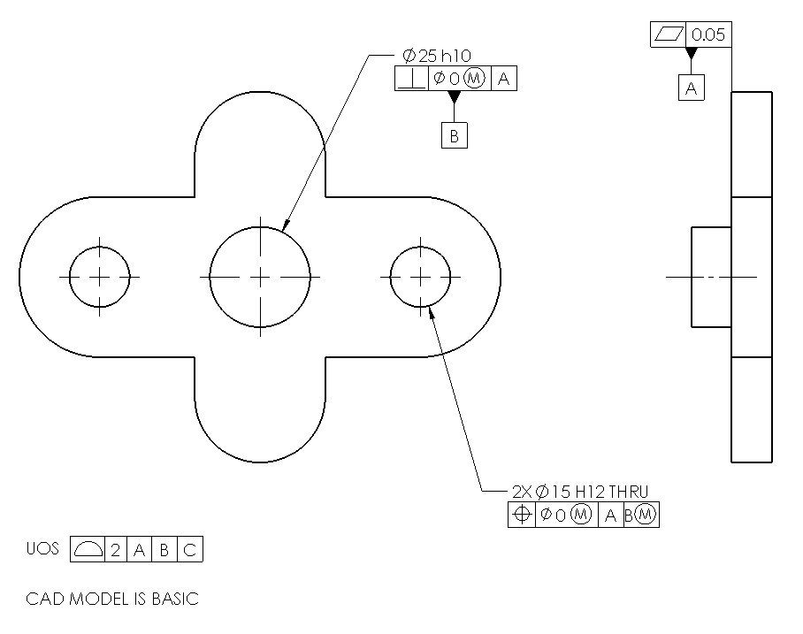

- Complete the tolerancing of the two parts in Exercise Problem#1 but this time do it in a different order. Treat the fit of the pattern of two holes and pins first (as the datum feature) and then the fit of the center feature.
Solution

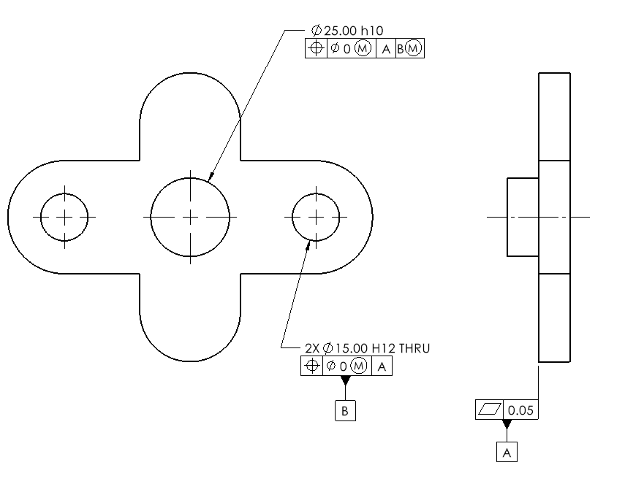

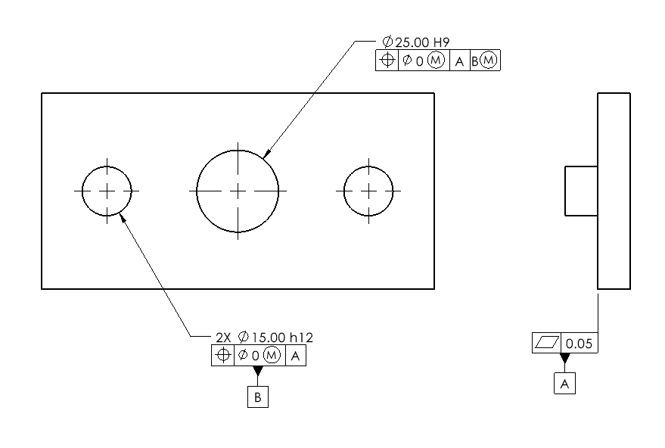

- Consider the simultaneous fit of two coaxial features as shown.
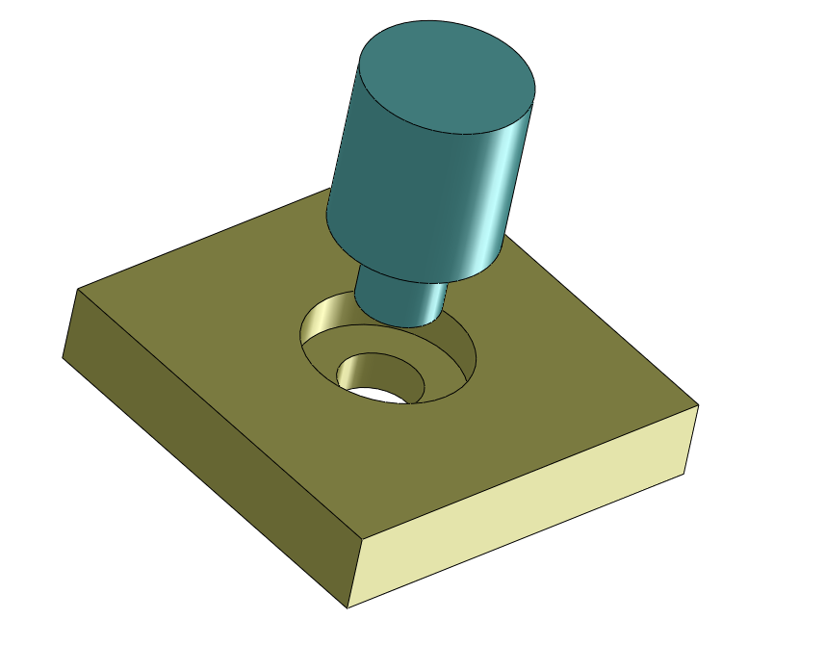
Fit of two coaxial features

The nominal dimensions of the larger cylinders are 40 mm and the smaller cylinders are 20 mm. We would like to tolerance the parts to assure assembly. In this application, the two parts need not perfectly rest on their flat shoulders. Create models of the two parts and their drawings and tolerance the part features to assure a zero worst-case fit gap. Extend the tolerancing for the case where there exists a third coaxial feature of size 60 mm.

Solution

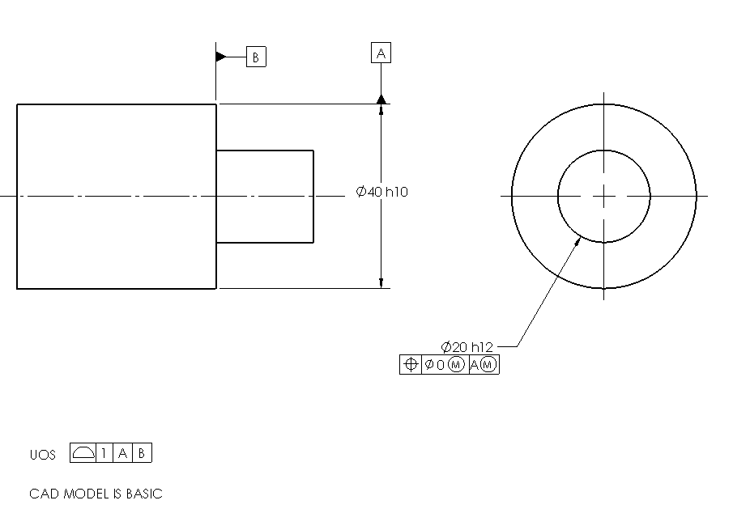

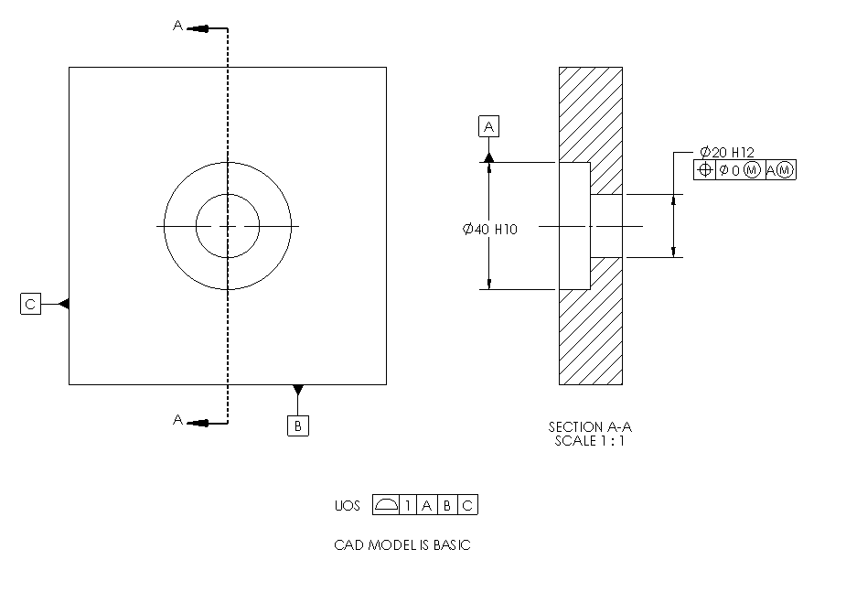

- Tolerance the coaxial fit feature parts in Exercise Problem#4 such that the fit is assured while the flat shoulders are in full primary contact.

Solution (correction: A datum should not be followed by M symbol)

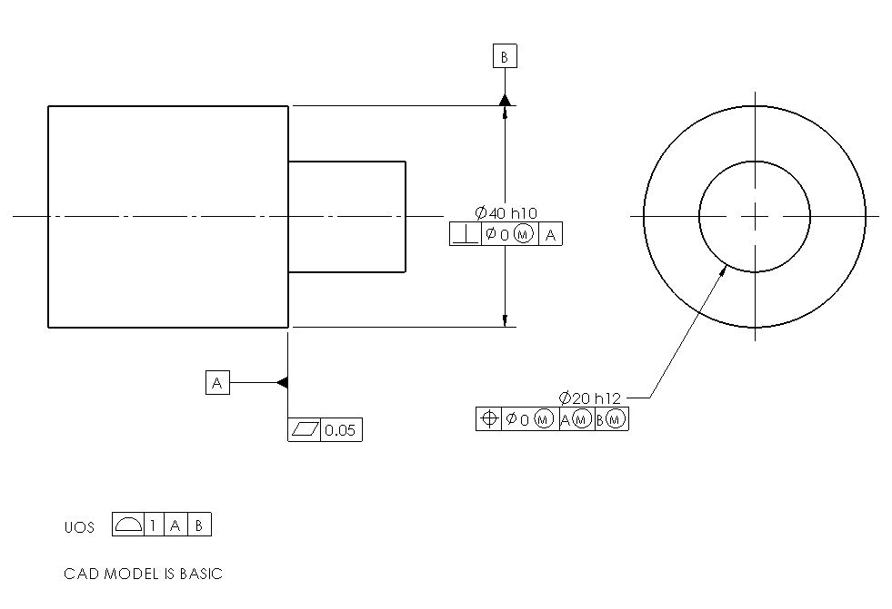

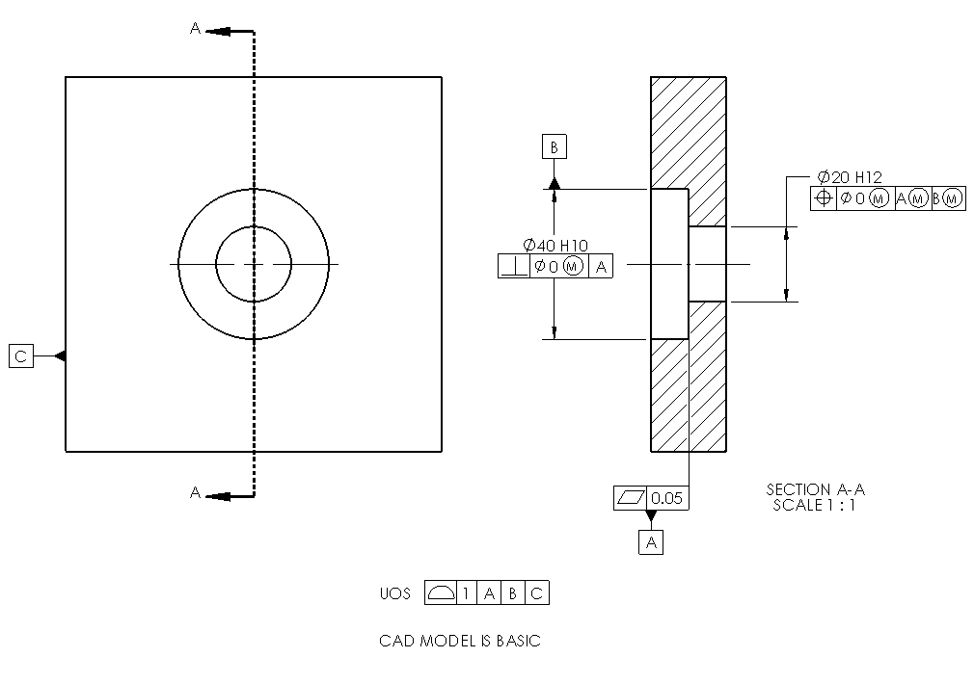

- Consider the assembly shown. One of the parts is flipped to better show the features.

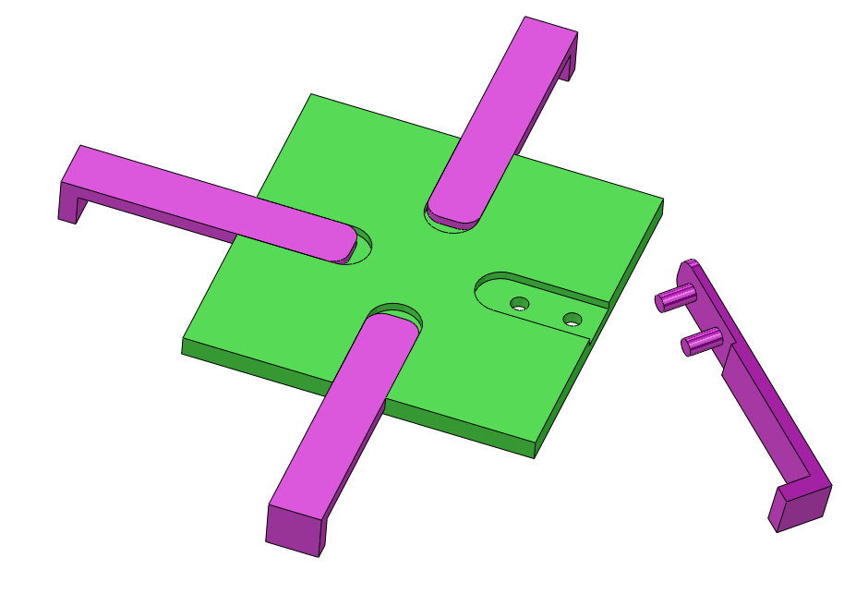
Fit of four separate parts to a plate
The pins and holes have 10 mm nominal size and the width of the rail and slot are 30 mm. The rest of the dimensions are up to you. Model the parts in a CAD system and create complete production drawings for the two parts. Assume milling process tolerances apply.

Solution

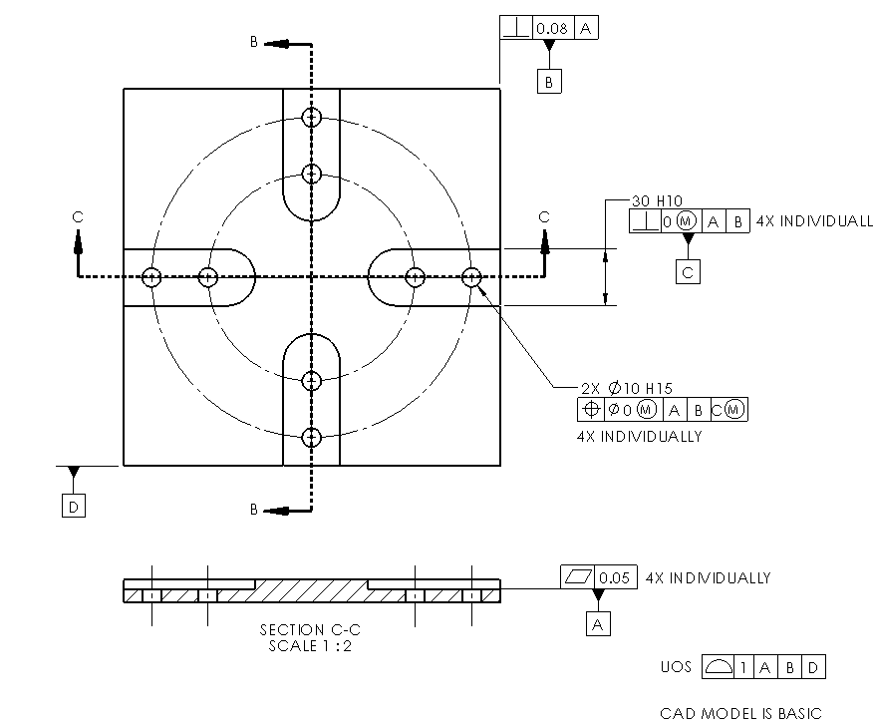

Note: 4X INDIVIDUALLY is equivalent to ALL FOUR SIDES or something similar
