- Consider the orientation-constrained fit situation shown.

A simple orientation-constrained fit

    - Using your CAD system and model both parts with dimensions that result in worst-case condition for fit. For example, the pin size would be at the MMC size of 19 mm plus 1 mm allowance for orientation. It is best to convert the features to ZGT format before modeling. Create an assembly of the two parts and check for play or interference. What is the play in the CAD assembly model?
Solution

Since the distance between the centers is 0.5 mm, the play in the fit is 1 mm.
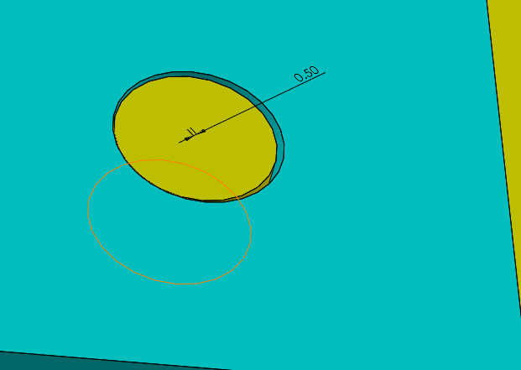

    - Model the parts with dimensions leading to the maximum play in the fit. Create an assembly and determine the maximum play in the fit?
Solution

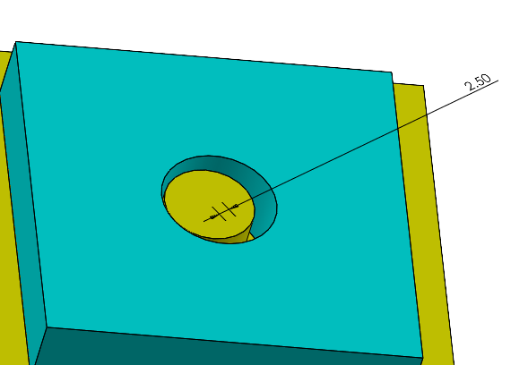

Since the distance between the centers is 2.5 mm, the play in the fit is 5 mm.

- Consider the fit of a hole and a pin in an orientation-constrained fit. The nominal size of the features is 25 mm. Both features must be specified in ZGT (Zero Geometric Tolerance) format. The minimum play is to be zero and the maximum play must not exceed 0.2 mm. For the most economical design, both feature sizes are to border the nominal size of 25 mm. Using equal tolerances for both features, determine the size limits of the two features.

Solution
In this case we will use the maximum play limit to find the tolerances. The maximum play is the summation of all tolerances:
P_{max} = t_{h} + t_{F} + T_{h} + T_{F} + P_{min}
Since the tolerances are equal:
P_{max} = 2t + 2T
With the ZGT format and using the combined tolerances:
P_{max} = 2(t_{ZGT}) 0.2 = 2 t_{ZGT} t_{ZGT} = 0.1 mm
For the features to border the nominal size of 25 mm:
Hole size limits = 25.0 – 25.1 mm
Pin size limits = 24.9 – 25.0 mm

- Consider the fit of a slot and a rail in an orientation-constrained fit. The slot feature size limits are 25.5 – 25.8 mm with a 0.1 mm perpendicularity tolerance at m. The minimum play is to be zero and the maximum play must not exceed 0.8 mm. Determine the widest size limits of the rail feature to achieve this fit performance using a ZGT format assuming equal size tolerances.

Solution

We use the maximum play limit to find the tolerances. The maximum play is the summation of all tolerances:
P_{max} = t_{h} + t_{F} + T_{h} + T_{F} + P_{min}
Since the tolerances are equal:
P_{max} = 2t + T_{h} + T_{F}
With the ZGT format and using the combined tolerances:
P_{max} = 2(t_{ZGT}) 0.8 = 2 t_{ZGT} t_{ZGT} = 0.4 mm
The slot size limits in ZGT format is 25.4 - 28.8

The rail size limits become: 25.0 – 25.4 mm

