Chapter -3

**Exercise Problems**

1. Use the LAF program and determine the size limits of a *15f6* shaft and a *15H7* hole. If these features fit together what is the resulting range of clearances or interferences?

**Solution**

15f6 = 14.973 – 14.984 mm 15H7 = 15.000 – 15.018 mm

Min Clearance = 0.016 mm Max clearance = 0.045 mm

========================

1. A shaft feature has 15d8 size limits. The offset(fundamental deviation) for the *d* code is given as -0.050 mm. The *d* offset represents an upper deviation. The tolerance value for IT8 is 0.027 mm for a 15 mm shaft. Determine the size limits by manual calculation. Check with the LF program.

**Solution**

Max size = 15 – 0.05 = 14.950 mm

Min size = 14.95 – 0.027 = 14.923 mm

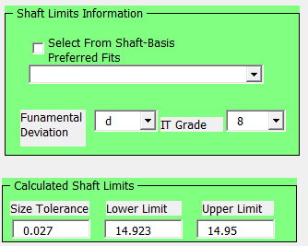

========================

1. What kind of named preferred fit is adequate as an initial selection for the following applications?
   * 1. A disk drive plain bearing sliding on a ground shaft.
     2. The ID of a ball bearing fitting a rotating shaft subject to heavy shock loading.
     3. The OD of a plain bearing fitting a stationary housing.
     4. The ID of a plain bearing and a shaft in a precision rotation application.
     5. A dowel pin fitting tightly into a jig hole – the fit is rigid but removable.
     6. A gear that can be freely assembled on a shaft with a snug fit.
     7. A shaft collar used to fix the axial location of a pulley.

**Solution**

1. Sliding Fit H7/g6
2. Locational interference fit H7/p6
3. Locational interference fit H7/p6
4. Close running fit H8/f7
5. Locational clearance fit H7/h6
6. Locational clearance fit H7/h6
7. Loose running fit H11/c11

========================

1. What is the size of the fit boundary associated with a hole having size limits of 15*H*11 and a straightness tolerance of 0.05 mm at MMC? What would be the theoretical size of a GO gage that would inspect the feature’s combined straightness and size tolerance?

**Solution**

FBH = Hmin – T = 15 - 0.05 = 14.95 mm Gage size =14.95 mm

========================

1. A disk drive guide rod has a 3*g*6 size tolerance specification and is intended to have a sliding fit with a 3*H*7 bearing ID. The length of fit is 5 mm. What tolerance specification is appropriate for the rod such that the sliding fit can be achieved without requiring the rod to have unneeded precision? Hint: You can specify a straightness tolerance value per length; for example, 0.1/5 m or 0/5 m for tolerance value.

**Solution**



1. The length of a shaft with 10f8 size limits is 20 mm long. If no form control specification is applied to this shaft length, what additional form control tolerance is implied by default.

**Solution:** Zero straightness at MMC

1. The ID of a collar designed for a 12 mm shaft is between 12 mm and 12.013 mm. Determine the fitting shaft size limits for a performance similar to a free running fit.

**Solution**

For a free running fit: Pmin = 0.05 and Pmax = 0.136,

Therefore: Pmin = FBH – FBF = H0min – F0max 🡺 0.05 = 12 – F0max 🡺 F0max = 11.950

Also: Pmax = Hmax – Fmin 🡺 0.136 = 12.013 - Fmin 🡺 Fmin = 11.877

Shaft limits: 11.877 – 11.950

========================

1. Calculations show that a 20 mm nominal size journal bearing must fit a shaft resulting in a minimum play of 0.065 mm. The maximum play must not exceed 0.169 mm. Determine the widest size tolerances for the shaft and the bearing used with ZGT format. Use the same size tolerance for both features. Also, specify H0min = 20 mm. Do these limits correspond to a particular named preferred fit? If yes, what is the named preferred fit.

**Solution**

Pmin = 0.065 and Pmax = 0.169

Pmin = FBH – FBF = H0min – F0max 🡺 0.065 = 20 – F0max 🡺 F0max = 19.935 mm

Pmax = Hmax – Fmin 🡺 0.169 = Hmax - Fmin

0.169 = (H0min + t) – (F0max – t) 🡺 0.169 = 20 – 19.935 + 2t 🡺 t = 0.052 mm

Alternatively: Pmax = TH + TF + t + t + Pmin

0.169 = 0 + 0 + 2t + 0.065 🡺 t = 0.052 mm

Hole size limits: H0min = 20 mm Hmax = 20.052 mm

Shaft size limits: F0max = 19.935 Fmin = 19.883 mm

The named preferred fit is Loose Running Fit 20H9/d9

========================

1. An interference fit requires a minimum radial interference of 0.005 mm and a maximum radial interference of 0.021 mm for a 20 mm nominal size fit. Determine the size limits of both fitting features using the ZGT format. Use the same size tolerance for both features.

**Solution**

Radial distances are half diametrical distances. Clearances and interferences in limits and fits are based on feature diameters. Therefore, the interference ranges from 0.01 mm to 0.042 mm.

Using the maximum interference that corresponds to Pmin, we have:

Pmin = Hmin – Fmax

The minimum hole size Hmin is selected to be 20 mm to border the nominal size.

-0.042 = 20 – Fmax 🡺 Fmax = 20.042 mm

Using the minimum interference that corresponds to Pmax, we have:

Pmax = Hmax – Fmin

Writing the feature sizes in terms of the other limits of size and size tolerance we get

Pmax = (Hmin + t) – (Fmax – t)

Pmax = (Hmin – Fmax) + 2t

Substituting numbers:

-0.01 = (-0.042) + 2t 🡺 t = 0.016 mm

**Hole size limits: 20.000 - 20.016 mm**

**Shaft size limits: 20.026 – 20.042 mm**

1. Pick three of the 10 classes of named preferred fits and find an actual example for them. You can find such examples in your gym, machine shop, automobile, labs, your kitchen or garage, or other common places. Take pictures and explain why the selected fit matches the preferred fit you picked.

**Solution**

The sliding bearing used in a variety of applications uses a sliding fit H7/g6 for a smooth motion. A little looser fit can create inaccuracy of motion and a little tighter fit can result in excessive friction and loss of smooth motion.

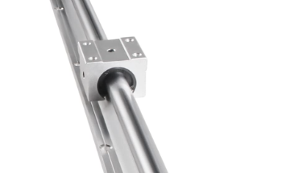

The fit of a high precision gear on a shaft is a locational clearance fit H7/h6. This allows free assembly but a tight fit allowing very little play.

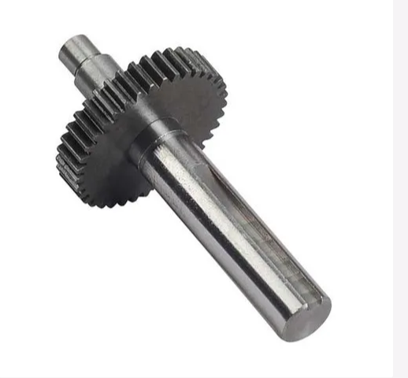

Shaft collars are stationary components that keep gears or pulleys in place. They do not need a precision fit. Therefore, a loose running fit H11/c11 can be an adequate fit for a shaft collar

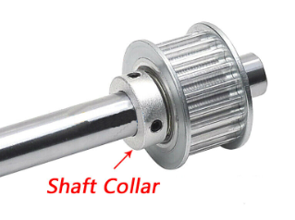

1. Search the internet for “Standard metric drill sizes” for a 20 mm twist drill per ANSI/ASME B94.11M standard. Search the internet for size tolerances that regular twist drills can hold in terms of IT grades and calculate the size limits a 20 mm twist drill can hold.

**Solution**

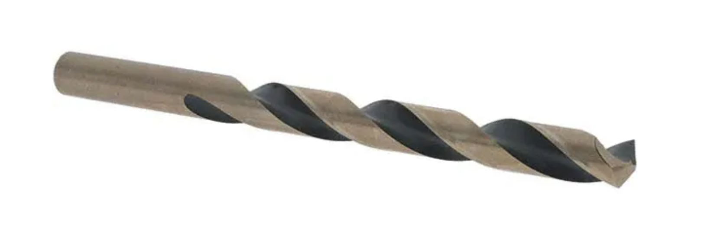

Twist drills can typically hold size tolerances in the range of IT10 to IT13.

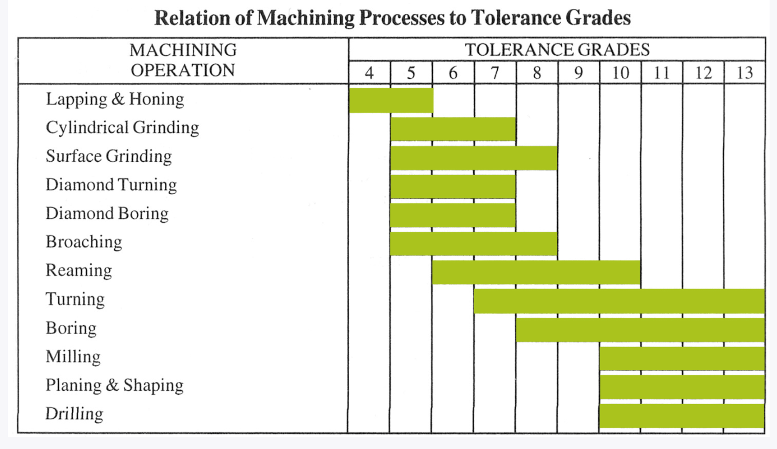

For a 20 mm basic size the numerical range is: IT10 = 0.084 mm and IT13 = 0.330 mm. Therefore, the size limits range is:

20.000 – 20.084 mm (high precision drills)

20.000 – 20.330 mm (regular drills)

1. Search the internet for a 20 mm metric reamer (Metric sizes per DIN1420 Standard). Search the internet for size tolerances that a 20 mm reamer can typically hold.

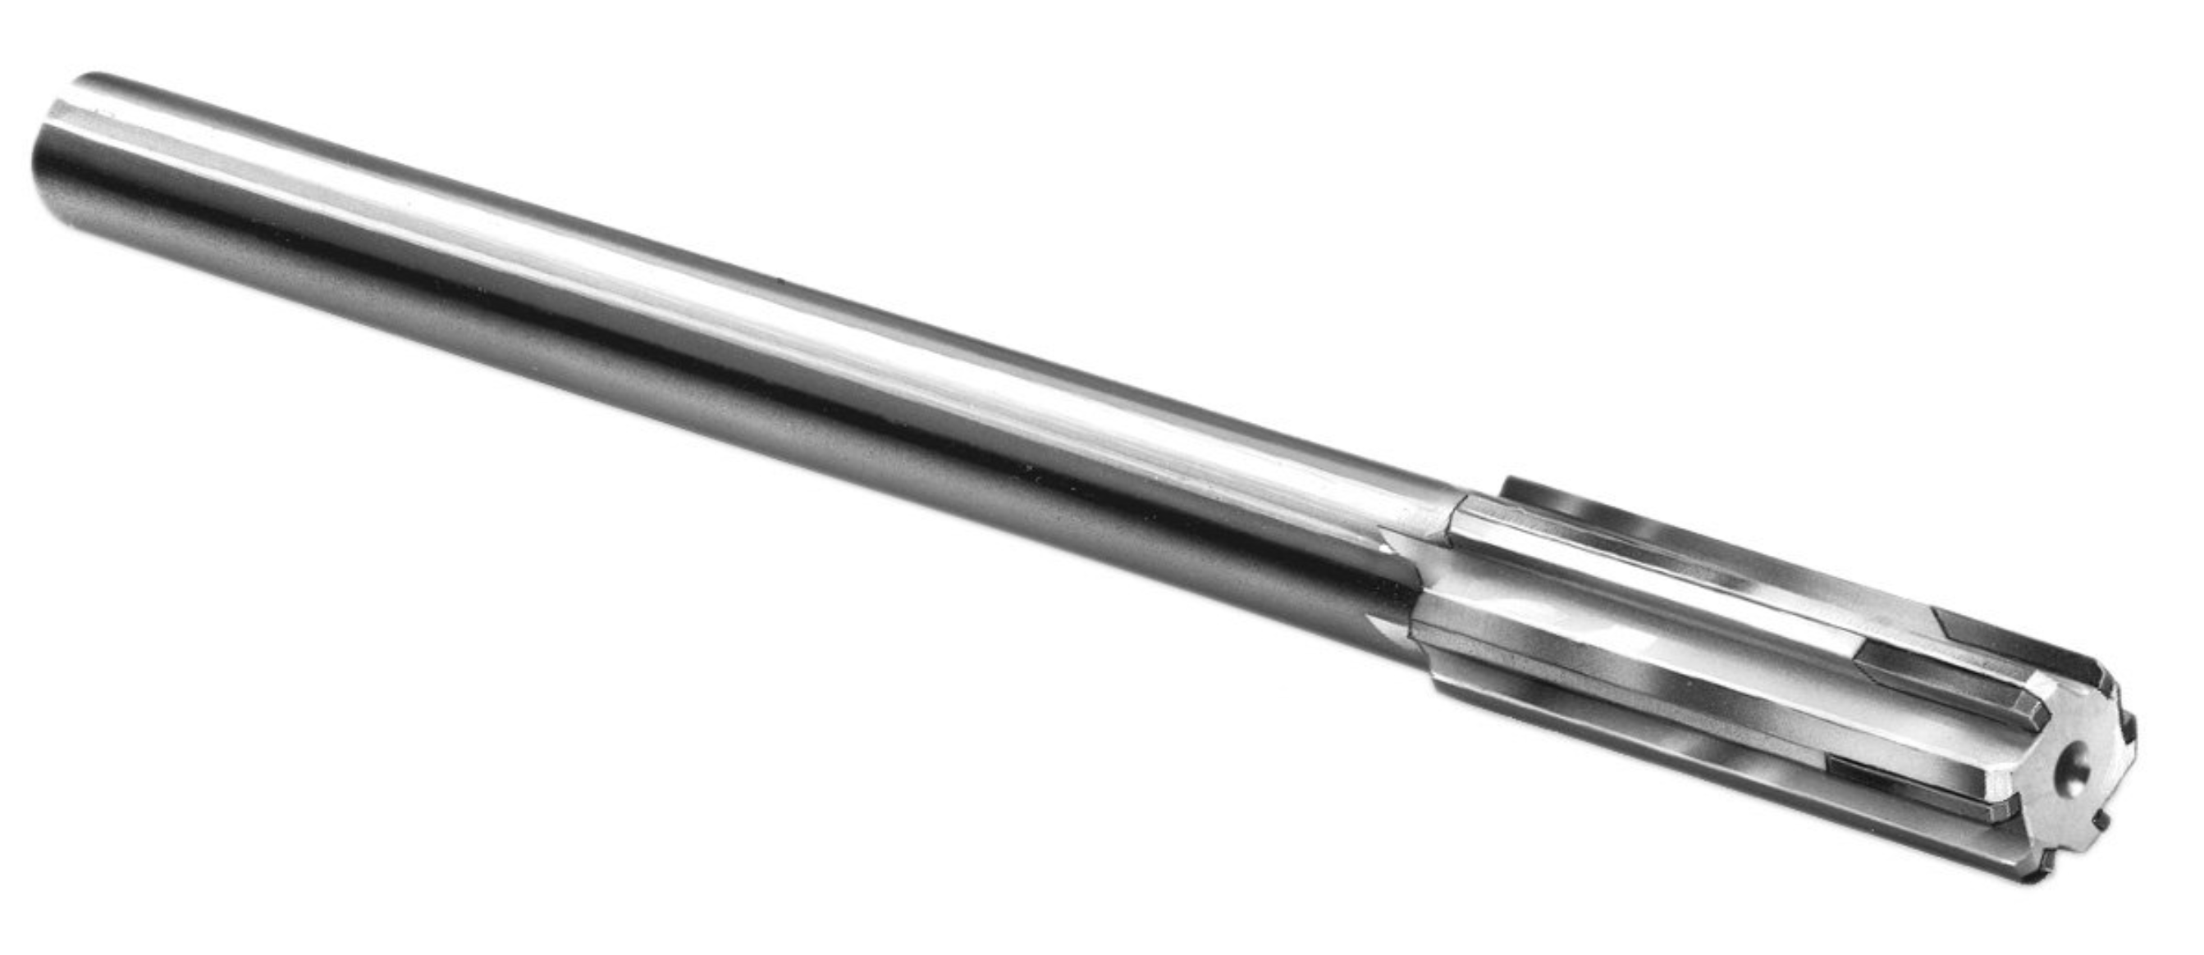

Reamers can typically hold size tolerances in the range of IT6 to IT10. For a 20 mm basic size the numerical range is: IT6 = 0.013 mm and IT10 = 0.084 mm. Therefore, the size limits range is:

20.000 – 20.013 mm (high precision reamers)

20.000 – 20.330 mm (regular reamers)

1. Search the internet for standard metric sizes of dowel pins.

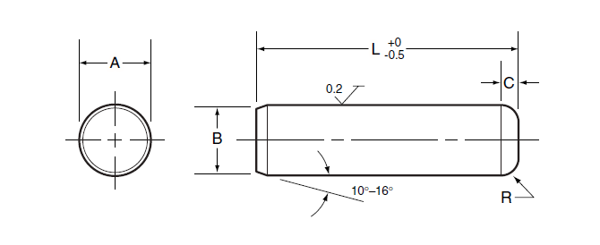

What is the main application of dowel pins? Dowel pins size limits usually matches a coded limit. What is the common coded size limits for this dowel pin?

**Solution**

The primary application of metallic dowel pins is in jigs and fixtures

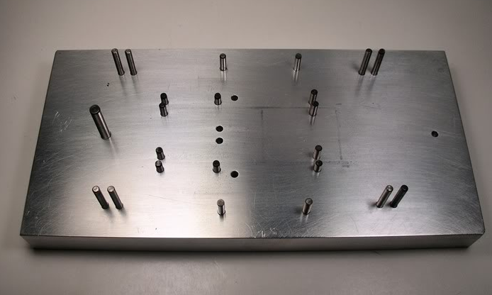

Metric dowel pins have an IT6 tolerance grade. For a 10 mm nominal size dowel pin, the size limits is 10m6 or 10.006 – 10.015 mm. A precision 10m5 dowel pin size limits is 10.006 – 10.012 mm.