Solution of HW#3

* + - 1. Consider the pin shown



**A pin with size and straightness tolerance specifications**

Determine:

1. The MMC and LMC sizes of the shaft
2. The size of the shaft’s fit boundary
3. The amount of bending allowed when the feature is 14.6 mm
4. The equivalent size limits for ZGT format

**Solution**

1. MMC size = Fmax = 15 mm LMC size = Fmin =14 mm
2. FBF = (Fmax + T) = (15 + 0.5) = 15.5 mm
3. Bending = 0.5 + (15 – 14.6) = 0.9 mm
4. F0max = Fmax + T = 15.0 + 0.5 = 15.5 mm

============================

* + - 1. **Gaging:** In this problem you will check the size tolerance for a shaft feature at one cross-section. Download Problem 2-2 from the book web site. The instructions are given within the file. Based on this one cross-section, is this shaft within size tolerance? Use the snip it tool and show a figure that supports the answer.

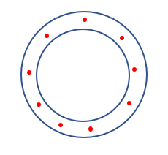

Yes, the shaft at this cross-section meets the size tolerance requirement.

* + - 1. **Gaging:** In this problem you will check the straightness tolerance for a shaft feature for a GO gage. The GO gage is a tube. Download Problem 2-3 from the book web site. All the points representing the shaft surface must fit inside the GO gage tube. Based on this information, is this shaft within straightness tolerance? Use the snip it tool and show a figure that supports the answer.

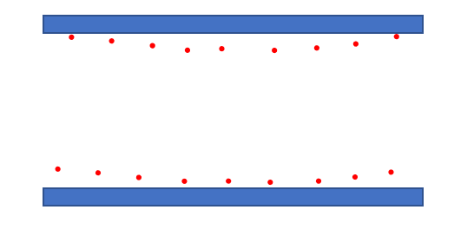

Yes, the shaft feature is within the stated straightness tolerance.

===============================

* + - 1. Consider the hole feature shown.



**A hole feature with size and straightness tolerance**

Determine:

1. The MMC and LMC sizes of the hole
2. The size of the hole’s fit boundary
3. The amount of bending allowed when the feature is made at 16.3 mm
4. The equivalent size limits for ZGT format
5. When this part is fit to the shaft in Problem-1, what is the minimum and maximum possible play in the fit

**Solution:**

1. MMC size = Hmin = 16 mm LMC size = Hmax = 17 mm
2. FBH = Hmin – T = 16 – 0.5 = 15.5 mm
3. Bending = T + (D – Hmin) = 0.5 + (16.3 – 16) = 0.8 mm
4. H0min = Hmin – T = 16 – 0.5 = 15.5 mm ZGT limits 15.5 – 17.0
5. Pmin = FBH – FBF = 15.5 – 15.5 = 0 mm Pmax = Hmax – Fmin = 17 – 14 = 3 mm.

===============================

* + - 1. **Gaging:** In this problem you will check the size tolerance for a hole feature at one cross-section. Download Problem 2-5 from the book web site. Each hole cross-section must be between 16 and 17 mm. The GO gage is a circle of size 16 mm and the NOTGO gage is a circle of size 17. Based on this one cross-section, is this hole feature within size tolerance? Use the snip it tool and show a figure that supports the answer.

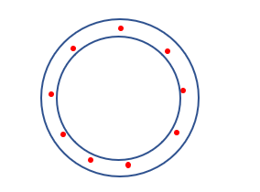

Yes, the hole feature is within size limits at this cross-section.

===============================

* + - 1. **Gaging:** In this problem you will check the straightness tolerance for a hole feature for a GO gage. The GO gage is a bar. Download Problem 2-6 from the book web site. All the points representing the hole surface must fit outside the GO gage bar. Based on this information, is this hole within straightness tolerance? Use the snip it tool and show a figure that supports the answer.

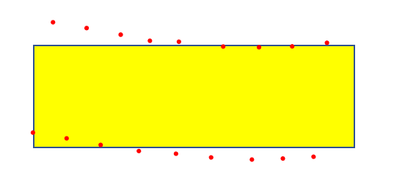

No, this hole does not meet the straightness tolerance requirement.

===============================

* + - 1. A rectangular key is to fit a keyway as shown. The key is desired to have an unconstrained fit to the keyway.



**Fit of a key and a keyway**

The fit tolerances are specified as shown in the figure. Determine:

1. The MMC and LMC sizes of the key and keyway
2. The size of the key and keyway fit boundaries
3. The amount of center plane bending allowed when the key is made at 4.95 mm
4. The amount of center plane bending allowed when the keyway is made at 5.05 mm
5. The equivalent size limits for key and keyway in ZGT format
6. When the key and the keyway fit, what is the minimum and maximum possible play in the fit?

**Solution**

1. Key: MMC size = Fmax = 4.95 mm LMC size = Fmin = 4.90 mm

Keyway: MMC size = Hmin = 5.05 mm LMC size = Hmax = 5.12 mm

1. FBF = 4.95 + 0.05 = 5.00 mm FBH = 5.05 – 0.05 = 5 mm
2. Bending of key allowed at MMC = 0.05 mm
3. Bending of the keyway allowed at MMC = 0.05 mm
4. Key: FBF = 4.95 + 0.05 = 5 mm Keyway: FBH = 5.05 – 0.05 = 5 mm
5. Pmin = FBH – FBF = 5 – 5 = 0 mm

Pmax = Hmax – Fmin = 5.12 – 4.9 = 0.22 mm

===============================