ME 481/581 HW on Chapter-9

- Draw theoretical gage for the circularity:
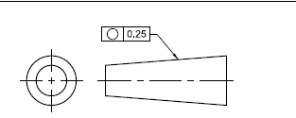

- Draw theoretical gage for the cylindricity:

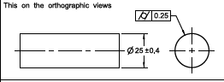

- Draw theoretical gage for the perpendicularity:
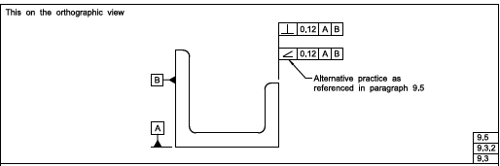

- Draw theoretical gage for the angularity:

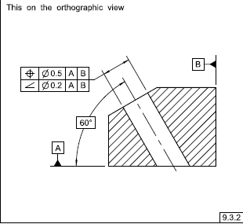

- Draw theoretical gage for the parallelism.
- Draw theoretical gage for the position tolerance
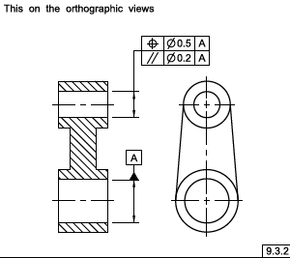

- Draw theoretical gage for the pattern of larger holes (lower specification):
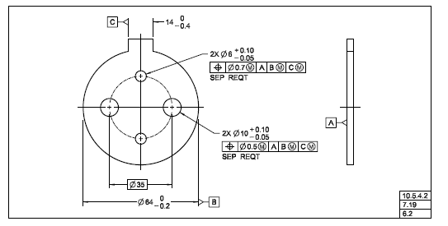
- Draw theoretical gage for the profile tolerance.
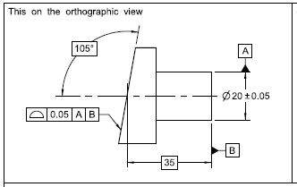
- Draw theoretical gage for the upper circular runout tolerance.
