Gaging: In this problem you will check the size tolerance for a shaft feature at one cross-section. Download Problem 2-2 from the book web site. The instructions are given within the file. Based on this one cross-section, is this shaft within size tolerance? Use the snip it tool and show a figure that supports the answer.
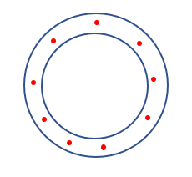
Yes, the shaft at this cross-section meets the size tolerance requirement. Note that the circles need not be concentric.

