Dimensioning Exercises

- What is implied in a drawing?

[T F] Lines that appear to be perpendicular are perpendicular.
[T F] Lines that appear to be parallel are parallel.
[T F] Diameters and radii that appear to be equal in size are equal in size.
[T F] Lines that appear to be collinear are collinear.
[T F] Lines and curves that appear to be tangent are tangent.
[T F] Lines that appear to have equal lengths have equal lengths.
[T F] Cylindrical features that appear to be coaxial are coaxial.
[T F] Two centerlines that appear to be aligned but the centerlines are not connected are still considered to be aligned.
[T F] Features that appear to be in the center are implied to be in the center

[T F] For mm values, a zero must be shown for values less than one (for example 0.25)
[T F] For inch values a zero must be shown for values less than one (for example 0.25)
[T F] Trailing zeros are important because they imply the accuracy of values (like 25.00 is preferred to 25)

- Over-dimensioning (repeated dimensions or unnecessary dimensions) is considered:
[T F] Good practice, adds clarity and assurance. Should be done frequently.
[T F] It must be avoided in most cases – the machinist will call you for explanation.
[T F] Not an error –but poor practice, annoying
[T F] Not an error – occasionally necessary when dimension is not clear

- A dimension is calculated from analysis (other than precision fits) to be 357.538 mm. Use the 1% rule to round up (or down) this number to be used as a dimension.
1% of the number=
Upper limit = Number + 1% =
Lower limit = Number – 1% = Selection =

- Fastener holes should always be described by compact notation [T F]. Larger holes (for bearings should be described by regular dimensions [T F]

- Name a few fastener hole types:

- Name some other features that is best to describe by compact notation:

- When do you show the size of a cylinder (or partial cylinder) by diameter and when do you show the size by radius?

- Dimensions that are based on stock size and are not to be altered are shown by:
- Basic dimensions (in brackets)
- Reference dimensions (in pranthesis)
- A dimension followed by words “STOCK – DO NOT ALTER”
- Dimension the size of the feature using compact notation. The size is 8 and depth is 16.

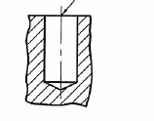

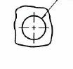

- Dimension the size of the feature using compact notation. The through hole is 6, counterbore hole is 10, depth of counterbore is 3, the fillet radius is 1 mm.
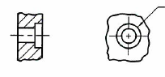

- Dimension the size of the features using compact notation. The size of the hole is 6.8, its depth is 20, the larger diameter is 10, the countersunk angle is 90 degrees.

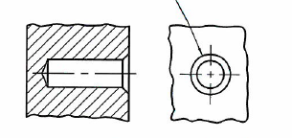

- Dimension the size of the features using compact notation. The total length of the slotted hole is 22, the width is 8, and the ends are semi circles.

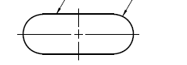

- Dimension the size of the features using compact notation. The chamfer is 2 by 2 (the angle is 45 degrees).

