1. Consider a plate with a center hole and two pins as shown.

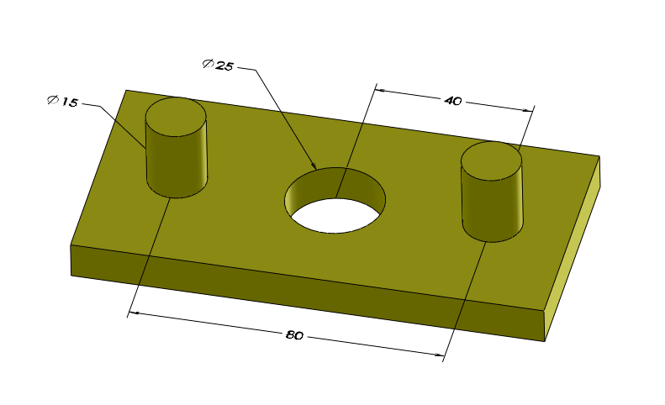

**A plate with a center hole and two pins**

Model this part on a CAD system and create a drawing. Specify the center hole to have size limits of 25H9. Specify the two pins to have size limits of 15h12. This plate is fitting a plate with a center pin and two holes as shown in the following figure.

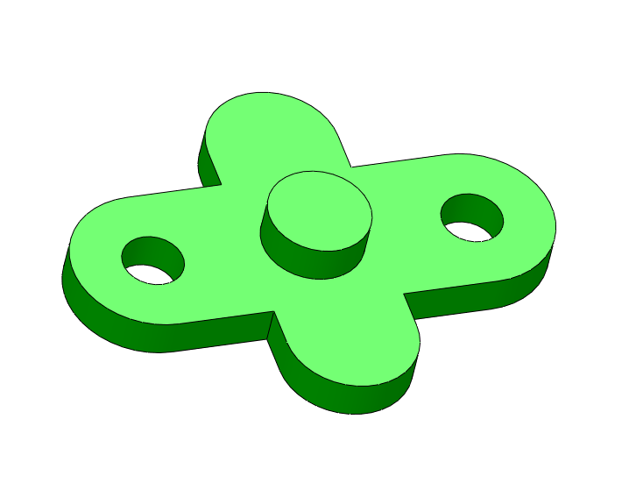

**A plate with a center pin and two holes**

For this plate use size limits of 25h10 for the center pin and 15H12 for the two holes. Model the two parts on your CAD system and complete the tolerancing information for the fitting features including identification and control of datum features. Use the ZGT format for all fit features.

**Solution**

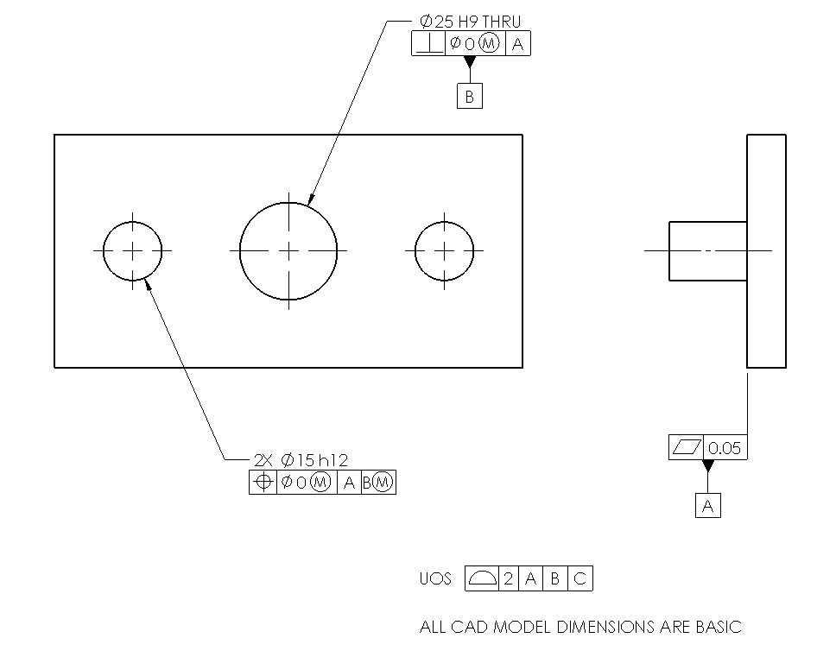

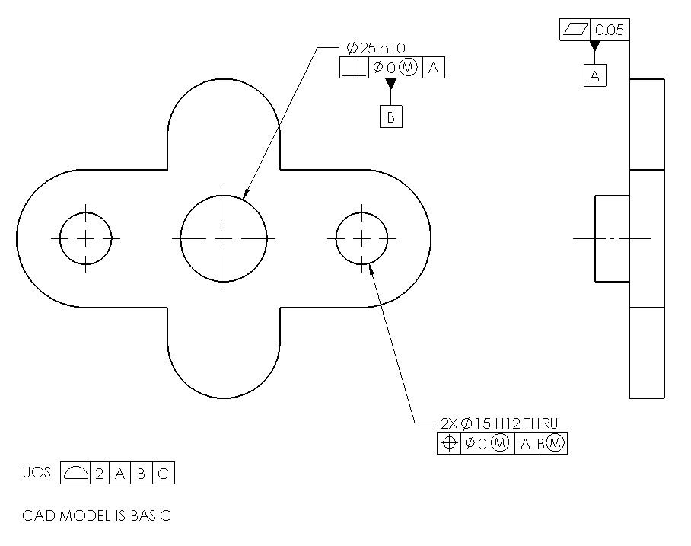

1. Complete the tolerancing of the two parts in Exercise Problem#1 but this time do it in a different order. Treat the fit of the pattern of two holes and pins first (as the datum feature) and then the fit of the center feature.

**Solution**

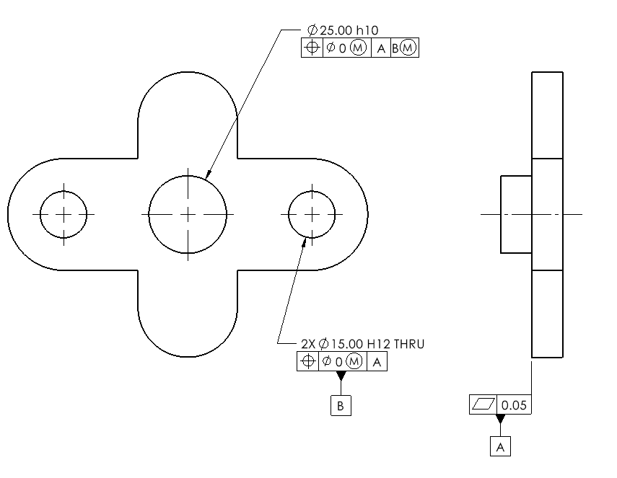

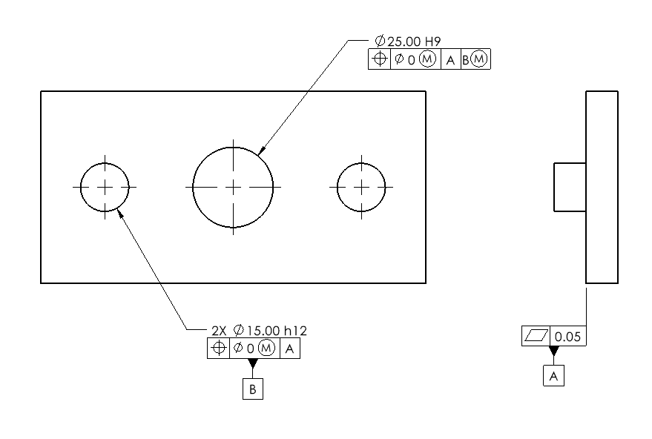

1. **Gaging:** Download Problem 5-4 from the book web site. In this problem you will check a position tolerance. Consider the part with the two pins in Exercise Problem#1. The part geometry is sampled by a CMM and the pattern of points representing both fit features and the sole contact datum are shown. The GO gage is made up of two holes and a pin in the center plus the datum plane. Move and rotate the gage if necessary to determine if the part passes the gage test. Based on this information, is this part within position tolerance? Note that both the part surface samples and the gage are 3D but only a 2D pattern can be shown on the plane of paper.

**Solution**

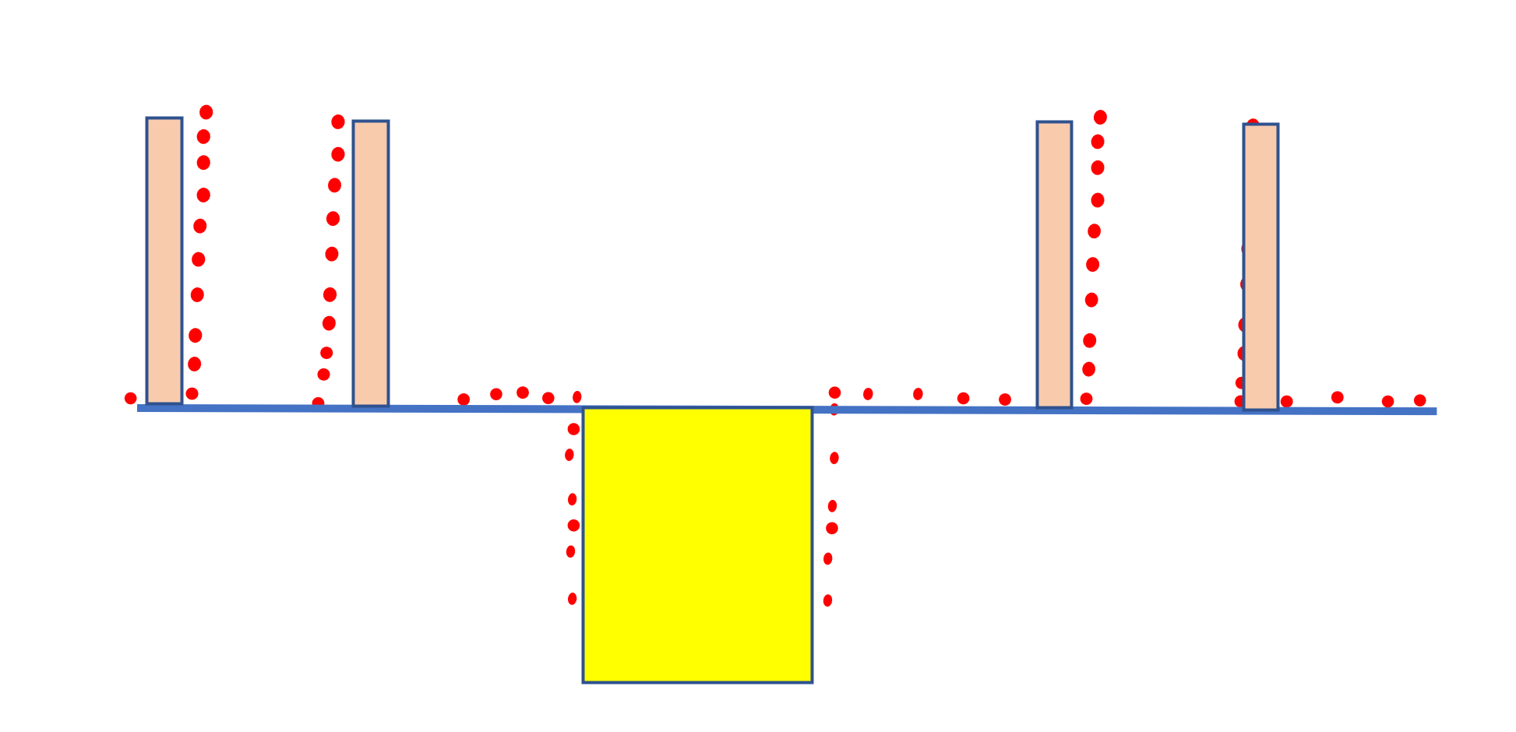

No, the distance between the two pins is too large.

1. Consider the simultaneous fit of two coaxial features as shown.

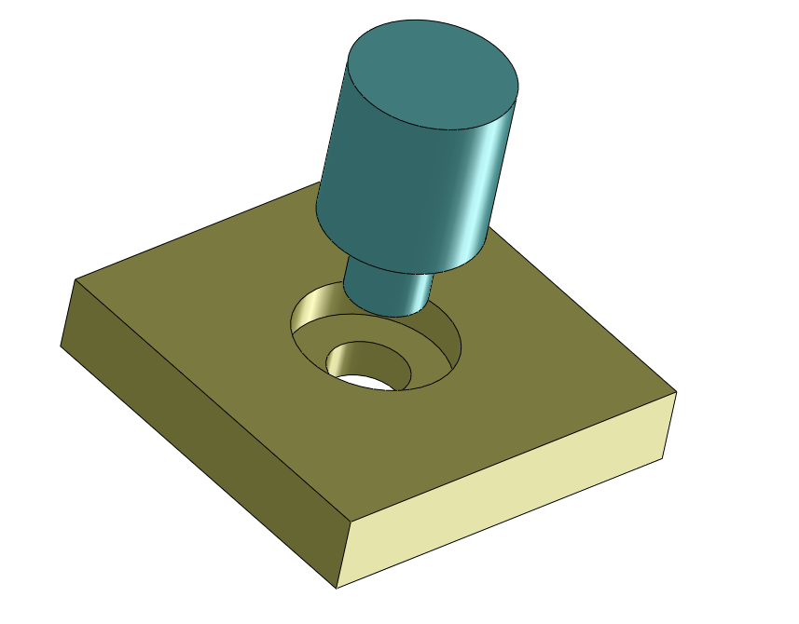

**Fit of two coaxial features**

The nominal dimensions of the larger cylinders are 40 mm and the smaller cylinders are 20 mm. We would like to tolerance the parts to assure assembly. In this application, the two parts need not perfectly rest on their flat shoulders. Create models of the two parts and their drawings and tolerance the part features to assure a zero worst-case fit gap. Extend the tolerancing for the case where there exists a third coaxial feature of size 60 mm.

**Solution**

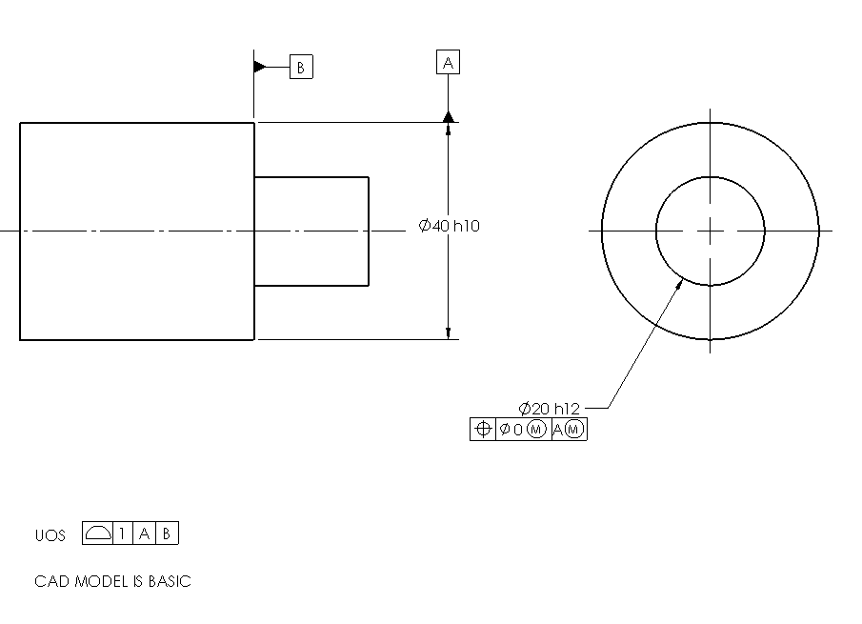

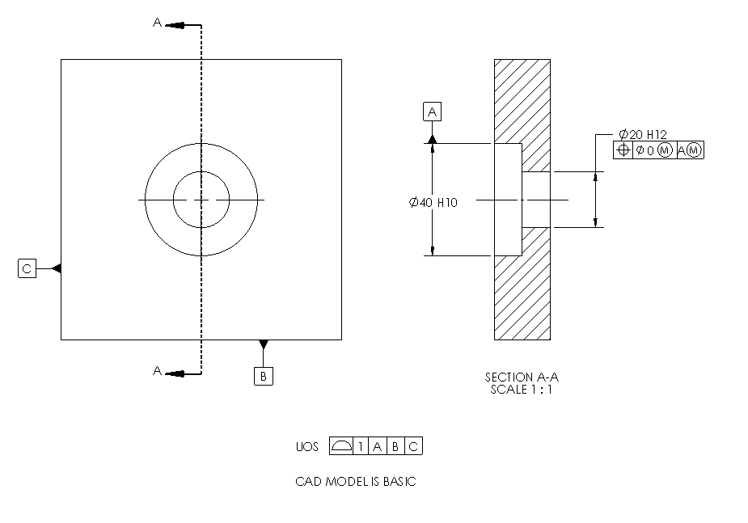

1. **Gaging:** Download Problem 5-6 from the book web site. In this problem you will check a position tolerance. Consider the plug part in Exercise Problem#4. The part geometry is sampled by a CMM and the pattern of points representing both pin features are shown. The GO gage is made up of two holes. Move and rotate the gage if necessary to determine if the part passes the gage test. Based on this information, is this part within position tolerance? Note that both the part surface samples and the gage are 3D but only a 2D pattern can be shown on the plane of paper.

**Solution**

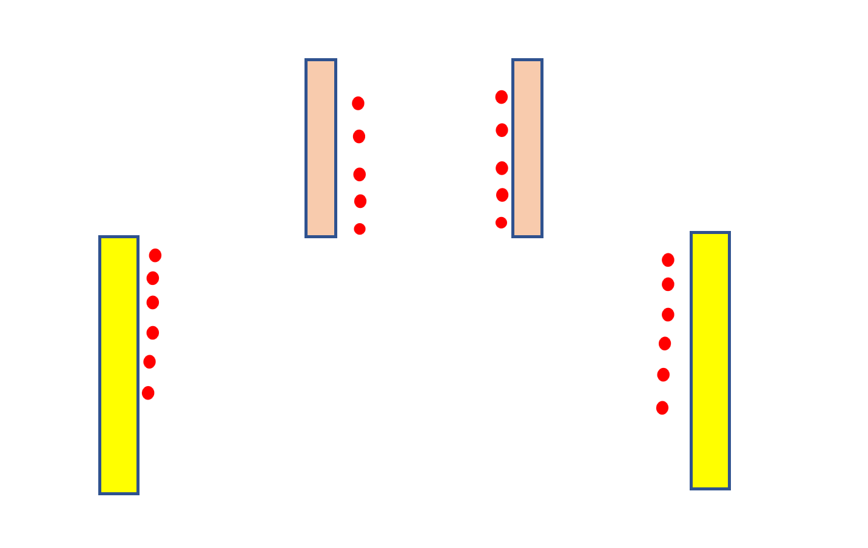

Yes, the feature meets the stated position tolerance.

1. Tolerance the coaxial fit feature parts in Exercise Problem#4 such that the fit is assured while the flat shoulders are in full primary contact.

**Solution**

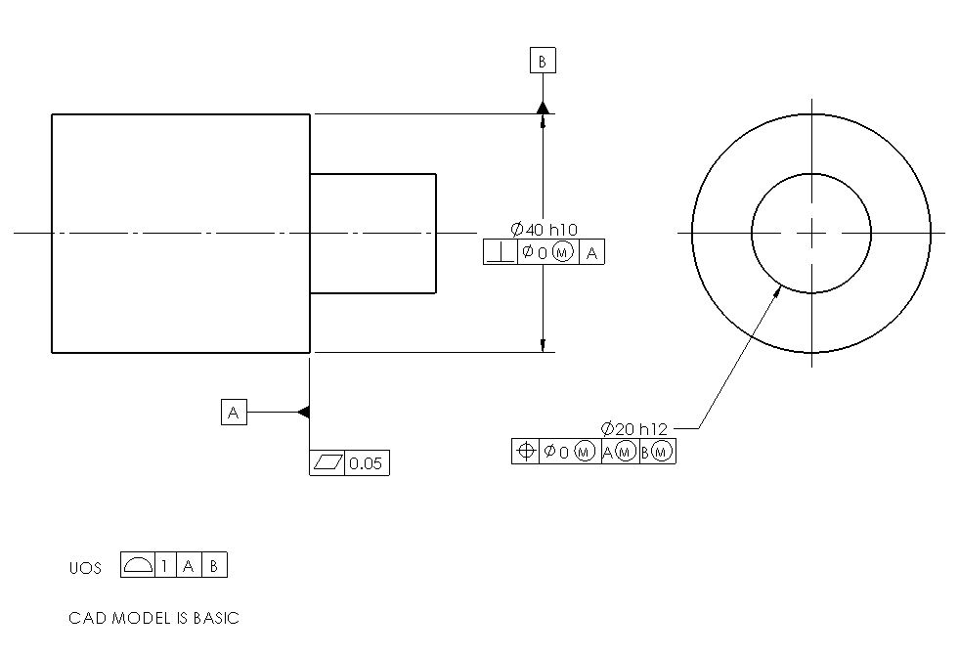

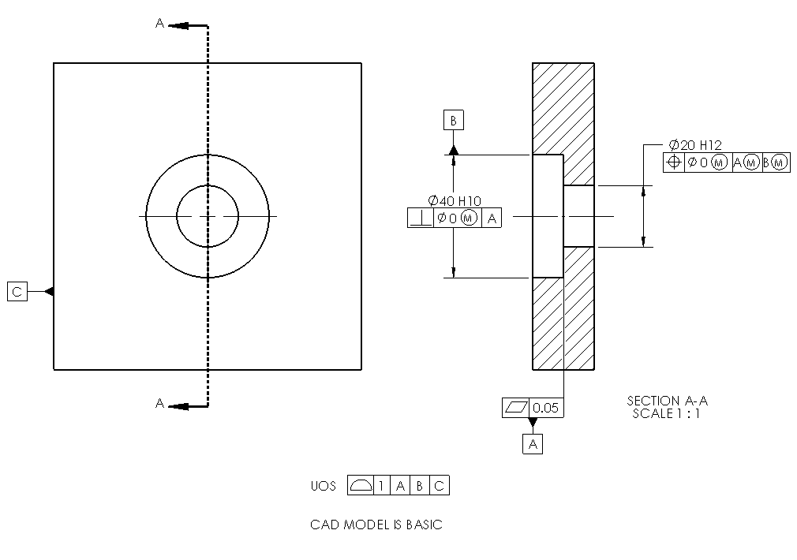

1. **Gaging:** Download Problem 5-8 from the book web site. Consider the plug part in Exercise Problem#4 and the tolerance requirement stated in Problem #6. The part geometry is sampled by a CMM and the pattern of points representing both pin features and the flat surface are shown. The GO gage is made up of two holes and a datum simulator. Move and rotate the gage if necessary to determine if the part passes the gage test. Based on this information, is this part within position tolerance? Note that both the part surface samples and the gage are 3D but only a 2D pattern can be shown on the plane of paper.

**Solution**

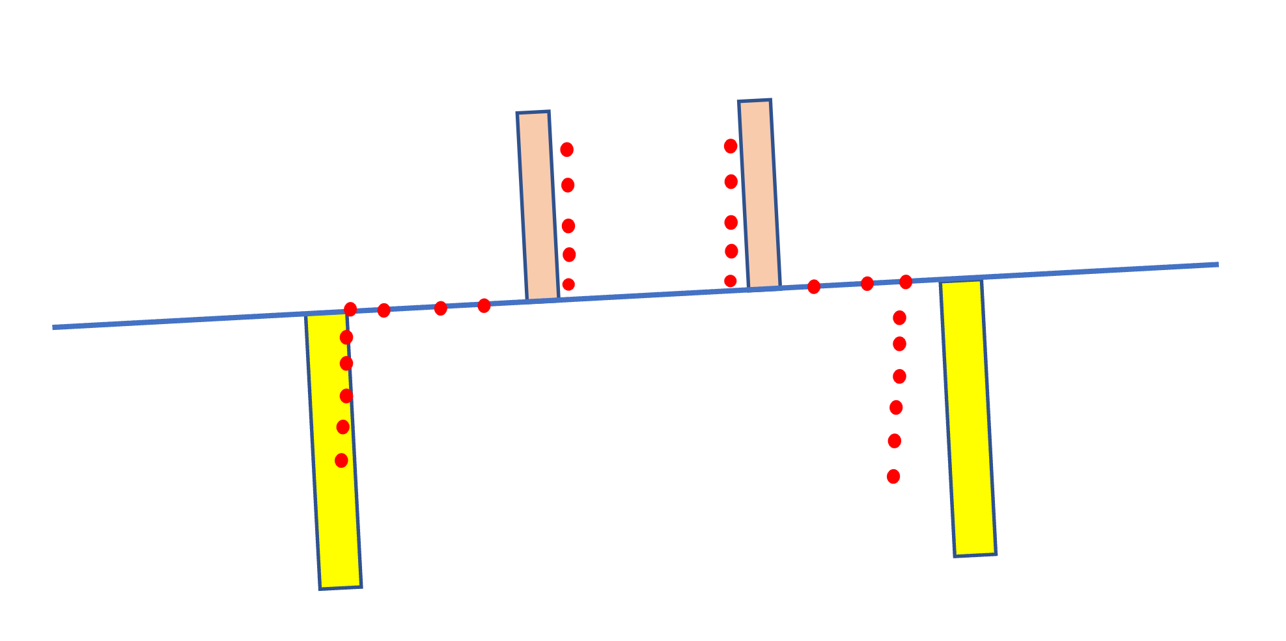

No, the feature does not meet the stated position tolerance.

1. Consider the assembly shown. One of the parts is flipped to better show the features.

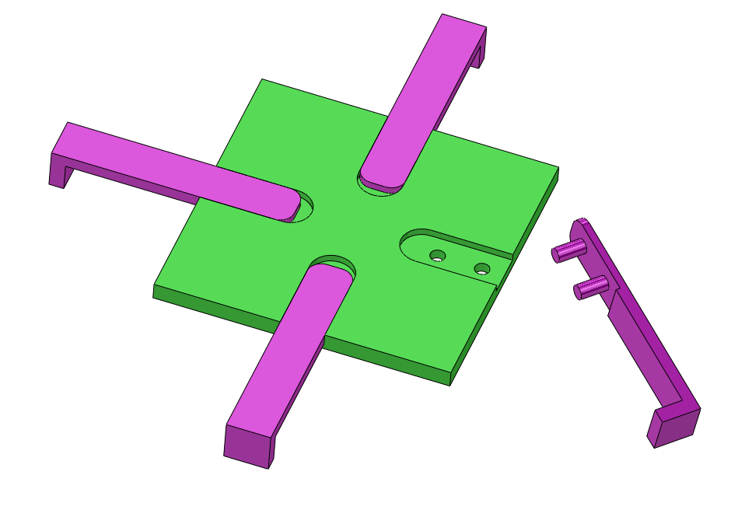

**Fit of four separate parts to a plate**

The pins and holes have 10 mm nominal size and the width of the rail and slot are 30 mm. The rest of the dimensions are up to you. Model the parts in a CAD system and create complete production drawings for the two parts. Assume milling process tolerances apply.

**Solution**

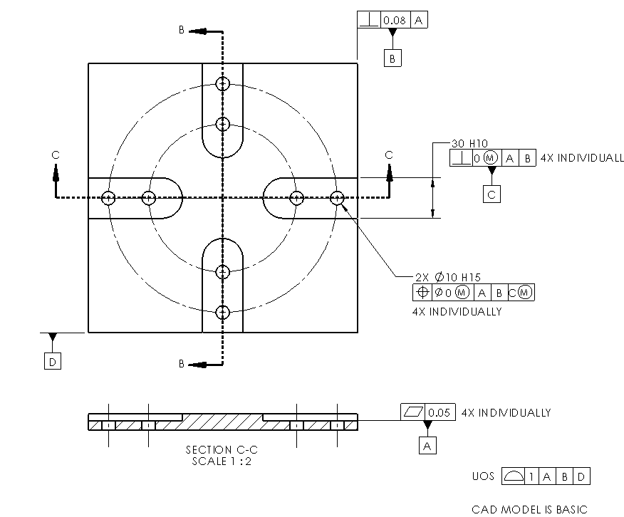

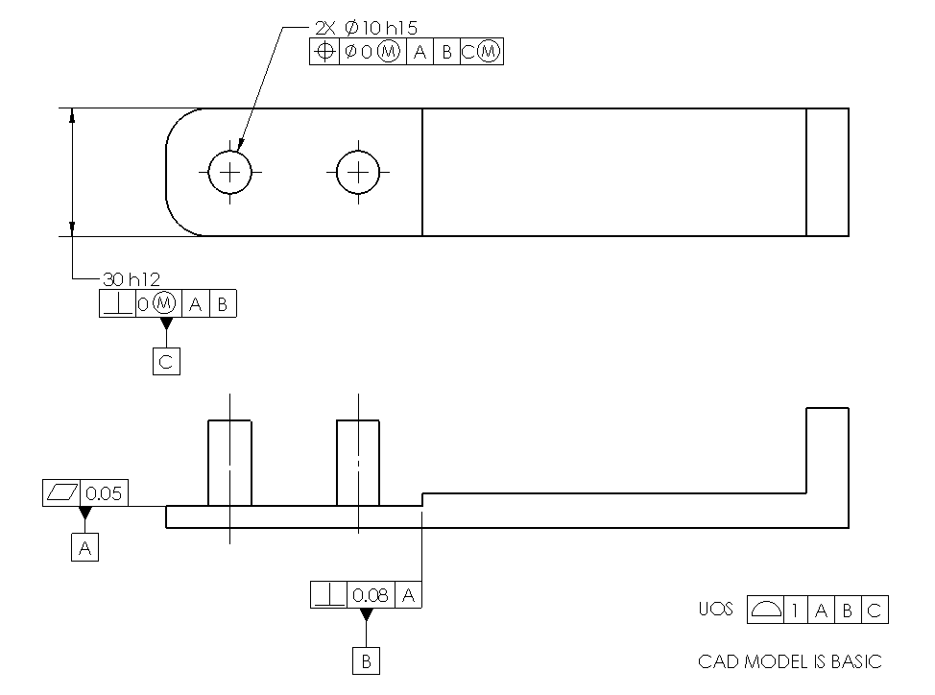

1. **Gaging:** Download Problem 5-10 from the book web site. Consider one of fit patterns on the plate part in Exercise Problem #8. The relevant geometry is sampled by a CMM and the pattern of points representing these features are shown. The GO gage is made up of a pattern of two pins, a rail features, and a datum simulator. Move and rotate the gage if necessary to determine if the part passes the gage test. Based on this information, is this part within position tolerance? Note that both the part surface samples and the gage are 3D but only a 2D pattern can be shown on the plane of paper.

**Solution**

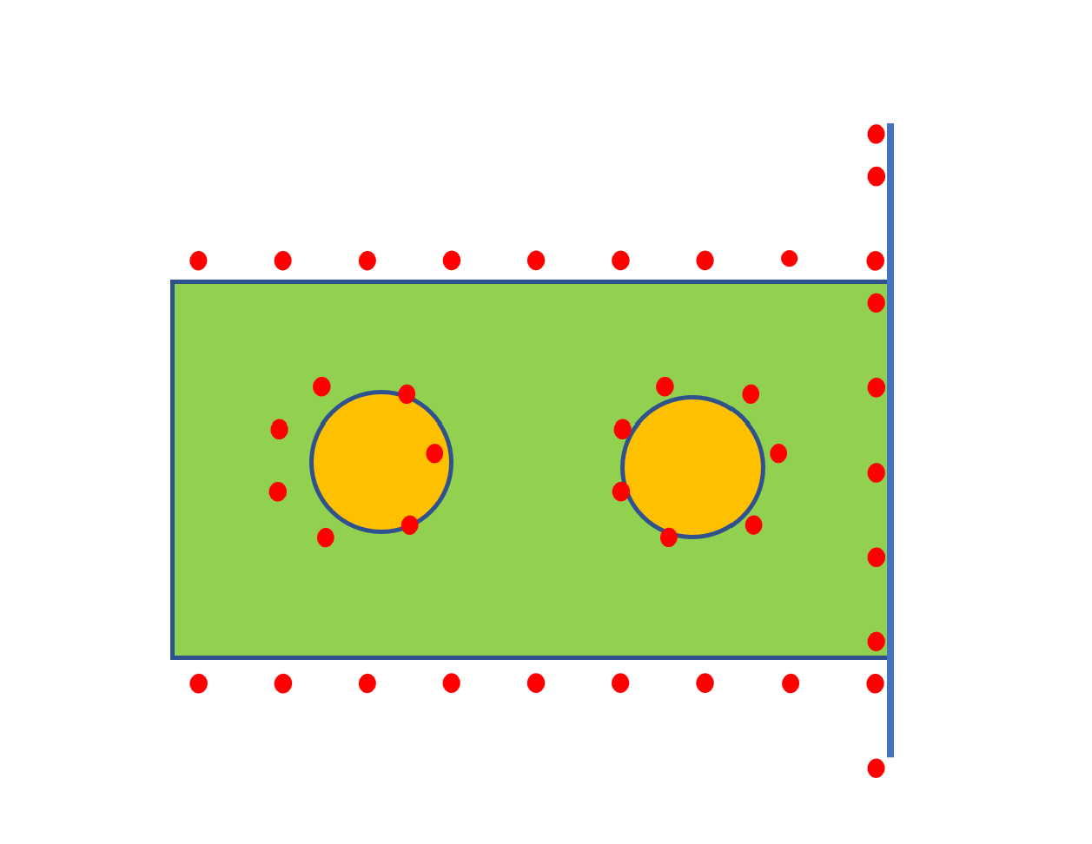

No, the feature does not meet the stated position tolerance.

1. Consider the base plate and the plug assembly shown below.

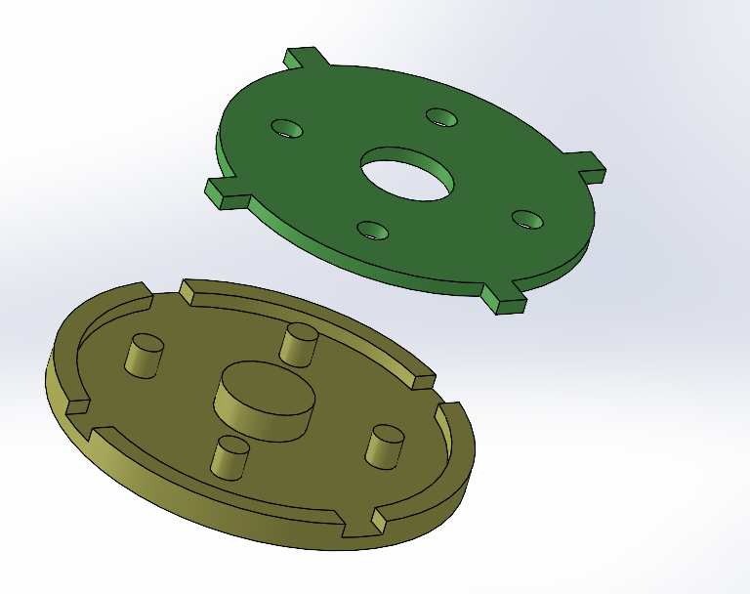

The model dimensions for plug and base plate are shown below (not all the dimensions are shown).

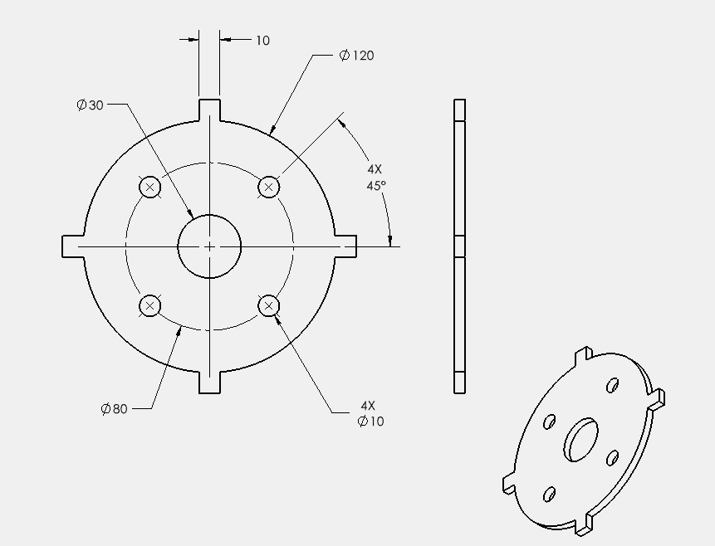

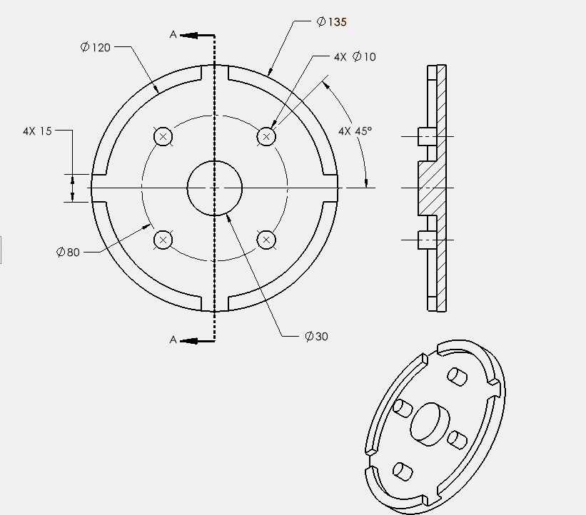

Model the two parts using your CAD system. Indicate all the tolerances necessary for a successful fit. Order the tolerancing of the fit features based on their fit precision (do the highest precision fits first). Tolerance both parts for the following requirements:

1. The fit of the center hole of the plug (the 30 mm dimension) to the base plate must have a Pmin=0 and a Pmax of less than 0.2 mm.
2. The fit of the outside cylinder of the plug (the 120 mm dimension) to the base plate must have a Pmin=0 and a Pmax of less than 0.4 mm
3. The fit of the pattern of 4 slots on the base plate to the rails of the plug must have a Pmin=0 and a Pmax of less than 0.6 mm.
4. The fit of the pattern of 4 bosses on the base plate to the holes of the plug must have a Pmin=0 and Pmax of less than 0.8 mm.

Place the size and geometric tolerances necessary for this fit on the two drawings. Use the same size and geometric tolerances for the fitting features. You can use the exact Pmax values to determine the widest tolerances.

**Solution**

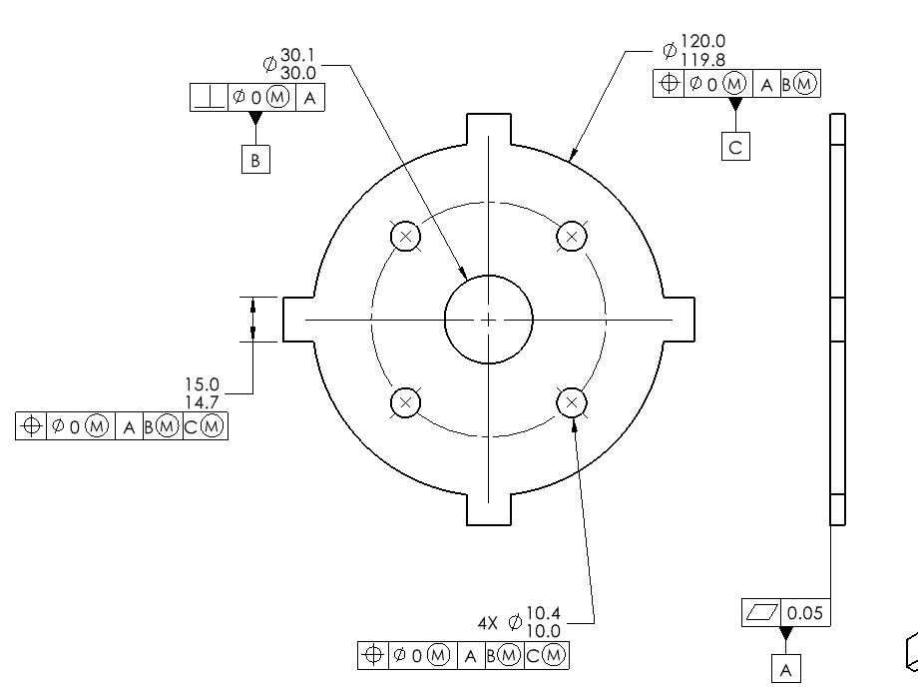

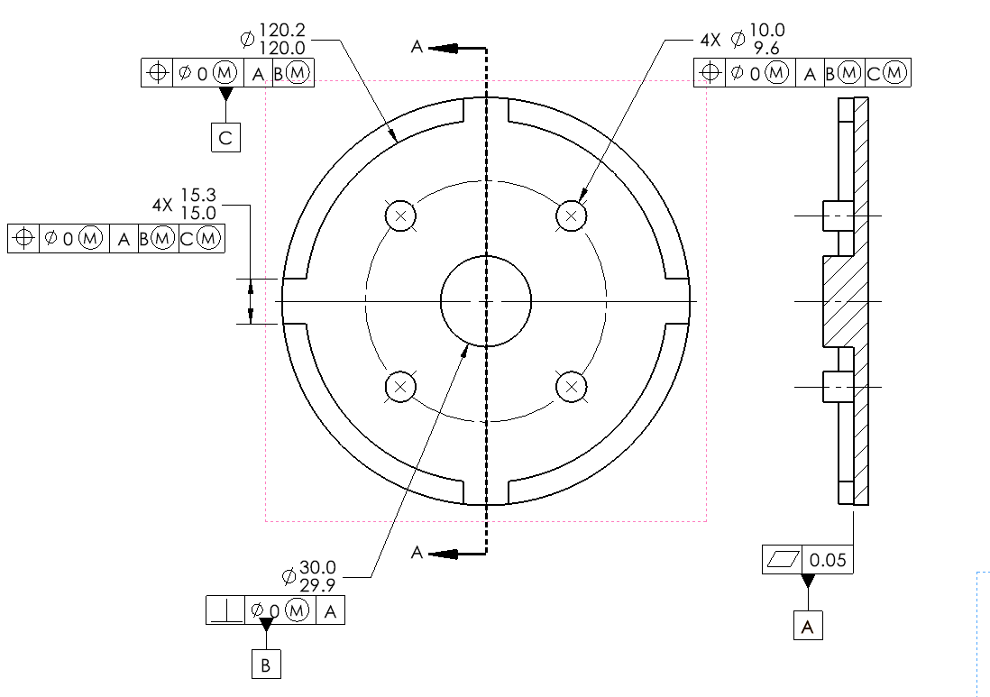

1. Find an actual example of a location-constrained fit. Take a picture and explain why the fit is a location-constrained fit. Create a model of the relevant features and tolerance them for fit.

**Solution**

The chain link assembly is an example of a location-constrained fit.

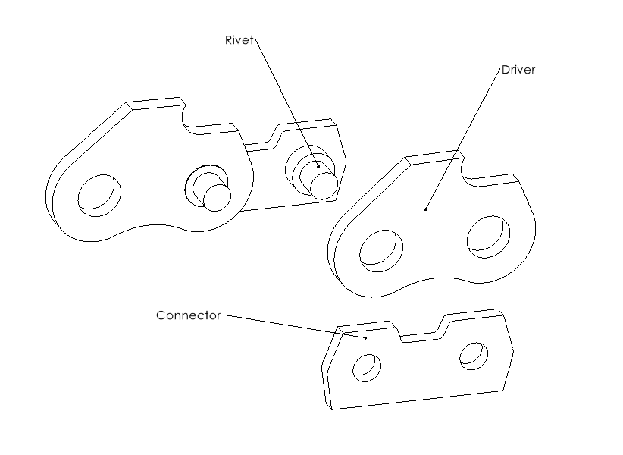

The position tolerance controls the distance between the two holes.

