1. Consider the orientation-constrained fit situation shown.



**A simple orientation-constrained fit**

* + 1. Using your CAD system and model both parts with dimensions that result in worst-case condition for fit. For example, the pin size would be at the MMC size of 19 mm plus 1 mm allowance for orientation. It is best to convert the features to ZGT format before modeling. Create an assembly of the two parts and check for play or interference. What is the play in the CAD assembly model?

**Solution**

Since the distance between the centers is 0.5 mm, the play in the fit is 1 mm.

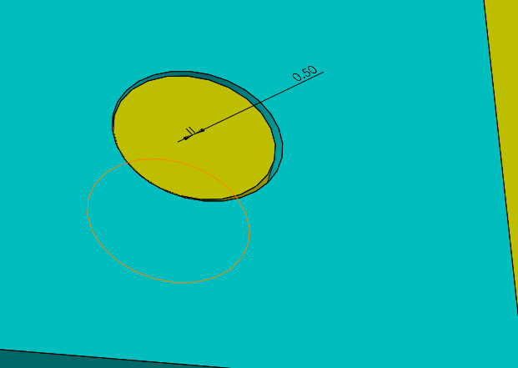

* + 1. Model the parts with dimensions leading to the maximum play in the fit. Create an assembly and determine the maximum play in the fit?

**Solution**

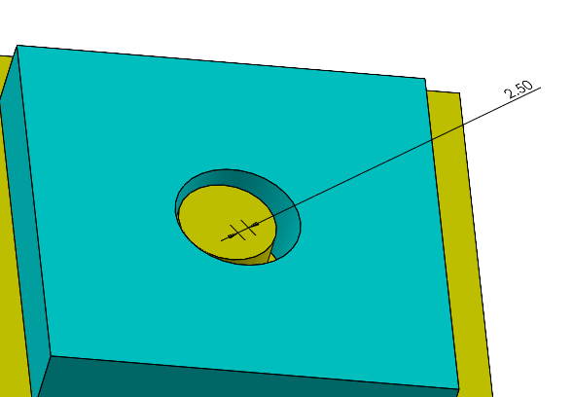

Since the distance between the centers is 2.5 mm, the play in the fit is 5 mm.

1. **Gaging:** Download Prob 4-2 from the book web site. In this problem you will check the perpendicularity tolerance for a rail feature. The rail size limits are between 20 and 21 mm. The perpendicularity tolerance is 0.2 mm at MMC with respect to a planar datum A. The GO gage is a slot of size 21 mm and the datum Plane A. All the points representing the rail feature must fit outside the GO gage while datum A feature makes full contact with the datum feature simulator of the gage. Based on this data, is this rail feature within perpendicularity tolerance?

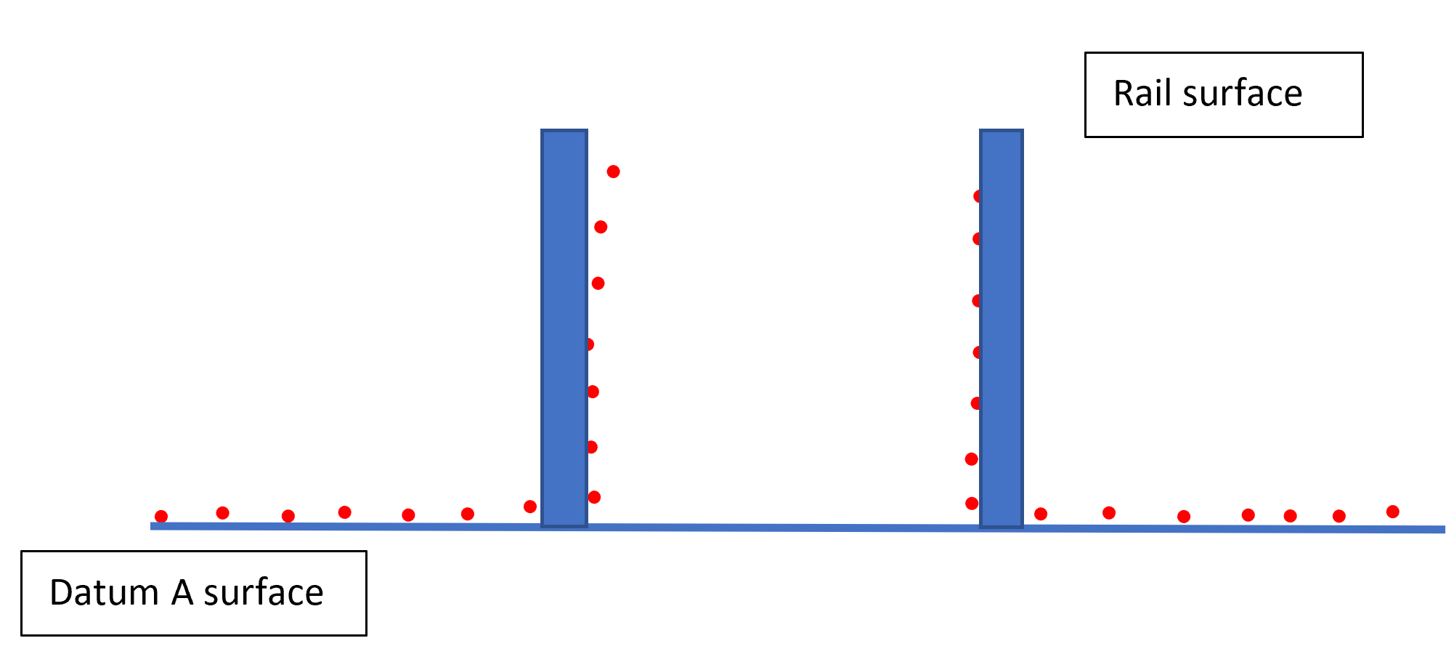

No, this rail feature is not within the perpendicularity tolerance.

1. **Gaging:** Download Prob 4-3 from the book web site. In this problem you will check the perpendicularity tolerance for a hole feature. The hole size limits are between 23 and 24 mm. The perpendicularity tolerance is 1 mm at MMC with respect to a planar datum A. The GO gage is a pin of size 22 mm and the datum Plane A. All the points representing the hole feature must fit outside the GO gage while datum A feature makes full contact with the datum feature simulator of the gage. Based on this data, is this hole feature within perpendicularity tolerance?

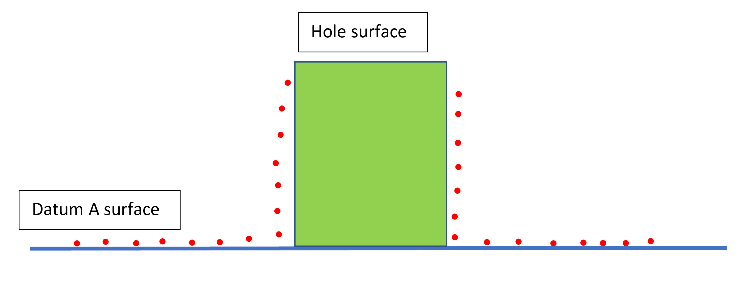

Yes, this hole feature meets the perpendicularity tolerance.

1. **Gaging:** Download Prob 4-4 from the book web site. In this problem you will check the perpendicularity tolerance for a hole feature specified RFS (without the m modifier). Read about the meaning of perpendicularity tolerance RFS in Chapter-9. The hole size limits are between 23 and 24 mm. The perpendicularity tolerance is 1 mm RFS with respect to a planar datum A. The gage is made up of a cylindrical zone of size 1 mm and the datum Plane A. The derived axis of the hole feature must fit inside the tolerance zone while datum A feature makes full contact with the datum feature simulator of the gage. First, using an expanding pin, identify the axis of the hole (UAME) and draw the axis (approximately by visual estimation). Then check the gage against this axis. Based on this data, is this hole feature within the perpendicularity tolerance?

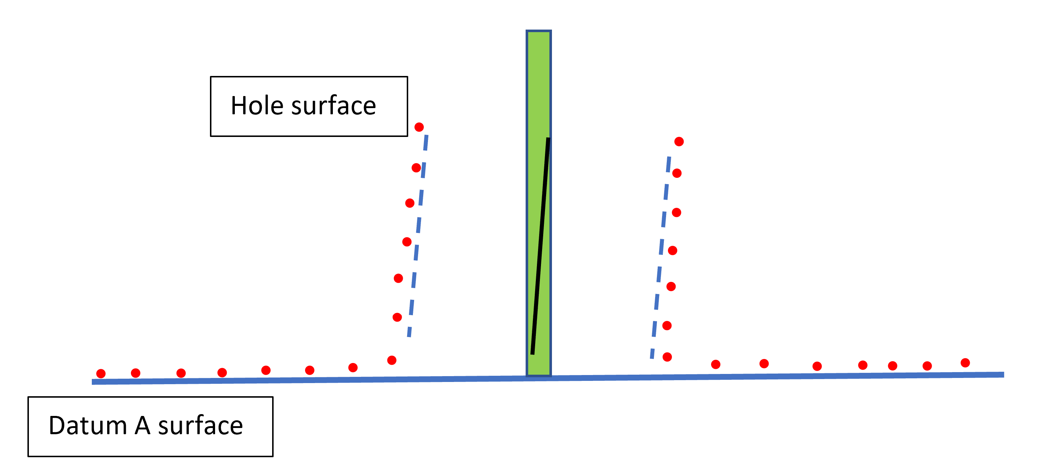

Yes, this hole feature meets the perpendicularity tolerance.

1. **Gaging:** Download Prob 4-5 from the book web site. In this problem you will indicate the size and axis of an OCAME. Follow the instructions in the problem statement.

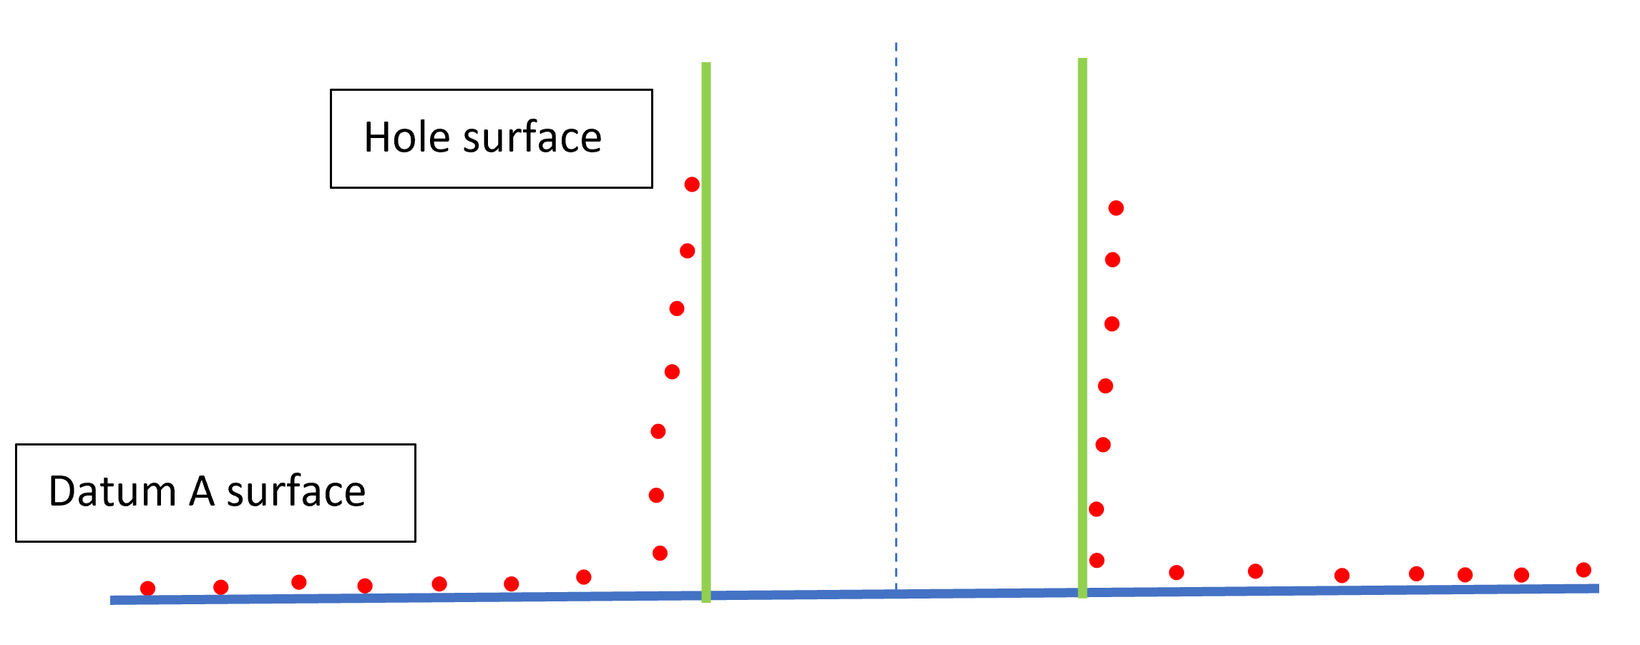

1. Find an actual example of an orientation-constrained fit. You can find such examples in your gym, machine shop, automobile, labs, your kitchen or garage, or other ordinary places. Take pictures and explain why the fit represents an orientation-constrained fit.

**Solution**

The fit of a pipe flange in this application is an orientation constraint fit.

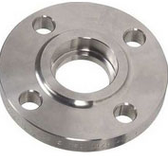

1. Consider the fit of a hole and a pin in an orientation-constrained fit. The nominal size of the features is 25 mm. Both features must be specified in ZGT (Zero Geometric Tolerance) format. The minimum play is to be zero and the maximum play must not exceed 0.2 mm. For the most economical design, both feature sizes are to border the nominal size of 25 mm. Using equal tolerances for both features, determine the size limits of the two features.

**Solution**

In this case we will use the maximum play limit to find the tolerances. The maximum play is the summation of all tolerances:

Pmax = th + tF + Th + TF + Pmin

Since the tolerances are equal:

Pmax = 2t + 2T

With the ZGT format and using the combined tolerances:

Pmax = 2(tZGT) 🡺 0.2 = 2 tZGT 🡺 tZGT = 0.1 mm

For the features to border the nominal size of 25 mm:

Hole size limits = 25.0 – 25.1 mm

Pin size limits = 24.9 – 25.0 mm

1. Consider the fit of a slot and a rail in an orientation-constrained fit. The slot feature size limits are 25.5 – 25.8 mm with a 0.1 mm perpendicularity tolerance at m. The minimum play is to be zero and the maximum play must not exceed 0.8 mm. Determine the widest size limits of the rail feature to achieve this fit performance using a ZGT format assuming equal size tolerances.

**Solution**

We use the maximum play limit to find the tolerances. The maximum play is the summation of all tolerances:

Pmax = th + tF + Th + TF + Pmin

Since the tolerances are equal:

Pmax = 2t + Th + TF

With the ZGT format and using the combined tolerances:

Pmax = 2(tZGT) 🡺 0.8 = 2 tZGT 🡺 tZGT = 0.4 mm

The slot size limits in ZGT format is 25.4 - 28.8

The rail size limits become: 25.0 – 25.4 mm