ME 481/581 Final Exam-Type Questions

For all the theoretical gages: If a dimension is not shown on your gage, it implies that the dimension is flexible. Indicate all the geometry information necessary to conceptually build the gages.

- [10 points] Consider the part shown in the figure. Draw the theoretical gage for the profile tolerance statement. Draw the gage in the same view as in the figure

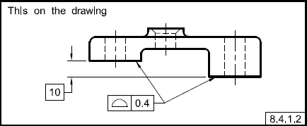

- [10 points] Draw a theoretical gage associated with the upper segment profile tolerance shown in the figure below. Draw the gage in the front view shown on the left. Show the theoretical shape with dashed lines.

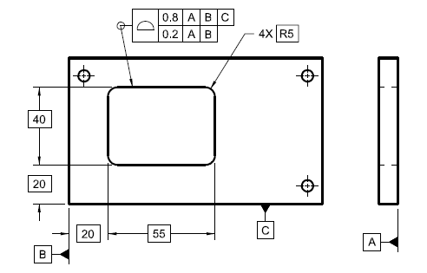

- (10 points) Draw the theoretical gage for the upper segment position statement. Draw the gage in two views corresponding to the two views on the right.

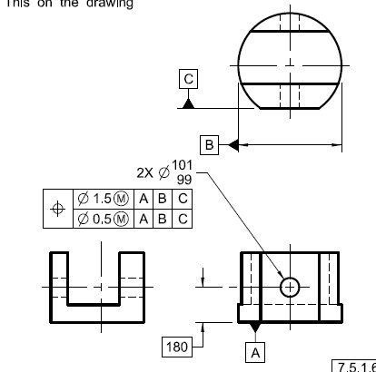

- (20 points) The bearing shown in the figure is to be fit to a motor shaft. We have selected the one with a bore size of 15 mm.

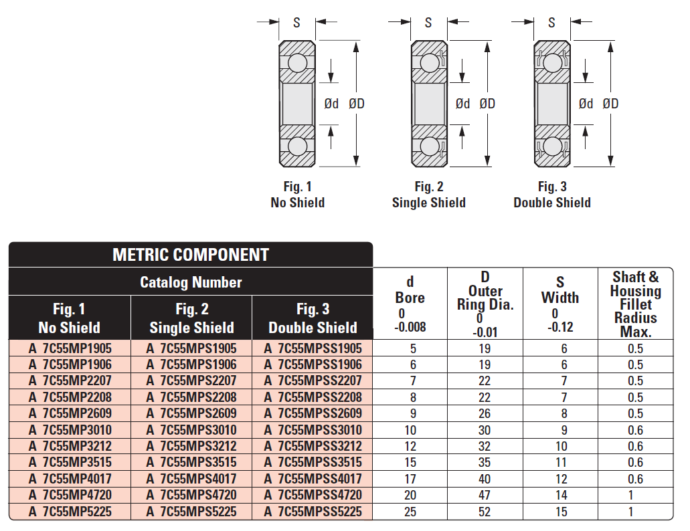
- Determine the shaft size limits for an unconstrained fit to the bearing bore. The shaft to bearing bore fit is to have fit limits identical to a 15H7/n6 locational transition fit. The fit play/interference values are between 0.006 mm clearance to 0.023 mm interference.

- (50 points) Consider the hand crank assembly shown. The bottom plate is the base plate. The vertical plates are side plates.

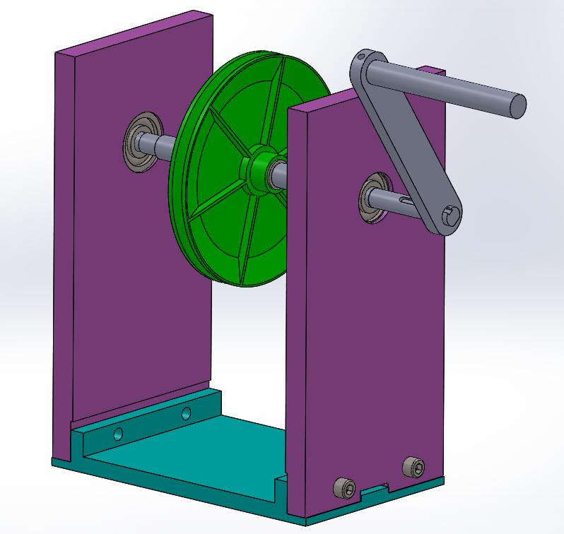

The screws are M6 (6 mm max diameter). Assume the clearance holes are made by using a 6.5 mm drill (the drill can create hole size limits of 6.50 – 6.58 mm. The thickness of the side plates where the screws fit is 12 mm.
- Determine the required (largest possible) position tolerance for the clearance holes and the threaded holes (assume they use equal position tolerances) that assures fit.
- Determine the clearance hole size tolerances when used with a zero position tolerance.

Assume the slot and rail features are nominally 20 mm in width.
- Determine the size limits of slot and rail such that the minimum possible play is zero and maximum possible play in the fit is 0.12 mm. Use the same size tolerance for both slot and rail.
- For the base plate in the figure below, show (on next page) all the required tolerances (including datum precision) to assure the fit of the side plates with threaded fasteners using the calculated information. To fit a larger figure I printed the page sideways, turn the page so the plate bottom is horizontal before adding tolerances. Basic dimensions need not be shown.
